Product Requirements Document
  - Multi-tenant conversation sentiment analysis and key-moment intelligence
This PRD defines the product requirements for a speaker-aware conversation intelligence platform where end-user sentiment and end-user key moments are first-class objects. Admin, system, and agent turns remain visible for context, but they are excluded from end-user scoring by policy.

Version | v1.0 (draft)
Date | March 27, 2026
Audience | Product, engineering, ML, platform, security, operations
Scope | Text transcripts only; multi-tenant; no tenant training; role-aware scoring

Contents
- 1. Product summary and problem statement
- 2. Goals, non-goals, and principles
- 3. Users, use cases, and scope
- 4. Functional and non-functional requirements
- 5. Success metrics, rollout, risks, and acceptance criteria

1. Product summary
The product is a multi-tenant conversation intelligence system that analyzes text transcripts and returns speaker-aware sentiment, business understanding, and key moments. The system must work across different tenants and use cases such as support, sales, collections, claims, or service operations without training on any tenant's private data.
The system's defining requirement is role-aware scoring. End-user sentiment must be derived from end-user turns, not from administrative notes, system messages, or agent speech. Likewise, the primary key moments surfaced in the end-user analytics workflow must be triggered by end-user evidence unless a tenant explicitly enables a different policy for a specific use case.
The product must be tenant-configured rather than tenant-trained. Tenant-specific language, policies, business rules, and taxonomies are injected at inference time via tenant packs. Shared models remain generic, globally trained, and never updated with tenant data.
Product promise
The most important product promise is not “good sentiment classification”; it is “correct speaker attribution plus evidence-backed business meaning.” If the wrong actor is scored, every downstream metric becomes misleading.

2. Problem statement
Most sentiment systems flatten a conversation into a single label and ignore speaker identity. That fails in real operational transcripts because transcripts often include customer turns, agent turns, supervisor interventions, administrative notes, bot text, and system-generated messages. If the system merges those together, it can label a call as positive because an agent is polite while the end user is frustrated, or it can highlight a key moment that was actually just an internal note.
The system therefore needs to solve four linked problems: determine who is speaking, determine what the end user feels and about what, determine what moments changed business state or user state, and map the result into tenant-specific business meaning without training on tenant data.

3. Goals and non-goals

Goals
- Produce end-user sentiment that is speaker-aware, aspect-aware, context-aware, and evidence-backed.
- Identify key moments that matter to the tenant’s workflow, with actor attribution, evidence spans, and business impact.
- Support multiple tenants and multiple use cases per tenant through runtime tenant packs, not tenant-specific training.
- Handle sarcasm, negation, mixed sentiment, policy disputes, and long-context calls using context-aware modeling and adjudication.
- Return structured outputs with confidence, review state, and canonical event labels before tenant mapping.
- Support short synchronous calls and long asynchronous jobs with the same canonical output contract.

Non-goals
- Do not use audio, prosody, speaker diarization from raw audio, or voice biometrics.
- Do not train or fine-tune models on any tenant’s transcripts, notes, or proprietary documents.
- Do not rely on a single monolithic prompt with no explicit schema or evidence requirements.
- Do not treat agent sentiment as a substitute for end-user sentiment; agent QA can be a separate product surface.
- Do not build a cross-tenant memory or shared cache that can leak tenant data or tenant language across requests.

4. Product principles
Principle | Meaning in practice
Role-aware first | Resolve speaker role before any scoring. End-user analytics use END_USER-eligible turns only.
Canonical before tenant | Extract universal events first, then map them into tenant labels and severity.
Evidence over vibes | Every important output must cite at least one transcript span with actor attribution.
Tenant-configured, not tenant-trained | Use tenant packs for vocabulary, policy digests, rules, and mappings at runtime.
Confidence and abstention | Low-confidence role assignments or moment labels route to review instead of forcing a confident answer.
Long-context safety | Use a fast pass for candidate detection and a deeper adjudication path for hard or long cases.

5. Users and primary workflows

Primary users
User | Need | What success looks like
Operations leader | Track customer dissatisfaction, escalations, and resolution quality at scale. | Dashboard metrics align with real customer state, not agent politeness or admin noise.
QA analyst | Inspect evidence and replay the reasons behind each label. | Each label has actor attribution, evidence spans, and review state.
Product or CX analyst | Compare behavior across workflows and tenants. | Canonical events and aspect sentiments are consistent enough to benchmark.
Tenant admin | Configure business rules without retraining. | Glossaries, policy digests, role aliases, and mappings can be versioned and rolled out safely.
Integration engineer | Consume structured output in downstream tools. | Stable API, stable schema, idempotent jobs, predictable latency tiers.

Representative use cases
- Support: detect user frustration, repeated-contact signals, broken promises, policy conflicts, and resolution acceptance or rejection.
- Sales: detect buying signals, objections, competitor mentions, next-step commitments, and sentiment toward pricing or product fit.
- Collections: detect hardship, disputes, promise-to-pay moments, refusal, escalation, and compliance-sensitive interactions.
- Claims or service operations: detect policy confusion, document blockers, empathy failures, and unresolved outcomes.

6. Scope and assumptions
Dimension | Decision
Input channel | Text transcripts only. Transcripts may contain timestamps, participant labels, notes, or metadata.
Primary mode | Post-call or post-thread analysis; optional synchronous mode for shorter transcripts.
Tenant adaptation | Inference-time tenant packs only; no tenant fine-tuning.
Language | English first, with architecture open to multilingual packs later.
Role policy | END_USER is the default scored actor for end-user sentiment and end-user key moments.
Output style | Structured JSON plus evidence spans, confidence, and review flags.

7. Functional requirements

7.1 Transcript ingestion and normalization
- The system shall accept transcript text, turn order, optional timestamps, optional participant metadata, and optional tenant use-case identifiers.
- The system shall normalize whitespace, duplicate system artifacts, macro text, and transcript formatting errors without altering evidence spans.
- The system shall preserve turn identifiers and make every returned evidence span traceable to original transcript coordinates.
- The system shall identify system notes, admin inserts, and transcript control messages where explicit markers exist.

7.2 Speaker and role resolution
- The system shall resolve each turn to a canonical role: END_USER, AGENT, ADMIN, SUPERVISOR, SYSTEM, BOT, or UNKNOWN.
- The system shall combine participant metadata, tenant role aliases, known IDs, transcript markers, and model predictions to produce role assignments.
- The system shall attach a role confidence to each turn and a job-level speaker-resolution confidence summary.
- The system shall support tenants where raw labels differ by channel, for example Customer / CSR / Internal / System / Note.
- The system shall default to safe behavior when role confidence is below threshold: exclude ambiguous turns from end-user scoring and flag the job for review if impact is high.
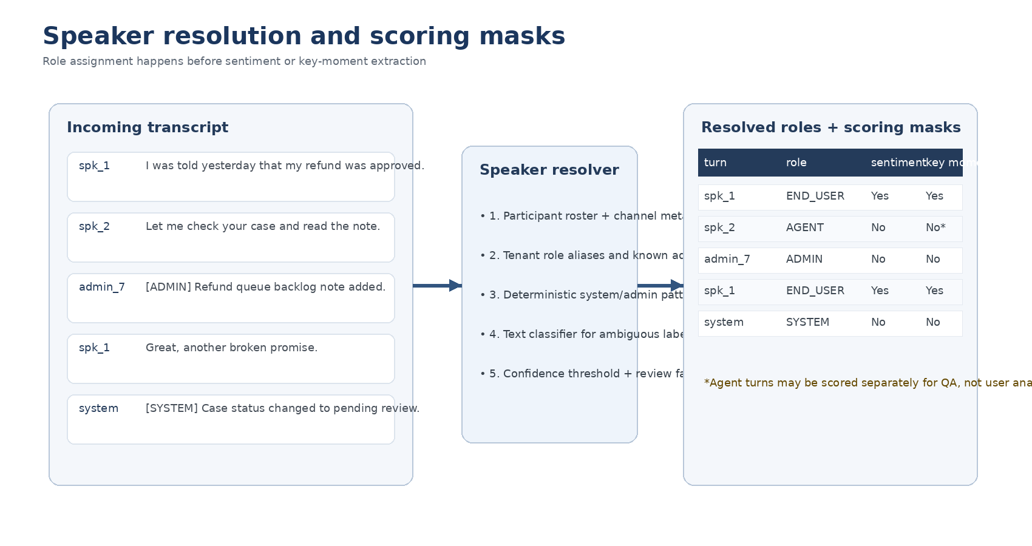
Figure 1. Speaker resolution must happen before sentiment or key-moment scoring.

7.3 Sentiment extraction
- The system shall compute end-user sentiment only from END_USER-eligible turns by default.
- The system shall return overall sentiment, aspect-level sentiment, intended sentiment, literal sentiment, intensity, and confidence.
- The system shall detect mixed sentiment, negation, and sarcasm / sentiment inversion at least at the span or aspect level.
- The system shall preserve context windows so that later turns can reinterpret earlier statements and vice versa.
- The system shall allow a separate agent-QA sentiment view, but that view shall never overwrite end-user sentiment objects.

7.4 Key-moment identification
- The system shall identify key moments as structured events with type, actor, start and end turns, evidence spans, confidence, and business impact.
- The system shall prefer end-user-triggered key moments for end-user analytics, such as frustration onset, escalation request, price objection, hardship disclosure, or promise to pay.
- The system shall support workflow-specific event sets per use case while keeping a stable canonical layer underneath.
- The system shall return the trigger rationale, not just the turn span, for example “promise broken relative to prior expectation.”

7.5 Business understanding and tenant mapping
- The system shall extract canonical business events before applying tenant mappings.
- The system shall map canonical events to tenant labels, priorities, and dashboard groupings using versioned tenant packs.
- The system shall retrieve only the relevant tenant policy digest and glossary for the active use case, not the full tenant document corpus by default.

7.6 Explainability, confidence, and review
- Every high-impact output shall include at least one transcript evidence span and actor attribution.
- The system shall return confidence and review state for role resolution, aspect sentiment, and key moments.
- The system shall support a human-review queue and correction capture for low-confidence or business-critical cases.

7.7 Tenant administration and change control
- Tenant packs shall be versioned, testable, and deployable independently from model releases.
- Tenant admins shall be able to configure role aliases, ignored speakers, key-moment taxonomies, severity rules, glossaries, and policy snippets.
- Every pack change shall support preview, canary rollout, and rollback.

7.8 Detailed requirement matrix
ID | Requirement | Priority | Acceptance criterion
FR-01 | Resolve canonical speaker role for every turn. | P0 | Each turn has role and role_confidence in the final trace.
FR-02 | Exclude non-END_USER turns from end-user sentiment. | P0 | Aggregate user sentiment changes only when eligible turns change.
FR-03 | Exclude non-END_USER turns from end-user key moments by default. | P0 | Every default key moment has eligible actor or explicit override policy.
FR-04 | Return aspect-level sentiment with evidence. | P0 | Each aspect record includes target/aspect/evidence/confidence.
FR-05 | Detect sarcasm or sentiment inversion. | P1 | System can distinguish literal vs intended sentiment on hard slices.
FR-06 | Return canonical events before tenant mapping. | P0 | Output includes canonical_events array plus tenant_mapped_events array.
FR-07 | Support synchronous and asynchronous analysis paths. | P1 | Short jobs can complete inline; long jobs via job status endpoint.
FR-08 | Tenant pack preview and rollback. | P1 | Pack versions can be validated, canaried, and reverted without model redeploy.
FR-09 | Low-confidence review workflow. | P1 | Jobs can emit NEEDS_REVIEW with rationale and route metadata.
FR-10 | Stable API schema. | P0 | Schema versions are explicit and backward compatible within a release line.

8. Output contract
The system returns a canonical analysis object and an optional tenant-mapped analysis object. The canonical layer exists so the same engine can support many tenants and many use cases. The tenant layer exists so each customer can see labels that match its own language, workflow, and dashboard conventions.
{
"job_id": "job_123",
"tenant_id": "tenant_acme",
"analysis_scope": {
"sentiment_roles": ["END_USER"],
"key_moment_roles": ["END_USER"],
"use_case": "support"
},
"speaker_summary": {
"resolved_roles": ["END_USER", "AGENT", "ADMIN", "SYSTEM"],
"confidence": 0.98
},
"overall_end_user_sentiment": {
"polarity": "negative",
"intensity": 0.84,
"confidence": 0.91
},
"aspect_sentiments": [
{
"target": "refund process",
"aspect": "speed",
"literal_sentiment": "neutral",
"intended_sentiment": "negative",
"sarcasm": true,
"evidence": [{"turn_id": "t14", "speaker_role": "END_USER"}],
"confidence": 0.87
}
],
"canonical_key_moments": [
{
"type": "policy_conflict",
"actor_role": "END_USER",
"start_turn_id": "t13",
"end_turn_id": "t14",
"business_impact": "high",
"confidence": 0.89
}
]
}

9. Non-functional requirements
Category | Requirement
Accuracy | END_USER role precision should be treated as a release-blocking metric because speaker mistakes poison downstream analytics.
Latency | Provide a fast path for short transcripts and an asynchronous path for long transcripts or deep adjudication.
Reliability | Idempotent requests, retry-safe jobs, explicit failure states, and durable audit trails are required.
Isolation | No cross-tenant cache or cross-tenant prompt memory for transcript content or tenant pack content.
Security | Encrypt data in transit and at rest; limit access by tenant, environment, and operator role.
Explainability | High-impact labels require evidence spans and actor attribution.
Configurability | Tenant packs deploy independently from shared model releases.

10. Success metrics
Metric | Why it matters
Speaker-role precision for END_USER | The highest-leverage quality metric. If wrong, sentiment and moment analytics are wrong.
Evidence-backed key-moment rate | Measures how often the system returns traceable, reviewable outputs.
Aspect sentiment F1 on hard slices | Captures mixed sentiment, sarcasm, long context, and policy disputes.
Human-accepted review rate | Measures usefulness of outputs after analyst review.
Tenant pack regression rate | Measures whether pack changes accidentally break existing tenants.
Schema-valid response rate | Ensures downstream systems can consume outputs reliably.

11. Rollout strategy
- Phase 1: support-only beta with asynchronous analysis, role gating, canonical events, and analyst review.
- Phase 2: add sales and collections use-case packs, faster path for short transcripts, and tenant self-service pack configuration.
- Phase 3: add advanced adjudication, regression automation, and tenant-level policy digests compiled from customer documentation.

12. Risks and mitigations
Risk | Mitigation
Wrong actor scored | Gate every downstream label on speaker resolution; add thresholds and review queue.
Tenant language drift | Use versioned tenant packs and pack-specific regression sets.
Overconfidence on sarcasm or ambiguous text | Use intended-vs-literal sentiment, confidence thresholds, and deeper adjudication for hard cases.
Prompt or mapping regressions | Run golden-set evals and canaries on every model or pack change.
Long transcript failures | Use scene segmentation, candidate extraction, and long-context adjudication only where justified.

13. Release acceptance criteria
- The product has a validated speaker-resolution stage and release thresholds for END_USER precision and UNKNOWN-role rate.
- Aggregate end-user sentiment demonstrably excludes AGENT, ADMIN, SYSTEM, and BOT turns under default policy.
- Key moments in the primary analytics view are actor-attributed, evidence-backed, and default to END_USER unless the tenant policy explicitly changes scope.
- All outputs are schema-valid and versioned.
- Tenant packs can be deployed and rolled back independently, with regression reports.
- Security review confirms tenant isolation, least-privilege access, retention policy, and no tenant-training path.

14. Companion documents
- Technical Architecture Document - logical components, deployment model, data contracts, and security design.
- Training, Evaluation, and Deployment Playbook - public-data strategy, annotation policy, model plan, evals, release process.

