|  |  |  |
| --- | --- | --- |
| Device Name | Start Address | End Address |
| External Memory | 0x0 | 0x1FFF_FFFF |
| Boot Rom | 0x4000_0000 | 0x4002_BFFF |
| Sram internal | 0x402F_0400 | 0x402F_FFFF |
| L3F CFG Regs | 0x4400_0000 | 0x443F_FFFF |
| L3S CFG Regs | 0x4480_0000 | 0x44BF_FFFF |
| McASP0/1 Data | 0x4600_0000 | 0x467F_FFFF |
| USBSS | 0x4740_0000 | 0x4740_0FFF |
| USB0 | 0x4740_1000 | 0x4740_17FF |
| USB1 | 0x4740_1800 | 0x4740_1FFF |
| USB scheduler | 0x4740_2000 | 0x4740_2FFF |
| USB Queue Manager | 0x4740_4000 | 0x4740_3FFF |
| MMCHS2 | 0x4781_0000 | 0x4781_FFFF |
| TPCC | 0x4900_0000 | 0x490F_FFFF |
| TPTC | 0x4980_0000 | 0x49AF_FFFF |
| GPMC | 0x5000_0000 | 0x50FF_FFFF |
| ADC_TSC_DMA | 0x54C0_0000 | 0x54FF_FFFF |
| EMIF0 SDRAM | 0x8000_0000 | 0xBFFF_FFFF |
| CM | 0x44E0_0000 | 0x44E0_0AFF |
| PRM | 0x44E0_0B00 | 0x44E0_12FF |
| GPIO0 | 0x44E0_7000 | 0x44E0_8FFF |
| UART0 | 0x44E0_9000 | 0x44E0_AFFF |
| I2C0 | 0x44E0_B000 | 0x44E0_CFFF |
| UART1 | 0x4802_2000 | 0x4802_4FFF |
| I2C1 | 0x4802_A000 | 0x4802_BFFF |
| McSPI0 | 0x4803_0000 | 0x4803_1FFF |
| GPIO1 | 0x4804_C000 | 0x4804_CFFF |
| GPIO2 | 0x481A_C000 | 0x481A_CFFF |
| GPIO3 | 0x481A_E000 | 0x481A_EFFF |
| PWM | 0x4830_0000 | 0x4830_425F |
| LCD Controller | 0x4830_E000 | 0x4830_EFFF |
| McSPI1 | 0x481A_0000 | 0x481A_0FFF |

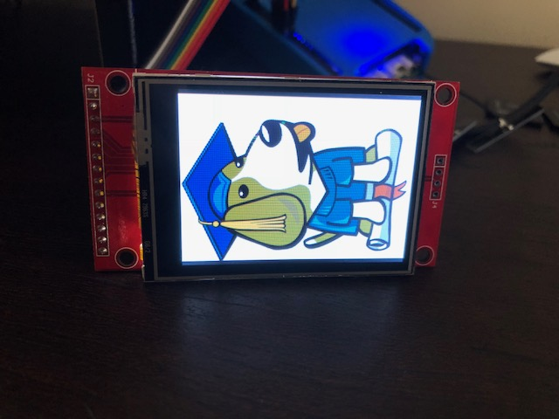

Figure 1 : Side ways Beagle

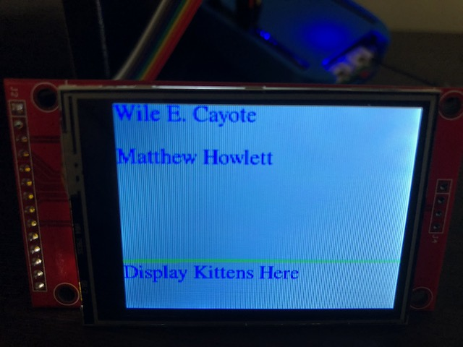

Exhibit 2: Edited text on LCD screen