|  |  |  |
| --- | --- | --- |
| ipn | **INSTITUTO POLITÉCNICO NACIONAL**  **ESCUELA SUPERIOR DE CÓMPUTO** |  |

**Redes de Computadoras**

**“ARP TUTORIAL WITH PACKET TRACER”**

**By:**

**Bastida Prado Jaime Armando**

Professor:

M. en C. NIDIA ASUNCIÓN CORTEZ DUARTE

May 2018



Introduction

What we are going to do in this tutorial is to show how the interaction between two computers. Sending a message from one to another produces (only the first time) an ARP message to be sent, how this protocol is constructed and how the computer fills in its ARP table with the addresses of the known computers.

1. We have this screen

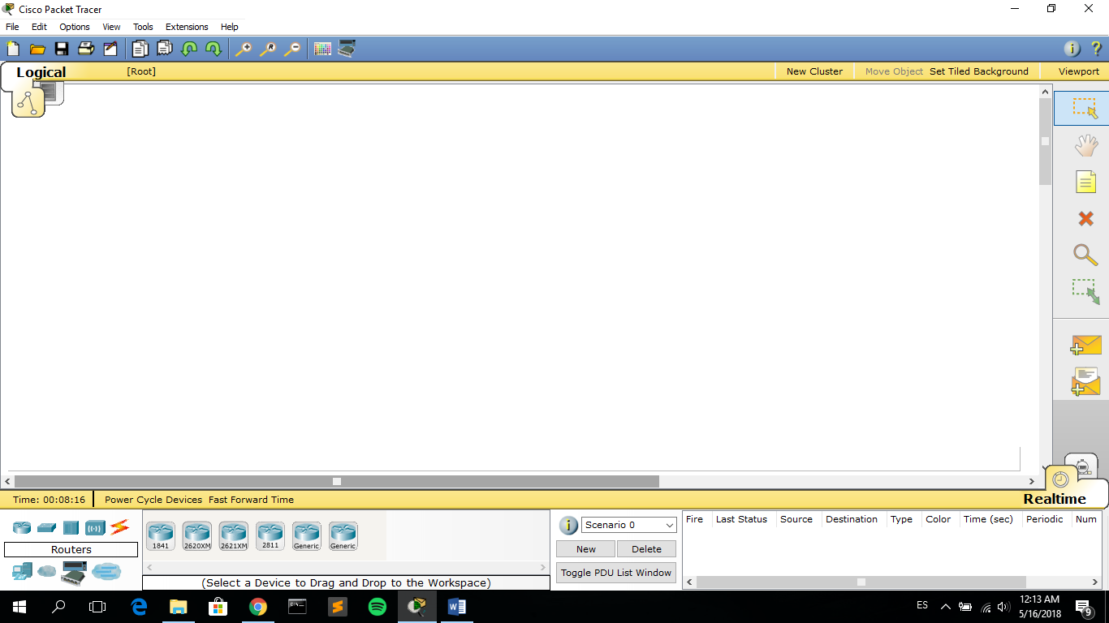

*Figure 1: Main Screen*

1. We need to put two computers so go to “End Devices” here:

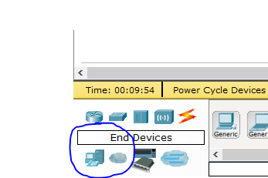

*Figure 2: End Devices*

1. Select “Generic” and put two computers anywhere in the blank space, double click on them and change their names to “Betito” and “Alicia”:

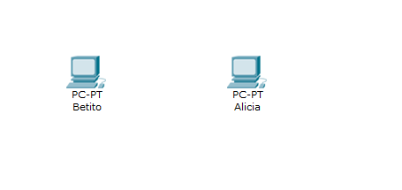

*Figure 3: Setting the names to both Computers*

1. Go to “Connections” and select “Copper Cross-Over” to connect Alicia and Betito, select Fast Ethernet:

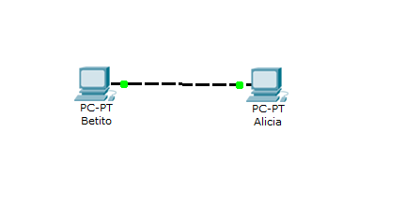

*Figure 4: Connecting both computers*

1. Now, click on “Simulation Mode” at the bottom right:

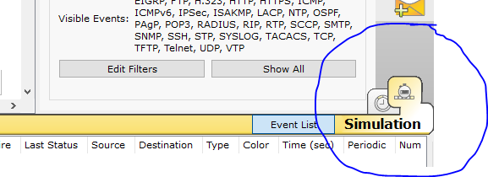

*Figure 5: Selecting Simulation mode*

1. Try to send a message from Betito to Alicia, click on the “Add Simple PDU” message:

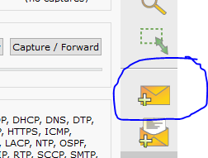

*Figure 6: Trying to send a message from Betito to Alicia*

And then click on Betito and click on Alicia. You will see a message that says, “Alicia has no functional ports”, Why is this message appearing? Because although both computers are connected to each other, they don’t have an IP address, there is no way they can communicate so, we are going to set an IP address for both.

1. Double click on Betito and a window like the following will appear:

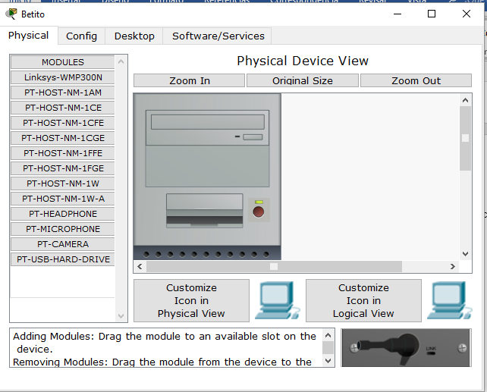

*Figure 7: Betito configuration*

Go to “Desktop” and then “IP configuration”, you will see the next window:

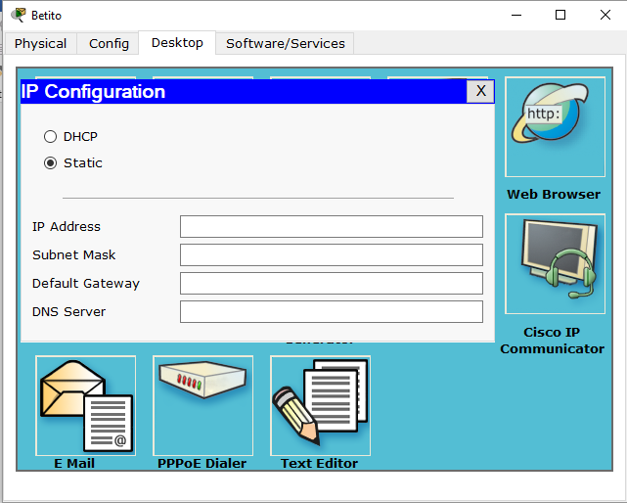

*Figure 8: Setting Betito IP*

DHCP is for a dynamic configuration in which the addresses are assigned automatically. We will select Static and assign 2.0.0.1 to Alicia and 1.0.0.1 to Betito. Note that they are in different Networks. Now if we try to send a message from Betito to Alicia again an error will be produced:

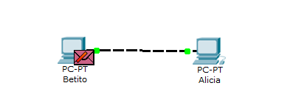

*Figure 9: Sending a message from Betito to Alicia. They are in different Networks*

This is because they are in different networks and there’s no router that can connect them. Betito will try to send a Broadcast message asking for the unknown MAC of Alicia but this broadcast message won’t go further. So, we need to set Alicia’s IP to 1.0.0.2.

After that go and try to send the message again:

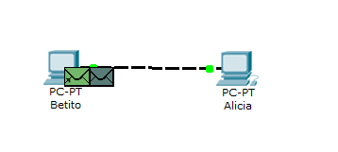

*Figure 10: Sending a message from Betito to Alicia. This time they are in same the Network*

This time is successful, and we can check the simulation by clicking on the “Capture Forward” button int the “Event List” section:

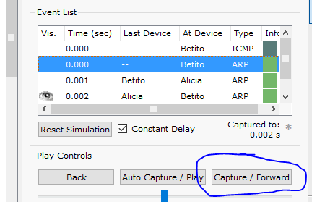

*Figure 11: Going to Event List*

Now I’m going to explain what is going on here:

1. Betito doesn’t knows Alicia’s MAC but he knows Alicia’s IP, so Betito needs to do an Inverse ARP Request defined in the ARP Protocol with the Code = 8, which means that he will send a broadcast message to the whole network asking for the owner of the IP address that he will append in his message: 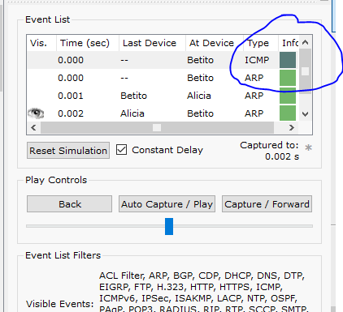

*Figure 12: Betito is trying to know the MAC of the owner of the IP address he knows*

If we click at the first coloured box in the event list a window will be displayed at the left:

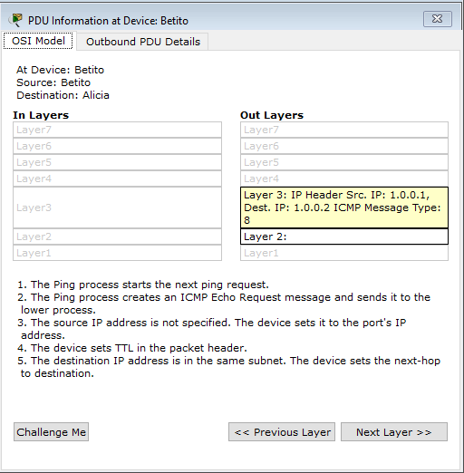

*Figure 13: Checking the PDU information at Betito computer*

From here we can see that the “Message Type” is 8 which means Inverse ARP request.

1. In the second event at the Event List if we click on it and then go to Outbound PDU Details we will be able to see the following information:

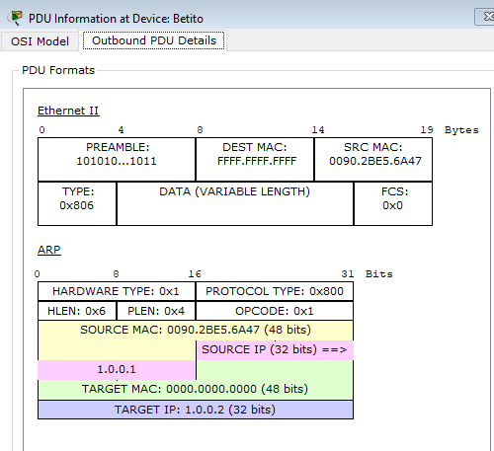

*Figure 14: Checking Betito PDU Details*

We can see at the Ethernet header that the Dest. MAC is “FFFF.FFFF.FFFF” which means that it is the broadcast message.

1. At the next event Alicia receives the broadcast message and fills the correspondent headers with the info, specially its MAC which was the address that Betito wanted to know, then Alicia sends the message back:

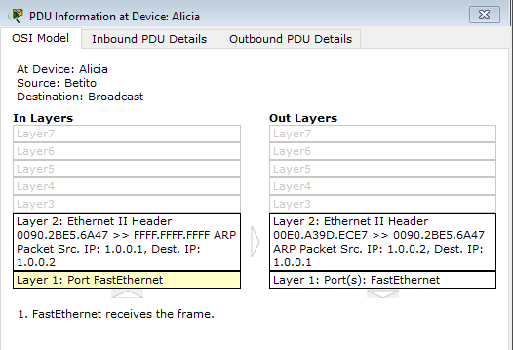

*Figure 15: Checking Alicia’s MAC response*

1. After that Betito receives the message with the MAC of Alicia:

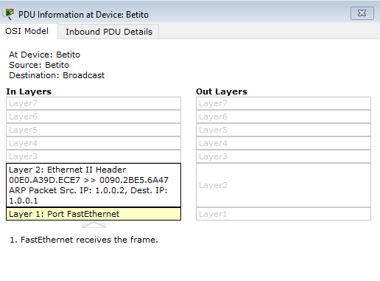

*Figure 16: Checking Betito reception of Alicia’s MAC*

1. Finally, Betito can send the information to Alicia:

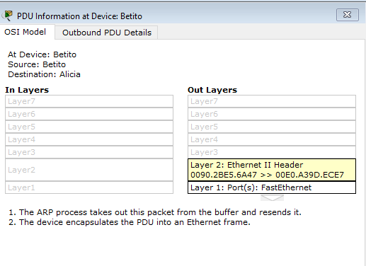

*Figure 17: Betito sending the information to Alicia*

After all this process Betito and Alicia will have their ARP tables filled with the IP and MAC address of each other. To see the table in Betito’s computer for example, double click on Betito, click on “Desktop” and then on “Command Prompt”, from it you can use two commands: “**arp -a**” to show the table and “**arp -d**” to delete it:

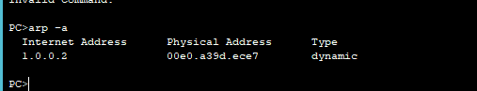

*Figure 18: Betito ARP table*

1. Now if you send another message from Betito to Alicia, all the process to find the MAC of Alicia will not be necessary since Betito will only need to check its ARP table to know the MAC of Alicia:

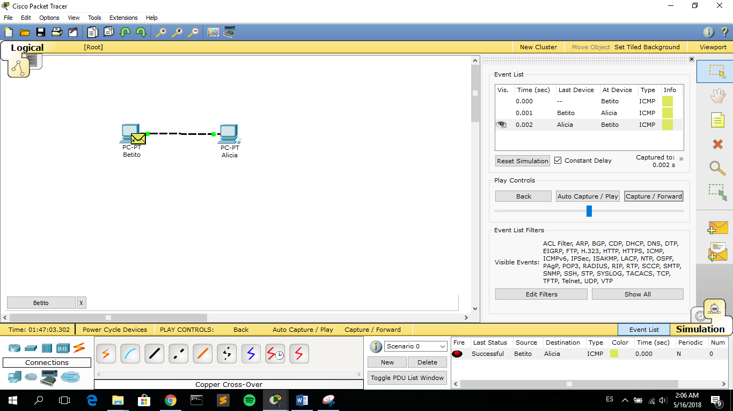

*Figure 19: Betito sending another message to Alicia*