**DOCUMENTATION FOR SOCIAL MEDIA WEBPAGE DEVELOPMENT**

Mal_Nep Webpage, (Our social media webpage) is mainly divided into two sections

1. Home-page:

The home page is the face for Mal_Nep, which consists of Log in and Registration page, The Login in page consists for Username and Password to let the user login into the system and Registration Page consists of Name, Email, Password and Phone Number, to register for the Mal_Nep

2. Index-page

For index page, Users are allowed to add photos, comment and like posts of other people. As, well on the index page, you can see available users to chat, can post their posts and upload their profile picture as well.

**DEVELOPMENT PHASES**

For the development of Mal_Nep, the webpage was developed into three phases:

1. Planning:

Before starting coding on HTML, PHP and CSS, we created some wireframe for the webpage, which can suits the requirement of the project. So, after couple of wireframe, we can out the actual design of Homepage and Index page, which is implemented to the system.

2. Execution:

After wireframe verification, we coded on HTML and CSS, to create the outer frame of the webpage which includes various design and background effect. We also used Java-script for the visual effect on the webpage. After creation of front-end, we worked on the backend development, which is coded on PHP and MySQL. PHP is used retrieve and store information on MySQL where-as MySQL stores those information on the basis of table. Session variables were created to allow a particular user use their respective pages and permissions.

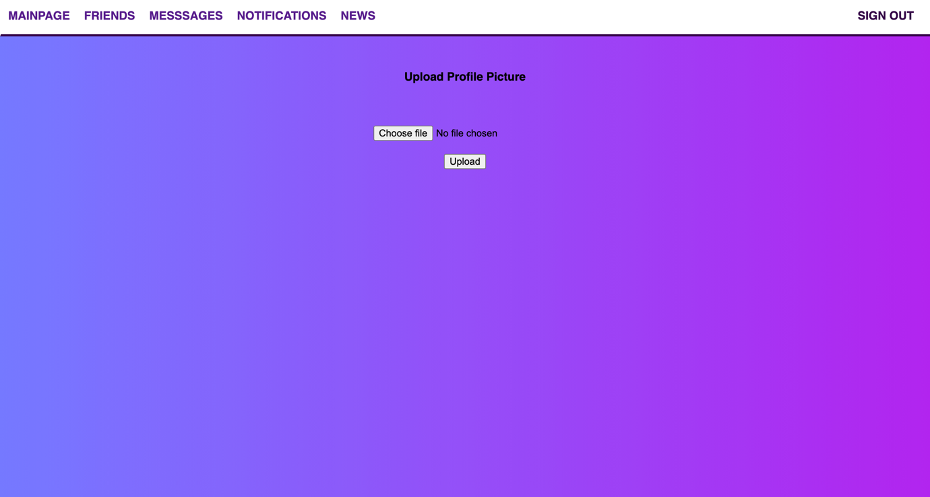

3. Testing:

After completion of the front-end and back-end development, each and every functions of the webpage were tested so that, there won’t be any problem during log in, registration and using various services of the webpage.

