AVENGER CHAT BOT

Project Overview

As, per the basic requirements of Software Development 2, Final Project. We as a team Rafael de Souza Ferreira, Howmun San and Bibek Pahari had developed a chat bot named Avenger Chat Bot. The chat bot is developed under Java language, which can interact with the user and can provide feedback on climate of a particular location.

1. Worksheet on testing

Each and every methods on the chat bot are tested using Junit, in order to check the computation time and error handling of the methods. During testing of the methods, we approached unit testing at first and after successful testing, Integration testing was done.

Following is one of the screenshot of the excel sheet after the unit test of a method:

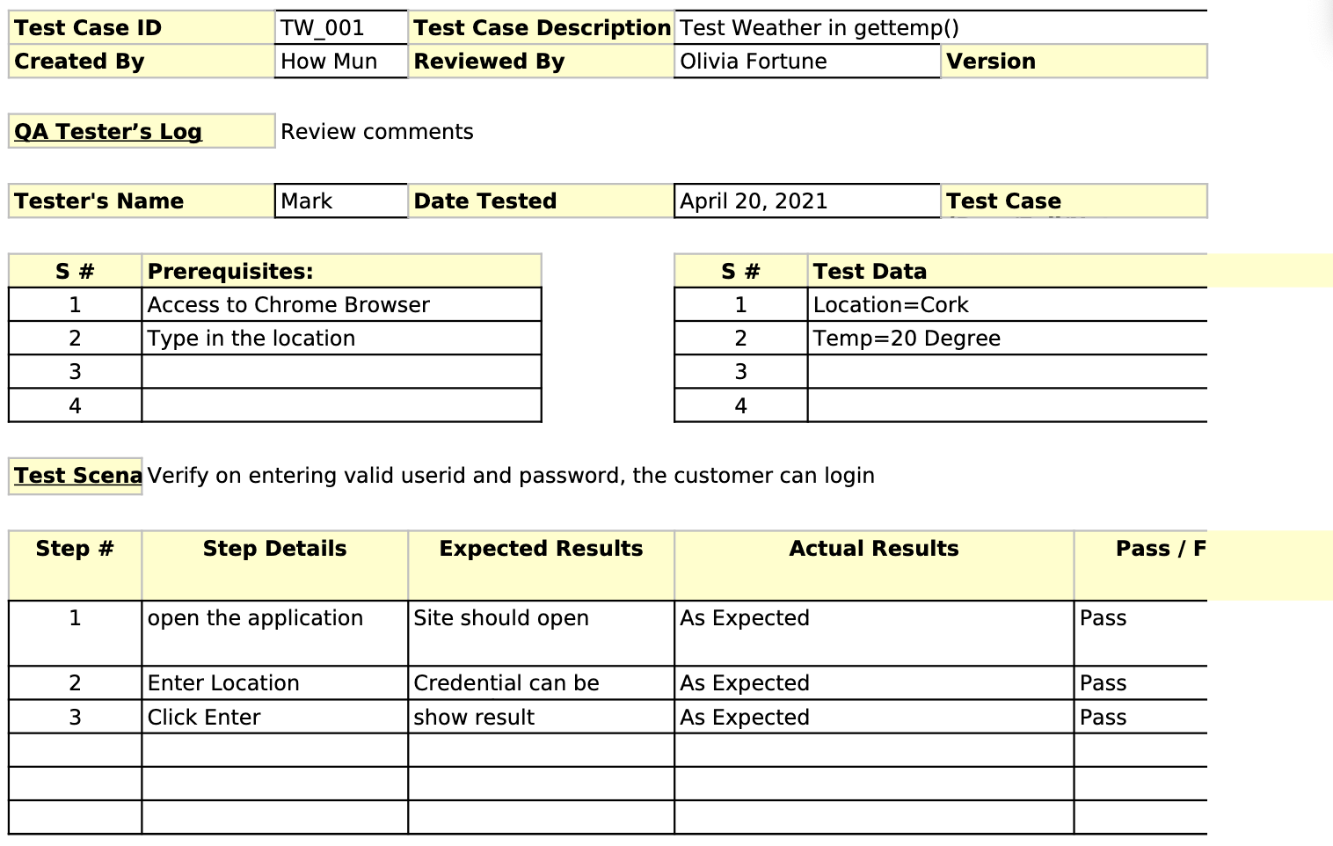

https://gitlab.griffith.ie/HowMun/sd2_finalproject2021/-/blob/master/testtemplate.xls

Above link consists of all the testing results of Avenger Chat bot

2. Project Planning

Project Planning for Avenger Chat bot

After going through the basic requirements of Final Assignment, Team decided to approach Waterfall model to complete the assessment. So, At first we collected all the information required for the chat bot development from the lecturer (Olivia Fortune) and also reading the requirement documents. Then after, We designed the chat bot, which includes what programming language to use, which testing method to adopt, dividing development work and creating roadmap for the project. After finalizing all the steps for the development, we did the actual coding using Java programming language, whose functionality are properly tested and integrated to develop a full functioning chat bot. We completed this assignment on 4 phases:

1. Requirement Gathering
2. Design
3. Implementation
4. Verification and Testing

To complete the assignment on time, we created a Gantt Chart, to keep track of events which we need to complete on the given time-frame. Here is the screen shot of Gantt Chart for Avenger Chat Bot:

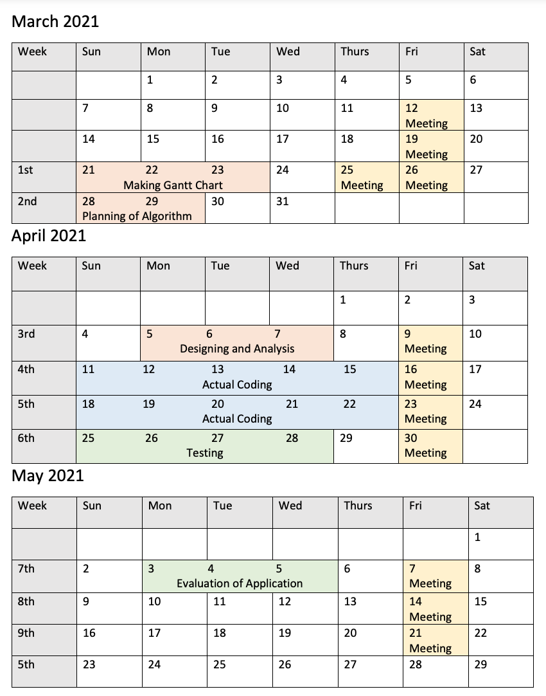

Here is the sequence diagram for The Avenger Chat bot, which explains how the chat bot will function

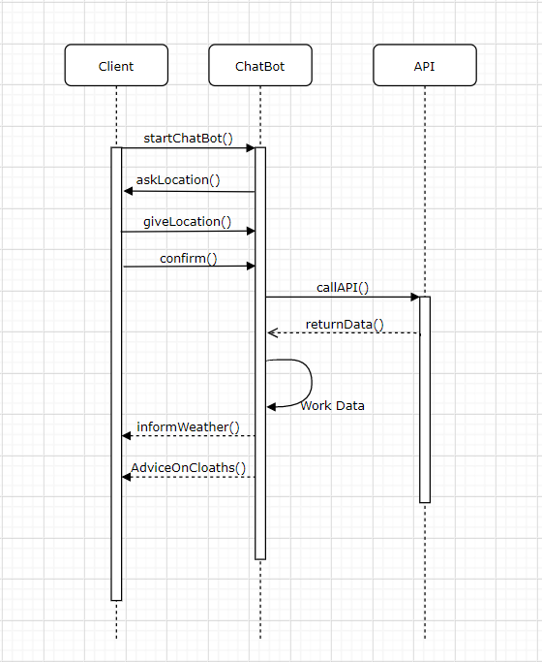

Milestones Achievements and Review

Before providing a full functioning chat bot, the chat bot was developed in various phases. After completion of each phase, the chat bot was reviewed and if there is any changes required on the system, the changes was made otherwise the system is moved to next version or phase. Here are the various versions of Chat bot before the final version of Avenger Chat bot

Version 1
Version 1.1

Version 2

Version 3

Development Phases
Regarding the development of Avengers Chatbot, It consists of three phases, Front End Development (GUI), Connection API with Chatbot, and Testing of Chatbot. Following are the details of Development Phases:

1. Graphical User Interface:

Java Swing is used to develop the GUI of Avengers Chatbot. It consists of JPanel, JTextField, JButton and JTextArea, which are the main components for GUI. It includes of basic function, which takes input from the user and analysis the data on its back end and provide information.

2. Connection API with Chatbot:

JSON is used to fetch data from web application to chat bot. Weather API is used to get those information. During connection of API with Chatbot various Java classes were created for successfully connection, JSON Parser class, is used to create to parse the JSON String and create Weather Object, Location to get and set the location of the place where the user want to know the climate of and Weather to get the various information about the climate such as maximum temperature, minimum temperature, speed and description and WeatherCookie is used to store information of the requested location and apiRequest is used to fetch the data from Weather API, which is used in Avenger Chatbot.

3. Testing of Chatbot:

During testing of the Chatbot, JUNIT is used for testing. Testing was done into two phases Unit Testing and Integration Testing. During unit testing each and every methods are tested individually, with expected and actual parameters, after successful completion of Unit testing the testing is moved to Integration testing. During Integration testing, all the methods are combined together, to check how much compatible are those methods when they work together. Integration testing helps to know error handling of the application, and computation timing of the application.

