**AVENGER CHAT BOT**

Project Overview

As, per the basic requirements of Software Development 2, Final Project. We as a team Rafael de Souza Ferreira, Howmun San and Bibek Pahari had developed a chat bot named Avenger Chat Bot. The chat bot is developed under Java language, which can interact with the user and can provide feedback on climate of a particular location.

The complete project with all the code and documents can be found on GitLab: [Project Link](http://gitlab.gcd.ie:8080/HowMun/sd2_finalproject2021)

**1. Worksheet on testing**

Each and every method on the chat bot are tested using Junit, in order to check the computation time and error handling of the methods. During testing of the methods, we approached unit testing at first and after successful testing, Integration testing was done.

Following is one of the screenshots of the excel sheet after the unit test of a method:

The link consists of all the testing results of Avenger Chat bot: [Test Results](https://gitlab.griffith.ie/HowMun/sd2_finalproject2021/-/blob/master/testtemplate.xls)

**2. Project Planning for Avenger Chat bot**

After going through the basic requirements of Final Assignment, Team decided to approach Waterfall model to complete the assessment. At first, we collected all the information required for the chat bot development from the lecturer (Olivia Fortune) and also reading the requirement documents. Then after, we designed the chat bot, which includes what programming language to use, which testing method to adopt, dividing development work and creating roadmap for the project. After finalizing all the steps for the development, we did the actual coding using Java programming language, whose functionality are properly tested and integrated to develop a full functioning chat bot. We completed this assignment on 4 phases:

1. Requirement Gathering

2. Design

3. Implementation

4. Verification and Testing

To complete the assignment on time, we created a Gantt Chart, to keep track of events which we need to complete on the given time-frame. Here is the screen shot of Gantt Chart for Avenger Chat Bot: 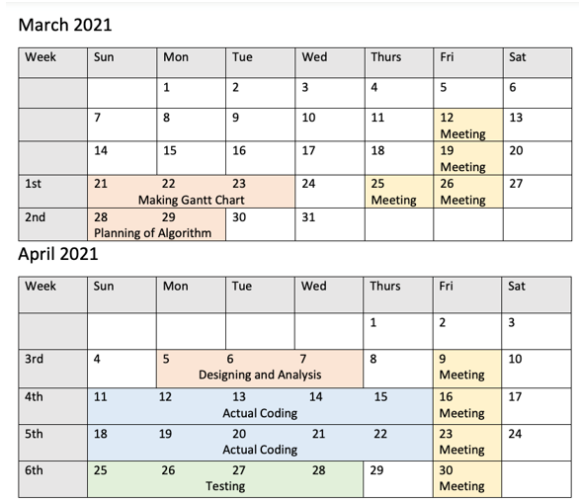

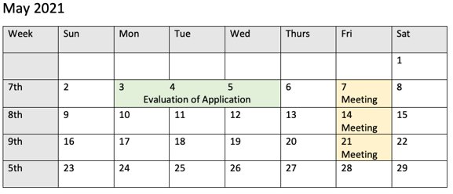

Here is the sequence diagram for The Avenger Chat bot, which explains how the chat bot will function

**3. Milestones Achievements and Review**

Before providing a full functioning chat bot, the chat bot was developed in various phases. After completion of each phase, the chat bot was reviewed and if there is any changes required on the system, the changes was made otherwise the system is moved to next version or phase. Here are the various versions of Chat bot before the final version of Avenger Chat bot

**Version 1**

The Version 1.0 has only one class created that make possible the connection with the Weather API. To send a HTTP request and receive a Json response.

The API used is the OpenWeatherMap (https://openweathermap.org/api), it is a free API that give detailed information about Weather in XML or JSON, there is limitation for the free signature that is used. It’s possible to only send 10 requests for minute and a 1000 a day.

This class uses a library called HTTP-Request, that have the methods necessary to build the HTTP request for the API and to receive the JSON file that class transform in a string to a posterior use.

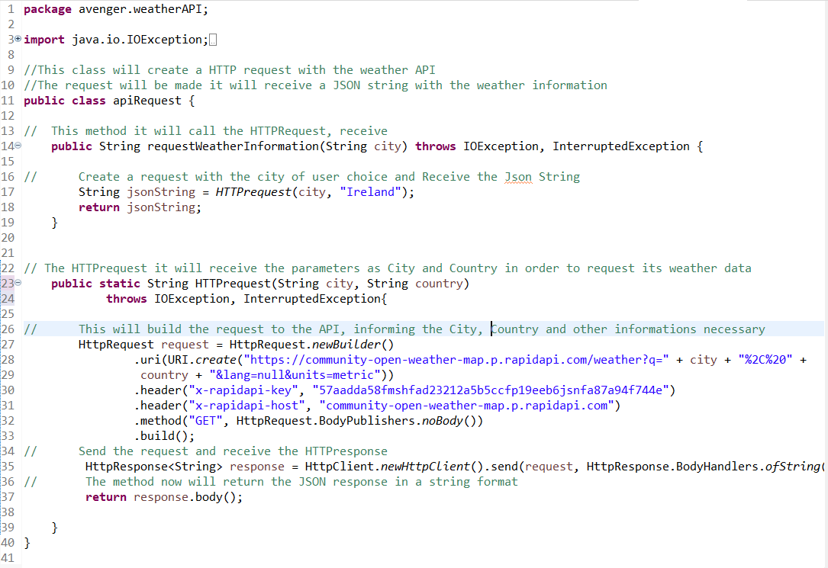

**Version 1.1**

The Version 1.1 receive Three more classes one that its able to parse the Json string, and another one that will hold the Weather values received from the API.

This class use a library called GSON, version 2.8.2, that have the methods necessary to parse a JSON file.

The class Json Parser allow us extract the information some Map and ArrayLists from Json into a Java data structure. This make it possible to later create an a Weather Object with de data necessary.

The Class Weather hold some variables that we evaluate necessary for further comparison in order to the Chatbot give advice for the user. The Class Location complete the Weather class holding the location that user wants to know the weather

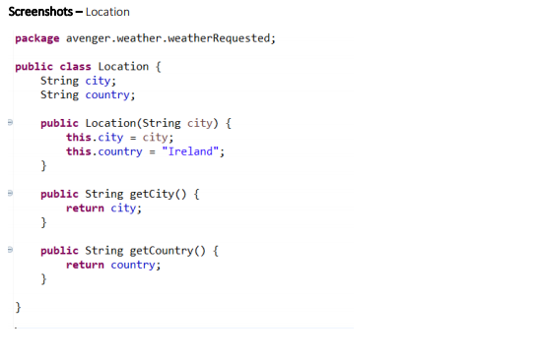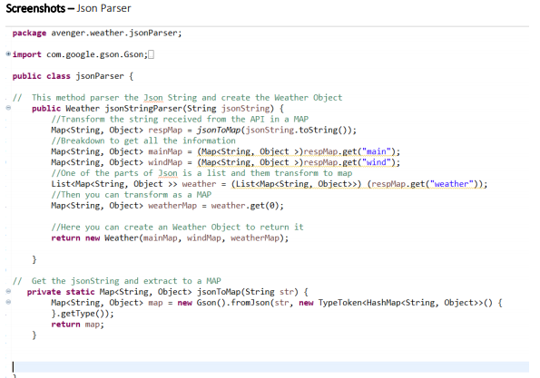

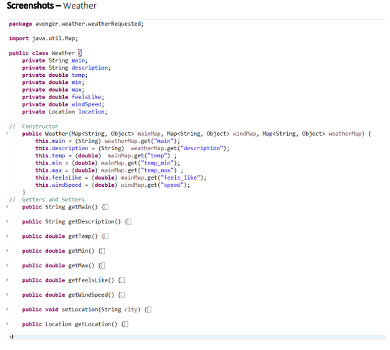

**Version 2**

This version receives a new class that allow to combine the first classes. The Class Request it will use the Parser and API Request Class.

This class it will ask for a City and use to call the APIrequest, check for error, parser the JsonString and then create a Weather Object that will be returned and can be manipulated.

Using this class, we can create a test to show the attributes of the Weather Object.

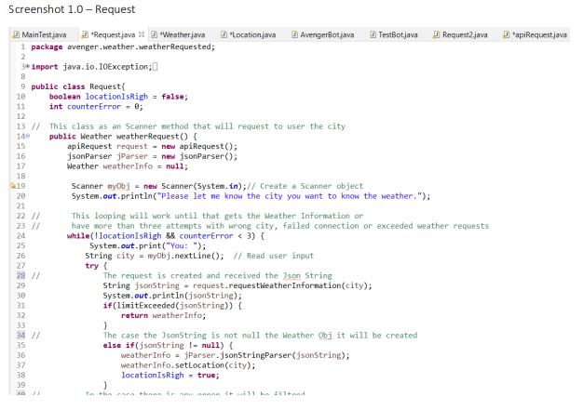

**Version 3**

The version contains the Chatbot, using methods from the Swing Library. This Chatbot can say and identify some patterns for greetings and when the user wants to user the Weather Resources and give clothes advice through a Global Variable that will hold the weather information.

It is only a simple chatbot, that cannot resolve any grammar issue. The Chatbot have a HashMap in order to store some patterns with key words, and enter in some loops to call methods about weather and clothes.

Screenshot – Global Variables

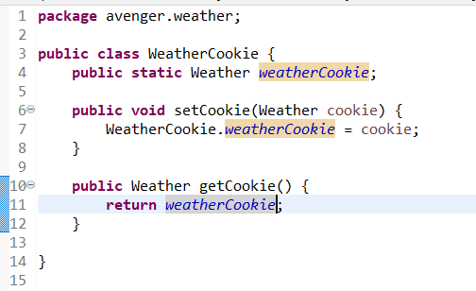

Screenshot - Chatbot

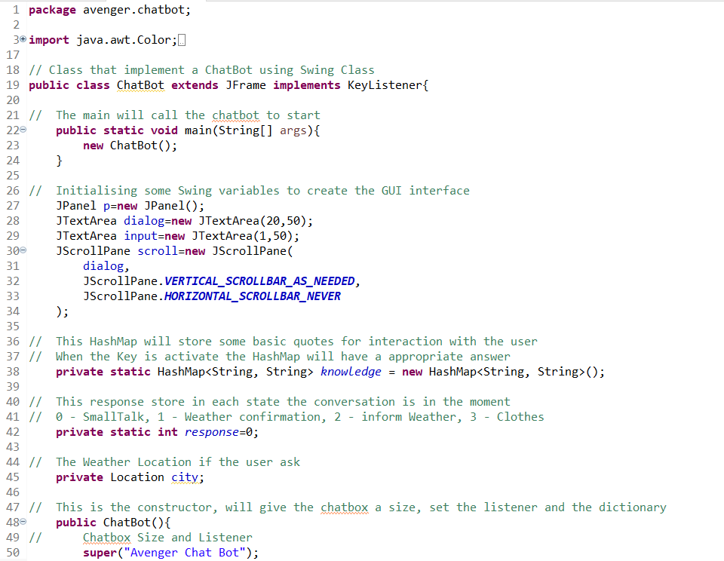

Screenshot – GUI Interface

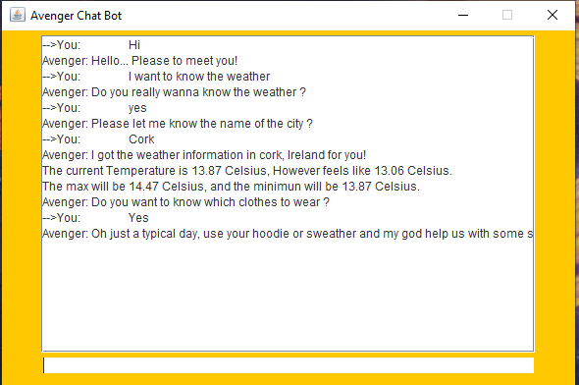

**Development Phases**

Regarding the development of Avengers Chatbot, it consists of three phases, Front End Development (GUI), Connection API with Chatbot, and Testing of Chatbot. Following are the details of Development Phases:

1. Graphical User Interface:

Java Swing is used to develop the GUI of Avengers Chatbot. It consists of JPanel, JTextField, JButton and JTextArea, which are the main components for GUI. It includes of basic function, which takes input from the user and analysis the data on its back end and provide information.

2. Connection API with Chatbot:

JSON is used to fetch data from web application to chat bot. Weather API is used to get that information. During connection of API with Chatbot various Java classes were created for successfully connection, JSON Parser class, is used to create to parse the JSON String and create Weather Object, Location to get and set the location of the place where the user want to know the climate of and Weather to get the various information about the climate such as maximum temperature, minimum temperature, speed and description and WeatherCookie is used to store information of the requested location and apiRequest is used to fetch the data from Weather API, which is used in Avenger Chatbot.

3. Testing of Chatbot:

During testing of the Chatbot, JUNIT is used for testing. Testing was done into two phases Unit Testing and Integration Testing. During unit testing each and every method are tested individually, with expected and actual parameters, after successful completion of Unit testing the testing is moved to Integration testing. During Integration testing, all the methods are combined together, to check how much compatible are those methods when they work together. Integration testing helps to know error handling of the application, and computation timing of the application.