# Segmentation

## Functions

Find connected pixels belongs to a touching object.

Find background pixels.

## Configurable Parameters

segResolution.

The range of signal is divided into a group of signal layers. A layer has range of signal, which is also named contour interval.

$$contour interval=\frac{Max Signal}{segResolution}$$

Max Signal is decided by saturate signal and noise.

A pixel is set to a specific layer by its signal. After that, a histogram can sort all of valuable pixels easily from high layer to low one.

The parameter reflects contour’s accuracy. if it too big, it is easy to over segment. If it too small it will omit some segment.

segROIThreshold.

Not any of pixel is valuable to be segmented. to remove noise as well as some nonsense small signal, the pixel with signal bigger than ‘segROIThreshold’ is categorized as ‘Region of Interesting’, which is going to be segmented later.

segMinPeak

Since the limitation of contour’s accuracy, it is possible to recognize some segment with small peak signal. If the peak is too small, the segment will be considered as a touch object. As result, it will be merged to the big one connected, or it will be removed.

segMergeCoeffection

Also because of limitation of contour’s accuracy, a touch object could be over segmented into multiple big sub-segments. All of the sub-segments are connected to each other. There is an algorithm to calculate how strong connection between two sub-segments. The strength of connection is called as ‘MergeCoeffection’. If ‘Merge Coeffection’ > ‘segMergeCoeffciton’, the two sub-segments will be merge into one.

## Input Data

transSigData

tx_num,

rx_num

## Output Data

LableMap

it is a pointer to an array with same size of transSigData. The array contains labels and connection of each pixel. Belonging to a segment, the pixels have same label and are connected into a link.

Background

it is pointer to the link which contains background/ not ROI pixels.

Objects

It is a pointer to the array where the first pixels of each touch objects links are located.

unSegment

It is a pointer to the links containing the pixels have big signal but can’t be segmented to any touch objects.

Objbitmask

It is a pointer to the bit masks of object segments’ id.

## Process Flow

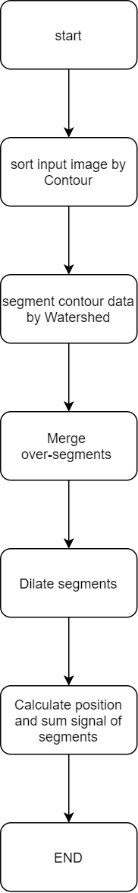

## Main Algorithm

Watershed Algorithm

Step1, Sort pixels by contour.

Step2, label pixels from the high level to the low.

Step3, at a specific level of signal,

3.1, pick out all pixels with labeled neighbor. Push them into a FIFO.

3.2, Pop one from the FIFO, label the pixel, according to following rules:

a, if there is only one labeled neighbor, assign the same label to it.

b, if there are different labeled neighbors, the pixel is labeled as “DAM”

c, if there is a labeled neighbor with “MINB”, label it as “DAM”. Moreover, assign a new object label to the neighbor and all pixels below Minpeak connected to the neighbor.

3.3, if a neighbor without label but located at the same contour level, push it into the FIFO.

3.4, repeat step 3.2 to 3.3 till the FIFO is empty.

3.5, by now, there are only isolated pixels left, which have no labeled neighbor. pick out one of them, assign a new label to it according to the following rules:

a, if the pixel is bigger than Minpeak, the label is a new object one.

b, otherwise, the label is a special one “MINB”

3.6, Traverse the neighbors of the new labeled pixel by Wide First Searching, and assign them the same label.

3.7, repeat 3.5 to 3.6 till no isolate pixel left.

Advantages:

1, it has good performance in segmentation.

2, it is free to pixel traverse direction.

Disadvantage:

it is easy to over segment if the sorting can’t distinguish noise and signal peak.

To avoid the shortcoming as much as possible, FW needs to sort the segments by discarding small ones or merging/separating the connected ones.

Segment Merge Algorithm

For two connected segments, there are following features to decide to merge them or not:

r: The distance between the centroid of the two connected segments.

m: the sum of signal of the segments.

s: the sum of signal of the dam between the two segments

$$MergeCoeffcient=\frac{{rr m}_{1}m_{2}}{ss}$$

The smaller ‘*MergeCoeffcient’* is, the more easily the two segments are merged.

Step1, go through the link of “DAM” pixels. Calculation Mergecoeffcient of each connected segment.

Step2, find the smallest coefficient. If it is smaller than “segMergeCoeffection”, merge the segments related to the coefficient.

Step3, repeat step1 and step2 till no small enough coefficient found.

Step4, go through the left “DAM”’s, assign the pixel to the segment which has biggest pixel in its neighbor.

## Memory Cost

Code/ROM: 4027 words.

Static Variable/ RAM: 73+ image size words

## Versions

|  |  |  |
| --- | --- | --- |
| version | revisor/time | content |
| 1.0 | Houxi/2020-7 | Initial the doc |
|  |  |  |
|  |  |  |