**HOW TO DRESS ON THE CURRENT RED STYLES**

Red goes through the style collections of excellent developers virtually every period and also even off the footways we do not intend to do without the undeniable pattern shade. The red accent functions all on its own as well as does not require much around it. These is specifically why red prizes have actually had the ability to hold their very own in our closets for time currently as well as are essential there. I'll reveal you one of the most prominent fads as well as just how to design red for every single celebration.

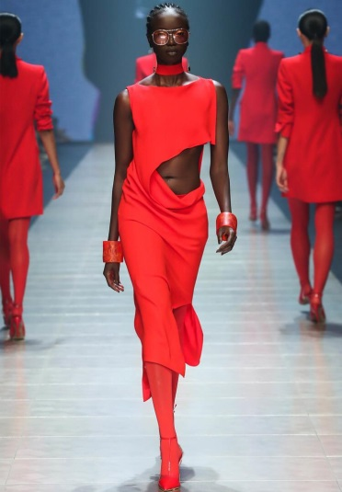

**Red Devices As Eye-Catchers**

Are red garments also noticeable for you? After that established fresh accents with red devices. Bags, belts, chains or headscarf in red bring energy to your attire and also work as a unique eye-catcher. Particularly for sophisticated appearances, such as white black trouser fits, red pumps and also a matching bag appearance excellent. You can enliven low-key colours with red dashes of shade as a whole. Devices in red show style recognition! It's constantly attractive to [combine strong colours with your wardrobe](http://www.howtodiyeverything.com/2019/07/06/how-to-combine-strong-color-with-your-wardrobe/).

**Solitary Declaration Parts In Red**

My much-loved shade red is crisp, however likewise very easy to incorporate. Red fits a lot of various other colours: whether it's timeless clothes in black, grey as well as white or as a vibrant colour blend with pink as well as pink. It is best to choose on your own whether you really feel a lot more comfy in severe colour obstructing or in straightforward mixes.

**Mix Of Red As Well As Off-White**

Revers draw in! This saying is validated not just crazy, however additionally in vogue. Incorporating red with camel, off-white and also lotion subtleties is definitely fashionable currently! This mix can look incredibly stylish and also simply waits everybody - try it!

**The Fashionable Colour In A Monochrome Appearance**

Not terrified of shade? After that simply design on your own totally in red! A monochrome appearance is not tough to integrate, for instance, you can obtain an outfit or a two-piece from the closet quicker, red device as well as footwear as well as you are well clothed. For the progressed: Integrating a number of tones of red is an essential part of the globe in 2019. Simply attempt various tones of red in mix and also you await your huge look or for your leisure time. A tiny idea: If you hesitate to attract attention excessive in a bright red, attempt a dark red. Bordeaux tones provide a terrific alternate! They bring shade to your appearance without looking crisp! Red is not the like red!

**Red Outfits Make The Style Heart Defeated Quicker**

I fell for red gowns! Use your red outfit with shoes to the yard celebration or tennis shoes to produce an informal try to find your leisure time. Refined jewelry does not swipe the program from your gown. Just how around a stylish knapsack currently? It uses lots of room and also is likewise comfy to use for longer tasks. Since for leisure: It needs to behave however at the same time comfy as well as sensible! So you can actually appreciate your spare time!

You wish to design your red gown elegantly? After that get hold of pumps or wedges, extend the leg and also instantly include a trendy touch to your appearance. Declaration jewelry as well as a clutch finish the total photo. Little red information on the devices I discover specifically matched to a red gown. On trendy days, there are no limitations-- whatever from sports jackets to natural leather coats is feasible.

**The Appropriate Cosmetics To Put On With Red**

Considering that red garments are currently an actual eye-catcher, you must maintain your cosmetics instead straightforward as well as minimized. Taking note! As stunning as red is, it stresses acnes on the skin as well as makes it specifically popular. So if you're trying to find an erratic skin tone, you ought to use some concealer or structure. Concrete your eyes with mascara select fragile rouge - ET voila!

If you such as to make use of eye shadow as well as lipstick: When it concerns eye shadow, the very best method to match bronze or gold tones is to make use of these colours completely. For your lips I can suggest you naked or a color of red that resembles the red from your clothing.

**Red Is For Every Person!**

As you can see, the existing colour pattern red deals the ideal seek every preference! Whether bright-eyed or very discreet in a dark red - there is definitely something for you in the variety of reds on the [**fashion spectrum**](http://www.howtodiyeverything.com/category/fashion/).