IT Application Project Final Report
By:
Dhavala Venkata Aarush Avadhani (251333B)
Seth Su Junyi (250996K)
Javen Ho Jun Rui (251250D)
Koh Jun Kang(250963M)

Company Background and Business Needs
JAJS Beans, established in 1926, began as a vehicle manufacturer known for reliability and durability. The company is named after its four founders. In 1978, the company’s vehicles were officially adopted into Singapore’s public transport ecosystem, a major step in its growth and reputation. Today, JAJS Beans has pivoted and rebranded itself as a sustainability-driven mobility company, focusing on electric vehicles (EVs) and low-emission transport solutions for both private consumers and public-sector fleets.
JAJS Beans is committed not only to producing EVs, but also to improving public understanding and confidence through customer education. By helping consumers make informed decisions, JAJS Beans supports Singapore’s sustainability goals while strengthening trust in EV adoption and building long-term demand for cleaner vehicles.

JAJS Beans aims to create a 4-stage interactive activity that helps correct the misconceptions of EVs and encourage users to consider EVs over petrol vehicles.

Javen - Intro
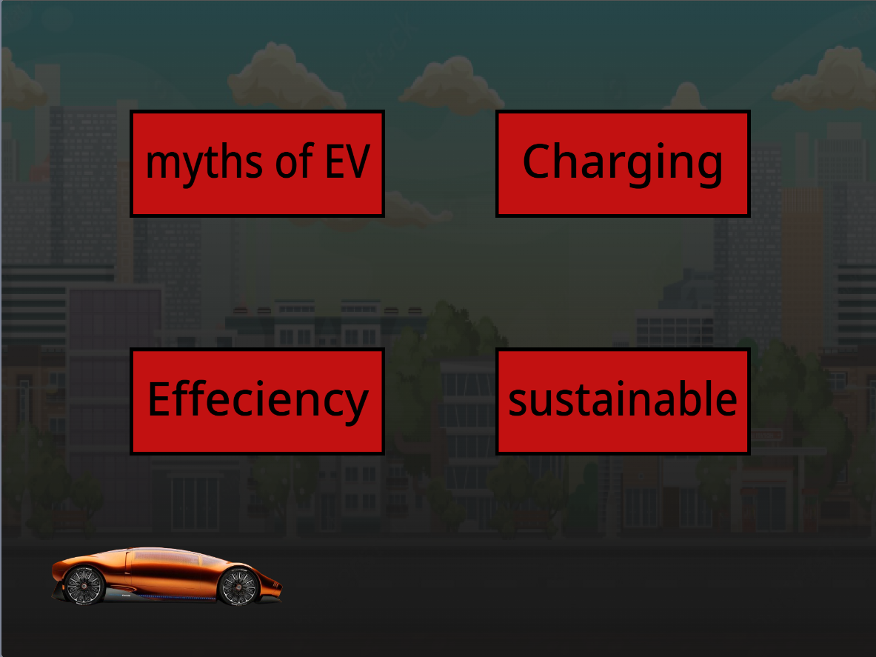

I learnt that an introduction is needed for people who do not want to switch to EVs because they are misinformed or do not know about why EVs are better than petrol vehicles.

What went well, what could be improved:
The scratch was created with the goal to introduce and inform consumers/users about the benefits of EVechidels towards both consumers and the environment. There were many problems creating the scratch such as missing sprites and sprites not linking. One improvement that can be made is better qualities and design for the introduction.

Aarush - Quiz
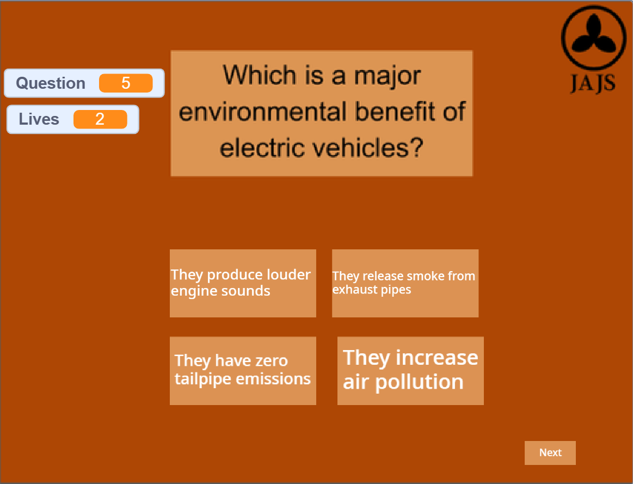
I learned that quizzes are important for consumers to retain the information that they learn. Consumers may not retain the information they learn about EVs.

What went well, what could be improved:
What went well was the incorporation of a fully functioning life system in the quiz. What could be improved was how I managed my sprites, early on I kept some of the sprites as images and later on when I had to change their contents it was very troublesome to fix it so I had to remake the sprites to be a box and editable text which is what I should have done from the beginning.

Jun Kang - Game
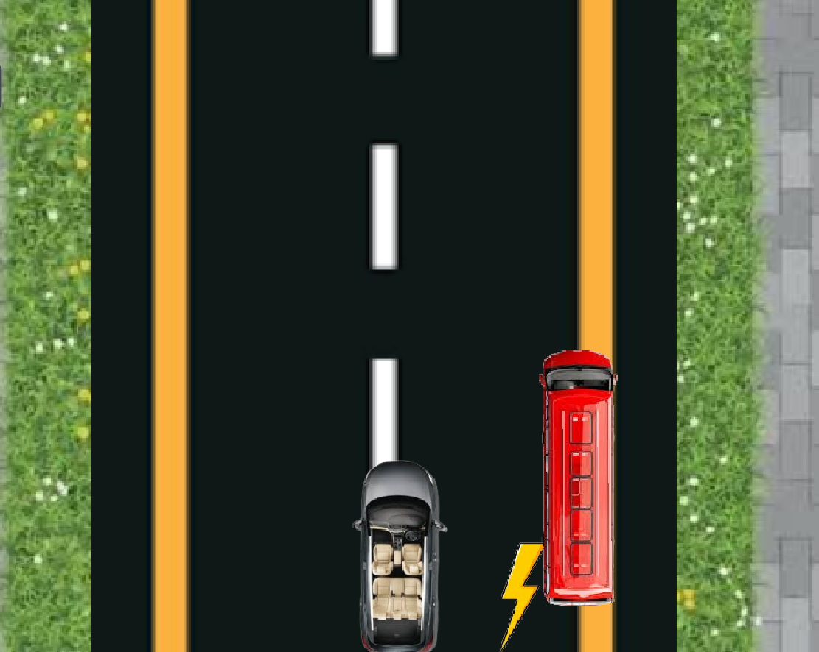
I learnt that games are essential for businesses to hook the users to stay and bring the idea across. Additionally, people are still having the wrong assumptions on electrical vehicles being unreliable for driving long distances among other misconceptions.

What went well, what could be improved:
The scratch was created with the goal of allowing users to understand that electrical vehicles are reliable. However, creating the scratch came with a lot of bugs such as buttons appearing when it is not supposed to because users restarted the game. The buttons were fixed with trial and error and the help of button enthusiasts of my other group members.
One improvement that can be made is better visuals on the obstacle, car and backgrounds. Another improvement could be more mechanics for the user to play with for example, inverted buttons where if you press the left arrow it goes right. This will engage the user to play past the first time.

Seth - Feedback
I learnt that feedback forms are essential for businesses to continuously improve and are greatly needed if they want the customers to feel heard. This allows the company to understand the needs of the customers better.

What went well, what could be improved:
The scratch was created with a goal to get feedback from the users about our experience and finding out where and ways we can improve to better enhance the experience for future users. Creating the scratch came with many flaws such as buttons not showing when supposed and vice versa.After working together and fixing bugs that came up in the code, we managed to fix the issue thanks to the clear communication in the group. One main problem I had was, when creating the scale question, the slider could be dragged across the entire screen and could record values that were not supposed to be recorded such as being able to answer -10 on a question where the scale was 0-10. But I was able to lock the slider onto the line and not be able to be dragged across the whole screen, the slider could still be dragged out of the line but the recorded values are capped at 0 and 10. One improvement that can be made is standardising the buttons and text font, size and colour before the development of the game.

