

# Project Summary

Diet Manager is a desktop – based application, which main focus is maintaining a user’s diet program. The user will be able to monitor their daily intake of food, such as calories, proteins, carbs, fats and others. This application will allow users to add food which will then be organized into subcategories; furthermore, the application will have a feature where the client will be able to make recipes by using newly added food as well as by using sub-recipes.

The user will be able to select all the food consumed during the day as well as the number of servings for each food. After that, the Diet Manager application will be programmed to display all the necessary information about the food, such as carbs, fat intake etc. from the food that the user has consumed during the day, as well as the servings of each food.

Another important part of the Diet Manager application is the ability to record user’s weight. For example, let’s say that the user wants to set their weight goal during some period of time, Diet manager will be able to show the weight change over time and show user how much calories and other nutrients he/she might consume in order to achieve their desired weight goal.

Finally, the user will be able to monitor his exercise via adding and removing his exercises. They will automatically affect the users calorie goal and they depend on time spent on doing them.

# Design Overview

Diet Manager will be divided into separate classes that will have different functionalities. When it comes to Separation of Concerns, the application will have its own classes that will address a separate concern. For example, as seen in the UML diagram Loader class will load foods from the CSV file and insert them into a data structure of Recipe or BasicFood, FMXL classes will only interact with the graphical user interface of the application, furthermore logger will only be used for logging the exceptions and errors that may occur during the run time of the application.

When it comes to cohesion, Diet manager is designed to have high cohesion, which means that the code inside of the application is closely related to each other for example, Food writer class as shown on the UML diagram, has only code related to that part. It contains write() for recipefood file; whereas, LogWriter contains write() method for the Log file. These two classes extend the Writer.

On the other hand, when we are talking about Coupling in the application, Diet Manager is created to have the lowest coupling possible, which in other words means that classes are independent from other classes. When one class is changed it does not affect other classes in the application. If we look at the UML diagram of our application Diet Manager GUI class only interacts with the Controller class, Recipe and Basic Food classes only Interact with the Food Interface.

Extendibility as well as dependency via interface has been carefully designed to provide the best solution for future scalability of the application. Data, in this case Recipe and Basic food implement interface Food which then interacts with other classes. This means that Diet Manager Application supports program to interface not implementation principle.

The design overview is the narrative that captures the thought process and evolution of the design from the preliminary design sketch through final implementation. The narrative should support how the project design addresses good design principles: separation of concerns, high cohesion, low coupling, dependency inversion via abstractions (interfaces), support for extendibility, etc.

It is equally important to document design decisions that did not go as anticipated, as it is decisions that worked out well. This is extremely helpful background for future readers of the document to help them avoid solution paths that already had been attempted when extending the project with new or modified features. It is common for some design documents to have an entire section dedicated to “rejected alternatives”.

# Subsystem Structure

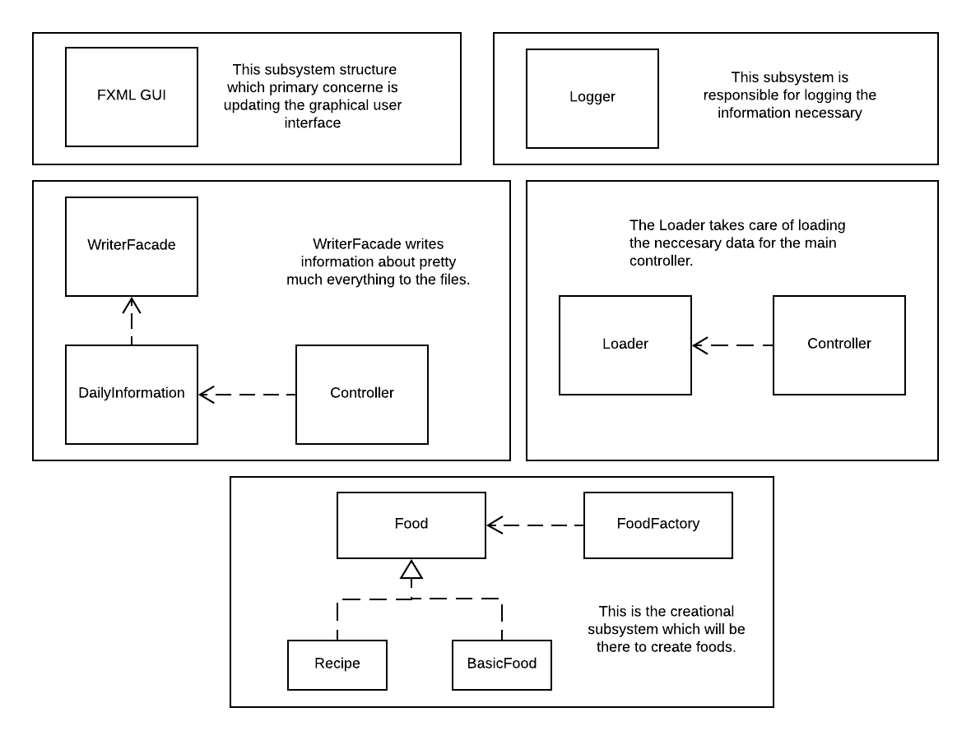

# Subsystem GUI

* Responsible for visuals and user communication
* Interacts with the controller class

# Subsystem Logger

* Responsible for logging the necessary information to a file

# Subsystem Writer

* Responsible for writing the data to the .csv file
* It can be used for writing either Daily Info or simply new foods the user comes up with
* Interacts with the controller

# Subsystem Reader

* Responsible for filling out the data within our objects with the data from the .csv file
* Can be used for reading either Daily Info or the foods that the user came up with

# Subsystem Create

* Responsible for creating food objects for other classes that require their usage.
* Interacts with the controller

**MVC Pattern UML Class Diagrams**

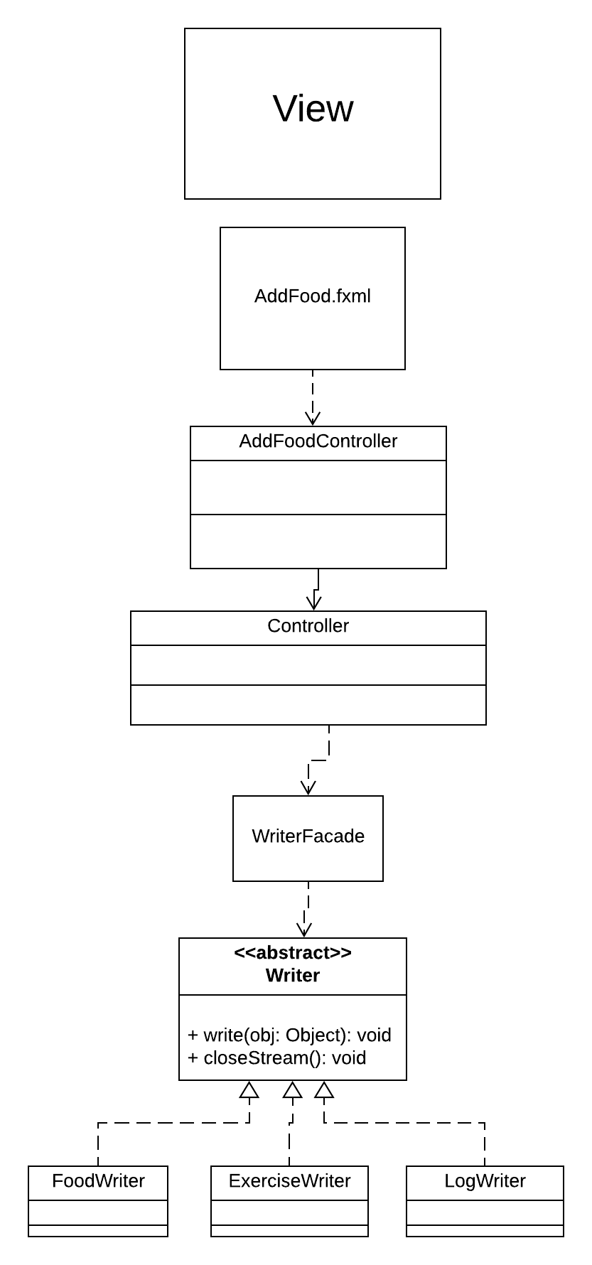

**UML Class Diagram of the overall program**

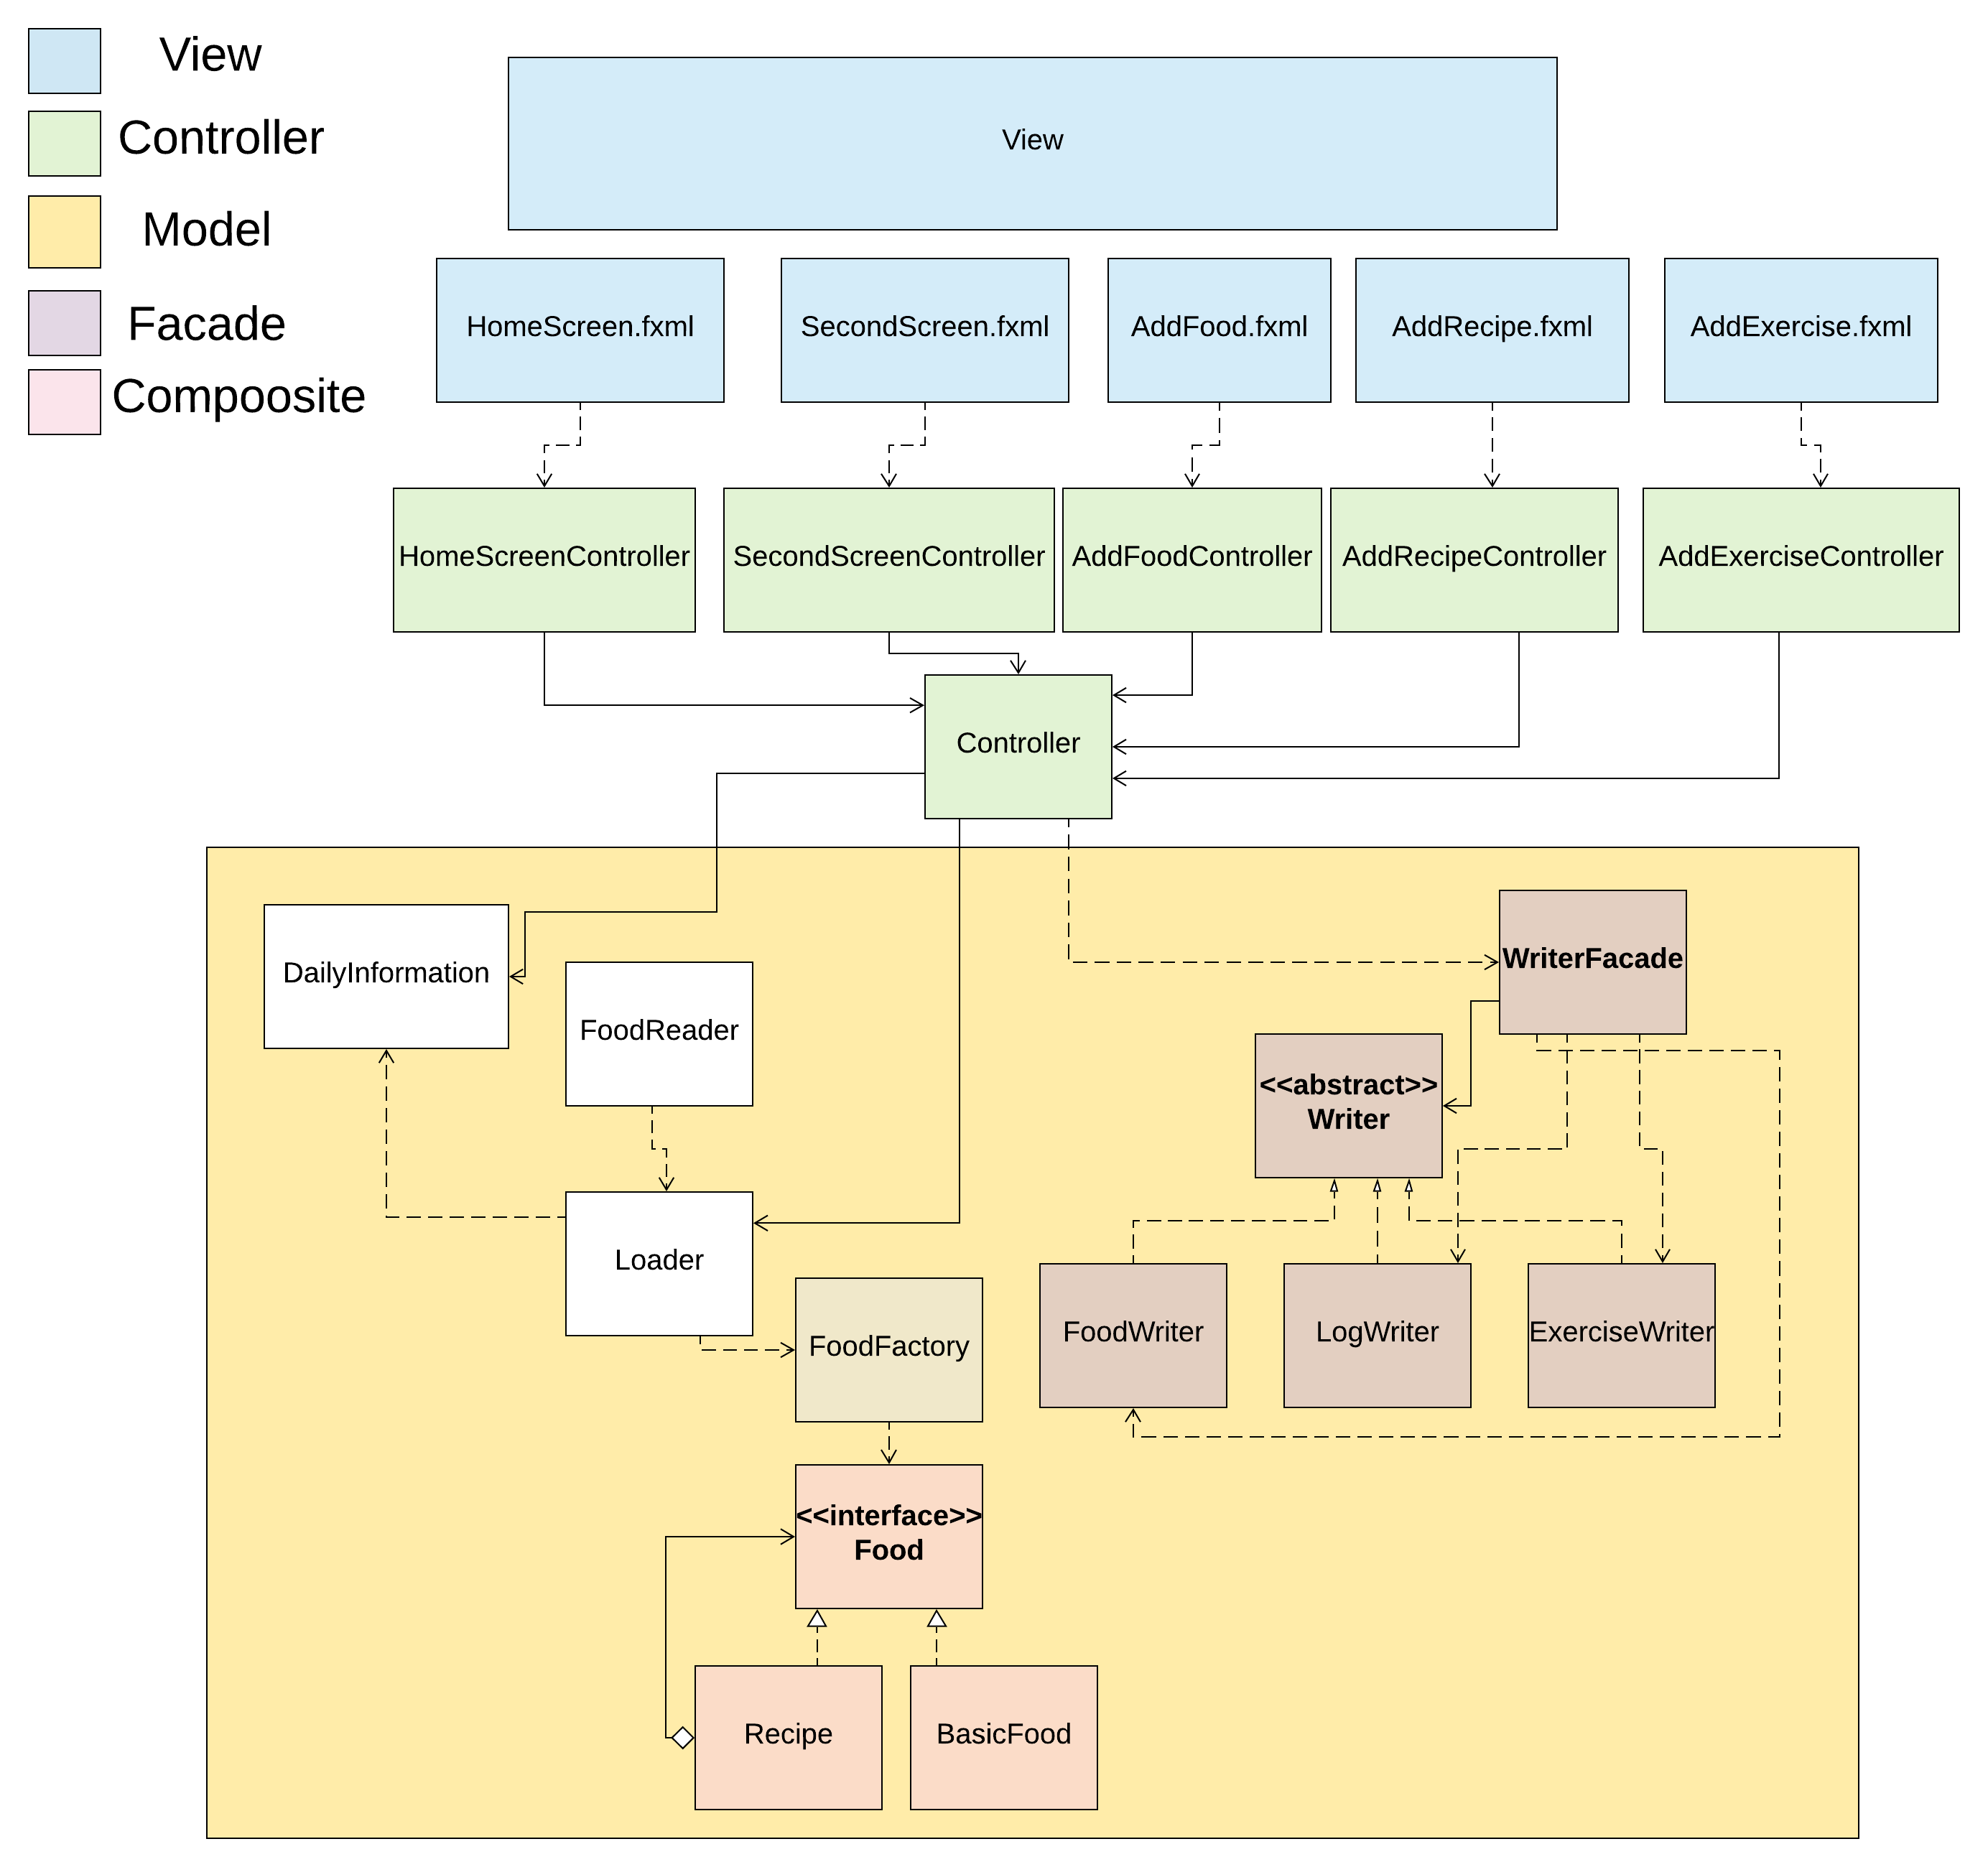

# Sequence Diagrams

## **Loading and writing foods – shows MVC (DietManagerGUI stands for the VIEW - FXML)**

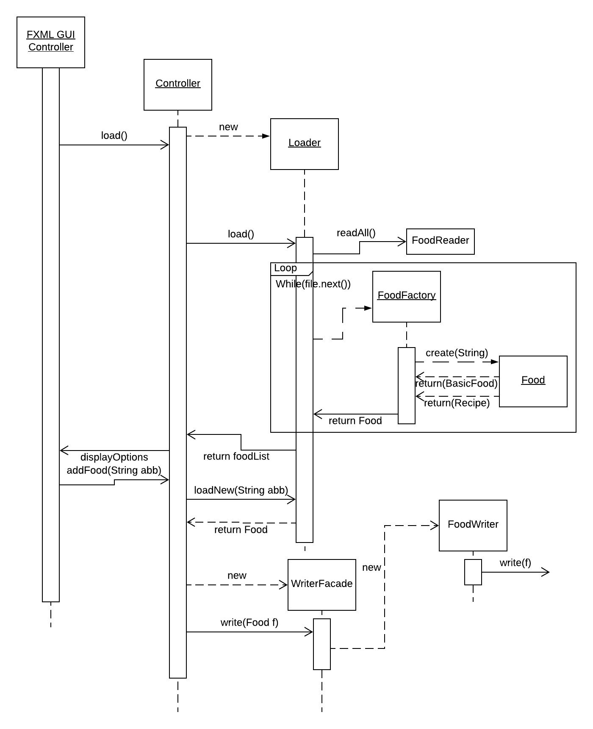

This diagram shows the interaction between MVC layers. View -> Controller -> Model.

## **Write the DailyInformation log – Uses our Façade to write the DailyInformation object data using the appropriate writer (decided by the facade). Appends data based on conditionals.**

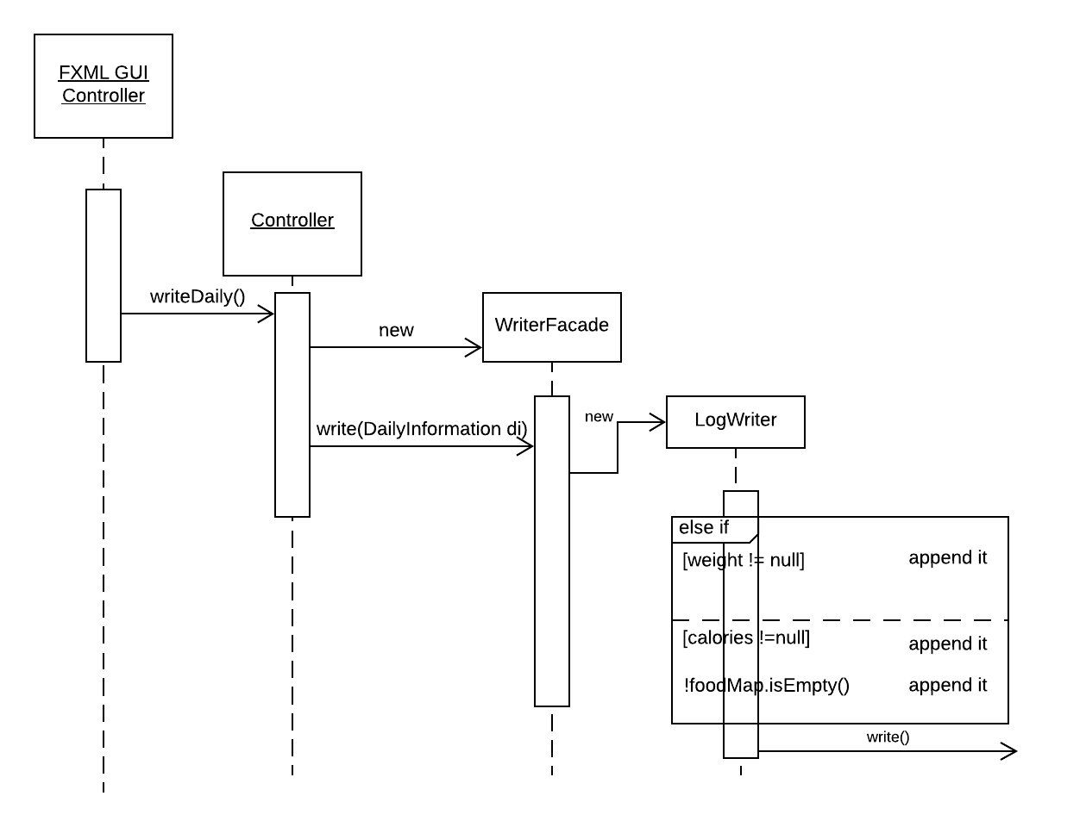

## **Write a new Food to the csv. This shows another interaction between the layers of MVC and it also uses façade writer to put the appropriate abbreviation of the food to its csv. file. Afterwards there is loading being done, but due to legibility this was cut.**

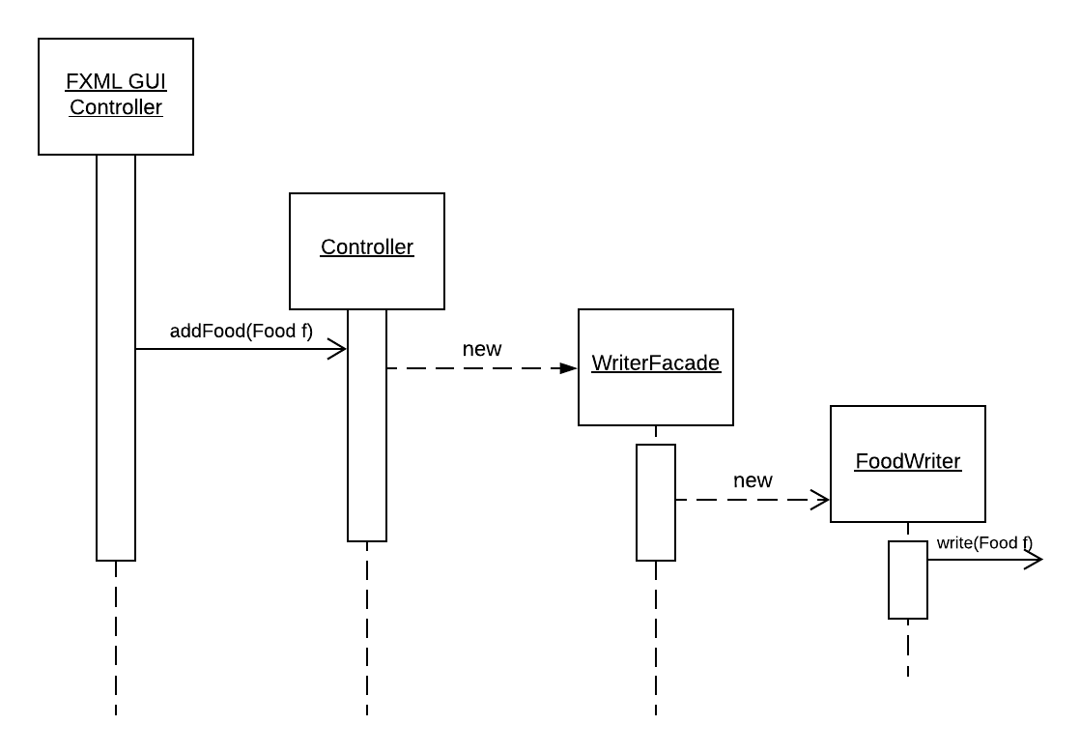

## 

## **Load Foods. This is being done for the loader class which contains all the necessary data for the controller in order to operate properly. While there are lines in the food.csv file this will create foods via Factory to populate the Loader.**

## 

## **Façade Class Diagram. Although the Façade also interacts with the interface Writer it serves its purpose of making its user (Controller) worriless regarding the usage of the Writers. All it has to do is pass what needs to be written to the façade and it will determine its position and writer required.**

## 

## **Façade Sequence. This is a “general” use case for our implementation (without conditionals).**

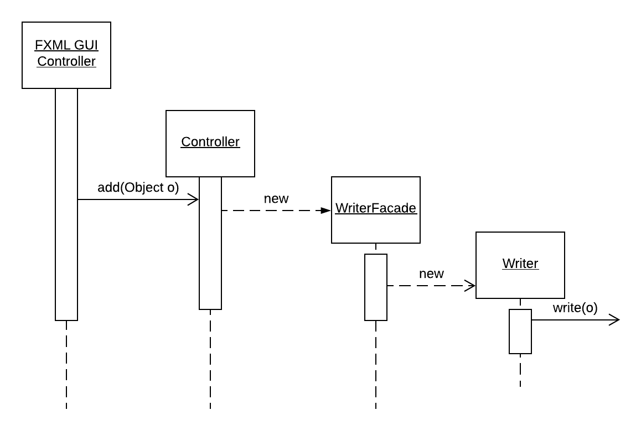

## **Façade Sequence. This is the specific case for writing Exercises via the façade.**

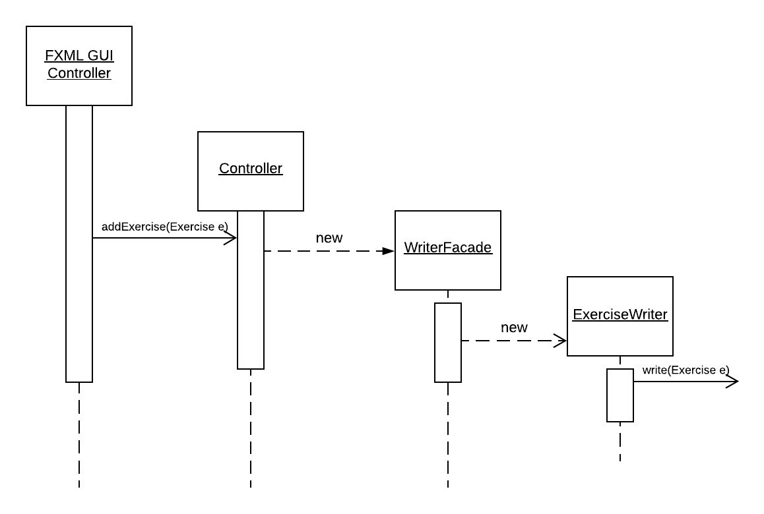

**Getting the calories from the DailyInformation in the specific case of the yellow sticker. This shows the use of Composite Pattern for this specific case since it goes through the recipe(composite) to access its leaves and get their calories.**

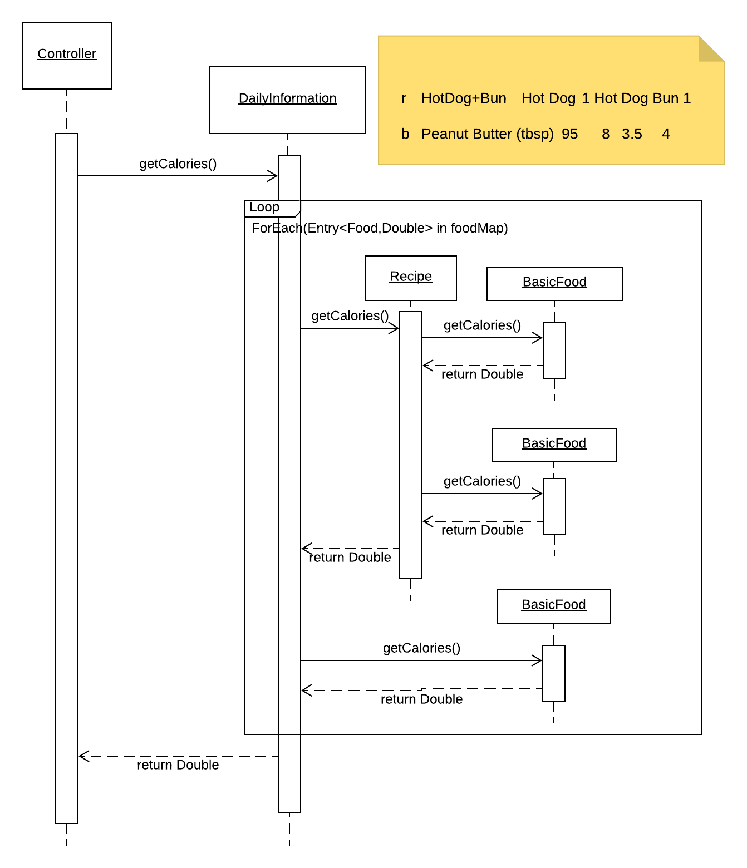

# Pattern Usage

## **Pattern #1** The Composite Pattern

|  |  |
| --- | --- |
| **The Composite Pattern** | |
| **Component** | Food |
| **Composite** | Recipe |
| **Leaf** | BasicFood |

## **Pattern #2** The Model-View-Controller Pattern

|  |  |
| --- | --- |
| **The Model-View-Controller (MVC) Pattern** | |
| **Model** | Food, FoodFactory, Recipe, BasicFood, DailyInformation, Loader… |
| **View** | FXML |
| **Controller** | Controller + FXMLControllers |

## **Pattern #3** The Factory Pattern

|  |  |
| --- | --- |
| **Factory Pattern** | |
| **Simple Factory** | FoodFactory |

## **Pattern #4** The Façade Pattern

|  |  |
| --- | --- |
| **Facade Pattern** | |
| **Facade** | WriterFacade |
| **User** | Controller |
| **Subsytems** | FoodWriter, LogWriter, ExerciseWriter |