Font Overlap Inspection Report
Date: June 5, 2026
Inspector: Automated visual inspection
Pages Tested: Collection, Shop, Onboarding (Log Owned)
Component: WireframePeriodicTable (shared across all three pages)

Executive Summary
Significant text overflow issues were found across ALL three breakpoints. Element names (.nm class) overflow their cell boundaries at every responsive size. At the small breakpoint, even some element symbols (.sym) overflow. The root cause is that the cell widths in an 18-column grid are too narrow for the current font sizes, especially for long element names like “Praseodymium”, “Rutherfordium”, and “Darmstadtium”.

Current Font Size Configuration
Breakpoint | Screen Width | Symbol (.sym) | Atomic # (.num) | Name (.nm)
Small | < 768px | 14px | 8px | 6px
Medium | 768px–1023px | 20px | 12px | 8px
Large | ≥ 1024px | 26px | 15px | 11px

Overflow Results Summary
Breakpoint | Name Overflows | Symbol Overflows | Total Elements
Small (500px) | 98 / 118 (83%) | 19 / 118 (16%) | 118
Medium (768px) | 55 / 118 (47%) | 0 / 118 | 118
Large (1024px) | 53 / 118 (45%) | 0 / 118 | 118

Key Finding
The element name (.nm) text overflows in nearly half of all cells even at the largest breakpoint. At the small breakpoint, the problem is catastrophic — 83% of element names and 16% of symbols overflow.

Worst Offenders (by overflow amount)

Small Breakpoint (cell width: ~21px)
Element | Text Width | Cell Width | Overflow
Praseodymium | 45px | 21px | +24px
Rutherfordium | 43px | 21px | +22px
Darmstadtium | 43px | 21px | +22px
Roentgenium | 40px | 21px | +19px
Mendelevium | 40px | 21px | +19px

Medium Breakpoint (cell width: ~36px)
Element | Text Width | Cell Width | Overflow
Praseodymium | 60px | 36px | +24px
Rutherfordium | 58px | 36px | +22px
Darmstadtium | 57px | 36px | +21px
Mendelevium | 54px | 36px | +18px
Roentgenium | 53px | 36px | +17px

Large Breakpoint (cell width: ~50px)
Element | Text Width | Cell Width | Overflow
Praseodymium | 82px | 50px | +32px
Rutherfordium | 79px | 50px | +29px
Darmstadtium | 79px | 50px | +29px
Mendelevium | 74px | 50px | +24px
Roentgenium | 73px | 50px | +23px

Pages Affected
All three pages use the shared WireframePeriodicTable component (app/components/WireframePeriodicTable.jsx) with the same CSS classes defined in app/tailwind.css. The overflow behavior is identical across:
- Collection Page (/app/cabinet/periodic-table) — Names like “Rutherfordium”, “Darmstadtium”, “Meitnerium” visibly bleed outside cells
- Shop Page (/app/cabinet/shop) — Same overflow, with shop-specific gradient styling making it slightly more noticeable
- Onboarding Log Owned (/onboarding/log-owned) — Same component, same overflow

Visual Evidence

Collection Page (Large viewport, 1536px)
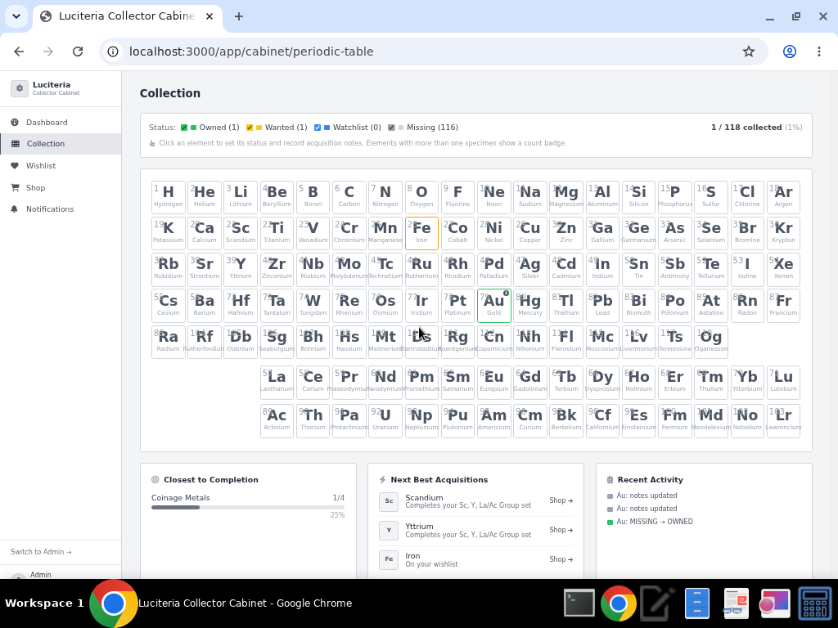
Collection Page
Names like “Rutherfordium”, “Molybdenum”, “Praseodymium”, “Darmstadtium” visibly overflow their cell boundaries in row 7 and the lanthanide/actinide rows.

Shop Page (Large viewport, 1536px)
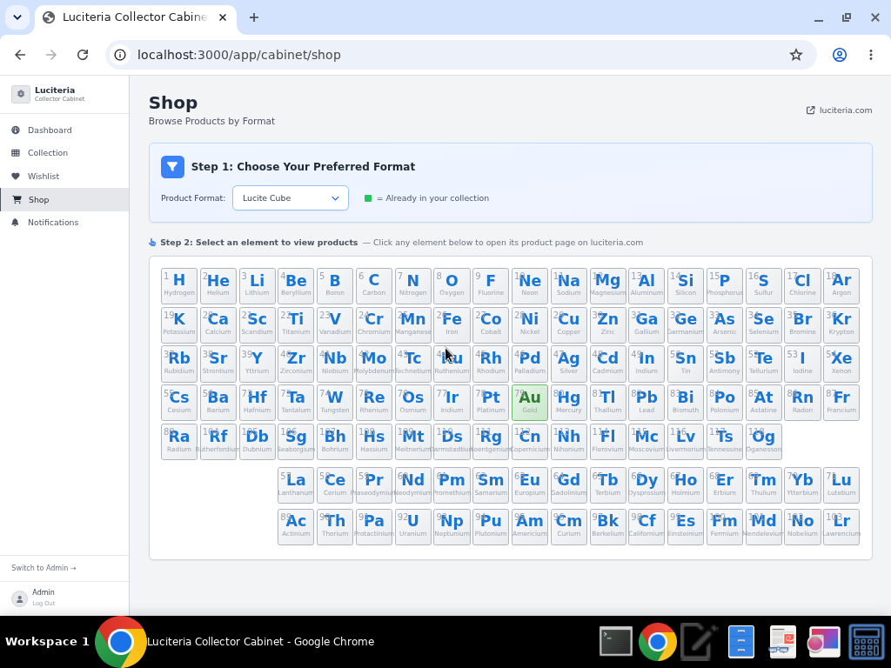
Shop Page
Same overflow pattern visible, particularly in the bottom rows with longer element names.

Automated Test — All Breakpoints Side-by-Side
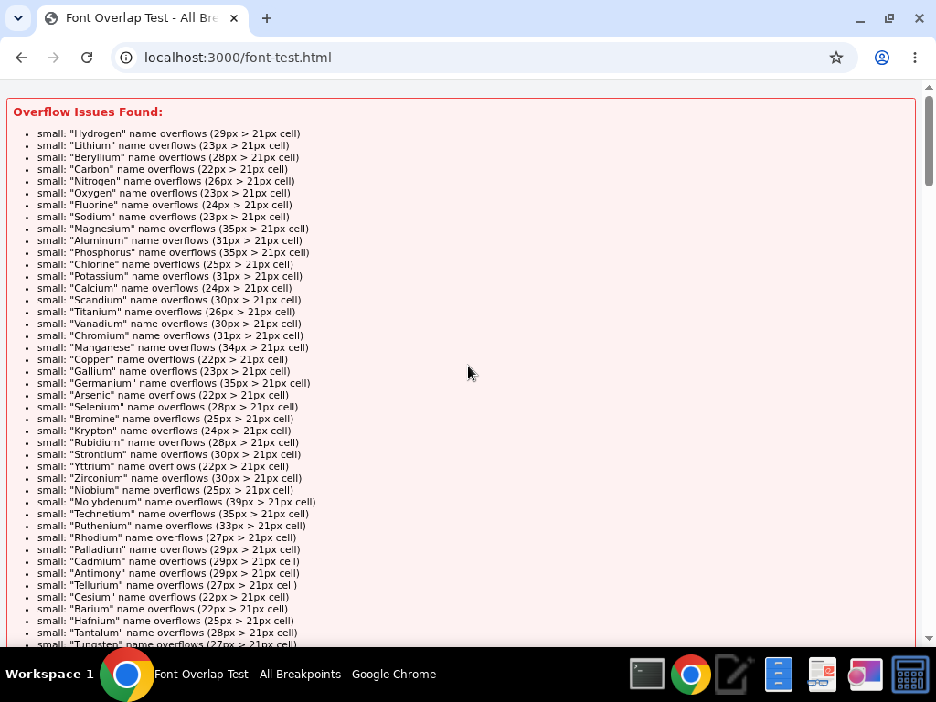
Overflow Report
Red-highlighted cells indicate overflow. The medium table shows ~55 overflowing cells, and the large table shows ~53.

Medium & Large Tables with Red Highlights
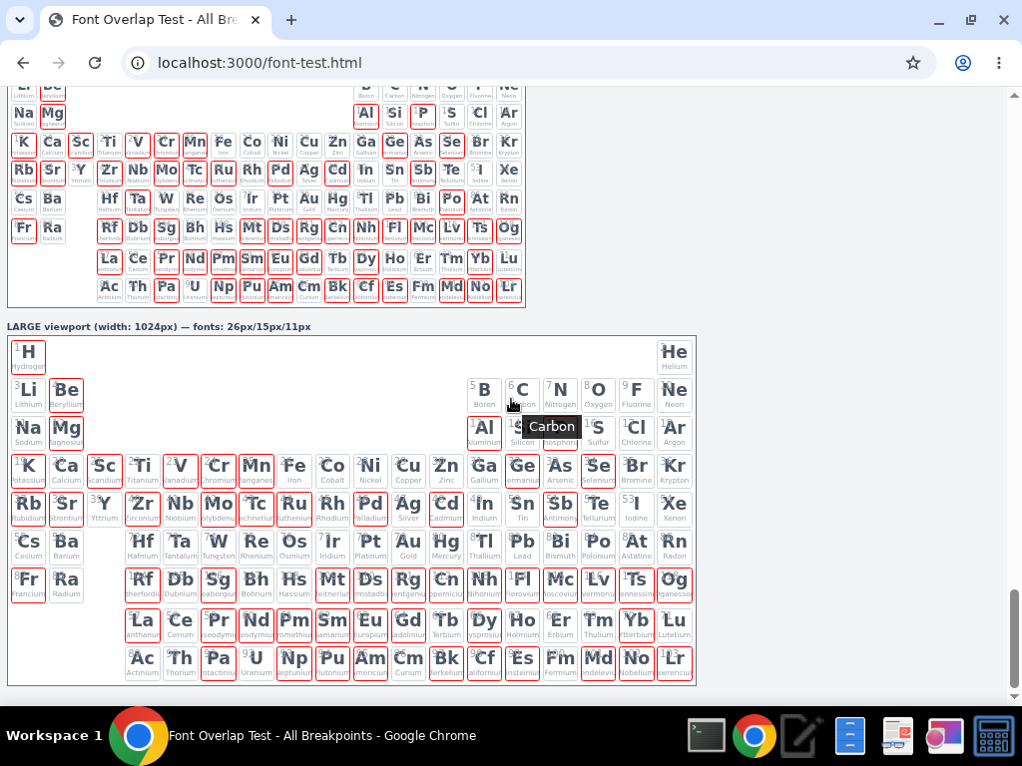
Tables with Overflow Highlights

Root Cause Analysis
The fundamental issue is a mismatch between font size and available cell width. In an 18-column grid:
- At 500px container width: each cell is ~21px wide → 6px font names still overflow
- At 768px container width: each cell is ~36px wide → 8px font names still overflow
- At 1024px container width: each cell is ~50px wide → 11px font names still overflow
The longest element names (Praseodymium = 13 chars, Rutherfordium = 14 chars) need roughly 1.6× the cell width even at the smallest font size.

Recommended Fixes

Option A: Add overflow: hidden + text-overflow: ellipsis (Quick Fix)
.cell .nm {
overflow: hidden;
text-overflow: ellipsis;
white-space: nowrap;
max-width: 100%;
}
This clips long names but keeps the layout clean. Most periodic tables use this approach.

Option B: Reduce Name Font Sizes Further
- Small: 6px → 4px (may be unreadable)
- Medium: 8px → 6px
- Large: 11px → 8px
This reduces overflow count but won’t eliminate it for the longest names.

Option C: Hide Names on Small Screens, Truncate on Medium/Large
/* Small: hide names entirely */
.cell .nm { display: none; }
/* Medium: show truncated */
@media (min-width: 768px) {
.cell .nm {
display: block;
font-size: 6px;
overflow: hidden;
text-overflow: ellipsis;
white-space: nowrap;
max-width: 100%;
}
}
/* Large: show with slightly larger truncated text */
@media (min-width: 1024px) {
.cell .nm { font-size: 9px; }
}

Option D: Use CSS scale() for Names (Best Visual Result)
.cell .nm {
white-space: nowrap;
transform: scale(var(--nm-scale, 1));
transform-origin: center;
}
Then use JavaScript to auto-calculate the scale factor per cell. This preserves readability while fitting within bounds.

Recommended Approach
Option A is the simplest and most standard approach for periodic tables. Combined with a title attribute (already present via the component), users can hover to see the full name. This is the industry-standard pattern used by most interactive periodic tables.

CSS Location
All styles are in: app/tailwind.css (lines 7–22)
Component: app/components/WireframePeriodicTable.jsx

