1. Clone the project to local environment
2. Open user data integration.sln under the user data integration folder. On the control flow page, open the Variables window  
   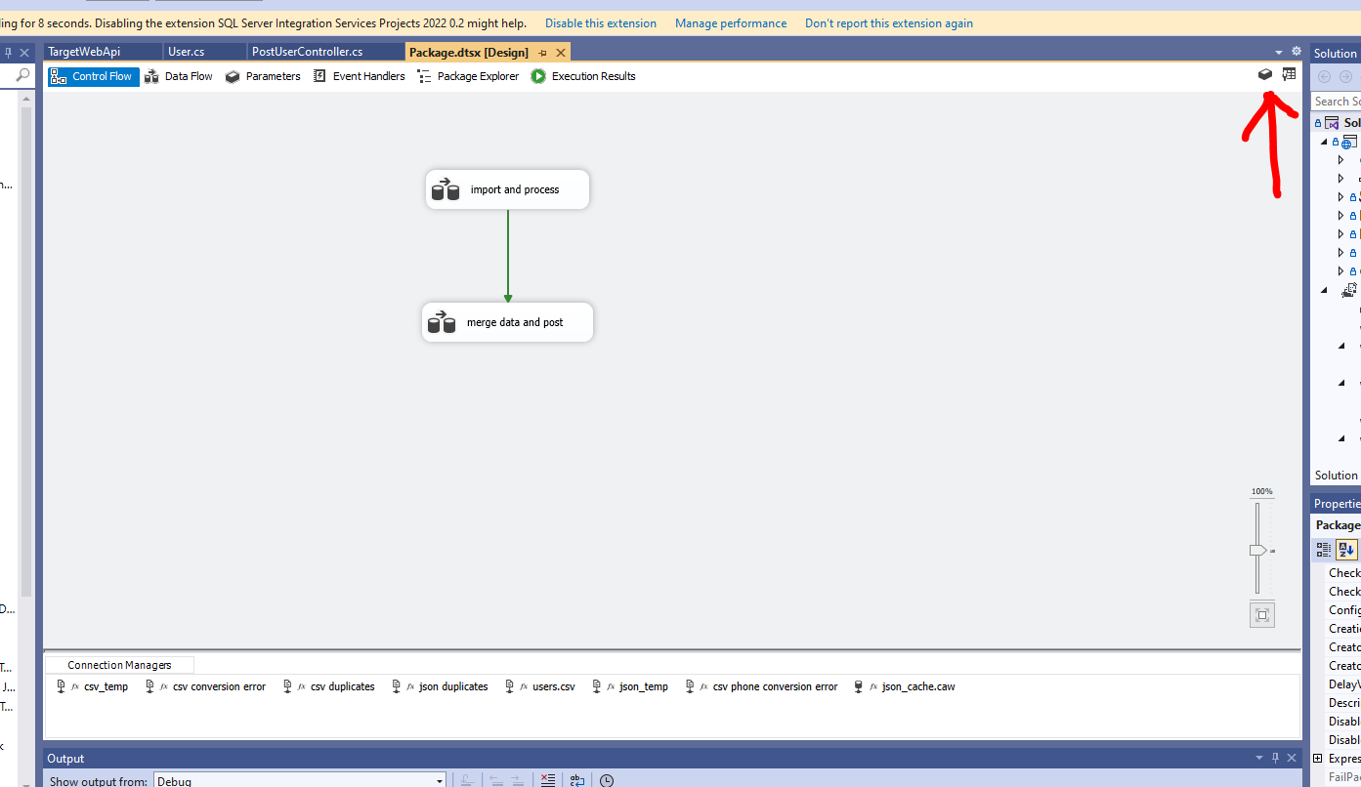
3. Put the location of csv folder to the csvFolder variable  
   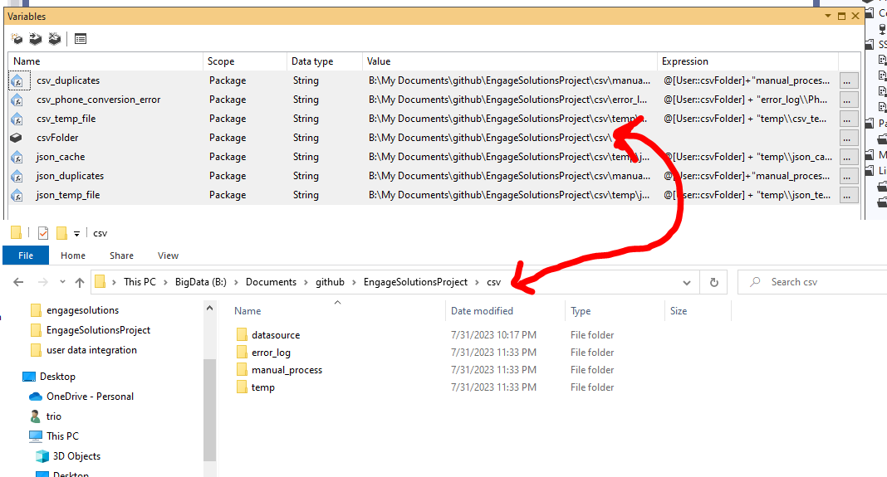
4. Press F5 to execute
5. The duplicate data files will be produced 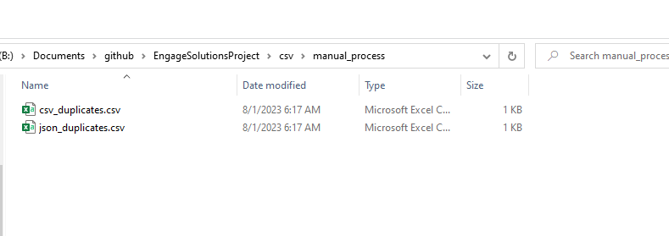
6. A json file will be also created in Company B’s API folder which reflects the SSIS POST function is working.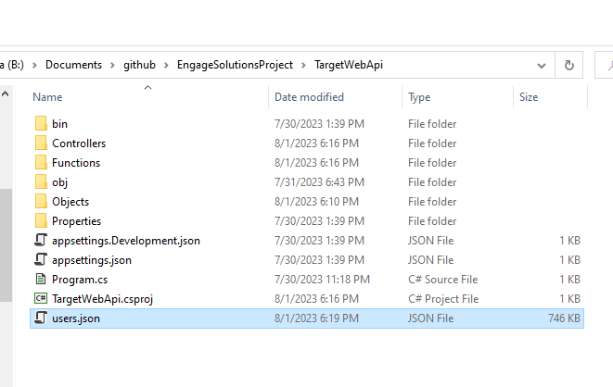
7. In the csvfolder, PostResults.txt will be created to record each HTTP POST response. 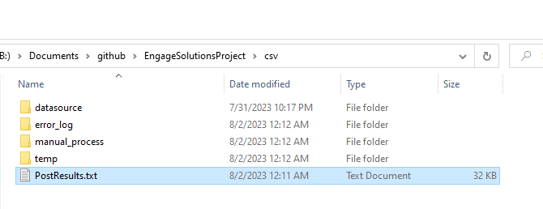
8. If you would like to test the duplicate data detection, please modify the phone numbers in users.csv under csv/datasource. Match the phone numbers with users on https://jsonplaceholder.typicode.com/users