Function 1: Change profile picture

We need to define an event handler for any click onto the profilePic, so that it will trigger a pop-up to add and change profile picture. So, we start with a function handleAvatarUpdate in the App.js:

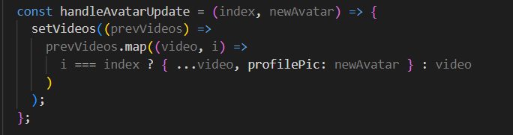

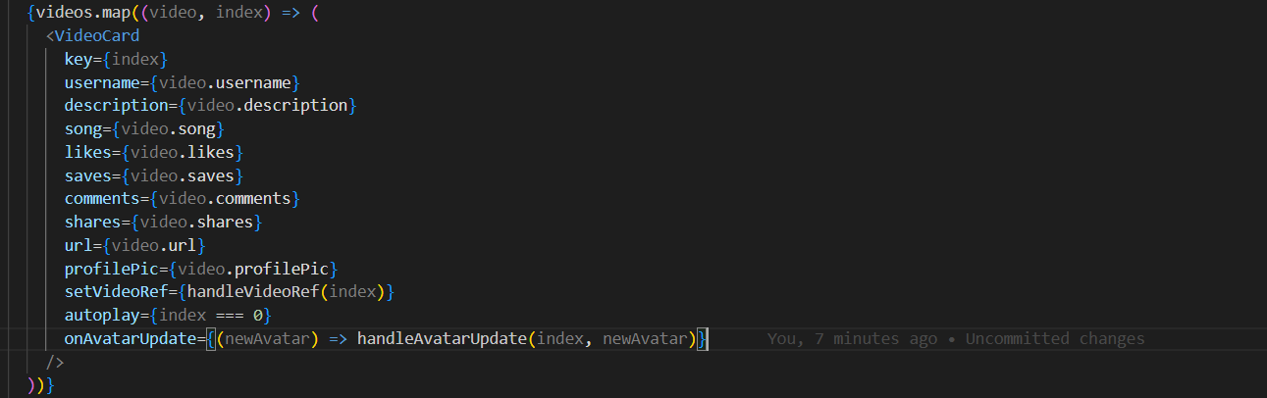

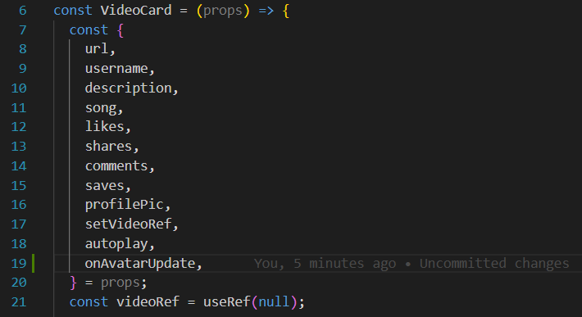

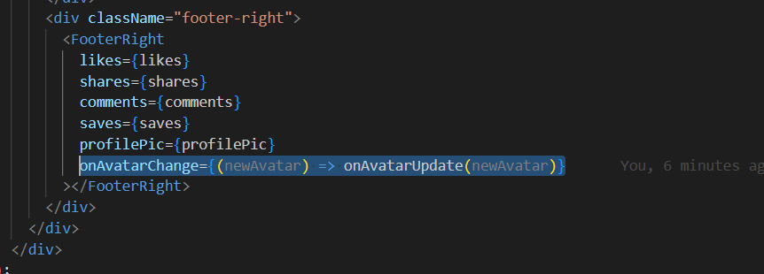

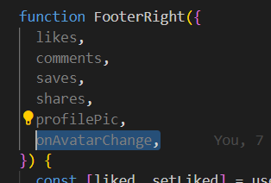
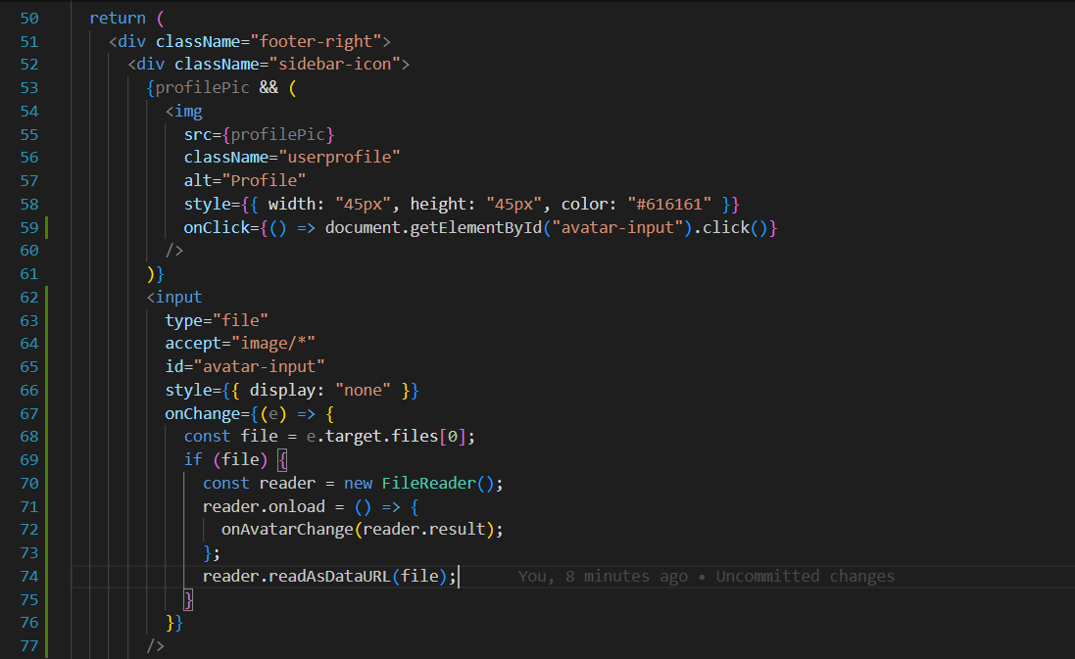

Function 2: Add a button in FooterRight to mute and unmute the video when clicked

Function 3: When selecting the 'Save' button, automatically copy the video URL.

