VISION TRANSFORMER-BASED
DISASTER-DAMAGE CLASSIFICATION
A systematic experimental study using CrisisMMD
MAAI 901 | Applied Vision Transformer Report
The study compares pretrained vision-transformer features, fine-tuning choices, classification heads, loss functions and three image-augmentation strategies.

Abstract
This study evaluates three-class disaster-damage classification on 3,463 CrisisMMD images. I first compared frozen DINOv2, ViT and ConViT features, then tested learning rates, fine-tuning depth, classification heads, loss functions and image augmentation. DINOv2 achieved the strongest frozen-probe validation Macro-F1 (57.30%), and the best result in the separate augmentation comparison was 64.18%. The selected realistic-augmentation checkpoint scored 59.78% Macro-F1 on the held-out test set. The validation–test gap and a possible label-index mismatch limit interpretation of the per-class results.

1. Research problem, objective and questions
Images shared during disasters vary in camera angle, resolution, lighting, compression, occlusion and context. Damage categories can be visually similar, while the class distribution is uneven. The aim is to measure how modelling choices affect class-sensitive performance and training cost, rather than optimize overall accuracy alone.
The research questions were:
RQ1. How do DINOv2, ViT and ConViT compare as pretrained feature extractors?
RQ2. How do learning rate, unfreezing depth and classification-head design affect performance?
RQ3. How do loss function and image augmentation affect Macro-F1, balanced accuracy and accuracy?
RQ4. How does the selected model perform on held-out test data, and what do the validation–test differences reveal?
RQ5. What dataset biases and ethical risks matter in a disaster-response context?
Macro-F1 was the primary selection metric because it gives equal importance to each class. Accuracy, balanced accuracy, per-class precision/recall/F1, confusion matrix and training time provided complementary views of performance. The report also considers class imbalance, possible dataset shortcuts and the limits of an image-level random split.

2. Dataset selection and justification
CrisisMMD is a disaster-related social-media dataset designed for crisis informatics research. This experiment uses its image-damage task, restricted to three labels: little/no damage, mild damage and severe damage. The reported inventory contains 3,463 images: 2,166 little/no damage, 823 mild damage and 474 severe damage. The task is relevant because visual damage classification may help organize large volumes of disaster imagery, while the uneven label distribution and variable image quality make it a realistic experimental challenge.
Partition | Images | Use
Training | 2,077 | Fit parameters and apply training-only augmentation
Validation | 693 | Compare configurations and select checkpoints
Test | 693 | Held-out final evaluation
Total | 3,463 | Three-class classification

The split was stratified at image level with seed 42: 2,077 training images, 693 validation images and 693 test images. Because images were not split by disaster event, these results do not measure generalization to entirely unseen events. The experiment uses the image-damage labels rather than the dataset’s full multimodal content.

3. Pre-processing strategy
Images are decoded, resized to the input resolution expected by each pretrained backbone, converted to tensors and normalized using that model’s expected statistics. The same label-to-index mapping must be used for training, validation and test; validation and test transforms should be deterministic, with augmentation applied only during training.
The split counts sum to 3,463. One issue remains before interpreting class-level performance: the test report lists supports of 95, 165 and 433 for little/no, mild and severe damage, while the inventory and stratified split imply approximately 433, 165 and 95 in that order. This suggests the displayed class names may not align with encoded label indices. Verify the mapping against the dataset metadata and evaluation code before making claims about individual classes.

4. Model selection and initial comparison
I selected three pretrained backbones to compare different representation approaches. ViT provides the standard Transformer reference, ConViT adds a convolutional inductive bias, and DINOv2 supplies self-supervised visual features. A frozen linear probe gives a low-cost initial comparison before spending compute on fine-tuning.
At inference time, the image is first transformed into the tensor format expected by the selected pretrained weights. A ViT-style backbone represents image patches as tokens and uses self-attention to combine information across regions; the resulting feature representation is passed to a three-class head. The head produces three logits, which softmax converts to class probabilities. The highest-scoring class becomes the predicted damage label. During training, the logits are compared with the known label using the configured loss, and backpropagation updates the classifier and any unfrozen backbone blocks. The frozen linear-probe baseline updates only the head.
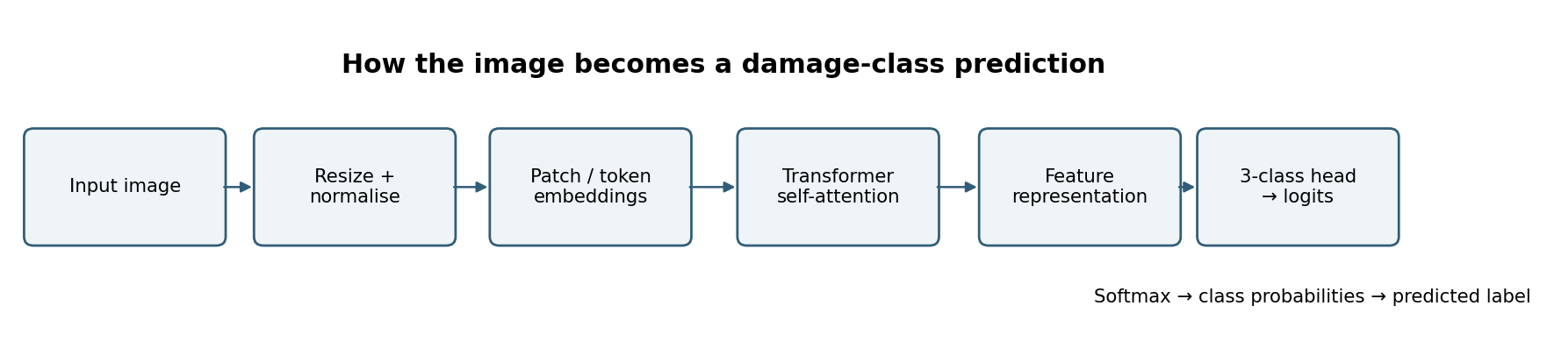
Figure 1A. Simplified inference path from the input image to the predicted damage class. The exact tokenisation and feature-pooling implementation depends on the selected backbone.
Frozen linear-probe model | Validation accuracy | Balanced accuracy | Macro-F1
DINOv2 Base | 62.77% | 59.30% | 57.30%
ViT Base | 58.15% | 53.36% | 51.57%
ConViT Tiny | 58.87% | 51.12% | 50.02%

I continued with DINOv2 because it had the highest initial Macro-F1 on this split.

5. Experiment sequence: configuration, loss and augmentation

5.1 Establish the baseline
The frozen-backbone comparison gave DINOv2 a validation Macro-F1 of 57.30%, above ViT (51.57%) and ConViT (50.02%). I used DINOv2 for the following experiments to examine whether optimization and classifier choices could improve its results.

5.2 Tune learning rate and fine-tuning depth
The learning-rate search tested 1e-4, 3e-4, 1e-3 and 3e-3 in the linear-probe setup. The best tested setting was 3e-4, with Macro-F1 of 59.10%, compared with 57.30% initially.
The learning rate controls the size of each optimizer update. At a very small rate, the classifier may improve slowly; at a rate that is too large, updates can overshoot useful weights and make validation performance less stable. In a linear probe, the pretrained backbone stays fixed and only the classifier learns, so the search mainly changes how quickly its decision boundary is fitted. The 3e-4 result was the best of the four values tested, not a universal optimum.
I then unfroze one or two transformer blocks, using a smaller learning rate for the backbone than for the classification head. The one-block run reached 60.00% Macro-F1; the reported two-block configuration reached 59.47%. These results show that deeper fine-tuning did not automatically improve Macro-F1.
Unfreezing changes which weights can adapt to CrisisMMD. With the backbone frozen, DINOv2’s pretrained visual features are preserved. Unfreezing the final block lets higher-level representations shift toward damage cues; unfreezing two blocks gives more flexibility but also exposes more weights to a small, imbalanced training set. The lower backbone learning rate limits how quickly those pretrained features move, while the larger head learning rate lets the newly added classifier adapt faster. The two-block run did not outperform the one-block run on Macro-F1, so extra trainable capacity did not guarantee a better class-balanced result.

5.3 Compare the classification head and loss
The Conv + GroupNorm head reached 64.92% Macro-F1, while an MLP head reached 64.81% in their respective runs. A separate focal-loss run with gamma=1 reached 65.74%. These are results from different configurations, not one controlled sequence in which each change can be credited with the full gain.
The head determines how the backbone features are converted into class scores. The MLP mixes the feature vector through fully connected layers. The convolutional head instead learns local patterns in the feature representation, while GroupNorm normalizes intermediate activations across groups of channels, which can make optimization less sensitive to batch statistics. Focal loss changes the contribution of training examples: with gamma=1, it down-weights examples the model already classifies confidently and gives relatively more attention to harder cases. This can help minority or ambiguous examples, although it can also amplify noisy labels. Because these head and loss results came from separate runs, their scores are comparisons across configurations rather than a clean estimate of each parameter’s individual effect.
I next tested whether changing the training images could improve robustness to the visual variation found in disaster photographs.

5.4 Compare image augmentation strategies
I compared three training pipelines: baseline augmentation, realistic augmentation and RandAugment. The goal was to test whether modest, plausible changes to image appearance helped the classifier, and whether stronger transformations improved class-balanced performance or reduced training time.
For this experiment, augmentation means applying image transformations to training examples while keeping their damage label unchanged. That assumption is valid only when a transformation preserves the visible evidence needed to judge damage severity.
Figure 1. Schematic examples of the three augmentation scenarios
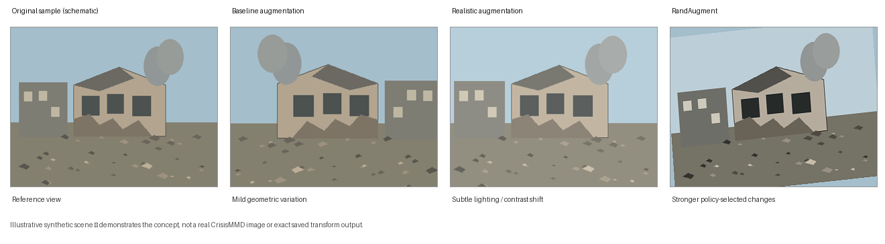
Schematic, not real CrisisMMD images. In the controlled augmentation series, realistic augmentation produced a validation Macro-F1 of 64.18%, compared with 64.07% for baseline and 63.53% for RandAugment.
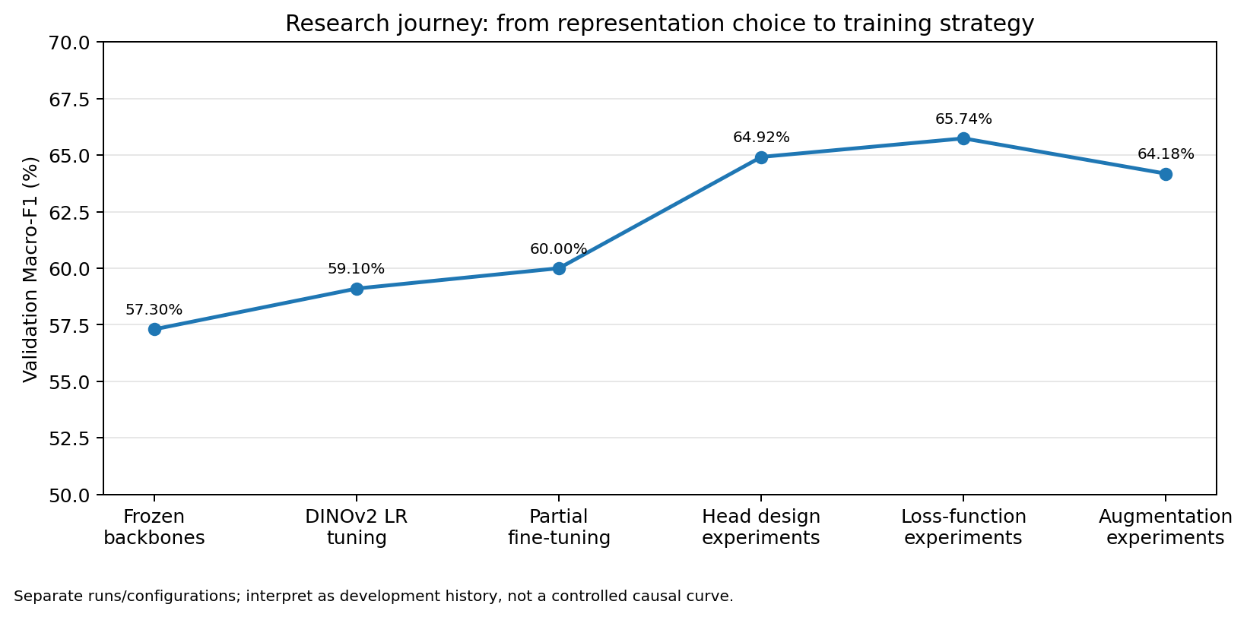
Figure 2. Experiment sequence; values come from separate runs and are not a controlled causal curve.
Development stage | Reported validation Macro-F1 | What the result informed
Frozen DINOv2 probe | 57.30% | Reference point for all later exploration
Learning-rate search | 59.10% | Optimization settings matter
One-block fine-tuning | 60.00% | Partial feature adaptation can help
Conv + GroupNorm head | 64.92% | Head design is a meaningful variable
Focal loss, gamma=1 (separate run) | 65.74% | Loss design can alter class-sensitive performance
Realistic augmentation, controlled series | 64.18% | Best Macro-F1 among the three augmentation variants

The realistic-augmentation result was 0.11 percentage points above baseline in Macro-F1. RandAugment had lower Macro-F1 but the highest balanced accuracy and shortest recorded training time. The differences are small and the preferred strategy depends on which metric matters for the task.

6. Evaluation and results

6.1 Controlled augmentation comparison
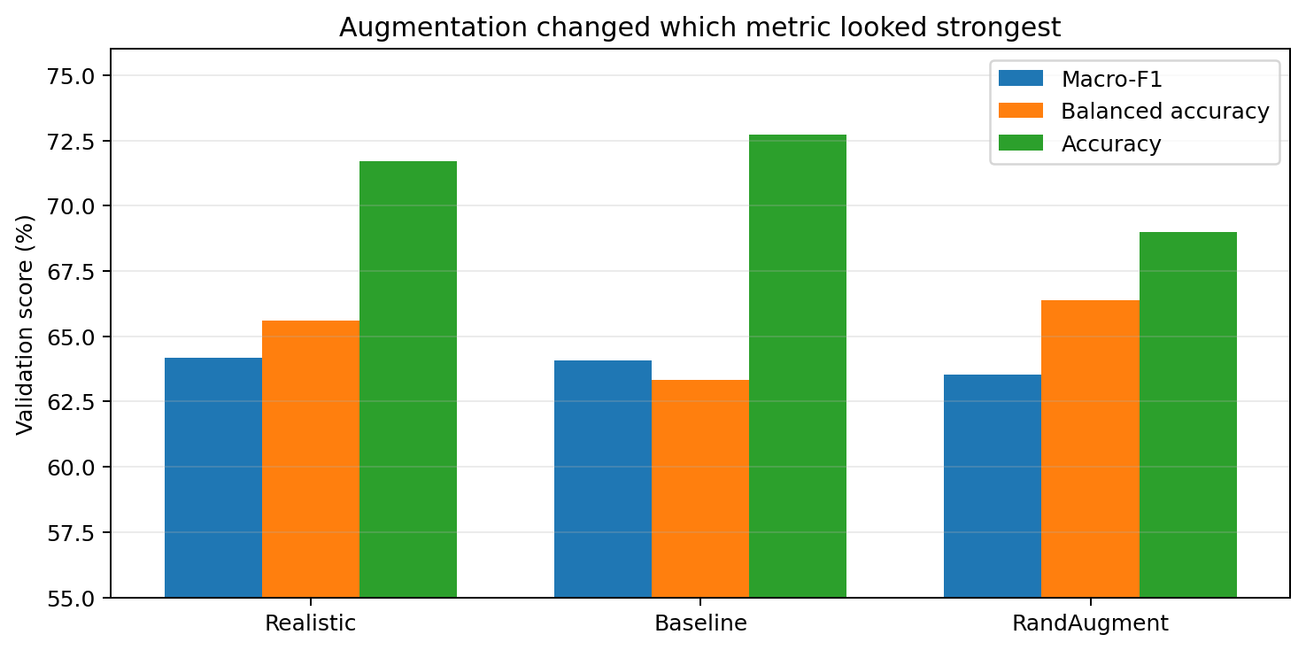
Figure 3. Validation metrics for the three augmentation strategies.
Augmentation | Macro-F1 | Balanced accuracy | Accuracy | Training time
Realistic | 64.18% | 65.60% | 71.72% | 449.5 s
Baseline | 64.07% | 63.32% | 72.73% | 422.6 s
RandAugment | 63.53% | 66.38% | 68.98% | 286.9 s

Realistic augmentation had the highest Macro-F1, baseline had the highest accuracy, and RandAugment had the highest balanced accuracy and shortest recorded training time. The augmentation comparison is separate from the earlier head and loss experiments, so the selected checkpoint should be understood as the best Macro-F1 configuration within this augmentation series—not the highest Macro-F1 across every experiment in the notebook.

6.2 Final held-out test evaluation
I selected checkpoint E07_Aug_Realistic_FocalG1 at epoch 5, with validation Macro-F1 of 0.6418. I loaded the saved checkpoint and evaluated it on the 693 test images using deterministic transforms.
Test metric | Result
Accuracy | 69.41%
Balanced accuracy | 61.30%
Macro-F1 | 59.78%
Weighted F1 | 70.23%

Test Macro-F1 was 4.40 percentage points below validation Macro-F1, and test balanced accuracy was 4.30 points below its validation value. This validation–test gap may reflect sampling variation, overfitting to validation choices or differences in image difficulty; the available results do not identify one cause.
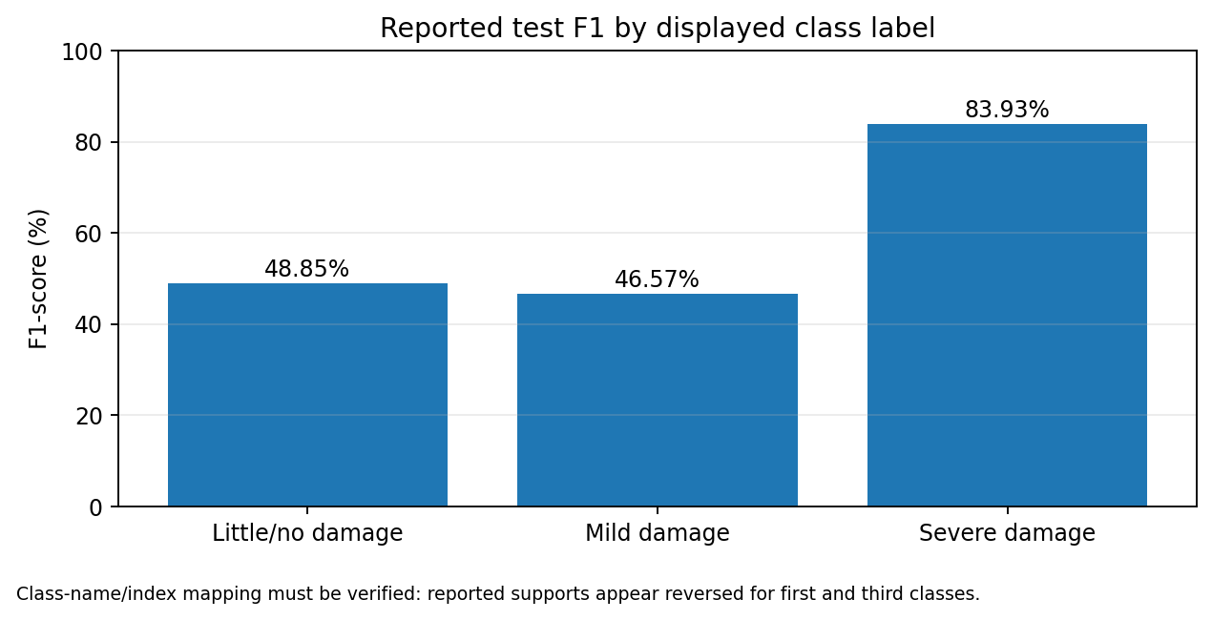
Figure 4. Per-class test F1 from the displayed classification report.
The displayed report gives F1 values of 0.4885 for little/no damage, 0.4657 for mild damage and 0.8393 for severe damage. However, the supports are 95, 165 and 433, which appear reversed for little/no and severe damage compared with the dataset inventory. Until the label-index mapping is verified, these class-specific scores should not be interpreted as definitive evidence that one damage category is easier to classify.

7. Performance, bias and efficiency analysis
Across the tested configurations, DINOv2 had the strongest frozen representation, and later results varied with learning rate, fine-tuning depth, head design, loss and augmentation. The best result in the augmentation comparison was 64.18% validation Macro-F1, while the selected checkpoint scored 59.78% Macro-F1 on test data.
The class distribution is imbalanced, so accuracy alone can hide weak performance on less frequent categories. Potential shortcuts include correlations with disaster event, geography, camera/device, image quality, lighting or background context. An event-held-out evaluation and a verified confusion matrix would help test whether the model relies on damage evidence rather than contextual cues.
The three augmentation runs took approximately 287–449 seconds. RandAugment was fastest in these runs, but a reliable efficiency comparison would require matched hardware, repeated runs, memory measurements and inference-latency tests.

8. Ethical and societal implications
Crisis images may contain identifiable people, distressed individuals, private property or sensitive locations. Images should be handled according to dataset terms, access should be restricted where appropriate, and unnecessary redistribution or identification should be avoided. A wrong damage prediction could mislead responders if treated as a reliable indicator of structural safety or used alone to prioritize aid. This model is an educational research prototype, not a validated structural assessment or autonomous emergency-triage system. Any operational use would require domain-expert validation, human oversight, uncertainty handling and evaluation across diverse events and communities.

9. Conclusion and next steps
I began with a frozen DINOv2 validation Macro-F1 of 57.30%, then tested learning rate, fine-tuning depth, head design and loss before comparing three augmentation strategies. Realistic augmentation had the highest Macro-F1 in that controlled series (64.18%), while RandAugment had the highest balanced accuracy and shortest recorded training time. The selected realistic-augmentation checkpoint achieved 59.78% Macro-F1 on the held-out test set, showing a measurable validation–test gap.
Before submission, verify the class-to-index mapping, retain each run configuration and checkpoint ID, and keep the test set out of model selection. Further work should include an event-held-out split, repeated runs, a confusion matrix after label verification, and targeted tests of class balancing and augmentation strength.

References
Alam, F., Ofli, F., & Imran, M. (2018). CrisisMMD: Multimodal Twitter datasets from natural disasters. Proceedings of ICWSM. https://crisisnlp.qcri.org/crisismmd
Dosovitskiy, A., et al. (2021). An Image is Worth 16x16 Words: Transformers for Image Recognition at Scale. ICLR. https://arxiv.org/abs/2010.11929
d’Ascoli, S., et al. (2021). ConViT: Improving Vision Transformers with Soft Convolutional Inductive Biases. ICML. https://arxiv.org/abs/2103.10697
Oquab, M., et al. (2023). DINOv2: Learning Robust Visual Features without Supervision. https://arxiv.org/abs/2304.07193
Sokolova, M., & Lapalme, G. (2009). A systematic analysis of performance measures for classification tasks. Information Processing & Management, 45(4), 427–437. https://doi.org/10.1016/j.ipm.2009.03.002

