

# Arduino Bluetooth RC Car

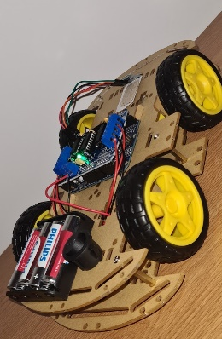

Project made by Hozu Cosmin

**Components and resources used:**

1. **Mechanical kit robot chassis with 4 wheels with reducer.**

The kit contains:

Wheels with 3-6V gear motor;

4AA battery support;

Encoders;

2 acrylic plates that make up the chassis;

Spacers, screws and other parts necessary for assembly;

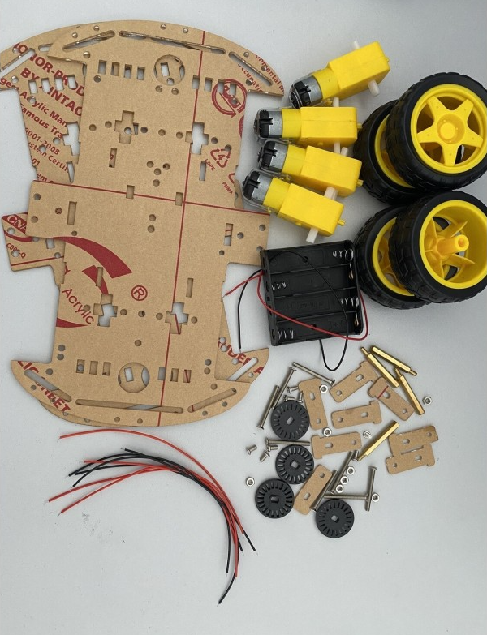

**B) L293D Module Shield**

Specifications:

Supply voltage logic circuits: 5V;

Power supply engines: 4.5V - 36V;

Current engines continuously: 0.6A;

Current engines peak: 1.2A;

Overcurrent and overtemperature protection;

Compatible with Arduino Uno.

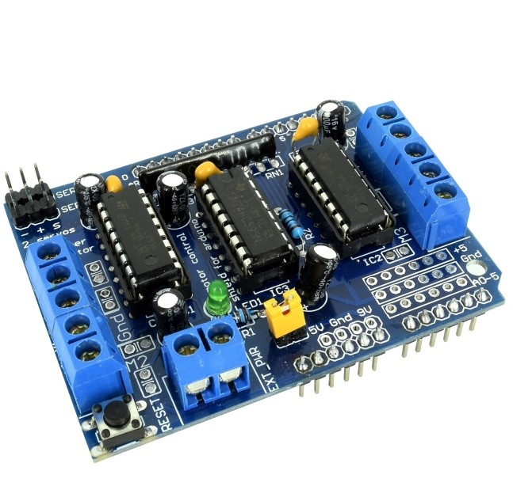

**C)Arduino UNO**

Technical specifications:

Microcontroller: ATmega328

ATmega16U2 programmer

Operating voltage: 5V

Recommended power supply voltage: 5-12V (recommended 7V)

Voltage limit: 6-20V

Digital input/output pins: 14 (of which 6 can provide PWM output)

Analog input pins: 6

Flash memory: 32KB

SRAM: 2KB

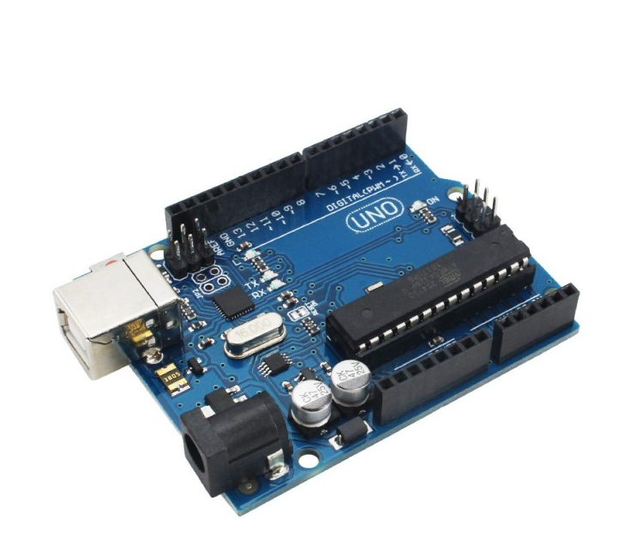EEPROM: 1KB (non-volatile memory type)

Operating frequency: 16 MHz

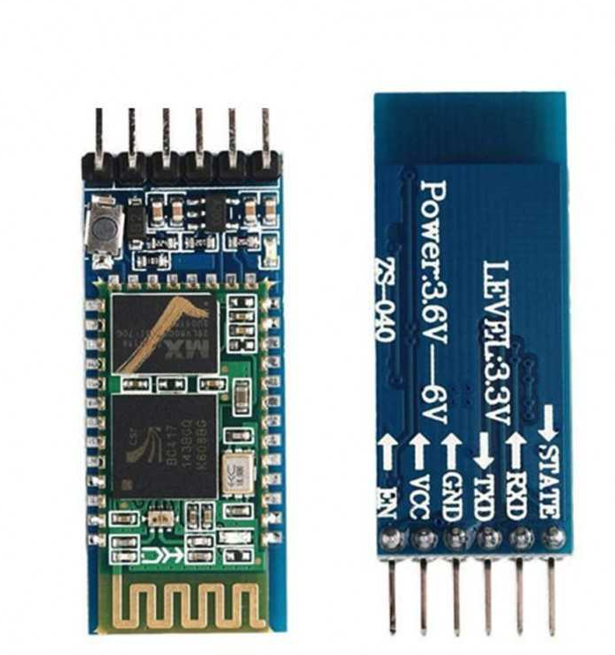**D)** **HC-05 Bluetooth Module**

Specifications:

Supply Voltage: 3.6-6V;

Current consumption: 30mA maximum;

Pins I/O compatible to 3.3v;

Communicate serial UART;

Baudrate: 9600-460800 bps;

Transmission distance up to 10m;

Transmission power: +4 dBm;

Reception sensitivity: -80 dBm.

**E)Switch KCD-1, SPST, ON-OFF**

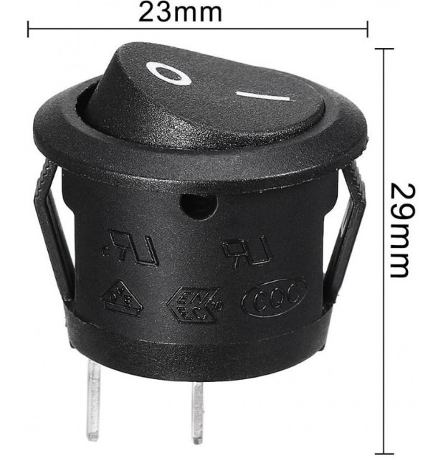Specifications:

Two positions and two pins.

Current: 10A at 125 VAC, 6A at 250VAC

Type: Round Rocker Switch

Material: Plastic

Color: Black

Dimensions: 23x29mm

**E)** Set cables with pins duponts 10 cm (female-female)

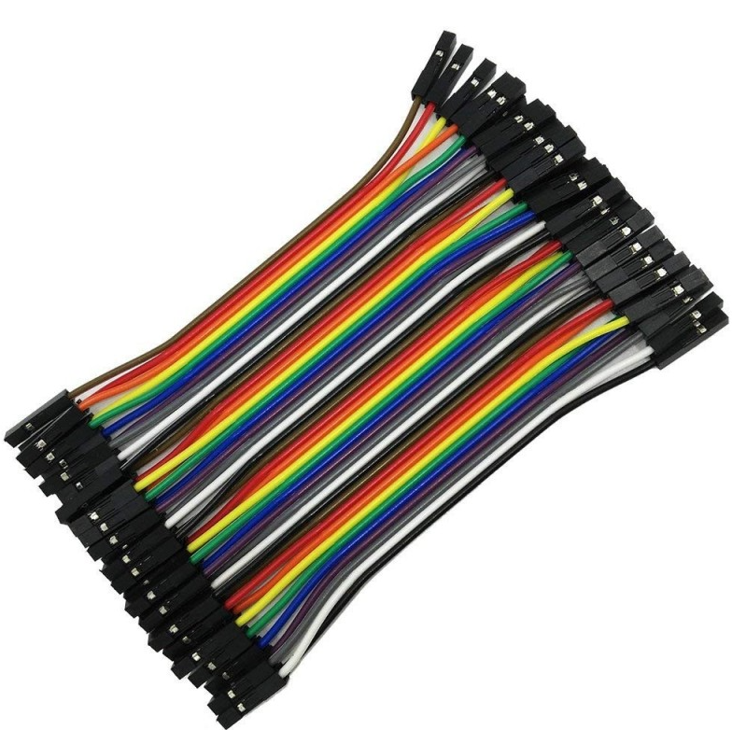

**F)Motor DC 3-6 V**

Operating voltage: 3-6V

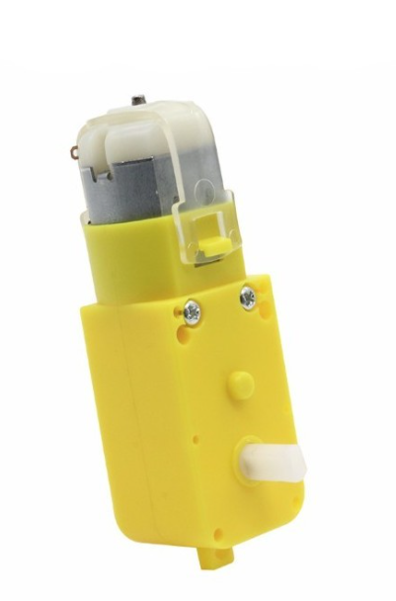The direction in which we polarize can define the direction in which the axis will rotate (trigonometric or inverse trigonometric direction)

Load current: 70 mA

Motor reduction: 1:48

