E-Commerce Sales Analysis in 2025
Chun Hei, POON
27th March, 2026
Content
1. Introduction 3
2. Methodology of Analysis 3
2.1 Categorical Performance 3
2.2 Dashboard Analysis 3
2.3 Regression Analysis 4
2.4 Revenue Forecasting Deep Learning Model 4
2.5 Product Clustering Model 5
3. Data Analysis 6
3.1 General Statistics of Products 6
3.2 Categorical Performance 7
3.3 Top Products 10
3.4 Product Feature Relationships 11
3.5 Product Segmentation 13
4. Suggestions to Business Directions 15
4.1 Categorical Expansion Directions 15
4.2 Seasonal Adjustment 15
4.3 Advertisement of Clothes 16
4.4 High-price Oriented 16
5. Acknowledgements 16
6. Conclusion 16
7. Citation 17

Introduction
E-commerce sales generated $1.5B in revenue last year, driving our largest business segment. Among six product categories, Books delivered the highest performance. Monthly revenue fluctuated between $119M-$129M. Strategic sales analysis will identify opportunities to accelerate growth and optimize business decisions.

Methodology of Analysis

Categorical Performance
We have built-up pivot tables and visuals in excel to analyse the number of products, average price, average review count, average review score, average year sales and average year revenue of each category. Then, we have also studied the monthly sales and revenue trend of each category to understand the seasonal variation.

Worksheet | Studied Feature by Category
2. category_general_analysis | Number of Products
 | Average Price
 | Average Review Count
 | Average Review Score
 | Average Year Sales
 | Average Year Revenue
3. category_monthly_sales | Monthly Sales Trend
4. categorical_monthly_revenue | Monthly Sales Revenue

Table 1 Excel Data Analysis

Dashboard Analysis
To provide a platform for other departments to understand the data easily, we have built 2 user-friendly dashboards to visualize the performance of each product. By leveraging Tableau, user can view the top products of each criterion in one page. Moreover, we have produced a categorical filter so that user can view the top productions among certain categories. On the other hand, we have produced a dashboard showing all features of a certain product. User can search for the performance of a product quickly by selecting the product. Both responsive designs support mobile/desktop access.

Dashboard Name | Feature
Top Product | - Top products of each criterion  - Categorical Filter  - Colored by category
Detail of a Product | - Performance of each criterion  - Select any product freely

Table 2 Tableau Dashboard

Regression Analysis
We have used linear regression model in sklearn library to study the relationships between numerous features, including review score, review count, price, total sales and total revenue. By looking on the seaborn regression plot, coefficients of the model, R-squared and p-value, we can conclude the relationship between each variable. More than that, we have also studied those relationships after separating the data by category, so we can analyse the situation within each category.

Explanatory Variable | Responsive Variable
Review Count | Review Score
Price | Review Score
Review Score | Total Sales
Review Score | Total Revenue
Price  Total Sales | Total Revenue

Table 3 Sklearn Linear Regression Models

Revenue Forecasting Deep Learning Model
The model consists of 4 inputs, including price, review score, review count and product category, forecasting the year revenue output. We have used one-hot-encoding for the only categorical variable, category. Then, we have split the data into training and testing dataset. Normalization scaler is used for the training dependent and independent variables, and transform the testing data by the trained scaler.

The deep learning model employs a compact feedforward neural network architecture: input features pass through an initial dense layer for feature transformation, followed by a second dense layer for hierarchical pattern learning, dropout regularization to prevent overfitting, and a final output dense layer producing revenue predictions.

The model is compiled with Adam optimizer and mean-squared error (MSE) loss for regression. Training uses Early Stopping callback monitoring validation MSE to prevent overfitting while optimizing revenue predictions.

To make a forecast with the model, we need at least a month of review count as a ratio to get an estimated yearly review count. Then, input the review score, estimated count, price and category will get the output forecast yearly revenue.

Hyperparameter Name | Hyperparameter Value
Training Size | 0.67
Test Size | 0.33
Neuron in Dense Layer 1 | 128
Neuron in Dense Layer 2 | 128
Dropout Proportion | 0.2
Adam Optimizer Learning Rate | 0.001
Callback Patience Round | 5
Batch Size | 64
Maximum Epochs | 50

Table 4 Hyperparameters of Revenue Forecasting Model

Product Clustering Model
In order to analyze our products accurately, we have used 3 clustering methods on R, to segmentize the products based on review score and the total revenue. The first one is hierarchical model by Ward’s method, while the second one is the k-means model. Both are using NbClust package to identify the best number of clusters. The third one is the Gaussian Mixture Model, selected base on the Bayesian Information Criterion. Then, we decided the model provided the most business insights by human intelligence. Lastly, we have made use of Akaike Information Criterion with forward stepwise model to use any combinations of price, review count and product category to predict the clusters belong to.

Finally, we have built a multinomial logistic regression model in R. When we are given a new product with price, the model will give probabilities of falling into each cluster. Hence, we can predict the final performance of the new product.
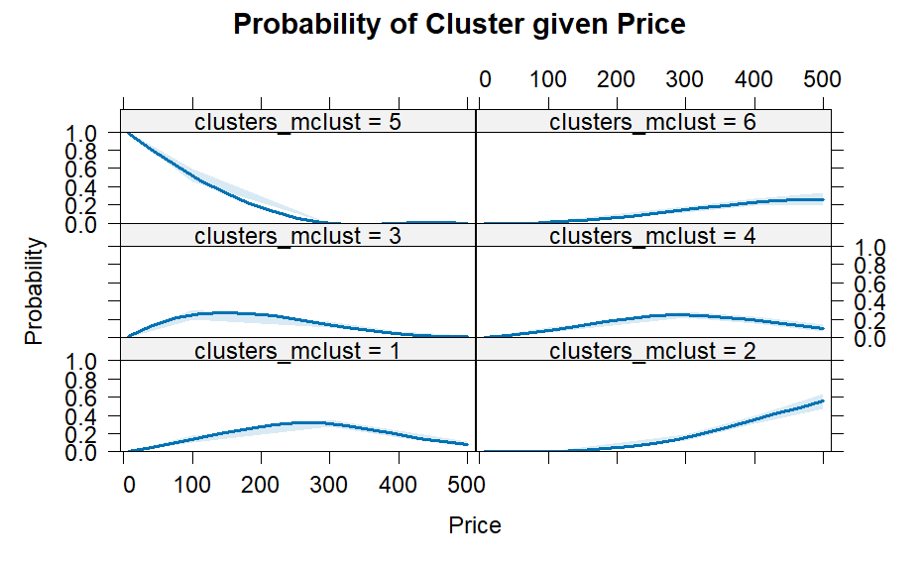
Figure 5 Probability of Cluster given Price

Data Analysis

General Statistics of Products
We have a total of 1000 products recorded in the ecommerce dataset. As we have done a customer survey for the product, the number of review and average review score is provided in the dataset. The following table shows some important statistics of each variable.
Statistics | Price | Review Score | Review Count | Total Sales | Total Revenue
Count | 1,000 | 1,000 | 1,000 | 1,000 | 1,000
Mean | 247.68 | 3.0 | 527 | 6,020 | 1,488,704
Standard Deviation | 144.61 | 1.2 | 282 | 992 | 920,996
Minimum | 7.29 | 1.0 | 1 | 2,972 | 47,485
25% Quartile | 121.81 | 2.0 | 284 | 5,392 | 706,656
50% Quartile | 250.92 | 3.1 | 543 | 5,992 | 1,406,161
75% Quartile | 373.44 | 4.0 | 772 | 6,680 | 2,198,797
Maximum | 499.86 | 5.0 | 999 | 9,151 | 3,812,159

Table 6 Summary Statistics of Products

Categorical Performance
To observe the performance of products by category, books have the highest sales (938 thousand) and revenue ($237 Million) in 2025. One of the main reasons is that books have the greatest number of product variety (157), slightly higher than the mean (143).

However, Home & Kitchen is the weakest category. It only has 125 products on sale, 742 thousand of total sales, and a total of 178 million revenue, which performs the worst among the 7 categories.

We have a good balance in different categories as the variation of performance of each category is quite small. Each category contributes a fair number of products, sales and revenue. In addition, the average count of review and review score are very close. The average review score falls between 2.9 to 3.1, which is the middle of 1 to 5 score scale.

Table 7 Category General Analysis

According to the sales data, we can observe different seasonal variations among different categories.

Category | Sales Pattern
Books | - First peak in February  - Lowest of the year in April  - Highest in October
Clothing | - Lowest in January  - Highest in March  - Another peak in August
Electronics | - Highest in January  - Sharp drop in August  - Slight improvement in October  - Lowest in December
Health | - Peak in April  - Lowest in June  - Highest in July  - Second trough in August
Home & Kitchen | - Lowest in February  - Peak in April  - Highest in November
Sports | - Highest in February  - Second peak in October  - Lowest in December
Toys | - Highest in February  - Trough in May  - Another peak in June  - Lowest in September
Total | - Peak in February  - Lowest in May  - Another peak in July  - Trough in September  - Highest in October

Table 8 Monthly Sales Pattern by Category

Table 9 Monthly Sales Data by Category

Chart 10 Monthly Sales Plot by Category

According to the revenue data, we can observe different seasonal variations among different categories.

Category | Revenue Pattern
Books | - Lowest of the year in August  - Highest in October
Clothing | - Lowest in January  - Highest in March
Electronics | - Highest in January  - Lowest in December
Health | - Highest in July  - Lowest in September  - Sharp jump in October
Home & Kitchen | - Lowest in February  - Peak in April  - Highest in August
Sports | - Highest in February  - Lowest in August  - Second peak in October
Toys | - Highest in February  - Lowest in September
Total | - Peak in April  - Lowest in June  - Highest in October

Table 11 Monthly Revenue Pattern by Category

Table 12 Monthly Revenue Data by Category

Chart 13 Monthly Revenue Plot by Category

Top Products
The most expensive product is Product_532, a book that price at $500. The highest sales product is electronic Product_224 with 9,121 sales, while the books, Product_306, generated $3.8 Million yearly revenue. For the review score, there were numerous products getting the highest 5.0 score.
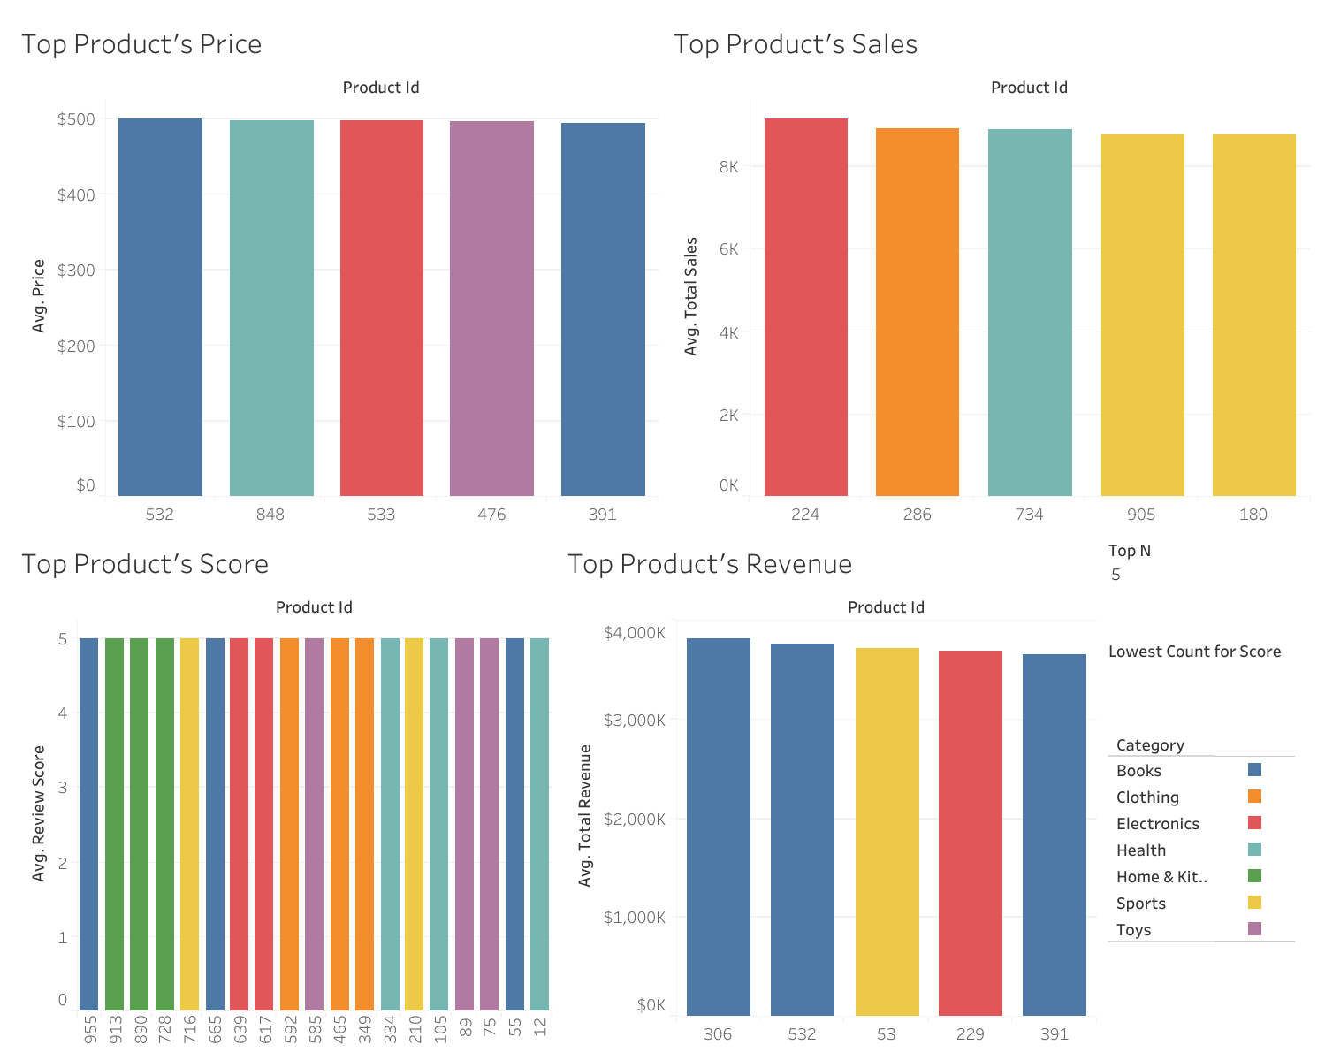
Chart 14 Top Product of each criterion

Product Feature Relationships
We have built up a total of 48 linear regression models by sklearn library in Python. Clothing is a special category that showing slightly significant relationships between review score and total sales, and the price-total sales pair. All other categories do not show significant relationships except the multiple regression of price and total sales against total revenue, as total revenue is the product of price and total sales. Although they exist a multiple relation, we still want to study the significance of each variable in additive relation. From the following table, we can see that the p-value for total sales are higher than that for price in most cases. It means that price is more important to earn a high revenue.

Dependent variable vs Independent variable | All Category | Books | Clothing | Electronics | Health | Home & Kitchen | Sports | Toys
Review Count vs Review Score | 0.3876 | 0.3527 | 0.9267 | 0.5151 | 0.1061 | 0.3204 | 0.4261 | 0.7913
Price vs Review Score | 0.3603 | 0.9624 | 0.7585 | 0.6151 | 0.6452 | 0.2249 | 0.1451 | 0.6776
Review Score vs Total Sales | 0.5657 | 0.3215 | 0.0687 | 0.8288 | 0.8961 | 0.4994 | 0.6687 | 0.8524
Review Score vs Total Revenue | 0.3776 | 0.7292 | 0.7205 | 0.7568 | 0.6760 | 0.2595 | 0.1710 | 0.6215
Price and Total Sales vs Total Revenue | 0 | 0 | 0 | 0 | 0 | 0 | 0 | 0
 | 0 | 0.0001 | 0.0439 | 0.0079 | 0.0004 | 0.0043 | 0.0011 | 0.0012
Price vs Total Sales | 0.6138 | 0.6226 | 0.0981 | 0.6045 | 0.7618 | 0.8097 | 0.8453 | 0.8509

Note: Red boxes mean p-value=0 (after machine rounding)
Orange means 0<p-value<=0.01
Yellow means 0.01<p=value<=0.05
Light Yellow means 0.05<p-value<=0.1
Table 15 P-value of Coefficient of Dependent Variables equal to 0

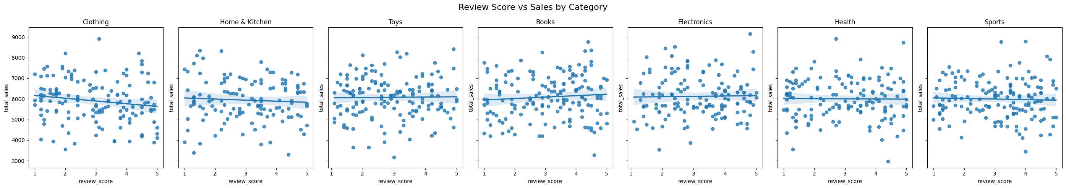
Chart 16 Review Score against Total Sales by Category

The regression model of review score against total sales for clothing shows a slightly negative relationship. It is interesting that the total sales are lower for the high rated clothes. By investigating the high rated clothes, since the review count are at least 120, the review score data should be accurate. The main reason of high review score products having low sales is the high price or low popularity.

Review Score against Total Sales for Clothing | Value
Slope | -133.42
Intercept | 6297.69
R-squared | 0.0238

Table 17 Regression Model of Review Score against Sales for Clothing

Product ID | Price | Review Count | Total Sales | Total Revenue
25 | 230.75 | 250 | 5,493 | 1,267,510
91 | 64.2 | 423 | 6,054 | 388,667
249 | 481.99 | 506 | 6,815 | 3,284,762
278 | 326.73 | 377 | 3,882 | 1,268,366
349 | 190.43 | 815 | 4,304 | 819,611
425 | 33.49 | 120 | 5,489 | 183,827
456 | 248.85 | 937 | 7,231 | 1,799,434
465 | 481.28 | 432 | 4,602 | 2,214,851
467 | 146.43 | 268 | 4,885 | 715,311
513 | 466.7 | 550 | 5,416 | 2,527,647
592 | 322.23 | 777 | 4,102 | 1,321,787
699 | 81.41 | 258 | 5,738 | 467,131
782 | 273.65 | 817 | 5,812 | 1,590,454
865 | 203.38 | 416 | 6,801 | 1,383,187
956 | 194.65 | 923 | 5,849 | 1,138,508

Table 18 Clothing Product Data with Rating greater than 4.5

For the price and total sales relationship, we thought a higher price must lead to a lower sale by basic economic principles. However, the research shows entirely different result as only clothes exhibit a significant negative relationship. From the regression plots below, all other regression line is almost horizontal. It means that the expensive product and cheap product share the same attractiveness level.

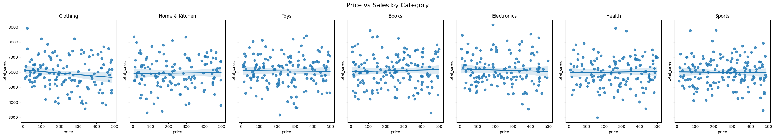
Chart 19 Price against Total Sales Plots by Category

Product Segmentation
The hierarchical and k-means model give 4 clusters after statistical modelling. However, it does not provide much business insights as it is just a combination of low or high review score and total revenue. On the other hand, the Gaussian Mixture Model gives a six-cluster model with equal size but variable shape of clusters.

Cluster | Characteristics
1 | Review Score below 2
2 | Review Score between 3 and 4 with high Revenue
3 | Medium low Revenue with Review Score between 2 and 4
4 | Lowest Revenue
5 | Review Score between 4 and 5
6 | Review Score between 2 and 3 with high Revenue

Table 20 Description of Clusters
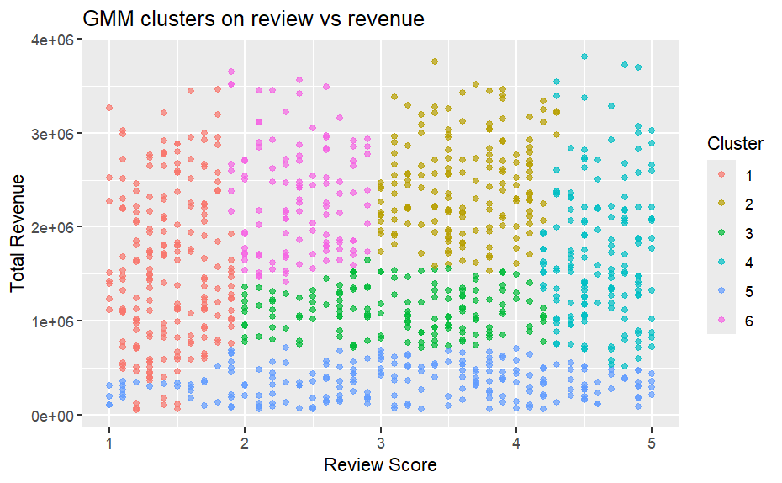
Chart 21 Product Clustering Plot

Suggestions to Business Directions

Categorical Expansion Directions
According to our research, Clothes and Home & Kitchen are the two lowest revenues category, which only contributes 12.6% and 12.0% revenue respectively. However, their corresponding ecommerce market shares are 19.7% and 12.5% respectively (Opensend, 2025). There are rooms for expansion to enjoy more profit in these 2 categories. More than that, we earn most in Books and Sports products. These 2 categories are not considered as necessity as Clothes and Home & Kitchen products. People will buy much less Books and Sports product during recession, so our business model is vulnerable. We must expand our business in Clothes and Home & Kitchen.

Seasonal Adjustment
From our data analysis, we can see the sales and revenue amount has a significant seasonal variation. We should operate sales campaigns with cheaper price and more discount in April and September, the 2 worst sales months. On the other hand, we can employ more part time staff in February, July and October to relieve supply chain pressure at high sales volume period.

In addition, we can advertise and launch discount sales campaigns according to the categorical monthly sales data variation. If we advertise the category in the high-sales period, we can get the major customer attention to earn the high-demand. On the other hand, launch discount sales campaigns in low-demand period will increase the sales and reduce the stocking cost and expired inventory loss.
Month | Discount Sales Campaign | Advertisement
January | Clothing | Electronics
February | Home & Kitchen | Sports
March | Electronics | Clothing
April | Toys | Health
May | Sports | Books
June | Health | Toys
July | Home & Kitchen | Health
August | Sports | Toys
September | Toys | Sports
October | Clothing | Books
November | Electronics | Home & Kitchen
December | Sports | Toys

Table 22 Suggestion of Marketing Direction each month

Lastly, the finance department can make use of the excess revenue in high months, like February, April and October, put them in short-term deposit time deposit or Treasury bills till poor months such as June and September. This will allow us to earn more interest while maintaining the liquidity.

Advertisement of Clothes
From the previous finding, clothes are the only category that exhibits a negative relationship between review score and sales, and the price-sales pair. It explained that several highly rated clothes are too expensive to the customers. We can make use of these features to organize some advertisement or discount campaign to encourage customers to buy these highly rated clothes, and avoid stop buying due to the high-price barrier, as other categories.

High-price Oriented
According to our previous finding, the price and sales volume have no significant relationship for all categories except clothes. At the meantime, price is a more crucial factor of revenue than sales. Hence, we can earn much more by selling more high-priced products, as the sales volume will not be hindered by the price.

Acknowledgements
The studied simulated dataset is provided by FAHMIDA on Kaggle. The URL is https://www.kaggle.com/datasets/fahmidachowdhury/e-commerce-sales-analysis.

Conclusion
We have found multiple business insights from our ecommerce sales dataset in 2025. Clothes and Home & Kitchen are 2 categories that we could expand our business. Moreover, we should pay attention to the seasonal variation of sales and revenue to adjust our advertisement, discount campaign, financing policies monthly. Furthermore, the special situation on clothes are somewhere we should be aware. Lastly, selling expensive products can increase our profit margins.

Citation
Opensend. (2025, December 24). 29 product categories popularity statistics for eCommerce stores. https://www.opensend.com/post/product-categories-popularity-statistics

