LockedMe

**Project Name:** LockedMe- FileSystem

**Product Specification and Functional Document**

**Create date: 28/05/2022**

Status: Prototype

Template Version: 1.0

Prepared by: Hari Prasanth R

Version History

* Version History is best captured by referencing the item being changed (e.g. enhancements, requirement changes etc

| Version # | Revision Date | Revised By | Change Description |
| --- | --- | --- | --- |
| 1.0 | 28-05-2022 | Hari Prasanth | Draft Version /Prototype Version |
| 1.1 |  |  |  |
| 1.2 |  |  |  |

Table of Contents

Project Specification

Version: 1.0 1

Prepared by: Hari Prasanth 1

1. Introduction Error! Bookmark not defined.

1.1 Project Context **Error! Bookmark not defined.**

1.1.1 Objective/Solution Statement **Error! Bookmark not defined.**

1.2 Project Definition **Error! Bookmark not defined.**

1.2.1 In Scope **Error! Bookmark not defined.**

1.2.3 Project Dependencies **Error! Bookmark not defined.**

1.2.2 Project Assumptions **Error! Bookmark not defined.**

2. Functional Requirements: Error! Bookmark not defined.

2.1 Product Execution Manual **Error! Bookmark not defined.**

2.2 Input/Output and Expected Flow **Error! Bookmark not defined.**

Appendix A: Technical Details with Repository Details Error! Bookmark not defined.

Project Objectives

LOCKED ME PROTOTYPE APPLICATION

This project delivers the basic functionality of a file system.

Listing of files of a local directory.

Copying a file from one directory to another.

Deleting a file from a directory.

This project shall be upgraded at future requirements.

Project Definition

Version 1.0 is intended as a demo or the Prototype model.

Amid the timelines and the initial release this project is aimed at performing basic file system handling with few features in scope as below.

And the Project is intended for command line execution flow.

In Scope

We aim at performing the basic operations as below

* **Works on same Server/System where the product is deployed (through command line/shell, etc.)**
* **Get all the files from the path specified. (Not subfolder files)**
* **Copy file from one location to another location. (Not subfolder files)**
* **Deleting the file.**
* **Smooth application to be run without any fault or code issue.**

##### The Project is aimed to upgrade the after the initial release. (Prototype)

##### The requirement modification or enhancements shall be taken in the future release.

Project Dependencies

## RAM: At least 128 MB

## Disk Space: 124 MB for JRE, 2 MB for Java Update

## Processor: Minimum Pentium 2 266 MHz processor

## Any terminal like CMD, shell etc. to compile and run java program.

## By default CMD is available in windows OS while shell is available in Linux based OS.

## Install JDK 1.8 and above version.

Project Assumption

## Assumption- The above requirements needs to be met, the steps of executions are to be known or followed based on the document provided along with the project scope.

Product Execution Manual.

This below manual specifies for windows model the same can be followed accordingly on the system deployed but sequence of inputs remain same.

* Run the program

Console must display (**LOCKED ME PROTOTYPE APPLICATION STARTED**)

* It displays 5 operation that are available and asks to choose among them

**PLEASE ENTER THE INPUT FOR REQUIRED PROCESS**

**1 - LIST ALL FILE**

**2 - COPY A FILE**

**3 - DELETE A FILE**

**4 - MAIN MENU**

**5 - EXIT APPLICATION**

Enter the option to proceed further

(input value for process required)

Any other input shall result in

Invalid entry Re-enter the input

1. LIST ALL FILE (Display all files)

Once you enter 1- it should display menu as **Display Files**

* **Input path = Specify the readable permission folder**

Enter the path to list all files

(input value for path)

* **Possible output**
  + **Displays all files.**
  + This Directory is not present please check the path
  + **If no files are present then it displays as**
  + No files present at the mentioned directory

1. Copy a file

Once you enter 2- it should display menu as **Copy File**

* **Input path = Specify the readable permission folder**
* **Output path = Specify the writable and readable permission folder**
* **Possible output**

**File copied successfully”.**

**The system cannot find the file specified**

* + ENTER SOURCE DIRECTORY
  + Input
  + ENTER INPUT FILE NAME
  + Input
  + ENTER DESTINATION DIRECTORY
  + Input
  + ENTER OUTPUT FILE NAME
  + Input

FILE COPIED SUCCESSFULY

1. Delete a file

Once you enter 3- it should display

**Input path = Specify the readable permission folder**

* + Enter the path to delete the file
  + input
  + Input file name= Specify the file name
  + Enter the file name to be deleted
  + input
  + ERROR... FILE NOT FOUND, TRY AGAIN
  + Type yes to confirm the action
  + input

FILE DELETED

Input/ Output and Expected Flow

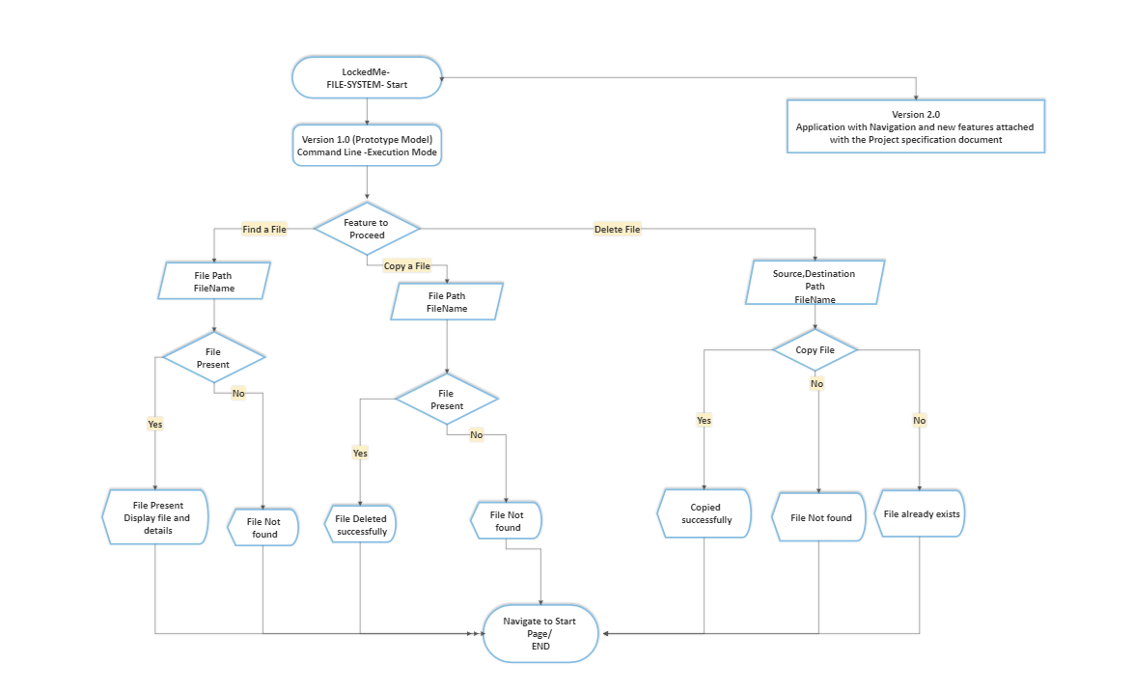

Technical Details and Repository Details

This Data is known to be technical and hence not intended to business understanding or explanation.

The Project is built on Java –

## JDK 1.8.

## Code is written using basic java coding with usage of utility libraries.

## This is an executable Program file.

## This doesn’t require any application server to be run upon.

## Internally uses concepts of File System, Scanners, Exceptional handling etc.

The current release and upcoming releases shall be found in Git repository location mentioned below.

Please contact to the below email for any queries.

r.hariprasanth253@gmail.com