Report: HW2-SelectiveSearch

# -CSCI 677, Hardik Prajapati (2678294168)

3.1: We implement Selective Search Algorithm on 3 input images with 2 strategies. We add Graph Segmentation with K=200, sigma=0.8 parameters to Selective Search algorithm. The two strategies implemented are

* Color Strategy
* All (color, texture, size, fill)

We generate proposal boxes for each image. Then IoU is calculated between each proposal box and GroundTruth box. We store the best proposal box, having IoU>=0.5. We then calculate recall score of GT boxes by computing the fraction of GT boxes that are overlapped with at least one proposal box with Intersection Over union (IoU)>=0.5

3.2/3.3: For each strategy, we display and store 2 outputs for each image:

* GT boxes & Proposal boxes
* GT boxes & Best Proposal boxes

Below are the results obtained.

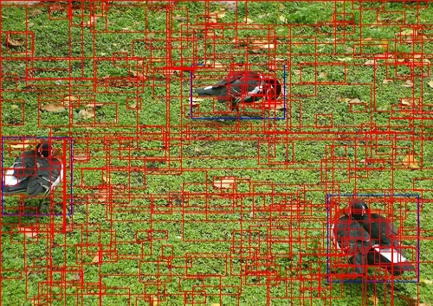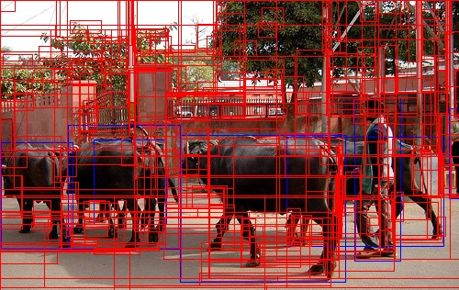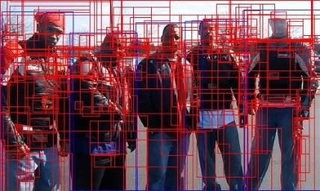**Color Strategy**

Fig1. Proposal Windows for Color Strategy

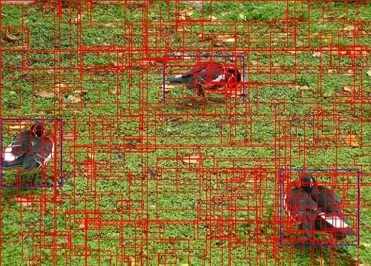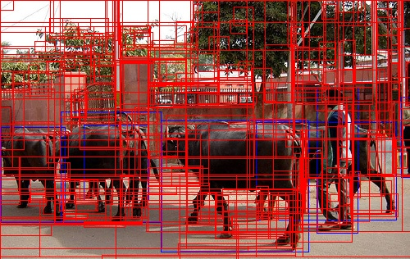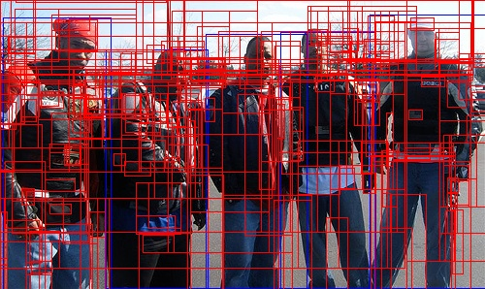**All(Color, Texture, Fill, Size) Strategy**

Fig2. Proposal Windows for All (Color, Texture, Size, Fill) Strategy

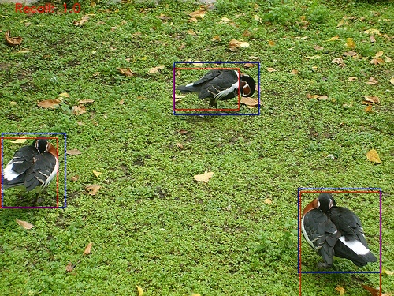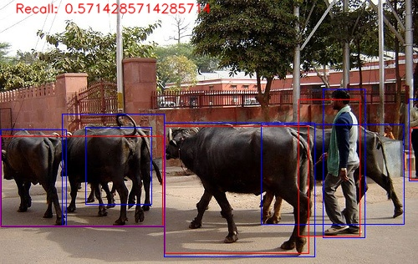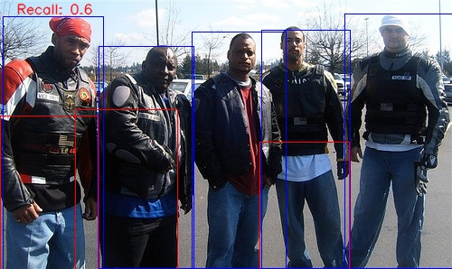**Color Strategy**

Recall = 0.6 Recall = 0.57 Recall = 1

Fig3. Best Proposal window & GT box for Color Strategy

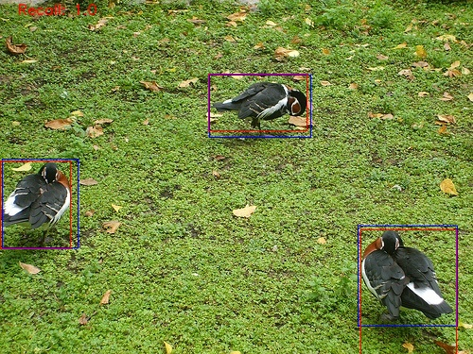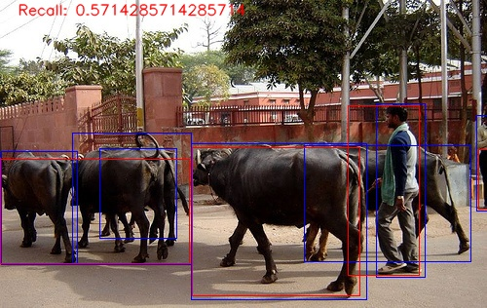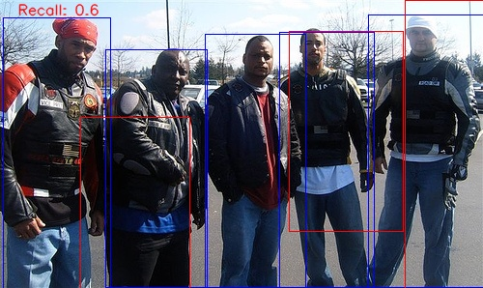**All(Color, Texture, Fill, Size) Strategy**

Recall = 0.6 Recall = 0.57 Recall = 1

Fig4. Best Proposal window & GT box for All (Color, Texture, Size, Fill) Strategy

Observations:

* Recall score for respective image is same for both the strategy. Although the positioning of the best Proposal window is different.
* The best proposal window is better positioned when Strategy = All on comparison with Strategy = Color.
* For Image 1 (5 people with black jackets):
  + The best proposal windows cover only a part of each man (lower half body) in case of Color strategy. Only 3 proposal windows have IoU > =0.5. From human interpretation, can’t say it’s a person from the captured window
  + 2 of the three best proposal windows capture the respective person more significantly in case of All strategy. From human interpretation (human classifier), one can say that it’s a person for those 2 proposal windows.
* For Image 2 (Buffalos & person):
  + Color strategy: The best proposal windows have captured all the 3 buffalos in the front as one. It captures the front man except his head.
  + All strategy: It has the same result as of the color strategy. The only significant difference that can be noticed is it also captures the front man along with his head.
  + For both the strategies, it has not been able to differentiate between different buffalos. Also, for the man standing on the side, has been captured with only his black pants in both cases.
* For Image 3 (3 ducks):
  + Color Strategy: The best proposal windows captures all the 3 ducks. Although, with the middle duck, the window leaves out the duck’s head
  + All Strategy: The best proposal windows captures all the 3 ducks in this case too. Only difference being, it does not leave out the head of middle duck as in the case of color strategy.

Conclusion:

* The Selective Search Algorithm proposes a lot of bounding boxes, but very few matches with the ground truth boxes with IoU values of at least 0.5.
* All strategy behaves better in positioning of bounding boxes in comparison to color strategy. Although the recall values are same for both the strategy.
* With less overlapping objects, the Selective Search algorithm works fine.
* When the identical/similar objects in the frame overlaps/coincides with each other, the Selective Search algorithm cannot distinguish between them.