Hardik Prajapati

USC ID: 2678294168

PyTorch, LeNet

HomewoRK 4 rEPORT

CSCI 677

|  |  |  |  |
| --- | --- | --- | --- |
| **Parameter** | **Main Experiment** | **Variation 1- Batch Normalization** | **Variation 2- L2 regularization** |
| **Epochs** | **100** | **100** | **100** |
| **Initial learning rate** | **0.001** | **0.001** | **0.001** |
| **Batch size** | **128** | **128** | **128** |
| **Optimizer** | **Adam(decay_rate=0)** | **Adam(decay_rate=0)** | **Adam(decay_rate=1e-5)** |
| **Layer1** | **Conv—Relu--maxpooling** | **Conv—batchNorm2d--Relu--maxpooling** | **Conv—Relu--maxpooling** |
| **Layer2** | **Conv—Relu--maxpooling** | **Conv—batchNorm2d--Relu--maxpooling** | **Conv—Relu--maxpooling** |
| **Layer3** | **FC--Relu** | **FC—batchNorm1d--Relu** | **FC--Relu** |
| **Layer4** | **FC--Relu** | **FC—batchNorm1d--Relu** | **FC--Relu** |
| **Layer5** | **FC-logSoftMax** | **FC-logSoftMax** | **FC-logSoftMax** |

1. **For your main experiment setting, show the evolution of training losses and validation losses with multiple steps.**

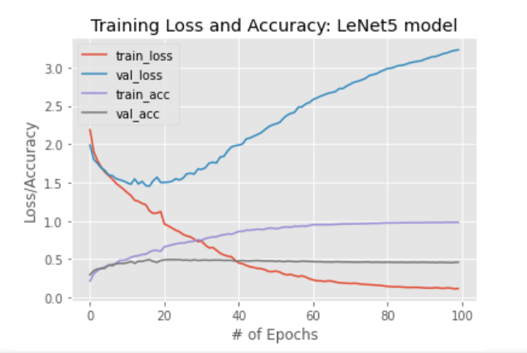

1. **Show the confusion matrix and per-class classification accuracy for this setting.**

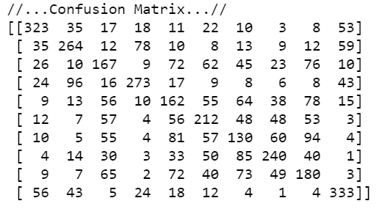

|  |  |
| --- | --- |
| **Class** | **Per-class classification accuracy** |
| **Airplane** | **0.646** |
| **truck** | **0.528** |
| **bird** | **0.334** |
| **car** | **0.546** |
| **cat** | **0.324** |
| **deer** | **0.424** |
| **dog** | **0.26** |
| **horse** | **0.48** |
| **monkey** | **0.36** |
| **ship** | **0.666** |

**Classification Report:**

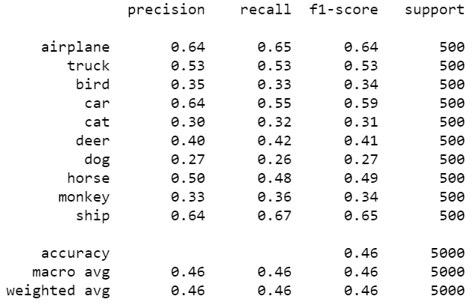

1. **Show some examples of failed cases, with some analysis if feasible.**

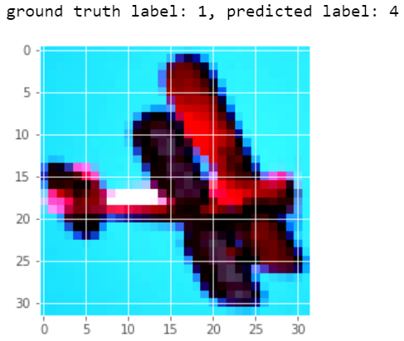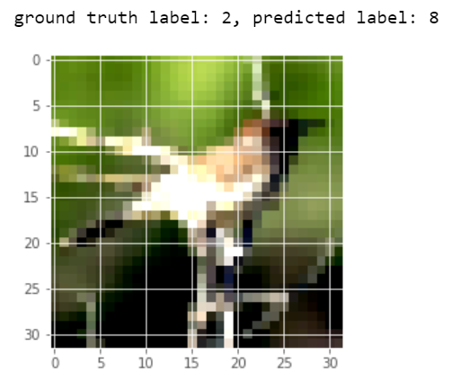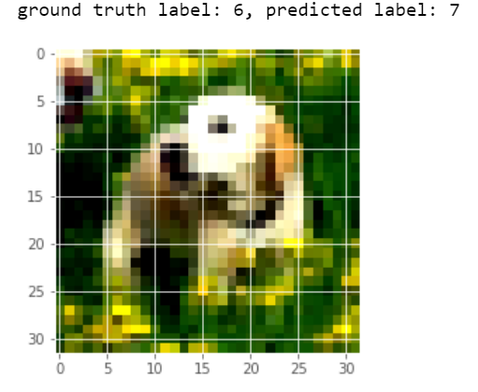

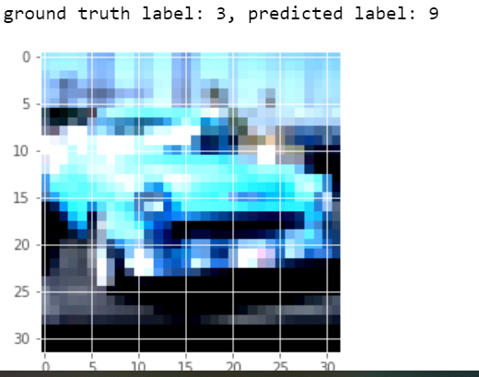

In general, macro accuracy for class prediction is low and hence we are getting wrong predictions in general.

Also We have re-sized from 96*96 to 32*32, hence loosing key features

Some of the background attributes are being learned and wrongly interpreted.

1. **Compare your results for the variations with the main experiment setting.**

|  |  |  |
| --- | --- | --- |
| **Main Experiment** | **Variation 1-Batch Normalization** | **Variation 2- L2 regularization** |
|  |  |  |
|  |  |  |
|  |  |  |

**Observations:**

1. **Training time for the network was slightly more for Variation 1**
2. **The model starts overfitting after 18 epochs in Main settings; 10 epochs in Variation-1; 19 epochs in Variation-2**
3. **All the 3 settings perform and learn best for ‘Airplane’, ‘car’ and ‘ship’ classes.**
4. **All the 3 settings perform the worst on ‘dog’ class.**
5. **It can be easily seen that Batch Normalization speeds up the learning of the network.**
6. **L2-Normalization helps to smoothly settle the validation error until the model starts overfitting.**