NAME  Harvey Christian Pacleb |  | DATE  February 4, 2017 | SCORE
SCHEDULE  10:00 A.M. – 1:00 P.M. | SCORE |  | SCORE

LABORATORY EXERCISES
RECURSION

OBJECTIVES:
- Understand recursion and its parts
- Use recursion to solve programming problems

PROCEDURE:
- Encode the C++ program below.
- Save as rec1.cpp,and rec2.cpp, respectively.
- Compile and run the program by pressing Ctrl + F9.
- For each syntax or logical error encountered in the given program, do the following:
- Correct the error
- Recompile the program
- Repeat step 4 until no errors are encountered in the program.
- Illustrate the output of the modified program.

Program No. 1

#include <iostream>
Output:

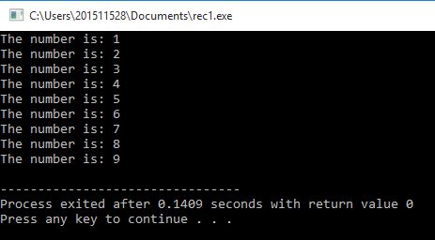

using namespace std;

void numberFunction(int i) {
cout << "The number is: " << i << endl;
i++;
if(i<10) {
numberFunction(i);
}
}

int main() {

int i = 1;
numberFunction(i);

return 0;
}

Program No. 2

#include <iostream>
using namespace std;

int factorial(int);

int main() {
int n;
cout<<"Enter a number to find factorial: ";
cin>>n;
cout<<"Factorial of "<<n<<" = "<<factorial(n);
return 0;
}
Output:
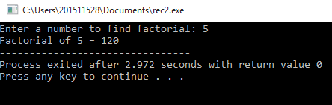

int factorial(int n) {
if (n>1) {
return n*factorial(n-1);
}
else {
return 1;
}
}

Supplementary Problem

- A recursive function that sums up the 10 integers in an array.

Program:

#include <iostream>
using namespace std;
int sum(int array[], int size){
if (size==0){
return *array;
}
else{
return *array + sum(++array , size-1);
}
}

int main (){
int i;
int arr[10];
for (i=0 ;i<10;i++){
cout << "Enter array " << i+1 <<" : "<< endl;
cin >> arr[i];
}
cout << "The sum of the array is : " << sum(arr, 9);
return 0;
}

Output:

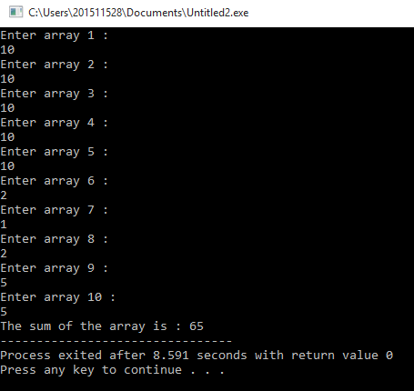

- A recursive function to produce the Fibonacci number for a given index in the series.
Use the function int fibonacci(int n)

Program:

#include <iostream>
using namespace std;
int fibonacci(int n){
if(n==0){
return 0;
}
if(n==1){
return 1;
}
else{
return fibonacci(n-1) + fibonacci(n-2);
}
}

int main (){
int n;
cout << "Enter n: ";
cin >> n;
cout << "Fibbonaci of " << n << " is : " << fibonacci(n) << endl;
return 0;
}

Output:
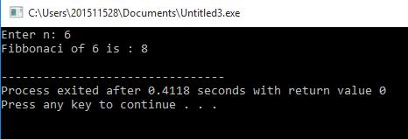

- A recursive function which raises its first parameter to the power of its second parameter.
Use the function int power(int number, int power)

Program:

#include<iostream>
using namespace std;
int pow(int number,int power){
if (power==1){
return number;
}
else{
return number*pow(number,power-1);
}
}

int main (){
int num , exp;
cout << "Enter number: ";
cin >> num;
cout << "Enter exponent: ";
cin >> exp;
cout << "Result: " << pow(num,exp) << endl;
return 0;
}

Output:
