Prepared for R4

Glorieta Gardens Buildings 7 and 8 Water Billing Evidence Packet
Pre-vacancy, vacancy and rehab, and post-rehab comparison
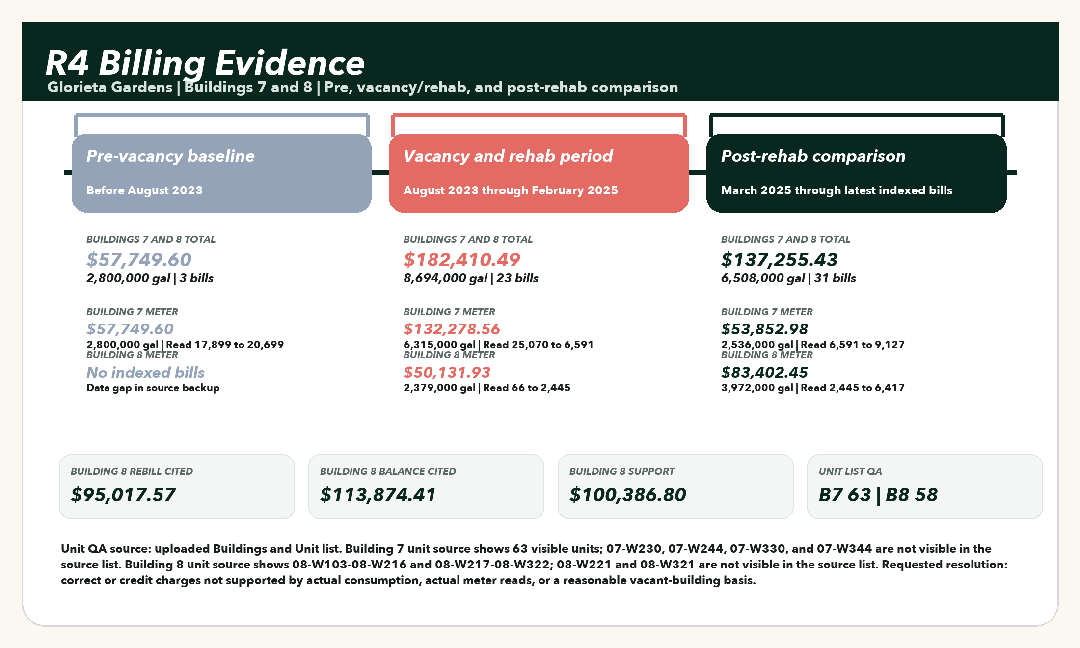
Purpose: show the billing chronology in order, compare Building 7 and Building 8 before, during, and after the vacancy and rehabilitation period, and isolate the Building 8 billing evidence supporting the correction request.
Evidence item | Value | Why it matters
Formal rebill cited | $95,017.57 | Cited in the July 23, 2026 dispute package.
Unpaid balance cited | $113,874.41 | Balance cited for the disputed Building 8 account.
Building 8 dispute support | $100,386.80 | Sum of 22 Building 8 account-period records in the dispute window.
Building 8 gallons | 4,764,000 gal | Total Building 8 usage in the dispute support.
Indexed water charges | $39,229.56 | Water charge category extracted from available WASD statement backup.
Indexed sewer charges | $55,474.80 | Sewer charge category extracted from available WASD statement backup.

Buildings 7 and 8 by phase
The comparison below is limited to Building 7 and Building 8. The absence of pre-vacancy Building 8 bills is shown as a data gap, not filled with an assumed number.
Building and meter | Unit context | Pre-vacancy  before Aug 2023 | Vacancy and rehab  Aug 2023-Feb 2025 | Post-rehab  Mar 2025-latest
Building 7 / North  Acct 1692380502  Meter 1800224848 | 63 visible units from 07-W123 through 07-W345 | $57,749.60  2,800,000 gal  3 bills | $132,278.56  6,315,000 gal  12 bills | $53,852.98  2,536,000 gal  15 bills
Building 8 / 13200 Alexandria  Acct 2745714336  Meter 61302354 | 58 visible units from 08-W103 through 08-W322 | No indexed bills | $50,131.93  2,379,000 gal  11 bills | $83,402.45  3,972,000 gal  16 bills

Building 7 monthly meter chronology
This table is limited to Account 1692380502, Meter 1800224848. It shows the available Building 7 records in chronological order.
Service period | Gallons | Current charges | Meter reads | Phase
2023-02-24 to 2023-03-28 | 949,000 gal | $19,570.87 | 17,899 to 18,848 | Pre-vacancy
2023-03-28 to 2023-04-26 | 910,000 gal | $18,771.77 | 18,848 to 19,758 | Pre-vacancy
2023-04-26 to 2023-05-25 | 941,000 gal | $19,406.96 | 19,758 to 20,699 | Pre-vacancy
2023-09-28 to 2023-10-27 | 819,000 gal | $16,907.20 | 25,070 to 25,889 | Vacancy/rehab
2023-10-27 to 2023-12-01 | 956,000 gal | $19,714.30 | 25,889 to 26,845 | Vacancy/rehab
2023-12-01 to 2024-01-03 | 803,000 gal | $16,579.36 | 26,845 to 27,648 | Vacancy/rehab
2024-01-31 to 2024-02-29 | 190,000 gal | $4,019.12 | 28,322 to 28,512 | Vacancy/rehab
2024-02-29 to 2024-03-27 | 0 gal | $1,498.88 | 28,512 to 28,512 | Vacancy/rehab
2024-05-06 to 2024-06-05 | 796,000 gal | $16,435.93 | 997 to 1,793 | Vacancy/rehab
2024-07-30 to 2024-08-27 | 707,000 gal | $14,612.34 | 3,128 to 3,835 | Vacancy/rehab
2024-08-27 to 2024-09-27 | 670,000 gal | $13,854.22 | 3,835 to 4,505 | Vacancy/rehab
2024-09-27 to 2024-10-29 | 676,000 gal | $13,977.16 | 4,505 to 5,181 | Vacancy/rehab
2024-10-29 to 2024-12-02 | 562,000 gal | $11,641.33 | 5,181 to 5,743 | Vacancy/rehab
2025-01-29 to 2025-02-28 | 102,000 gal | $2,216.02 | 6,455 to 6,557 | Vacancy/rehab
2025-02-28 to 2025-03-31 | 34,000 gal | $822.70 | 6,557 to 6,591 | Vacancy/rehab
2025-03-31 to 2025-04-29 | 34,000 gal | $822.70 | 6,591 to 6,625 | Post-rehab
2025-04-29 to 2025-05-29 | 126,000 gal | $2,707.77 | 6,625 to 6,751 | Post-rehab
2025-05-29 to 2025-07-01 | 74,000 gal | $1,642.30 | 6,751 to 6,825 | Post-rehab
2025-07-01 to 2025-08-04 | 77,000 gal | $1,703.78 | 6,825 to 6,902 | Post-rehab
2025-08-04 to 2025-08-29 | 33,000 gal | $802.22 | 6,902 to 6,935 | Post-rehab
2025-08-29 to 2025-09-29 | 52,000 gal | $1,191.53 | 6,935 to 6,987 | Post-rehab
2025-09-29 to 2025-10-28 | 62,000 gal | $1,396.43 | 6,987 to 7,049 | Post-rehab
2025-10-28 to 2025-12-01 | 120,000 gal | $2,584.83 | 7,049 to 7,169 | Post-rehab
2025-12-01 to 2026-01-02 | 203,000 gal | $4,285.48 | 7,169 to 7,372 | Post-rehab
2026-01-02 to 2026-01-28 | 202,000 gal | $4,265.00 | 7,372 to 7,574 | Post-rehab
2026-01-28 to 2026-02-24 | 225,000 gal | $4,736.26 | 7,574 to 7,799 | Post-rehab
2026-02-24 to 2026-03-31 | 317,000 gal | $6,621.33 | 7,799 to 8,116 | Post-rehab
2026-03-31 to 2026-05-05 | 333,000 gal | $6,949.16 | 8,116 to 8,449 | Post-rehab
2026-05-05 to 2026-06-01 | 298,000 gal | $6,232.01 | 8,449 to 8,747 | Post-rehab
2026-06-01 to 2026-06-29 | 380,000 gal | $7,912.18 | 8,747 to 9,127 | Post-rehab

Building 8 monthly meter chronology
This table is limited to Account 2745714336, Meter 61302354. It shows the indexed monthly support used for the Building 8 dispute amount, in chronological order.
Service period | Gallons | Current charges | Meter reads | Phase
2024-04-09 to 2024-05-02 | 216,000 gal | $4,551.86 | 66 to 282 | Vacancy/rehab
2024-05-02 to 2024-06-03 | 216,000 gal | $4,551.86 | 282 to 498 | Vacancy/rehab
2024-06-03 to 2024-07-03 | 216,000 gal | $4,551.86 | 498 to 714 | Vacancy/rehab
2024-07-03 to 2024-08-01 | 216,000 gal | $4,551.86 | 714 to 930 | Vacancy/rehab
2024-08-01 to 2024-09-03 | 216,000 gal | $4,551.86 | 930 to 1,146 | Vacancy/rehab
2024-09-03 to 2024-10-01 | 216,000 gal | $4,551.86 | 1,146 to 1,362 | Vacancy/rehab
2024-10-01 to 2024-11-01 | 216,000 gal | $4,551.86 | 1,362 to 1,578 | Vacancy/rehab
2024-11-01 to 2024-12-04 | 216,000 gal | $4,551.86 | 1,578 to 1,794 | Vacancy/rehab
2024-12-04 to 2025-01-02 | 217,000 gal | $4,572.35 | 1,794 to 2,011 | Vacancy/rehab
2025-01-02 to 2025-02-03 | 217,000 gal | $4,572.35 | 2,011 to 2,228 | Vacancy/rehab
2025-02-03 to 2025-03-04 | 217,000 gal | $4,572.35 | 2,228 to 2,445 | Vacancy/rehab
2025-03-04 to 2025-04-04 | 217,000 gal | $4,572.35 | 2,445 to 2,662 | Post-rehab
2025-04-04 to 2025-05-01 | 217,000 gal | $4,572.35 | 2,662 to 2,879 | Post-rehab
2025-05-01 to 2025-06-03 | 217,000 gal | $4,572.35 | 2,879 to 3,096 | Post-rehab
2025-06-03 to 2025-07-01 | 217,000 gal | $4,572.35 | 3,096 to 3,313 | Post-rehab
2025-07-01 to 2025-08-07 | 217,000 gal | $4,572.35 | 3,313 to 3,530 | Post-rehab
2025-08-07 to 2025-09-04 | 217,000 gal | $4,572.35 | 3,530 to 3,747 | Post-rehab
2025-09-04 to 2025-10-02 | 217,000 gal | $4,572.35 | 3,747 to 3,964 | Post-rehab
2025-10-02 to 2025-11-04 | 217,000 gal | $4,572.35 | 3,964 to 4,181 | Post-rehab
2025-11-04 to 2025-12-08 | 217,000 gal | $4,572.35 | 4,181 to 4,398 | Post-rehab
2025-12-08 to 2026-01-06 | 216,000 gal | $4,551.86 | 4,398 to 4,614 | Post-rehab
2026-01-06 to 2026-02-02 | 216,000 gal | $4,551.86 | 4,614 to 4,830 | Post-rehab
2026-02-02 to 2026-03-04 | 186,000 gal | $3,937.16 | 4,830 to 5,016 | Post-rehab
2026-03-04 to 2026-04-03 | 70,000 gal | $1,560.34 | 5,016 to 5,086 | Post-rehab
2026-04-03 to 2026-05-05 | 549,000 gal | $11,374.95 | 5,086 to 5,635 | Post-rehab
2026-05-05 to 2026-06-01 | 359,000 gal | $7,481.89 | 5,635 to 5,994 | Post-rehab
2026-06-01 to 2026-06-29 | 423,000 gal | $8,793.24 | 5,994 to 6,417 | Post-rehab

Formal request for corrected billing and credit
To: City of Opa-locka Public Works Department and Miami-Dade Water and Sewer Department
Re: Glorieta Gardens - Account 2745714336, Meter 61302354, Building 8 / 13200 Alexandria Drive
Dear Public Works and WASD Billing Review Team,
We are requesting a corrected billing review and credit for the Building 8 water and sewer account at Glorieta Gardens. The disputed period covers the vacancy and rehabilitation window beginning in April 2024 and continuing through January 2026, when Building 8 was not operating as an occupied residential building.
The owner-side record shows that the account was billed using estimated usage of approximately 216,000 gallons per month during a period when ordinary residential consumption could not have occurred. The July 23, 2026 dispute letter identifies a $95,017.57 retroactive rebill and a $113,874.41 unpaid balance. The available billing statement backup shows 4,764,000 gal and $100,386.80 in current charges tied to Account 2745714336 within the dispute window.
Our request is straightforward: please remove charges that are not supported by actual consumption, actual meter reads, or a reasonable service-location consumption basis for the period when the building was condemned, vacant, and under rehabilitation. Where actual reads are unavailable, please apply the corrected-billing principles in WASD's rules using actual consumption from a comparable service-location period or average anticipated consumption appropriate to a vacant building, not an occupied multifamily building.
We also request the meter-change work order, installation date, starting register reading, read history, estimate basis, adjustment worksheet, payment ledger, late charge ledger, and any internal investigation notes used to support the rebill.
Until the review is complete, please suspend any past-due classification, late charge escalation, collection action, discontinuance process, or adverse account action related to the disputed estimated amount.
Respectfully,
R4

