APAS Consulting | OneWater.ai | ProjOS Water Intelligence

Glorieta Gardens Building 8 Water Billing Dispute Chronological Evidence Packet
Account 2745714336 | Meter 61302354 | April 2024 through January 2026
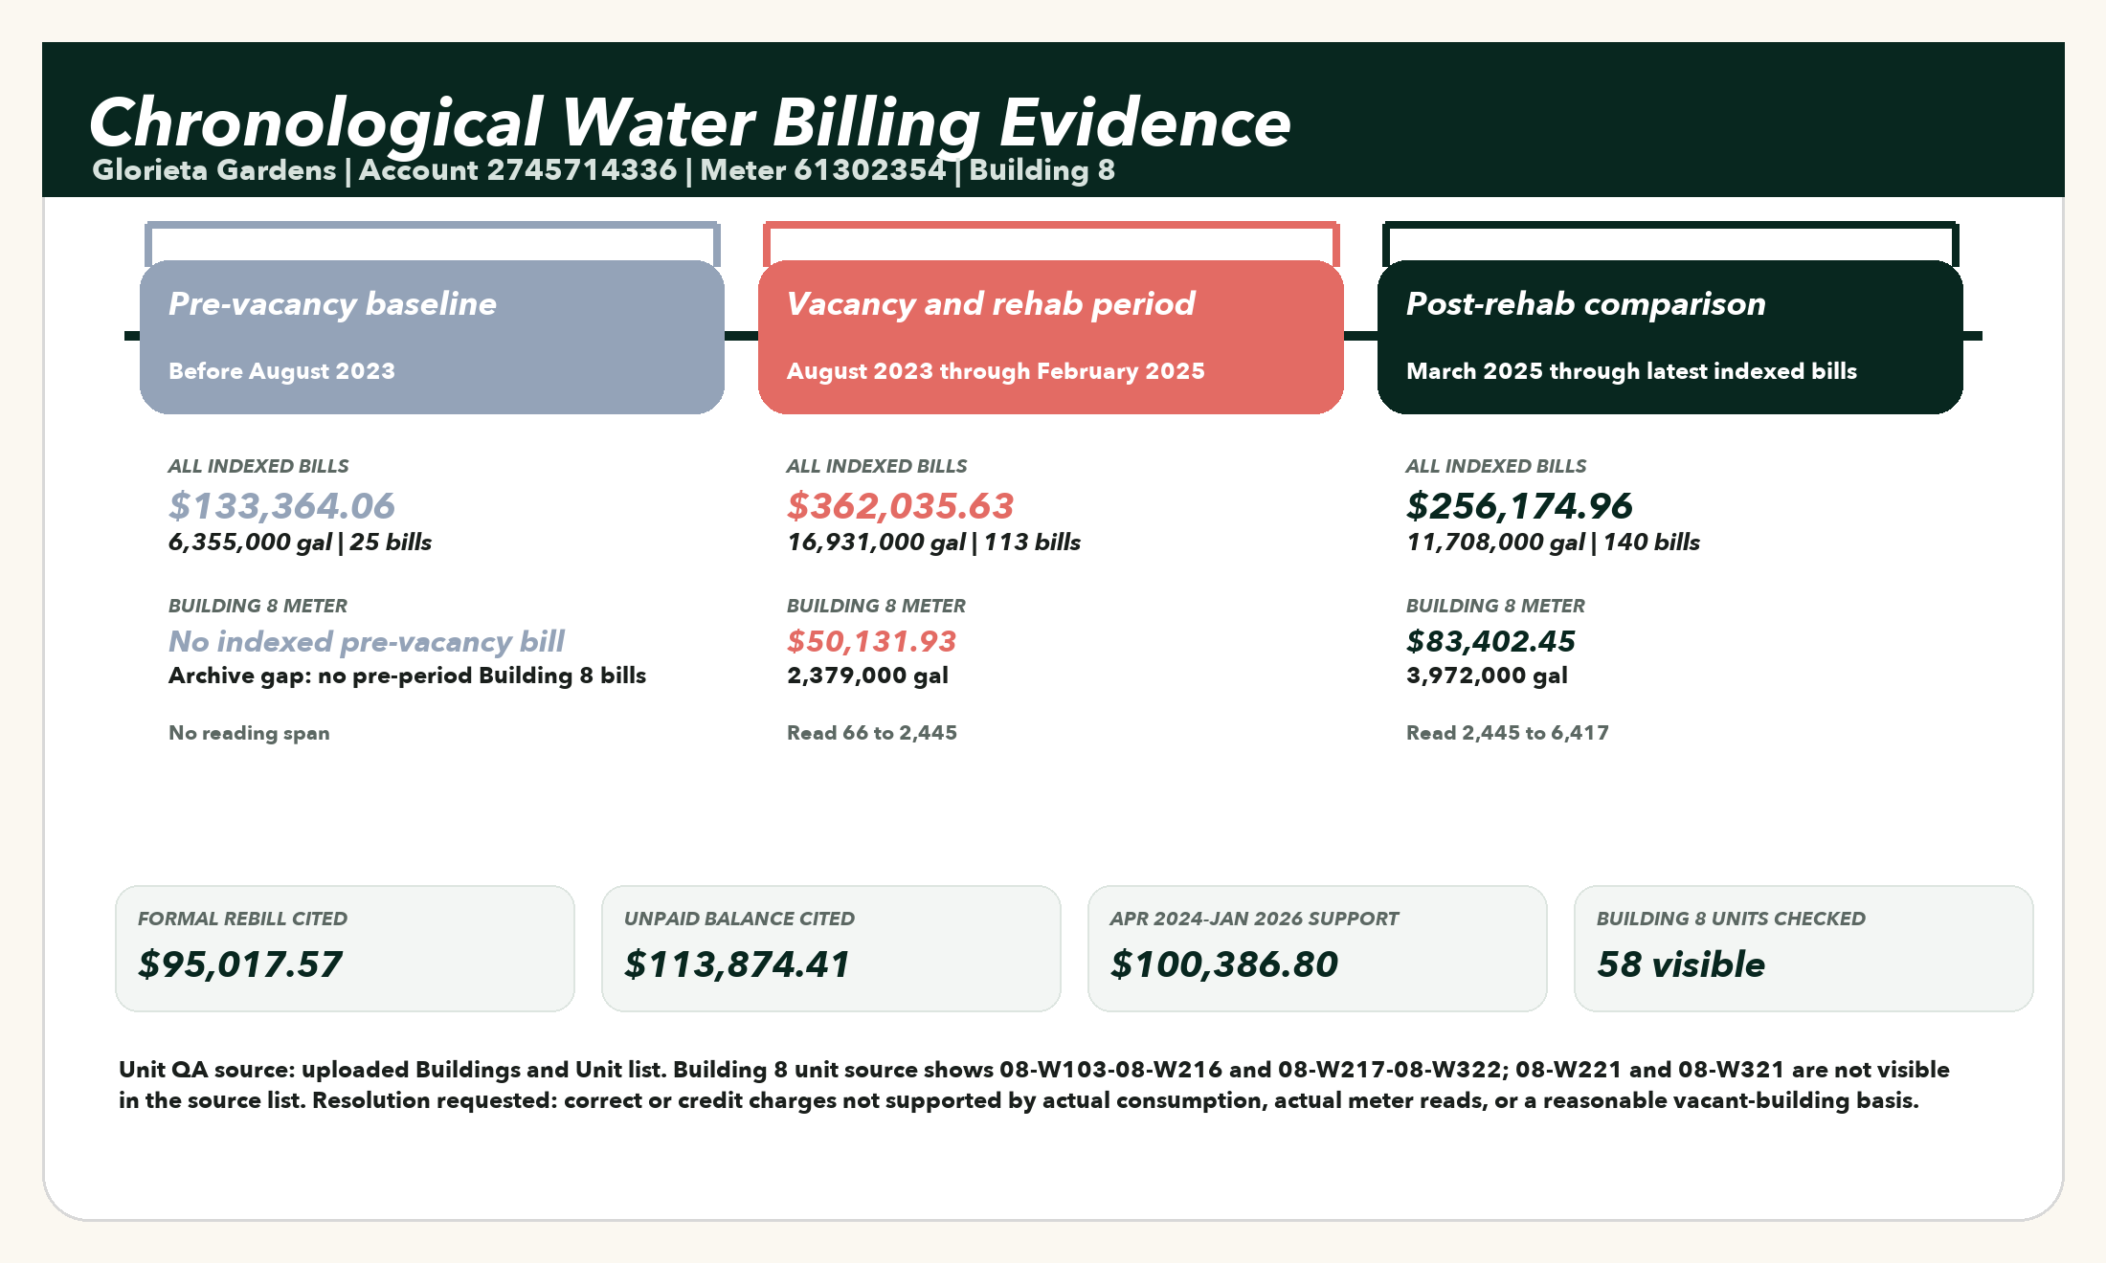
Purpose: show the billing chronology in order, compare all indexed Glorieta bills before, during, and after the vacancy and rehabilitation period, and isolate the Building 8 meter evidence supporting the correction request.
Evidence item | Value | Why it matters
Formal rebill cited | $95,017.57 | Cited in the July 23, 2026 dispute package.
Unpaid balance cited | $113,874.41 | Balance cited for the disputed Building 8 account.
Indexed dispute support | $100,386.80 | Sum of 22 Building 8 account-period records in the dispute window.
Indexed gallons | 4,764,000 gal | Total Building 8 usage in the indexed dispute support.
Indexed water charges | $39,229.56 | Water charge category extracted from available WASD statement backup.
Indexed sewer charges | $55,474.80 | Sewer charge category extracted from available WASD statement backup.

All indexed bills by phase
The comparison below uses every canonical bill record in the Water Intelligence archive. Building 8 is highlighted because it is the disputed meter. The absence of pre-vacancy Building 8 bills is shown as a data gap, not filled with an assumed number.
Account and meter | Address or unit context | Pre-vacancy  before Aug 2023 | Vacancy and rehab  Aug 2023-Feb 2025 | Post-rehab  Mar 2025-latest
Building 8 / 13200 Alexandria  Acct 2745714336  Meter 61302354 | 58 visible units from 08-W103 through 08-W322 | No indexed bills | $50,131.93  2,379,000 gal  11 bills | $83,402.45  3,972,000 gal  16 bills
13210 Alexandria  Acct 8082997418  Meter 16020268 | 13210 Alexandria Dr | $293.10  2,000 gal  2 bills | $2,318.04  27,000 gal  14 bills | $6,668.08  227,000 gal  16 bills
13210 Alexandria (idle meter)  Acct 2218802663  Meter 19188783 | 13210 Alexandria Dr | No indexed bills | No indexed bills | $885.04  0 gal  4 bills
13235 Alexandria  Acct 1674911185  Meter 16020263 | 13235 Alexandria Dr | $603.56  11,000 gal  3 bills | $3,629.38  91,000 gal  14 bills | $3,140.74  61,000 gal  15 bills
Aswan North  Acct 9952938168  Meter 1800224837 | 13440 Aswan Rd | $39,824.16  1,919,000 gal  4 bills | $100,613.80  4,812,000 gal  16 bills | $56,987.89  2,689,000 gal  15 bills
Aswan South  Acct 0285466092  Meter 61019149 | 13410 Aswan Rd | $19,006.51  903,000 gal  4 bills | $37,138.19  1,751,000 gal  10 bills | $39,940.37  1,857,000 gal  15 bills
Building 7 / North  Acct 1692380502  Meter 1800224848 | 13250 Alexandria Dr | $57,749.60  2,800,000 gal  3 bills | $132,278.56  6,315,000 gal  12 bills | $53,852.98  2,536,000 gal  15 bills
Port Said East  Acct 4621903166  Meter 17096378 | 13180 Port Said Rd | No indexed bills | $381.69  4,000 gal  6 bills | $757.19  30,000 gal  15 bills
Port Said West  Acct 7963207450  Meter 16020115 | 13120 Port Said Rd | $7,040.46  319,000 gal  4 bills | $14,120.19  611,000 gal  13 bills | $5,415.09  172,000 gal  15 bills
The Gardens  Acct 1787762492  Meter 16081147 | 13120 NW 32Nd Ct | $8,846.67  401,000 gal  5 bills | $21,423.85  941,000 gal  17 bills | $5,125.13  164,000 gal  14 bills

Building 8 monthly meter chronology
This table is limited to Account 2745714336, Meter 61302354. It shows the indexed monthly support used for the Building 8 dispute amount, in chronological order.
Period | Gallons | Current charges | Phase
Apr 2024 | 216,000 gal | $4,551.86 | Vacancy/rehab
May 2024 | 216,000 gal | $4,551.86 | Vacancy/rehab
Jun 2024 | 216,000 gal | $4,551.86 | Vacancy/rehab
Jul 2024 | 216,000 gal | $4,551.86 | Vacancy/rehab
Aug 2024 | 216,000 gal | $4,551.86 | Vacancy/rehab
Sep 2024 | 216,000 gal | $4,551.86 | Vacancy/rehab
Oct 2024 | 216,000 gal | $4,551.86 | Vacancy/rehab
Nov 2024 | 216,000 gal | $4,551.86 | Vacancy/rehab
Dec 2024 | 217,000 gal | $4,572.35 | Vacancy/rehab
Jan 2025 | 217,000 gal | $4,572.35 | Vacancy/rehab
Feb 2025 | 217,000 gal | $4,572.35 | Vacancy/rehab
Mar 2025 | 217,000 gal | $4,572.35 | Post-rehab
Apr 2025 | 217,000 gal | $4,572.35 | Post-rehab
May 2025 | 217,000 gal | $4,572.35 | Post-rehab
Jun 2025 | 217,000 gal | $4,572.35 | Post-rehab
Jul 2025 | 217,000 gal | $4,572.35 | Post-rehab
Aug 2025 | 217,000 gal | $4,572.35 | Post-rehab
Sep 2025 | 217,000 gal | $4,572.35 | Post-rehab
Oct 2025 | 217,000 gal | $4,572.35 | Post-rehab
Nov 2025 | 217,000 gal | $4,572.35 | Post-rehab
Dec 2025 | 216,000 gal | $4,551.86 | Post-rehab
Jan 2026 | 216,000 gal | $4,551.86 | Post-rehab

Formal request for corrected billing and credit
To: City of Opa-locka Public Works Department and Miami-Dade Water and Sewer Department
Re: Glorieta Gardens - Account 2745714336, Meter 61302354, Building 8 / 13200 Alexandria Drive
Dear Public Works and WASD Billing Review Team,
We are requesting a corrected billing review and credit for the Building 8 water and sewer account at Glorieta Gardens. The disputed period covers the vacancy and rehabilitation window beginning in April 2024 and continuing through January 2026, when Building 8 was not operating as an occupied residential building.
The owner-side record shows that the account was billed using estimated usage of approximately 216,000 gallons per month during a period when ordinary residential consumption could not have occurred. The July 23, 2026 dispute letter identifies a $95,017.57 retroactive rebill and a $113,874.41 unpaid balance. ProjOS Water Intelligence has indexed the available WASD statement backup and currently shows 4,764,000 gal and $100,386.80 in current charges tied to Account 2745714336 within the dispute window.
Our request is straightforward: please remove charges that are not supported by actual consumption, actual meter reads, or a reasonable service-location consumption basis for the period when the building was condemned, vacant, and under rehabilitation. Where actual reads are unavailable, please apply the corrected-billing principles in WASD's rules using actual consumption from a comparable service-location period or average anticipated consumption appropriate to a vacant building, not an occupied multifamily building.
We also request the meter-change work order, installation date, starting register reading, read history, estimate basis, adjustment worksheet, payment ledger, late charge ledger, and any internal investigation notes used to support the rebill.
Until the review is complete, please suspend any past-due classification, late charge escalation, collection action, discontinuance process, or adverse account action related to the disputed estimated amount.
Respectfully,
APAS Consulting LLC
Powered by OneWater.ai and ProjOS Water Intelligence

