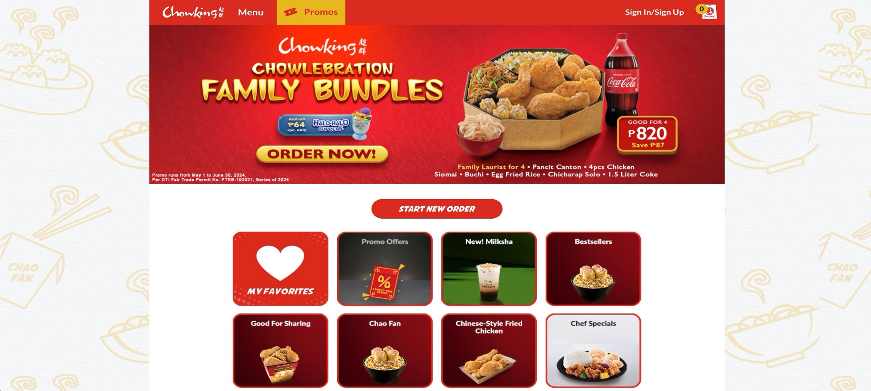LEGEND:

* IMAGE - TEXT - CONTAINER



