ChatGPT

Q> Show me a full project source example To write data to a database using a Spring Boot filter

A>

Below is a simple Spring Boot project that demonstrates writing data to a database using a filter. The example uses the H2 in-memory database and JPA for persistence.

1. pom.xml

The pom.xml file includes dependencies for Spring Boot, JPA, H2, and other necessary components.

실습

C:\Users\ADMINI~1\AppData\Local\Temp\SNAGHTML15114e86.PNG

## New Spring Starter Project

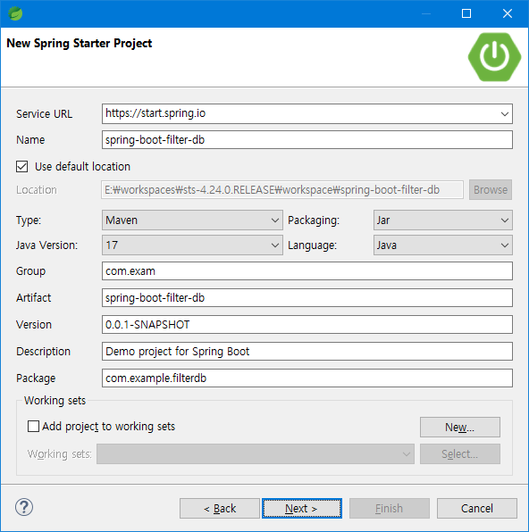

## New Spring Starter Project Dependencies

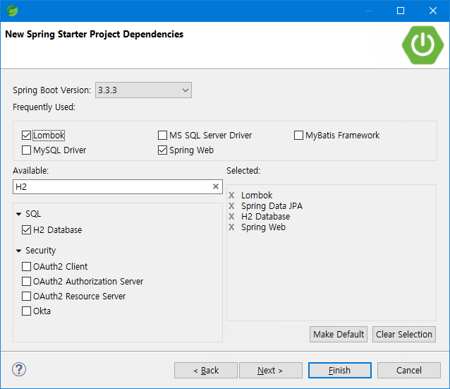

## New Spring Starter Project

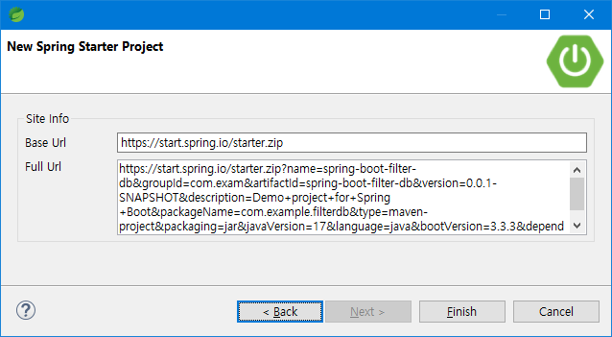

https://start.spring.io/starter.zip?name=spring-boot-filter-db&groupId=com.exam&artifactId=spring-boot-filter-db&version=0.0.1-SNAPSHOT&description=Demo+project+for+Spring+Boot&packageName=com.example.filterdb&type=maven-project&packaging=jar&javaVersion=17&language=java&bootVersion=3.3.3&dependencies=lombok&dependencies=h2&dependencies=data-jpa&dependencies=web

Run As > Spring Boot App

에러 발생

|  |
| --- |
| 2024-09-10 05:40:36.811[0;39m [33m WARN[0;39m [35m42224[0;39m [2m---[0;39m [2m[ main][0;39m [36mConfigServletWebServerApplicationContext[0;39m [2m:[0;39m Exception encountered during context initialization - cancelling refresh attempt: org.springframework.beans.factory.support.BeanDefinitionOverrideException: Invalid bean definition with name 'logFilter' defined in class path resource [com/example/filterdb/config/FilterConfig.class]: Cannot register bean definition [Root bean: class [null]; scope=; abstract=false; lazyInit=null; autowireMode=3; dependencyCheck=0; autowireCandidate=true; primary=false; factoryBeanName=filterConfig; factoryMethodName=logFilter; initMethodName=null; destroyMethodName=(inferred); defined in class path resource [com/example/filterdb/config/FilterConfig.class]] for bean 'logFilter': There is already [Generic bean: class [com.example.filterdb.filter.LogFilter]; scope=singleton; abstract=false; lazyInit=null; autowireMode=0; dependencyCheck=0; autowireCandidate=true; primary=false; factoryBeanName=null; factoryMethodName=null; initMethodName=null; destroyMethodName=null; defined in file [E:\workspaces\sts-4.24.0.RELEASE\workspace\spring-boot-filter-db\target\classes\com\example\filterdb\filter\LogFilter.class]] bound. |