The Intersectionality of Taylor Swift and the NFL
In recent months, the presence of international sensation Taylor Swift has been impossible to ignore on American television screens, particularly during National Football League (NFL) broadcasts of Chiefs games. Swift, who is romantically connected to tight-end Travis Kelce, is shown frequently during Chiefs’ games. Many long-time NFL fans are upset with the amount of publicity the NFL is giving Swift.
Evan Gruen is a lifelong NFL fan who has noticed an increase in Swift coverage during games. “At the beginning it didn’t bother me that much, but when they started talking about her during every single NFL game it got annoying very fast,’ said Gruen. “It got the worst during the Super Bowl because it felt like I saw more coverage of Taylor Swift than I did the actual game.”
Not only is Swift shown during games, but the NFL also frequently makes Instagram posts about the pop star using photos of her and her lyrics. Swift commented on this issue during her TIME’S Person of the Year feature saying, “I have no awareness if I’m being shown too much and pissing off a few dads, Brads, and Chads.” After doing a content analysis of when Taylor Swift was shown during the past three Chiefs games (Chiefs v. Ravens Jan 28, Chiefs v. Bills Jan 21, Chiefs v. Dolphins Jan 13) I found Swift was typically shown at the beginning of the broadcast, before and after halftime, at the end of the game, and any time Kelce made a big play.
Cassandra Secrease, a communication professor at the University of Dayton said the attention is due to human nature, “we love the narrative of a ‘hated’ relationship, which brings in the views for the NFL. We are story-telling creatures. We love a good love story; I mean her first major hit was Love Story.”
Despite the discontent among viewers, the NFL’s persistent showcasing of Swift stems from clear motivation: revenue. According to Matt Johnson of Sportsnaut, the average yearly income for the NFL is around 18 billion dollars. The first three games Swift was shown, averaged approximately 485 million dollars in revenue, which is 2.7% of the yearly amount. If Swift were to continue to bring in an average of 161 million dollars per game for an entire season she would bring in 15% of the yearly income for the NFL. An article by Al Jazeera stated there has been a 20% increase in sponsorships for the NFL since Taylor Swift began attending games.
Not only does Taylor Swift boost revenue for games, but she also brings in a new fan base for the NFL. Michaela Linehan is a lifelong ‘Swiftie.’ “I think the NFL is showing Taylor Swift because there’s a demand,” said Linehan. “Taylor fans want to see her. I think the NFL has recognized that demand to see Taylor and used that to benefit financially and grow their fanbase.
Al Jazeera also stated there has been a 53% increase of female teenage fans, and a 24% increase of female early adult NFL fans since they started including shots of Taylor Swift during broadcasts. Historically, the NFL has been made of primarily male fans, making up about 70% of the viewership. Linehan went on to describe her overall thoughts of Swift being shown at games saying, “I think her attendance is creating a space for women in sports and bringing people together.”
Additionally, the Swift and NFL crossover has bombarded the internet and social media. Many fans comment about how annoying it is to see Swift so often. In reality, Swift is typically shown for less than a minute per game. In the recent Superbowl between the Chiefs and the 49ers, Swift was shown a total of 54 seconds during a three-hour game before the winning celebration.
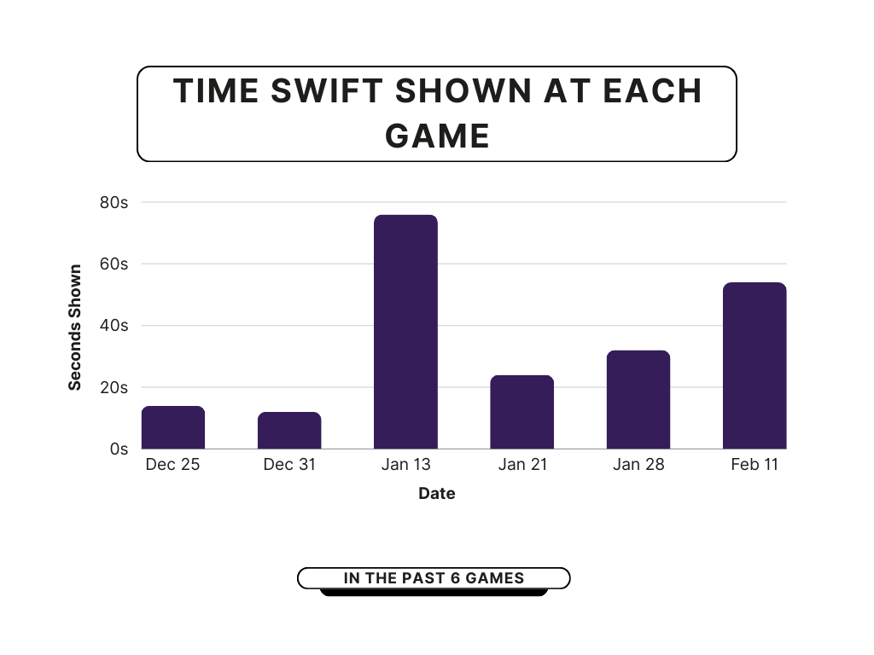
Graph of the past six Chief’s games Swift attended and how long she was shown on screen. Data from The New York Times.
In an industry that has faced scrutiny for intolerance of female employees, players arrested for domestic abuse, and is typically characterized by a large male fanbase, the Swift backlash begs the question, is the hate due to her success as a woman? In recent months Swift was named TIME Person of the Year, became a billionaire, engrossed on a massive world tour, and started a new relationship with Kelce. Outrage over shots of celebrities has not been equal. During the playoffs, rapper Eminem was shown at a Lions game celebrating and cheering on his team. The internet applauded Eminem, laughing alongside how expressive he was during the game.
Other women associated with the NFL have also been ridiculed. Brittany Mahomes and Kristen Juszczyk, both of whom are dating NFL stars, have recounted their experience received hate online. Mahomes often gets criticized for being annoying and having a big mouth, while Juszczyk gets condemned for creating clothing for other wives and girlfriends.
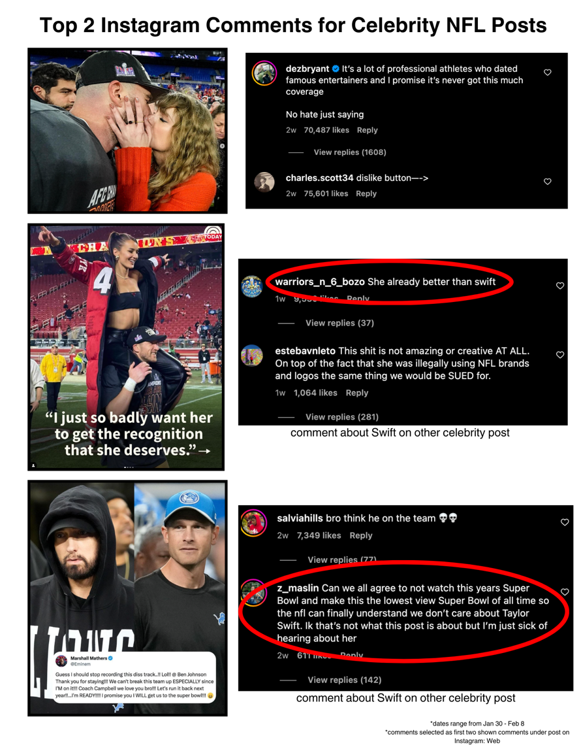
Top two comments under celebrity Instagram posts from NFL. Shows comments about Swift under other celebrity posts.
Swift’s frequent appearances during NFL broadcasts are more than just celebrity endorsement. Regardless of the backlash and complaints from groups of viewers, the truth is in the data: Swift’s association relates to an increase in revenue and new female fans. The reactions of fans raise concern about gender bias within sports. Despite the embellished numbers online, Swift’s on-screen appearances are minimal compared to the entire game. While the NFL continues to employ the landscape of Swift marketing, it is important to keep up with data and information about appearances made by Swift before coming to conclusions.

