FRAUD INVESTIGATION PLATFORM
AI Agentic Workflow
System Architecture Document

Field | Value
Document Type | System Architecture Document
System | BSI Fraud Investigation Platform — Massachusetts
Platform | OpenText AppWorks
Version | 1.0
Audience | Solution Architects, Technical Leads, Stakeholders
Status | POC — Architecture Diagram Included

1. Purpose
This document describes the system architecture of the BSI Fraud Investigation Platform — an AI-powered investigation workflow built on OpenText AppWorks. It provides a high-level view of how the platform components connect, how data flows through the system, and where the AI agents operate within the existing BSI workflow.

This document is for architects, technical leads, and stakeholders who need to understand the overall system design. For agent-level implementation detail and screen specifications, refer to the Developer Specification Document.

2. System Context
The platform enhances the existing AppWorks complaint management workflow at the Bureau of Special Investigations, Massachusetts. The AI layer sits alongside this workflow — not replacing it. At each stage, AI agents provide investigators with relevant information, risk assessments, and recommendations. All final decisions remain with human staff.

Who uses the system | What they get from the AI
Analyst | Risk score and similar historical cases displayed automatically when they open a case
Reviewer / Supervisor | Investigation playbook and evidence checklist on demand
Investigator | On-demand chat assistant grounded in case data and historical archive
Director | On-demand investigation summary report generated fresh at decision time

NOTE — Complaint Form Already Captures Key Data

The existing BSI complaint form captures fraud type, subject, and prior cases
as structured fields at submission time. AI agents build on this — they do not
re-classify or re-discover what the form already provides.

3. Architecture Diagram
The diagram below shows the high-level system architecture for the BSI AI Agentic Workflow. It illustrates the three main layers — the AppWorks Platform, the Semantic Layer (Tool Registry), and the AI Agent Service — and how they interact.

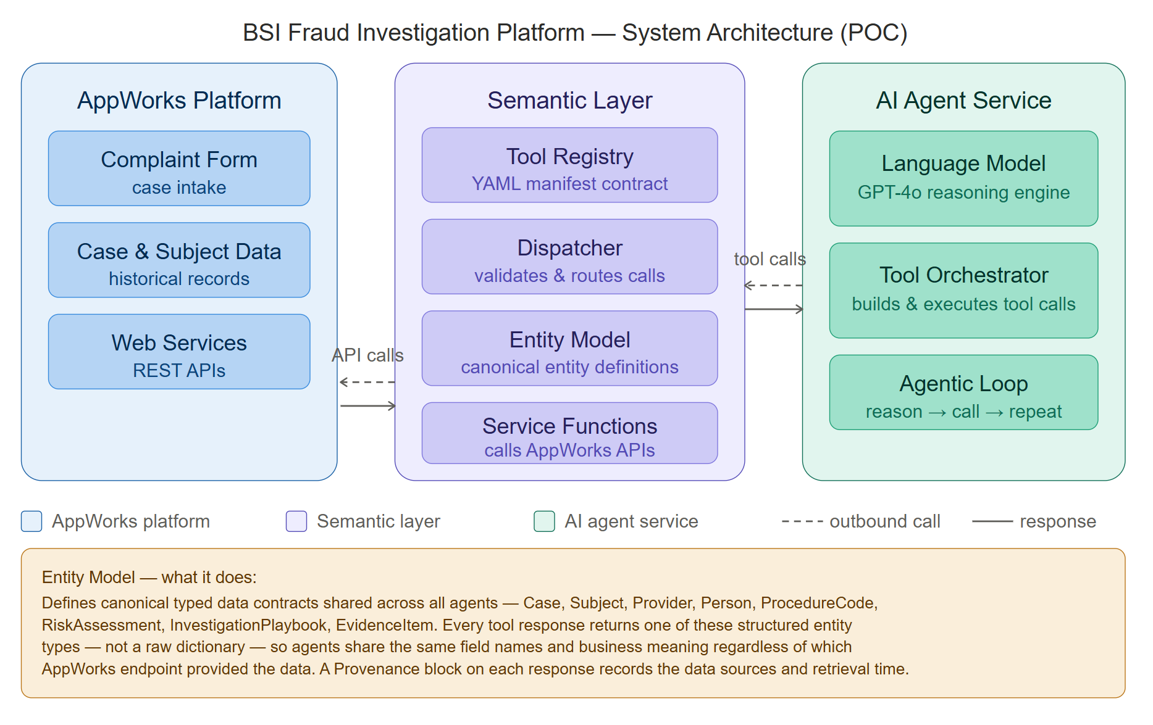

Figure 1: BSI AI Agentic Workflow — System Architecture (POC). Shows the three-layer architecture: AppWorks Platform (data source), Semantic Layer (tool registry, dispatcher, service functions), and AI Agent Service (language model, tool orchestrator, agentic loop).

4. Component Overview

4.1 AppWorks Platform
The existing OpenText AppWorks deployment at BSI. Complaint forms, case data, subject records, workflow routing, and document storage all live within AppWorks. The AI platform does not write to or modify the AppWorks database — it reads from AppWorks Web Services (REST APIs) only.

4.2 Semantic Layer — Tool Registry, Entity Model and Rules Engine
A controlled gateway between the AI agent and all AppWorks data. Built from five parts:
- Tool Registry — a YAML configuration file defining every approved tool: what it does, what data it needs, and which AppWorks service it calls. The AI reads this and reasons from it.
- Dispatcher — receives every AI tool request, validates it against the manifest, and routes it to the correct AppWorks service. Blocks any call that is not registered.
- Service Functions — Python functions that call AppWorks REST APIs to retrieve case data, subject history, billing records, playbooks, and reports.
- Rules Engine — evaluates active fraud detection rules fetched from a configurable table in AppWorks. Rules are loaded at runtime via get_risk_rules(), not hardcoded in the application. BSI can add, update, or deactivate rules in AppWorks without any code change.
- Entity Model — canonical typed data contracts defining the shared vocabulary across all agents. Every tool response returns a structured entity type (Case, Subject, RiskAssessment, etc.) rather than a raw dictionary. A Provenance block is included on every response, showing which AppWorks endpoints were called, when, and how the result was computed. For risk assessments, computed_by is always SCORING_LOGIC — never LLM.

This layer ensures the AI can never access arbitrary data or fabricate information. Every data request is validated and traceable. The canonical entity model ensures every agent operates on structured business meaning — not ad-hoc data — which directly reduces hallucination risk beyond tool-level validation alone.
For this POC, the Semantic Layer is implemented as a Semantic Access Layer — governing tool access and validating contracts. Canonical entity definitions, entity relationship definitions, and governance policy enforcement are the next-phase additions built on this foundation.
Canonical entity definitions strengthen hallucination control beyond tool-level validation. When every tool response conforms to a typed schema with defined field names, the LLM operates on structured business meaning rather than ad-hoc data. It cannot misinterpret or invent fields that do not exist in the contract.

4.3 AI Agent Service
The intelligence layer, powered by OpenAI GPT-4o. The agent receives a case reference and the list of approved tools from the manifest. It reads the tool descriptions, decides which data to retrieve, reviews each result, and decides the next step — autonomously, without hardcoded step ordering.

All tool calls are intercepted by the Semantic Layer before execution.
Within each workflow phase, the AI determines which tool to call next based on data dependencies. However, major phase transitions are governed — the intake phase completes before context enrichment begins, risk assessment runs before strategy generation, and analyst approval is required before the final report is produced. Agentic autonomy operates within phases, not across them.

5. Data Flow
The following describes how data moves through the system from complaint submission to final report:

Stage | What happens
1. Complaint submitted | Investigator submits the AppWorks complaint form — including fraud type(s), subject, and prior cases already captured as structured fields. A webhook triggers the AI agent with the case reference number.
2. Intake structuring | The Complaint Intake Agent reads the structured form fields and extracts additional entities from the complaint narrative — key persons, linked organisations, amounts, and procedure codes. Structures everything into a clean JSON context for all downstream agents.
3. Context enrichment | The Context Enrichment Agent reads across the prior cases already listed on the form. It surfaces cross-case connections — persons appearing in multiple cases, shared addresses, escalation patterns — that are not visible from the case IDs alone.
4. Similar cases | The Similar Case Retrieval Agent queries AppWorks for closed cases matching the submitted fraud type(s). Returns top matching cases with outcomes and loss amounts.
5. Risk assessment | The Fraud Risk Assessment Agent first fetches active fraud detection rules from the AppWorks configurable rules table via get_risk_rules(). The rules engine then evaluates those rules against the AppWorks case and billing data. A deterministic risk score and tier are calculated and returned with full provenance.
6. Strategy (on demand) | On reviewer request, the Case Strategy Agent retrieves the investigation playbook and tailors the recommended steps to the specific case context.
7. Analyst review | The analyst reviews AI findings, approves or modifies the recommended strategy. Decision recorded in the case audit trail.
8. Investigation | The investigator uses the on-demand Copilot to ask questions throughout the case. Each answer is grounded in verified case data only.
9. Final report (on demand) | At director request, the Report Generation Agent compiles all findings into a formatted investigation summary report.
10. Case closed | Case outcome is recorded. Future reference available through AppWorks case archive.

6. Integration Points
Integration | Details
AppWorks Webhook | FastAPI endpoint receives form submission events from AppWorks and triggers the AI agent with the case_id.
AppWorks REST APIs | Semantic Layer calls AppWorks Web Services to retrieve case data, subject records, billing history, and playbooks. Read-only access.
OpenAI API | AI Agent Service calls GPT-4o via the OpenAI API. Requires an API key in the configuration.
AppWorks Rules Table | A configurable table maintained by BSI within AppWorks that stores the active fraud detection rules (rule ID, condition description, weight, active flag). The rules engine fetches this table at runtime via the AppWorks REST API — no deployment is needed to update rules.

7. Key Architecture Decisions

7.1 No Direct Database Access
The AI agent does not connect to the AppWorks database directly. All data access goes through AppWorks Web Services. The AppWorks database schema is complex, partially undocumented, and missing foreign key relationships that would be needed for reliable AI-driven queries.

7.2 Semantic Layer as Hallucination Control
The Semantic Layer prevents the AI from fabricating tool calls or data. By registering only approved tools in the manifest and validating every call before execution, the system ensures the AI can only retrieve data from defined, tested AppWorks endpoints.

7.3 Human Authority Preserved
Every AI recommendation is labelled as AI-generated and presented alongside a human decision control — approve, modify, or reject. No case outcome, escalation, or investigation action is taken by the AI autonomously. The AI informs; humans decide.

7.4 Form Data as Foundation
The existing complaint form already captures the fraud type, subject, and prior cases as structured data. The AI builds on this foundation — it enriches, deepens, and cross-references what the form provides rather than re-doing what the workflow already handles. This respects the existing BSI process and avoids duplication.

8. Semantic Layer and MCP Server

8.1 What is MCP?
MCP (Model Context Protocol) is an open standard published by Anthropic that defines how AI agents connect to external tools and data sources. Think of it as a universal connector — the same way USB-C standardises how devices plug into each other, MCP standardises how any AI agent plugs into any backend service.

Without MCP, every team that wants to connect an AI agent to a backend system — whether AppWorks, Salesforce, Gmail, or a custom database — writes its own custom integration code. Each integration is one-off, non-transferable, and tied to a specific agent framework. MCP replaces this with a single protocol that any MCP-compatible AI can use.

Without MCP | With MCP
Each AI-to-backend connection is hand-rolled custom code | One standard protocol — any MCP-compatible AI connects to any MCP server
Integration is tied to one specific agent framework | Agent framework can be swapped without rewriting integrations
No standard for validation, error handling, or tool discovery | Protocol enforces validation, parameter typing, and tool discovery by spec
Audit trail depends on custom logging implementation | Every MCP call is structured, typed, and protocol-level traceable

8.2 How the BSI Semantic Layer Relates to MCP
The Tool Registry Semantic Layer built for this platform is not a direct MCP implementation — it is a custom-built equivalent that solves the same problem. The table below shows how the two map to each other:

BSI Semantic Layer Component | MCP Server Equivalent | Purpose
manifest.yaml — tool definitions | MCP Server tool definitions | Declares what tools exist, what they need, and what they return
Dispatcher — Gate 1, 2, 3 | MCP Protocol handler | Validates every tool call before it reaches the backend
Service Functions — AppWorks calls | MCP Server implementation | Executes the actual backend service call and returns structured data
Tool Builder — LLM schema converter | MCP Client tool registration | Translates tool definitions into the format the LLM receives
Agent Runner — agentic loop | MCP Client session | Manages the LLM conversation and routes tool calls through the gateway

The BSI Semantic Layer does what an MCP Server does — but built from first principles.

It was built this way for the POC because:
- It required no additional infrastructure or protocol dependencies
- It could be validated end-to-end before any AppWorks integration was in place
- The manifest.yaml and dispatcher are simple enough for any developer to read and modify

7.5 POC as Foundation — Evolutionary Architecture
The current POC delivers what is correctly described as a Semantic Access Layer — a governed, manifest-driven tool contract that sits between the AI agent and AppWorks. This is the right and sufficient scope for proof of concept. However, it is deliberately designed so that each component maps directly to a more complete production layer when BSI is ready to invest in the fuller architecture.

Current POC Component | Maps to Future Layer | What gets added in future
manifest.yaml tool definitions  semantic_model.py entity model | Semantic Model Layer | Entity relationship definitions — documenting how subjects, cases, providers and persons connect to each other, controlled vocabularies, canonical field dictionary, response schema contracts
Dispatcher — three validation gates | Governance Policy Layer | Role-based access control, case-state authorization, PII masking rules, policy denial reasons, audit event emission
Agent runner — agentic loop | Execution Control Layer | Workflow phase enforcement, max tool call limits, retry/timeout policies, loop prevention, correlation IDs, idempotency
AppWorks service functions | Service Adapter Layer | Authentication handling, response normalization, transport error mapping, versioned API contracts

Current state: Semantic Access Layer — governed tool contracts, validated access, canonical vocabulary
Future state: Full governed agentic architecture — semantic model, governance policy, execution control

8.3 Key Differences Between the BSI Semantic Layer and a Formal MCP Server
While the BSI Semantic Layer achieves the same goal as an MCP server, there are architectural differences worth understanding:

Dimension | BSI Semantic Layer (Current) | MCP Server (Standard)
Location | Lives inside the application codebase — same project as the agent | Runs as a separate network service — independent of the agent
Transport | Direct Python function calls — no network layer | HTTP / SSE over the network — agent and tools are decoupled
Portability | Only works with this agent codebase | Any MCP-compatible LLM or agent framework can connect
Tool discovery | Tools loaded from manifest.yaml at startup | LLM queries the MCP server at runtime for available tools
Multi-agent support | One agent, one codebase | Multiple different agents can share the same MCP server simultaneously
Governance | Custom dispatcher enforces validation | Protocol-level — validation, versioning, and audit built into the spec
Maintenance | BSI development team owns the tool definitions | AppWorks team can own and update the MCP server independently

8.4 MCP and Semantic Layer — Complementary, Not Competing
MCP and the Semantic Layer are not alternatives — they answer different questions and operate at different levels of the architecture. Understanding how they complement each other is important for positioning the current design and the future direction.

Layer | Answers the question | In this platform
Semantic Layer | WHAT can the AI do? What tools exist, what do they mean, what are the rules? | manifest.yaml + semantic_model.py + dispatcher — defines and governs the tool contract
MCP Server | HOW does the AI connect? What is the transport standard, how are tools discovered? | Not implemented in POC — the semantic layer handles this internally via direct Python function calls

In a future architecture where both are present, the Semantic Layer sits inside or above the MCP Server. The MCP Server handles the network transport and tool discovery protocol. The Semantic Layer handles the business meaning, governance rules, and access control. The investigator sees neither — they see only the AI Insights panel delivering governed, traceable findings.

Scenario | Correct architecture
Single workflow, one application (current BSI POC) | Semantic Layer only — no MCP needed. All governance in one codebase, no network overhead, simple to debug and audit.
Multiple AI applications sharing AppWorks data | Spring AI MCP Server + per-application Semantic Layers. MCP handles the shared integration. Each semantic layer governs its own workflow.
BSI wants any AI tool to connect to AppWorks | Spring AI MCP Server only — the same pattern used in Case360. AppWorks team owns the server, any agent connects via standard protocol.

For the POC: the Semantic Layer provides governed tool access, canonical entity contracts, and provenance-aware responses — a practical foundation for this workflow.
For future scale: MCP becomes the transport layer that makes AppWorks accessible to any AI tool,
while the Semantic Layer continues to govern what each specific workflow is allowed to do.

— End of System Architecture Document —

