Multimedia Appendix 3. Component independence (per-pair statistics and figure) and construct-validity simulation (original pipeline version, repository tag v1)
These results come from the original pipeline version (repository tag v1, commit fca1d9c) [1]: notebook NDI_Pipeline.ipynb, cells B2 (component independence on real data), C2.0 to C2.4 (construct-validity simulation) and C2.5 (independence on simulated data), with the saved files in results_final_v1_frozen_backup/. They were not re-run for the revision. The same cells, run again in the version 1.2 session (NDI_v1.2_Corrections.ipynb), printed identical values. Because these channels come from the original implementation, T was computed from whole-series statistics (Multimedia Appendix 1, correction 2), and PMData had 15 participants (p12 was not yet loaded; correction 5). Values are given to three decimals.

1. Component independence on real data
For each dataset the three channels were pooled over participant-days. Three checks were applied to each pair of channels: the Spearman correlation; mutual information (MI) compared with a within-participant shuffle null, in which one channel is permuted within each participant 200 times, with dependence declared when the observed MI exceeds the 95th percentile of the null; and normalised MI. The effective rank of the standardised three-column component matrix (the exponential of the entropy of its normalised singular values) is 3 when the channels carry three independent directions and 1 when they carry one. DEPRESJON [2] contributed 54 recordings (23 patients and 32 controls, less one patient recording with fewer than 15 days), and PMData [3] 15 participants.
Table 1. Per-pair independence statistics for the three neutrosophic channels (tag v1).
Dataset | Pair | Spearman ρ | MI, observed | MI, 95th percentile of shuffle null | Normalised MI | Dependence detected
PMData | T–F | 0.057 | 0.171 | 0.090 | 0.072 | Yes
PMData | T–I | 0.096 | 0.124 | 0.088 | 0.075 | Yes
PMData | F–I | 0.074 | 0.196 | 0.157 | 0.095 | Yes
PMData | Effective rank (T, I, F) | — | — | — | — | 2.99 of 3
DEPRESJON | T–F | 0.369 | 0.116 | 0.062 | 0.184 | Yes
DEPRESJON | T–I | −0.245 | 0.093 | 0.079 | 0.122 | Yes
DEPRESJON | F–I | −0.582 | 0.363 | 0.269 | 0.279 | Yes
DEPRESJON | Effective rank (T, I, F) | — | — | — | — | 2.94 of 3
Source: NDI_Pipeline.ipynb, cell B2; results_final_v1_frozen_backup/item7_independence_real_data.csv. MI: mutual information.
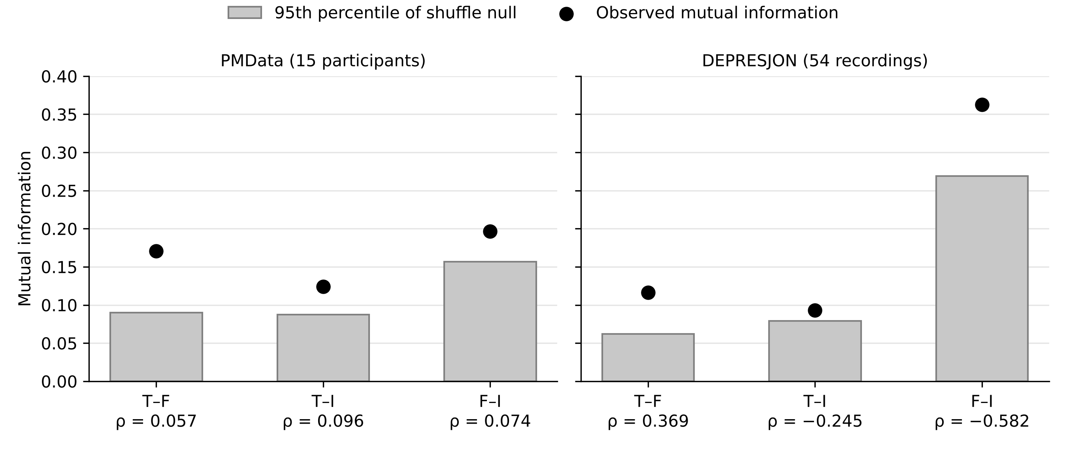
Figure 1. Observed mutual information for each pair of channels (black points) against the 95th percentile of the within-participant shuffle null (grey bars), with the Spearman ρ of each pair below its label. The observed value lies above the null in all six dataset-pair combinations, including the three PMData pairs whose linear correlations are near zero.
Drawn for this appendix from the values in Table 1; no analysis was re-run.
Linear correlations were near zero on PMData (|ρ|≤0.10) and moderate on DEPRESJON (|ρ| 0.25 to 0.58), but the shuffle-null test detected dependence in all six dataset-pair combinations, and the effective rank was close to 3 on both datasets. Linear checks alone would therefore miss the nonlinear redundancy between channels.

2. Construct-validity simulation
The simulation asks whether each channel recovers the property it was designed to measure. Its settings were fixed in cell C2.0 before any data were generated, and the signal-to-noise ratio (SNR) levels were not tuned afterwards.
Table 2. Simulation design (cells C2.0 and C2.1).
Setting | Value
Cohort | 15 simulated participants, 140 days each, at each of three SNR levels (0.5, 1.0, 2.0); random seed 20260817
Latent state | Two-state Markov process (well or episode), with mean durations of 60 days (well) and 14 days (episode); the episode mean is shifted by 2 × SNR
Participant effects | Level intercept a ~ N(0, 1.0); log-volatility intercept b ~ N(0, (0.6 × SNR)²), so the emission SD is exp(b); data-quality parameter c ~ U(0.3, 1.0)
Injected missingness | Each day missing with probability (1 − c) × 0.4 × SNR
Injected sensor instability | Flat-line runs of 3 to 6 identical values, started with probability (1 − c) × 0.02 × SNR per day
Channels | T, I and F computed with the same functions as on the real data (including the leave-one-participant-out population volatility norm), on the raw series with missing days left missing
Table 3. Recovery of the planted structure by each channel, at each SNR level.
Channel | Test | Expected sign | SNR 0.5 | SNR 1.0 | SNR 2.0
T | Spearman(T, −level deviation), observed days | Positive | 0.928 | 0.867 | 0.850
T | Spearman(T, latent episode state), observed days | Negative | −0.098 | −0.203 | −0.489
F | Spearman(participant mean F, −b), sign-aligned | Positive | 0.846 | 0.911 | 0.771
I | Spearman(I, injected missingness), all days | Positive | 0.979 | 0.974 | 0.948
I | Spearman(I, injected flat-line instability), all days | Positive but weak | 0.119 | 0.115 | 0.119
Source: NDI_Pipeline.ipynb, cell C2.4; results_final_v1_frozen_backup/arm2_recovery_summary.csv. Observed days for T and F: 1,976, 1,870 and 1,602 of 2,100 at SNR 0.5, 1.0 and 2.0. The F test correlates each participant's mean F with its log-volatility intercept b (15 participants per SNR level). F scores reduced variability as falsity, so its raw correlation with b is negative (−0.846, −0.911 and −0.771); the table gives the sign-aligned value. Planted flat-lines cover only a small share of days, so the instability test is weak by design.
Each channel recovered its planted structure: T tracked level deviation (ρ=0.85 to 0.93), F the volatility offset (|ρ|=0.77 to 0.91), and I injected missingness (ρ=0.95 to 0.98) but flat-line instability only weakly (ρ≈0.12).
Table 4. Independence of the channels on simulated data (observed days).
SNR | Effective rank (T, I, F), of 3 | Spearman ρ, T–F | Spearman ρ, T–I | Spearman ρ, F–I
0.5 | 2.998 | 0.048 | −0.055 | −0.039
1.0 | 3.000 | 0.014 | 0.034 | 0.013
2.0 | 2.998 | −0.042 | 0.063 | −0.000
Source: NDI_Pipeline.ipynb, cell C2.5; results_final_v1_frozen_backup/arm2_independence_eff_rank.csv and arm2_independence_pairs.csv. On the observed days of the simulated series I is nearly constant, so normalised MI is not reported for the pairs that involve I.

References
1. Patel H, Kandasamy I. NDI_Depression_Risk_Index: analysis code, configuration files, and results archive, release v1.5-final. GitHub. 2026. URL: https://github.com/hpatel09112004/NDI_Depression_Risk_Index
2. Garcia-Ceja E, Riegler M, Jakobsen P, Tørresen J, Nordgreen T, Oedegaard KJ, et al. Depresjon: a motor activity database of depression episodes in unipolar and bipolar patients. In: Proceedings of the 9th ACM Multimedia Systems Conference (MMSys'18). 2018 Presented at: MMSys'18; June 12-15, 2018; Amsterdam, The Netherlands p. 472-477. doi:10.1145/3204949.3208125
3. Thambawita V, Hicks S, Borgli H, Stensland HK, Jha D, Svensen MK, et al. PMData: a sports logging dataset. In: Proceedings of the 11th ACM Multimedia Systems Conference (MMSys'20). 2020 Presented at: MMSys'20; June 8-11, 2020; Istanbul, Turkey p. 231-236. doi:10.1145/3339825.3394926

