## horizontal line



Hotel Reservation System

Milestone 1 Project Idea and proposal

Jul 18, 2022

Group7:

Harshil Patel 148847213

FanghaoMeng 180210213

LinlinFan 179675210

# Introduction

The tourism industry has a good perspective. Online reservations assist travelers with more options with the range of the rooms according to their budget. It also helps hotels to sell their products and it is convenient for customers to select and view the comments for the hotel so that they can pick the best place to live. All our team members like traveling and exploring new places. As a result, we mostly prefer to book hotels online, so we are interested in how this business is working and how the database is designed.

# Problem Statement

A hotel group Halfang is seeking for a database design solution to help their online hotel booking business. The Halfang group has many branches located in many cities. Because of the late update of room booking and canceling information, rooms cannot be managed effectively which caused the loss of profits. Meanwhile, the management office is not able to get accurate and timely data analysis reports to make business decisions.

# Solution

We will build a database that can store travelers’ details who booked their expected room online, the room information and the database will also store data that is unavailable to outer world about how much margin earned (we know it is a calculated field we won’t include it directly) and that will help platform manager and hotel manager to make business decisions to move forward. My team began with the brainstorming about what are the features that our database should fulfill. After that, we are to develop a database using the Data Modeling steps and we do try to go through every step with efficiency and try to provide an efficient solution(database).

# Requirements

1. A user interface web page/application is required to interact with the customers.
2. An online payment system is required.
3. Updating of the price according to the discount applied.
4. User login/registration.
5. Storing registered user payment types and card details.
6. User profile.
7. Search algorithms (search according to the location, date, time, price range, and hotel rating)
8. Details about orders.
9. Details about canceled orders.
10. Hotels rating and comment details.
11. Financial reports and benefit calculation analyst.

# ERD

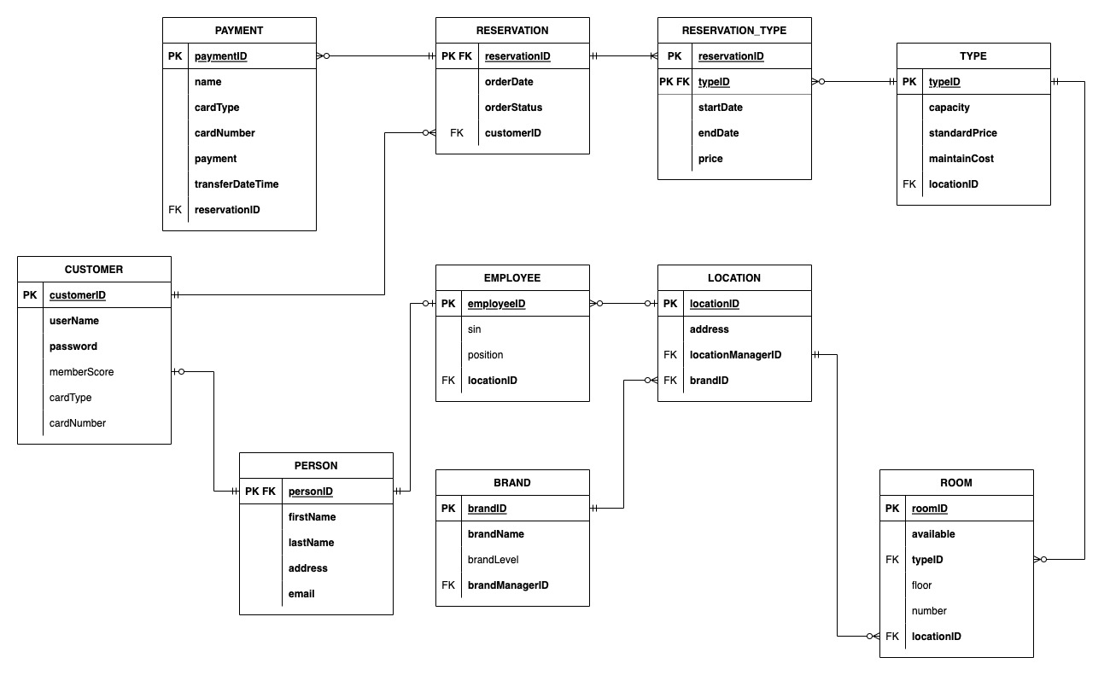

# Data Dictionary

|  |  |  |  |  |  |  |  |  |
| --- | --- | --- | --- | --- | --- | --- | --- | --- |
| Table: | **Payment** |  |  |  |  |  |  |  |
| Column | Data Type | Size, precision | Default | PK/FK | Required | Range | Sample Data | Notes |
| paymentID | NUMBER | 10 |  | PK | Y |  | 1234567890 |  |
| name | String | 25 |  |  | Y |  | Fanghao Meng |  |
| cardType | String | 25 |  |  | Y | Debit, Credit | Credit |  |
| cardNumber | String | 16 |  |  |  |  | 1796752101 |  |
| payment | NUMBER | 9,2 | 0.00 |  | Y |  | 360.55 |  |
| transferDateTime | DATE |  |  |  | Y |  | 2022-12-22 |  |
| reservationID | NUMBER | 10 |  | FK | Y |  | 1234567890 |  |
|  |  |  |  |  |  |  |  |  |
| Table: | Reservation |  |  |  |  |  |  |  |
| Column | Data Type | Size, precision | Default | PK/FK | Required | Range | Sample Data | Notes |
| reservationID | NUMBER | 20 |  | PK/FK | Y |  | 12345678900987600000 |  |
| reservationDate | DATE |  |  |  | Y |  | 2022-08-01 |  |
| reservationStatus | Boolean |  |  |  | Y | 0 or 1 |  | 1 if finish payment |
| customerID | NUMBER | 7 |  | FK | Y |  | 1234567 |  |
|  |  |  |  |  |  |  |  |  |
| Table: | Reservation_Type |  |  |  |  |  |  |  |
| Column | Data Type | Size, precision | Default | PK/FK | Required | Range | Sample Data | Notes |
| reservationID | NUMBER | 20 |  | PK | Y |  | 12345678900987600000 |  |
| typeID | NUMBER | 6 |  | PK/FK | Y |  | 123456 |  |
| startDate | date |  |  |  | Y |  | 2022-08-01 |  |
| endDate | date |  |  |  | Y |  | 2022-08-02 |  |
| price | NUMBER | 9,2 | 0.00 |  | Y |  | 200.99 |  |
|  |  |  |  |  |  |  |  |  |
| Table: | Type |  |  |  |  |  |  |  |
| Column | Data Type | Size, precision | Default | PK/FK | Required | Range | Sample Data | Notes |
| typeID | NUMBER | 5 |  | PK | Y |  | 123456 |  |
| capacity | NUMBER | 3 |  |  | Y |  | 2 | how many people |
| standardPrice | NUMBER | 9,2 |  |  | Y |  | 210.00 |  |
| maintainCost | NUMBER | 9,2 |  |  | Y |  | 130.56 |  |
| locationID | NUMBER | 5 |  |  | Y |  |  |  |
|  |  |  |  |  |  |  |  |  |
| Table: | Customer |  |  |  |  |  |  |  |
| Column | Data Type | Size, precision | Default | PK/FK | Required | Range | Sample Data | Notes |
| customerID | NUMBER | 10 |  | PK | Y | 0 to 2,147,483,647 | 1234567890 |  |
| userName | String | 25 |  |  | Y |  | John |  |
| password | String | 20 |  |  | Y |  | Smith1957 |  |
| memberScore | NUMBER | 10 | 0.00 |  |  | 0 to 2,147,483,647 | 25000 |  |
| cardType | String | 20 |  |  |  |  | Debit |  |
| cardNumber | string | 16 |  |  |  |  | 1796 7521 0101 8856 |  |
|  |  |  |  |  |  |  |  |  |
| Table: | Employee |  |  |  |  |  |  |  |
| Column | Data Type | Size, precision | Default | PK/FK | Required | Range | Sample Data | Notes |
| employeeID | NUMBER | 10 |  | PK | Y | 0 to 2,147,483,647 | 1488472 |  |
| sin | NUMBER | 10 |  |  | Y | 9-10 digits | 777777777 |  |
| position | String | 25 |  |  | Y |  | cook chef cleaner |  |
| locationID | NUMBER | 5 |  | FK | Y | 1-999 | 1 |  |
|  |  |  |  |  |  |  |  |  |
| Table: | Location |  |  |  |  |  |  |  |
| Column | Data Type | Size, precision | Default | PK/FK | Required | Range | Sample Data | Notes |
| locationID | NUMBER | 5 |  | PK | Y | 0 to 32,767 | 1 |  |
| address | String | 60 |  |  | Y |  | 9 diploma pl |  |
| locationManagerID | NUMBER | 10 |  |  | Y | 0 to 2,147,483,647 | 1234567555 |  |
| brandID | NUMBER | 5 |  | FK | Y | 0 to 32,767 | 1 |  |
|  |  |  |  |  |  |  |  |  |
| Table: | Person |  |  |  |  |  |  |  |
| Column | Data Type | Size, precision | Default | PK/FK | Required | Range | Sample Data | Notes |
| personID | NUMBER | 10 |  |  | Y | 0 to 2,147,483,647 | 1488472123 |  |
| firstName | String | 25 |  |  | Y |  | Fanghao |  |
| lastName | String | 25 |  |  | Y |  | Meng |  |
| address | String | 60 |  |  | Y |  | 9 diploma pl |  |
| email | String | 60 |  |  | Y |  | [fmeng18@myseneca.ca](mailto:fmeng18@myseneca.ca) |  |
|  |  |  |  |  |  |  |  |  |
| Table: | Brand |  |  |  |  |  |  |  |
| Column | Data Type | Size, precision | Default | PK/FK | Required | Range | Sample Data | Notes |
| brandID | NUMBER | 5 |  | PK | Y | 0 to 32,767 | 12345 |  |
| brandName | String | 60 |  |  | Y |  | Hilton |  |
| brandLevel | NUMBER | 1 |  |  |  | 1 to 5 | 3 |  |
| brandManagerID | NUMBER | 10 |  |  | Y | 0 to 2,147,483,647 | 1234567321 |  |
|  |  |  |  |  |  |  |  |  |
| Table: | Room |  |  |  |  |  |  |  |
| Column | Data Type | Size, precision | Default | PK/FK | Required | Range | Sample Data | Notes |
| roomID | NUMBER | 10 |  | PK | Y | 0 to 2,147,483,647 | 0000001234 |  |
| available | Boolean |  |  |  | Y | true, false | available |  |
| typeID | NUMBER | 5 |  |  | Y |  | 123456 |  |
| floor | NUMBER | 3 |  |  |  |  | 2 |  |
| number | NUMBER | 10 |  |  |  |  | 103 |  |
| locationID | NUMBER | 5 |  | FK | Y | 1-999 | 1 |  |