**Bahareh Fardanian**  
  
Bahar is a Technology Evangelist with more than five years of extensive experience in Big Data, ETL and Data Science. Expert in design and develop scalable solutions using virtualized clustered technologies to address business needs from problem statement through solution delivery. She is currently involved in innovation to enhance an end user experience in HPCC Systems by building new cutting-edge tools, libraries, and training.



**Lili Xu**

Lili is a Software Engineer with years of experience in in Distributed Computing,

Data Analytics, and Machine Learning. She is involved in research and

development of Distributed Computing related tasks such as a Covid19

projects.

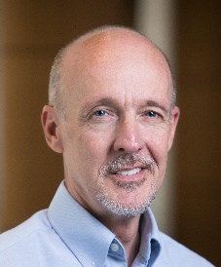 **Dan Camper**

Dan is a Senior Architect in the Solutions Lab Group. He has worked for Apple as well as Dun & Bradstreet, and he ran his own custom programming shop for a decade. He's been writing software professionally for more than 35 years and has worked on a myriad of systems, using many different programming languages.

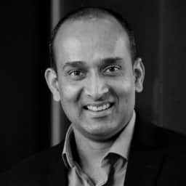**Arjuna Chala**

With over 20+ years of working in the field, Arjuna’s expertise spans software application development for desktop, web, phone and data analytics. Being part of the original LexisNexis Risk Solutions team instrumental in open sourcing their big data platform as HPCC Systems, Arjuna leads the R&D of the HPCC Systems Solutions Lab.