NFS-FILESYSTEM
NFS-SERVER
Step :1
Install required nfs and rpcbind pacakages in server node
Check the status
systemctl status nfs-server
Systemctl restart nfs-server
Step :2
Check the firewall service
Systemctl status firewalled.service
Systemctl stop firewalled service
OR
if firewalled service must enabled add the following services and enabled port number
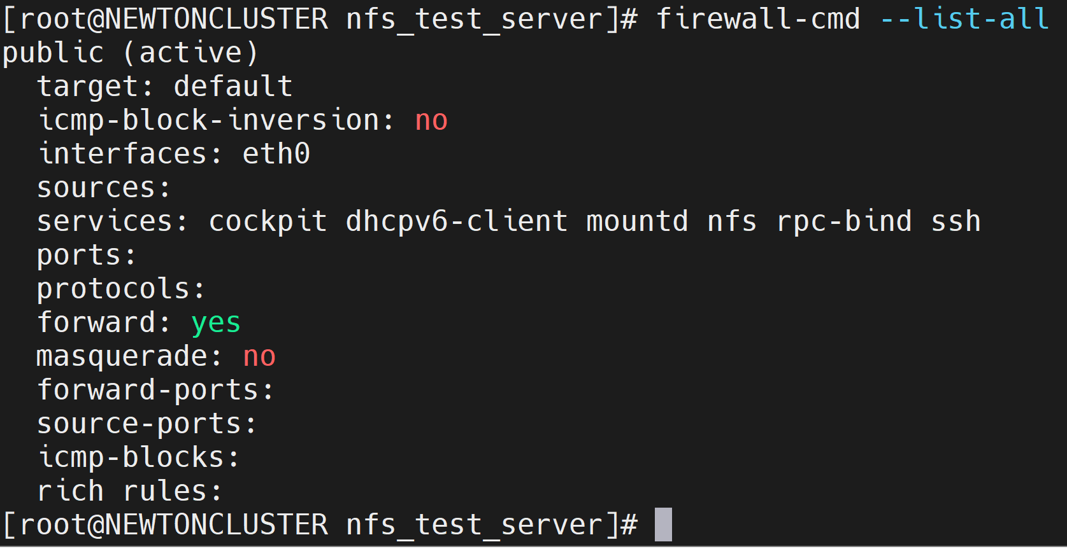
step :3
Create directory which is want share across network
change owner ship for the directory
if require change the directory permissions also
Step 4:
Add the nfs shared values in /etc/exports
/directory_which_is_want_share ip_address_of_network(permissions for shared point)
/directory_which_is_want_share ip_address_of_clint_machine(permissions for shared point)
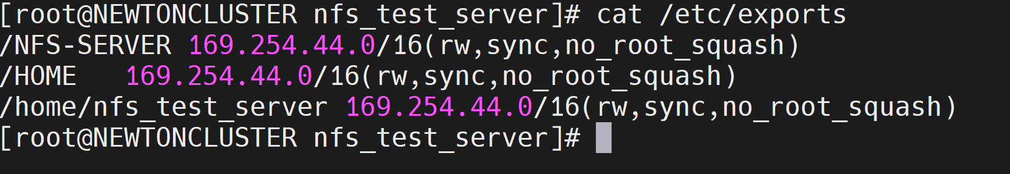
step 5:
Check the expoert values with
exportfs –a
exportfs –r
exportfs –v
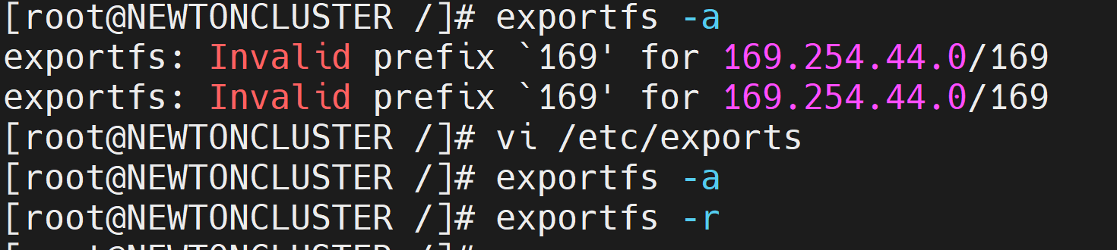
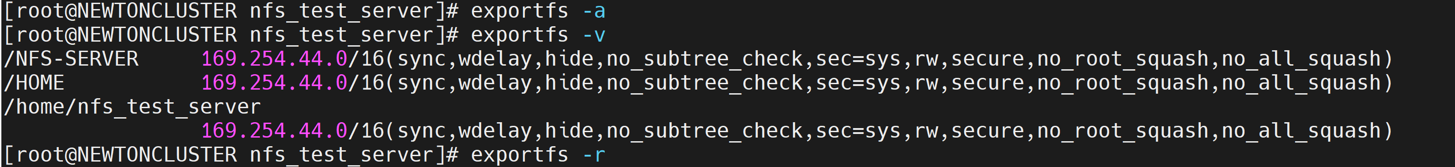
Everything is good we need to configure the NFS-CLINT server
NFS-CLINT
Step 6:
Check the network of the nfs-server machine
If network is reachable we can go farther configuration
check the firewall rules and port enable
step 7:
Create a mounting directory
Step 8:
Mount the nfs_mount path
or
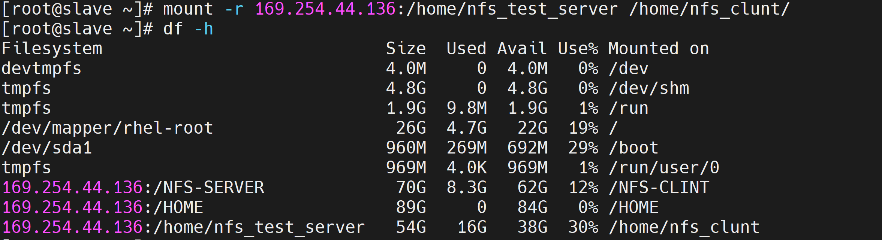
step 9:
For perment mount of after reboot add the nfs server valves in /etc/fstab conf file
the values of nfs system, ip addres of server,mount path of server,mount of the clint and defaults values
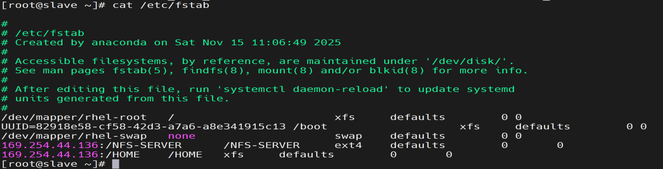
step 10 :
Check and verify mount point mounted or not
