**Introduction**

Switched linear systems are a category of hybrid systems. They have a switching rule that selects through an available list of subsystems in order to achieve global asymptotic stability. An affine system is a system that is linear in the input u, $\dot{x}=f\left(x\right)+G\left(x\right)u$. A switched affine system is therefore a system of the form $\dot{x}=A_{σ}x+B_{σ}$, where $x\left(t\right)∈R^{n}$ is the state, $σ(.)$ is the switching strategy and $u\left(t\right)∈R^{m}$ is the input, linearly related to $B_{σ}$. Not all switched affine systems can be stabilized globally. Until the paper of Hetel and Bernouau [4], if a switched affine system could not be stabilized globally, it could not be stabilized at all.

In their work [4], they show a way in which they stabilize a switched affine system in a region close to the origin even if the system cannot be stabilized globally. They show that if there exists a classical continuous feedback $k^{c}(x)$ that renders a switched affine system locally or globally stable, then there also exists a local discontinuous stabilizer $k(x)$ that selects subsystems from a set and renders the affine system locally stable.

In this report, the theory developed in [4] will be applied to control a power converter. These devices are widely used in power electronics. They are circuits controlled by transistors and diodes to adjust the electrical energy of a power source to meet the requirements of a load. They are controlled through Pulse Width Modulation technique and therefore these devices are good candidates to be modeled by non-linear switched systems.

The report gives further details about the problem in the Problem Statement section 2, gathers and analyses data from the literature in the Literature Review section 3, further expands the problem statement in section 4 and presents analysis and simulation results in sections 4 and 5, respectively.

Literature review

**Stabilization of switched affine systems: An application to the buck-boost converter**

In their paper, authors Corona, Buisson, Schutter and Giua present a technique to design an asymptotic switching law to stabilize switched systems. It is called the Switched Table Procedure (STP) and it consists of 3 steps. In the first step, it is decided if a switch from the current dynamics should occur based on some cost function. The second step states that there exists a maximum number of switches after which there is limited improvement that can be achieved. The third step obtains an augmented system by adding a stable dummy dynamic, and so if the solution of the optimal control problem for the augmented system does not contain the label associated to the dummy dynamics, the table found is also a solution of the initial system.

As an example, the STP is used to derive a switching law for the Buck-Boost converter, successfully. When compared to deriving a switching law from a unique Lyapunov function derived from the converter model, the STP stabilizes the system at a reduced cost.

**Switched Affine Systems Control Design with Application to DC DC Converters**

A paper that is mentioned multiple times when searching for stabilization of switched affine systems is that of Deaecto, Geromel, Garcia and Pomilio. Their goal is to calculate the set of attainable equilibrium points that can be reached from any initial condition. In order to do so, they design a switching rule that can take any trajectory of the system to a desired point inside a set by minimizing a cost function.

The switched systems presented are of the form

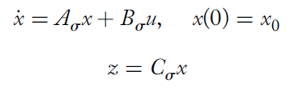(2) and (3)

where x(t) is the state, u(t) = u is the input, constant for all time, z(t) is the controlled output and $σ(.)$ is the switching strategy.

They provide two theorems to find switching laws but only one is simple enough to be implemented in practice because it has a linear switching function.

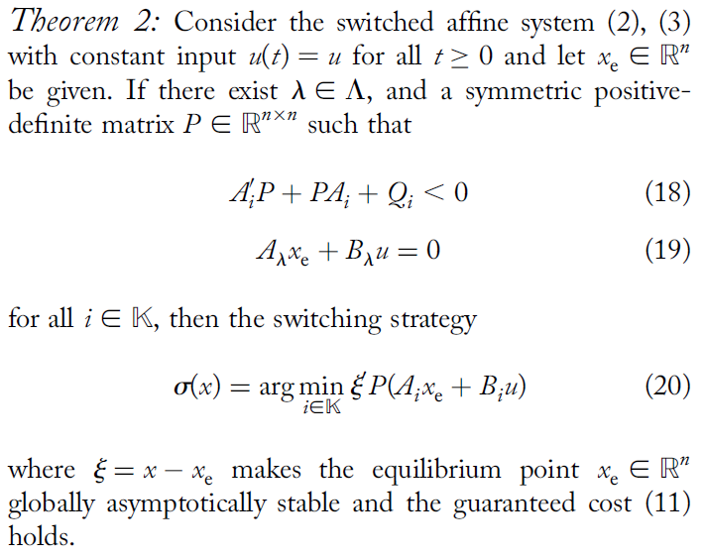

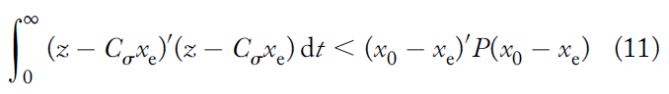

The paper goes on to apply this theorem to Buck, Boost and Buck-Boost converters. For each of the converters, the state trajectories start from the 0 initial condition and reach equilibrium points, thus successfully applying the switching strategy of Theorem 2 to power systems.

**On Control Design of Switched Affine Systems with Application to DC-DC Converters**

Mainardi Junior, Teixeira, Cardim, Moreira, Assunacao and Yoshimura present a theory that constructs a switching rule for switched affine systems to achieves asymptotic stability for a known equilibrium point. It applies to switched affine systems with constant input and given equilibrium point $x_{r}$. If there exists $λ ϵ Λ$, symmetric matrices Ni, and a symmetric positive definite matrix $P ϵ R^{n × n}$ such that

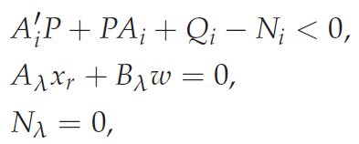

For all $i ϵ K$, where $Q_{i}=Q_{i}^{'}$, then the switching strategy.

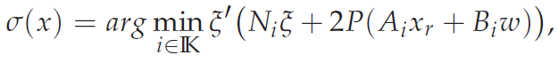

where $ξ=x- x_{r}$, makes the equilibrium point xr globally asymptotically stable and from

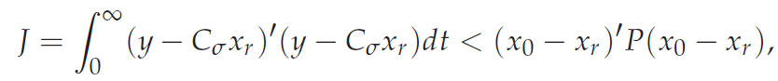

the guaranteed cost function



holds.

The theory is then applied to buck, boost, buck-boost and sepic DC-DC converters. For every power system the matrices P and Ni are calculated and a switching law is found, thus stabilizing the system within reasonable time and cost.