Personalized Science Comics
Business Plan and 90-Day Action Plan
A direct-to-consumer publisher of personalized, curriculum-aligned science and social-emotional comics for children aged 5 to 10, built on each child's own avatar, family, friends and life experiences.
Prepared for: the founder (PhD, education measurement; professional learning designer; ten years of ESL teaching and student consulting)
Working title: Science Detective Club (placeholder; see Section 9, Brand and naming)
Date: September 2026
Status: Draft v2 for founder review. All financial figures are planning estimates in Canadian dollars.

Contents

Part 1: Business Plan

0. Read this first: the honest assessment
Your idea has a strong core and one serious flaw. Both need to be said plainly before any plan.
What is genuinely strong
- The pedagogy is the product, not the characters. Look at the five prototypes in prototypes/. The things a parent would pay for are: the child as the protagonist, inquiry-style dialogue ("Which cup will lose water faster?"), the two-level scaffolding (Level 1 Grades 2 to 3, Level 2 Grade 4), bilingual keyword cards, "Think Like a Scientist" questions, and the "Remember" summary. No competitor in personalized children's books does this. Wonderbly, Hooray Heroes and the AI story apps personalize a name and a face into a generic story. You personalize a learning progression. Your measurement background is a real moat: you can build assessment into the comics and show parents evidence of learning.
- The "grows with your child" ladder. The same topic at two reading and reasoning levels is a subscription in disguise. Parents buy the rainbow comic at Grade 2 and the Grade 4 version two years later.
- A real field test. You made these for your daughter and her friend and took them to a theme park. That is a lived use case parents will recognize.
- A built-in production partner. Your husband animating the comics into video gives you a free marketing channel and a second product line.
The serious flaw: the business depends on other people's intellectual property
Peppa Pig (owned by Hasbro through Entertainment One), Snoopy and the Peanuts cast (Peanuts Worldwide, majority owned by WildBrain and Sony), Bluey (BBC Studios and Ludo Studio) and Canada's Wonderland (Six Flags Entertainment) are all registered trademarks and copyrighted works. Making these comics for your own daughter is fine. Selling them, putting them on a website, monetizing YouTube videos of them, or offering "pick Peppa as the character" is trademark and copyright infringement in Canada, the US, the EU and China. In practice this means:
- Payment processors and print-on-demand suppliers will refuse or cancel orders that feature these characters.
- YouTube's Content ID and Hasbro's brand-protection teams issue takedowns and channel strikes quickly. A monetized channel built on Peppa Pig will not survive.
- You cannot obtain copyright in the parts of the work that are theirs, so the "protect it internationally" goal is impossible while the characters are borrowed.
- Licensing is not a realistic option at launch. Character licences for a preschool property of this size carry minimum guarantees that usually start in the tens of thousands of dollars per territory, require style-guide approval of every page, and are granted to established publishers with distribution. It is a Year 3 or Year 4 conversation once you have sales to show.
There is a second, smaller version of the same problem. The prototypes are AI-generated art. In the United States, purely AI-generated images are not eligible for copyright; Canada has not settled the question; China's courts have gone both ways. To own what you sell, the parts that matter (character designs, scripts, curriculum, page layouts) must have clear human authorship and be documented as such.
The fix is simpler than it looks, and it makes the product better. Keep the mechanism and change what the story is built on. Instead of a borrowed cartoon world, build every comic on two things that are entirely the family's own:
- The child's avatar, plus avatars of the real people and pets in the child's life: a friend, a sibling, a parent, a grandparent, the family dog. In your Wonderland prototype the friend was already a real friend. That was the part the two girls cared about.
- The child's own life experiences as the setting for the science. The trip to the amusement park becomes the forces comic. The rainy walk to school becomes the water-cycle comic. Bath time becomes floating and sinking. Baking with grandma becomes states of matter. The parent picks the experience from a menu, or describes a real moment in two sentences, and the comic opens there.
One original mascot (a curious animal or robot guide) carries the brand across titles and the YouTube series, and is designed by a human illustrator who assigns the copyright to you.
Why this is stronger than the licensed-character version, not just safer:
- Pedagogically. Anchoring a new concept in an experience the child has already had is the most reliable way to activate prior knowledge and get transfer. This is the principle behind situated learning and it is exactly what an education-measurement specialist would design. It is also a claim no competitor can make.
- Emotionally. "Here is the physics of the day we went to the park together" is a memory book and a lesson at once. Parents and grandparents buy memory books. That was your own first instinct ("a memory for their kids"), and it survives the pivot intact.
- Commercially. Every new experience is a new purchase. A family that buys the amusement-park comic in July buys the camping comic in August and the first-snow comic in December. The licensed character gave you one hook. Life experiences give you a hook every month.
- Legally. Everything in the book belongs to the family or to you. Nothing in it can be taken down.
Your daughter did not fall in love with Peppa's copyright. She fell in love with a warm, funny, family-centred world with short episodes about ordinary days. Those are format choices, and building the stories on her actual ordinary days copies the format more faithfully than Peppa ever could. Every section below assumes you make this change.

1. Executive summary
The business. A direct-to-consumer publisher of personalized, curriculum-aligned science and social-emotional comics for children aged 5 to 10, delivered as printed hardcover books, digital comics, and a subscription "club", with an animated YouTube series as the top of the marketing funnel. The child, their real friends and family, and an experience the child has actually had are the story; the science is found inside it. Each title exists at two or three developmental levels so the same story can be repurchased as the child grows.
The customer. Parents (and grandparents) of children aged 5 to 10 in Canada and the United States who want screen-time alternatives that teach something. Secondary: elementary teachers and homeschool families. Later: Chinese-speaking families in North America, then mainland China through a local partner.
Why now. Generative image tools make per-child personalization affordable at unit level for the first time. Parents are anxious about screen time and about early science and math. Personalized children's books are already a proven category (Wonderbly alone has sold over ten million books). Nobody has combined personalization with real curriculum design.
The founder advantage. A PhD in education measurement, ten years of classroom experience, and professional learning-design practice. Competitors have engineers and illustrators. You have the one thing they cannot hire easily: the ability to design a learning progression and prove it works.
Model and targets. Bootstrapped. Base-case Year 1 revenue about CAD 110,000 on 1,000 printed books, 1,500 digital comics and 400 subscribers; Year 3 about CAD 900,000 with a school channel and a China partner. Contribution margin per printed book about CAD 24 before marketing. Break-even in Year 1 on roughly 1,600 printed-book equivalents. Detailed model in Section 7.
The first 90 days. Incorporate, file trademarks (Canada, US, and China, because China is first-to-file), disclose outside activity to your employer, commission the avatar system and mascot from a human illustrator, rebuild the five prototypes on the child-avatar and life-experience model, launch a waitlist landing page, and pre-sell 50 books to validate demand before building anything automated.

2. Product

2.1 What the product is
A personalized learning comic built on the child's own life: a 24 to 32 page story in which the child (name, appearance) and the real people in their life (a friend, a sibling, a parent, a pet) investigate one science phenomenon inside an experience the child has actually had. An original mascot guides the inquiry. Each title contains:
Element | Purpose | Already in your prototypes
Six-panel inquiry story | Narrative hook, predict-observe-explain structure | Yes
Focus labels per panel ("Focus: inertia") | Concept tagging for parents and teachers | Yes
Keyword cards, bilingual | Vocabulary, dual-language families | Yes (English and Chinese)
"Remember" summary | Retrieval practice | Yes
"Think Like a Scientist" questions | Formative assessment | Yes (Level 2)
"Challenge" extension | Differentiation for advanced readers | Yes (Level 2)
Try-at-home experiment page | Hands-on transfer | Add
Parent page: what to ask, what to notice | Parent engagement and evidence of learning | Add (your measurement background)
QR code to the animated episode | Links the book to the YouTube series | Add

2.2 The experience library
The parent chooses the experience; the experience determines the science. This table is the product catalogue and the content roadmap at once. Each row is one title at two levels.
Everyday experience | Science or learning focus | Grade band | Season or trigger
A day at the amusement park | Force, gravity, inertia, energy, circular motion | 2 to 4 | Summer trips
A rainy walk and a puddle | Water cycle, evaporation, infiltration | 2 to 4 | Spring, fall
A rainbow after the rain | Light, refraction, reflection, colour | 2 to 4 | Any
Bath time | Floating, sinking, density | K to 2 | Any
Baking with a grandparent | States of matter, heat, mixtures | 1 to 3 | Holidays
The playground swing | Pendulums, energy, friction | 1 to 3 | Any
First snow | Melting, freezing, insulation | 1 to 3 | Winter
Learning to ride a bike | Balance, friction, forces | 2 to 4 | Spring, birthdays
A night looking at the moon | Moon phases, day and night, shadows | 2 to 4 | Any
Planting a seed | Plant needs, life cycles, fair tests | 1 to 3 | Spring
A camping trip | Sound, heat, light, animal habitats | 2 to 4 | Summer
Building a fort | Structures, stability, materials | 1 to 3 | Any
Sharing toys with a new friend | Fairness, turn-taking, feelings (social-emotional) | K to 2 | Back to school
A disagreement with a sibling | Emotions, perspective-taking, repair | 1 to 3 | Any
The first day at a new school | Belonging, courage, making friends | K to 2 | September
Counting out a birthday party | Measurement, grouping, fractions (math) | 1 to 3 | Birthdays

Launch with the first three (your existing prototypes, re-cast). Add two titles per month. The library should reach 24 experiences by the end of Year 1 and about 60 by the end of Year 2, at which point almost any week in a family's life maps to a comic.

2.3 Product ladder
Tier | Product | Price (CAD) | Notes
Free | Animated episodes on YouTube, printable worksheets, one free digital sample comic in exchange for email | 0 | Top of funnel
Digital | Personalized digital comic (PDF and web reader) | 19 | Delivered in minutes; highest margin
Printed | Personalized hardcover, 32 pages, 21.6 by 27.9 cm | 49 plus shipping | The gift product; birthdays and holidays
Bundle | Three-title set in a slipcase (one subject pack) | 129 | Raises average order value
Subscription | "Science Detective Club": one new personalized digital comic plus experiment sheet and video every month; printed annual collection at a discount | 14.99 per month or 149 per year | Recurring revenue, retention through the leveled ladder
School | Classroom licence: non-personalized leveled comics, teacher guide, assessment rubric, 30 student digital copies | 199 per classroom per year | Sold to teachers and homeschool co-ops

2.4 Subject packs (how the library is sold)
The experiences are grouped into packs for browsing, bundles and the school channel:
- Physics Detectives (force, gravity, inertia, energy, circular motion). Your Wonderland set, re-cast and set in a generic amusement park the family names.
- Earth and Water (water cycle, weather, seasons). Your Puddle Mystery.
- Light and Colour (rainbows, shadows, reflection). Your Rainbow Mystery.
- Math Detectives (measurement, fractions, patterns). Extends into a second subject with the same format.
- Friendship and Feelings (social-emotional learning: sharing, disagreement, big feelings). Your Bluey idea, now built on the child's real friends and siblings. Social-emotional content is where personalization is most powerful, because the child sees themselves resolving a real conflict with a real person.
Each pack ships with Level 1 (Grades 2 to 3) and Level 2 (Grade 4) from the start, and a Level 0 (Kindergarten to Grade 1, picture-heavy, one sentence per panel) added in Year 2 to capture your daughter's age group and younger.

2.5 Curriculum alignment
Map every title to three frameworks and print the codes on the parent page:
- Ontario Science and Technology Curriculum (2022), Grades 1 to 6, strands B to E.
- Next Generation Science Standards (NGSS) for the US market, for example 3-PS2-1 (forces) and 4-PS4-2 (light).
- The Chinese Compulsory Education Science Curriculum Standards (2022 edition) for the China edition.
This is cheap for you to do and impossible for the AI story apps to do credibly. It is also what teachers and school buyers look for first.

2.6 Personalization inputs and the privacy design
Collect the minimum:
- Child's first name, age or grade, and an avatar built from a picker (skin tone, hair, glasses, hijab, wheelchair, and so on).
- The experience, chosen from the library, plus an optional two-sentence "what happened" written by the parent ("We went to the park on Saturday and Tina screamed on the swing ride"). The sentence appears in the opening panel and nowhere else.
- Up to three companions, each a name plus an avatar: a friend, a sibling, a parent or grandparent, a pet.
- Optional: the name of the real place ("Wonderland" becomes "the park" unless the family types a name they are entitled to use in their own book).
Do not store uploaded photos. If you offer photo-to-avatar, convert the photo to an avatar description at upload time, delete the photo immediately, and say so on the page. This single design choice removes most of your privacy exposure under PIPEDA (Canada), Quebec's Law 25, COPPA (US), GDPR-K (EU) and PIPL (China, which requires separate parental consent for any data of a child under 14).

3. Market

3.1 Size (order-of-magnitude estimates, verify before using with investors)
Segment | Children aged 5 to 10 (approx.) | Assumed addressable share | Addressable children
Canada | 2.3 million | Parents who buy educational products online and spend over CAD 50 per year on books: 25 percent | about 575,000
United States | 24 million | Same 25 percent | about 6 million
Chinese-speaking families in North America | about 400,000 children | High affinity for bilingual educational content: 40 percent | about 160,000
Mainland China (urban, middle class) | 60 million plus | Reached only through a partner; 5 percent | about 3 million

At CAD 60 average annual spend per buying household, Canada plus the US alone is a serviceable market of roughly CAD 400 million per year. Capturing 0.1 percent is CAD 400,000. You do not need a large share to have a good business.

3.2 Demand signals
- The personalized children's book category is established and growing: Wonderbly (UK), Hooray Heroes (Slovenia), I See Me (US) and Librio (Switzerland) each sell hundreds of thousands to millions of books per year, at CAD 40 to 60 per book, almost entirely as gifts.
- Educational comics are a fast-growing print category (First Second's Science Comics, Max Axiom, the Magic School Bus graphic novels).
- Search interest for "screen-free learning", "STEM for kids" and "personalized book" peaks every November and December. Q4 will be 40 to 50 percent of your printed book revenue.
- Bilingual English and Chinese educational content is undersupplied in North America relative to the size of the community.

3.3 Competitors and your position
Competitor | What they do | What they lack
Wonderbly, Hooray Heroes, I See Me | Personalized printed picture books, gift-oriented | No curriculum, no levels, no assessment, no video
AI story apps (Oscar Stories, StoryBee, Hey Kiddo, dozens more) | Generate a story from a prompt in seconds, cheap or free | Generic, inconsistent characters, no learning design, low print quality, parents do not trust them
Science Comics, Max Axiom, Magic School Bus | Excellent educational comics | Not personalized, one reading level, no parent scaffolding
Mystery Science, Generation Genius | Classroom science video subscriptions | Not for parents, not printed, not personalized
Kiwico, Little Passports | Subscription STEM kits | Physical kits, expensive to ship, no story or literacy component

Position: "The only book where your child, your family and your own day become the science lesson, designed by an education scientist, and that grows with your child." Nobody else can say all four parts of that sentence.

4. Business model and pricing rationale
- Printed personalized book at CAD 49 matches the category (Wonderbly sells at roughly CAD 45 to 60). Parents anchor on it as a gift, not a workbook.
- Digital at CAD 19 is priced below the printed book to capture impulse buyers and international customers where shipping is prohibitive. It carries the highest margin.
- Subscription at CAD 14.99 per month is priced at the level of a streaming service, which is the direct substitute you are selling against ("less Peppa, more physics").
- School licence at CAD 199 is inside the discretionary spending limit of most Ontario and US teachers and small enough for a principal to approve without a tender.
Revenue mix target by Year 3: 40 percent printed, 20 percent digital, 30 percent subscription, 10 percent school and licensing.

5. Production pipeline
The goal is a pipeline where you design once and the system personalizes many times, with a human checking science accuracy and art quality before anything ships.
- Character bible (one-time, human illustrator). Commission an illustrator to design the avatar system (child and companion avatars: six skin tones, eight hairstyles, ages from toddler to grandparent, glasses, hijab, wheelchair, common pets) and the one original mascot. Get written assignment of copyright. This is the single most important spend in Year 1: roughly CAD 4,000 to 8,000 for a professional character sheet set.
- Experience settings (once per title). Each experience gets a small set of backgrounds (the park entrance, the swing ride, the queue) generated once and reused for every family. Backgrounds are the expensive part of the art and they do not change per child.
- Script templates (you). One master script per title with personalization slots: {child}, {friend}, {sibling}, {pet}, {place}, {what_happened}, {he/she/they}. Two levels per title. Science reviewed by a second educator or a subject-matter friend.
- Art generation (AI, trained on your own cast). Train a consistent-character model (a LoRA or equivalent reference-image pipeline) on the illustrator's sheets so avatars look the same on every page. Composite the family's avatars onto the shared backgrounds. Human touch-up of every printed page. Use a provider whose terms allow commercial use and do not train on your inputs.
- Layout automation. HTML or InDesign templates that pull the personalized text and panels into a print-ready PDF (CMYK, bleed, 300 dpi). Your husband's animation pipeline can share the same assets.
- Fulfilment. Print-on-demand with an API: Lulu Direct, Gelato, Printful, or Blurb. Gelato and Printful print locally in Canada, the US, Europe and Australia, which keeps shipping under CAD 12 and delivery under a week. Digital orders are delivered by email link within minutes.
- Quality gate. Every new title: science review, reading-level check (Flesch-Kincaid and a hand read), sensitivity check of the avatar system, a physical proof copy.
Time cost per new title once the pipeline exists: about 20 to 30 hours of your time across two levels, plus CAD 500 to 1,500 in contractor and generation costs.

6. Marketing plan

6.1 Principles
- Sell the outcome, not the product: "Your child is the scientist." Parents share pictures of their child's face in a book; that is your organic engine.
- Every piece of content has a job in the funnel: video creates awareness, the free sample captures email, email sells the book, the book sells the subscription, the subscription sells the next level.
- Founder credibility is the differentiator. You are the education scientist and the mom. Put yourself on camera.

6.2 Channels
Channel | Role | Owner | Cost
YouTube (animated episodes, 3 to 5 minutes, mascot plus a sample family) | Awareness, brand, SEO ("physics for kids") | Husband | Time
YouTube Shorts, Instagram Reels, TikTok (parent-facing 30 to 60 second clips: "the physics of a roller coaster explained to a 7-year-old") | Discovery | Founder on camera | Time
Pinterest (printable worksheets, experiment sheets) | Long-tail traffic from homeschool parents; Pinterest pins keep driving traffic for years | Contractor | CAD 200 per month
Email (free sample comic in exchange for email, then a 5-email sequence) | Conversion | Founder | Tool cost
Teachers Pay Teachers and homeschool co-ops (free and low-cost leveled comics with the school licence upsell) | School channel, credibility | Founder | Time
Paid social (Meta, targeting parents of children 5 to 10, heaviest in October to December) | Scale printed book sales for gifting season | Contractor | CAD 1,000 to 3,000 per month in Q4
Partnerships: science centres (Ontario Science Centre, Ingenium in Ottawa), children's museums, theme parks, libraries | Credibility, events, co-branded editions (with a signed agreement, unlike the Wonderland prototype) | Founder | Time
Chinese-language community: WeChat parent groups, Xiaohongshu, Chinese schools in Toronto, Vancouver, Ottawa | Bilingual edition | Founder | Time
PR: local news (an Ottawa federal scientist-mom builds a science comic for her daughter), education podcasts | Launch spike | Founder | Time

6.3 Launch sequence
- Waitlist (month 2). One-page site: the story of why you built it, three sample spreads built on the new model, "Reserve your child's first mystery" with a CAD 10 deposit. Target 200 emails and 50 deposits.
- Founding families (month 4). Ship the first 50 books by hand. Ask every family for a photo of the child with the book and a one-sentence quote. This becomes the website.
- Public launch (month 5). Open ordering, announce on YouTube with the first three animated episodes, run PR.
- Gift season (months 8 to 10). Paid ads, bundles, "give the gift of science" campaign, guaranteed delivery cut-offs.
- Subscription launch (month 9). Offer to every existing customer first.
- School pilot (month 10). Ten Ontario classrooms free in exchange for feedback and a case study; use your assessment design to show learning gains.

6.4 Marketing budget, Year 1
About CAD 12,000: CAD 8,000 in paid ads concentrated in Q4, CAD 2,400 in Pinterest and design contracting, CAD 1,600 in tools (email, landing page, analytics).

7. Financial model
All figures in CAD. These are planning estimates. Replace them with your own quotes as you get them.

7.1 Unit economics
Printed personalized hardcover (32 pages)
Line | Amount
Price | 49.00
Shipping charged to customer | 9.00
Print-on-demand cost (hardcover, colour, 32 pages) | (16.00)
Actual shipping | (12.00)
Payment processing (2.9 percent plus 0.30) | (2.00)
AI generation, layout compute, human check | (3.00)
Packaging insert and returns allowance | (1.00)
Contribution before marketing | 24.00 (49 percent of price)
Blended customer acquisition cost | (15.00)
Contribution after marketing | 9.00

Digital personalized comic
Line | Amount
Price | 19.00
Payment processing | (0.85)
Generation and check | (3.00)
Contribution before marketing | 15.15 (80 percent)
Acquisition cost | (10.00)
Contribution after marketing | 5.15

Subscription
Line | Amount
Price | 14.99 per month
Cost to serve (generation, hosting, email) | (2.50) per month
Assumed monthly churn | 8 percent (average lifetime about 12 months)
Lifetime revenue per subscriber | about 180
Lifetime contribution | about 150
Acquisition cost | (30.00)
Lifetime contribution after marketing | about 120

School licence
Line | Amount
Price | 199 per classroom per year
Cost to serve | (10)
Acquisition cost (mostly your time and TPT fees) | (40)
Contribution | about 149

7.2 Fixed and start-up costs, Year 1
Item | Amount
Incorporation (federal, Canada) and basic legal | 1,000
Trademarks: Canada, US, China (word mark plus logo) | 4,500
Original character bible (illustrator, copyright assigned) | 6,000
Privacy policy, terms of service, child-likeness consent (lawyer review) | 2,500
Website, ordering, personalization tool (no-code first, Shopify plus a form, then custom) | 3,000
Software (design, AI generation, email, analytics, accounting) | 2,400
Content production: 6 titles at 2 levels | 9,000
Business insurance (general and product liability) | 900
Proof copies, samples, event materials | 1,200
Marketing (Section 6.4) | 12,000
Contingency (10 percent) | 4,250
Total Year 1 cash need | about 46,750

Founder and spouse time is not costed. At 10 hours per week for you and 5 for your husband, this is the real constraint, not cash.

7.3 Three-year scenarios
Sales begin in month 4 of Year 1.
 | Conservative | Base | Upside
Year 1
Printed books | 300 | 1,000 | 2,500
Digital comics | 400 | 1,500 | 4,000
Subscribers acquired (average 6 paid months in year) | 100 | 400 | 1,000
School licences | 0 | 5 | 20
Revenue | 31,000 | 114,000 | 290,000
Contribution before marketing | 20,000 | 70,000 | 176,000
Fixed and start-up costs (excluding marketing) | 34,750 | 34,750 | 34,750
Marketing | 6,000 | 12,000 | 25,000
Net | (20,750) | 23,250 | 116,250
Year 2 (Level 0 added, 12 titles, bilingual edition)
Revenue | 90,000 | 350,000 | 800,000
Net | (5,000) | 95,000 | 300,000
Year 3 (school channel, China partner royalty, licensing conversations)
Revenue | 180,000 | 900,000 | 2,000,000
Net | 25,000 | 280,000 | 700,000

Break-even. With Year 1 fixed costs of about CAD 35,000 plus CAD 12,000 marketing, you break even at roughly 1,600 printed-book equivalents (CAD 24 contribution each), or about 1,000 printed books plus 1,000 digital comics plus 200 subscribers. That is about 130 orders per month from month 4. The base case gets there; the conservative case does not until Year 2. Plan cash for the conservative case.
What moves the numbers most, in order: Q4 conversion rate on paid traffic, subscription churn, and how many titles exist (more titles means more repeat purchases per family). Your leveled ladder directly attacks the second and third.

7.4 Funding
Bootstrap through Year 1 (about CAD 47,000, of which about half is only needed if the pre-sale validates demand). Do not raise outside money before you have 200 paying families and a churn number. If you want non-dilutive support, the realistic Canadian options are Futurpreneur (loan and mentorship for founders under 40, if applicable), the BDC Xpansion or small business loan, Ontario Creates Interactive Digital Media funding for the video series, and the Canada Media Fund for the animated series once it has a broadcaster or platform letter. SR&ED credits may apply to the personalization pipeline development if it involves genuine technical uncertainty. Confirm eligibility with an accountant before relying on any of these.

8. Legal, IP and compliance checklist
Do these in this order. Items 1 to 3 come before you sell anything.
- Disclose to your employer. As a federal public servant you are bound by the Values and Ethics Code for the Public Sector and your department's code of conduct. Outside employment and business activity must be disclosed to your deputy head (through your departmental values and ethics office) before starting, and they will assess conflict of interest. Your professional learning-design work for the government may overlap in subject matter; keep the business entirely separate (no government time, equipment, or content) and document that separation. This is a real career risk if skipped and a non-issue if done properly.
- Retire the borrowed characters. No Peppa, Snoopy, Bluey, Canada's Wonderland or any other third-party IP in anything public or sold. Keep the prototypes as private personal work. The existing files in prototypes/ are in this repository as internal reference only and must not be published.
- Incorporate. A federal corporation (Corporations Canada) gives you name protection across Canada and is straightforward for a future US or China structure. Both spouses as shareholders; put the IP ownership and each person's contribution in a short shareholders' agreement now, while it is easy.
- Trademarks. File the brand name and logo in Canada (CIPO), the US (USPTO) and China (CNIPA) in the same month. China is a first-to-file jurisdiction: trademark squatters watch foreign brands that get traction and register their names first, then sell them back. Filing in China before you have any Chinese presence is the single most important international IP step and costs roughly CAD 1,000 to 1,500 per class through an agent. Use the Madrid Protocol from a Canadian base filing to reach both the US and China. Also check the name in the Chinese-character form you intend to use.
- Copyright. Register the character bible, scripts and the first titles with CIPO and the US Copyright Office. Keep dated records of human authorship: the illustrator's contract with copyright assignment, your script drafts, and a written description of how AI tools were used and what humans changed. This documentation is what makes the work protectable and what lets you send a takedown when someone copies you.
- Contracts. Work-for-hire with copyright assignment for every illustrator, animator, voice actor and developer. A licence agreement, not a sale, for any partner edition (a science centre, a theme park).
- Privacy. A privacy policy written for PIPEDA and Quebec Law 25 (which has real penalties), a COPPA-compliant flow for US customers (the parent, never the child, is your customer; no accounts for children), and a data-retention rule of deleting personalization inputs 90 days after the order. If you ever offer photo upload, get a separate explicit consent and delete the photo after avatar conversion.
- AI provider terms. Use image and text models on plans that grant commercial rights and do not train on your data. Keep the cast model weights (your LoRA) as a trade secret.
- Product safety. Printed books for children are subject to the Canada Consumer Product Safety Act and, in the US, CPSIA (lead and phthalates in inks). Print-on-demand suppliers provide compliance statements; keep them on file.
- Sales tax. Register for GST/HST immediately (you will exceed the CAD 30,000 threshold in the base case) and for US state sales tax through your platform (Shopify handles this) once you cross state thresholds.

9. Brand and naming
"Tina" is your daughter's name and the name in the prototypes. Since the child's name is the personalized field, the brand should not be a child's name. It should describe the promise. Working candidates, all to be checked against CIPO, USPTO and CNIPA before use:
- Science Detective Club (descriptive, easy for parents, weak as a trademark because it is descriptive; pair it with a distinctive cast name).
- The Curious Crew (distinctive, works in Chinese as 好奇小队).
- Mystery Lab (short, strong in search, may be crowded).
Name the mascot first. A distinctive mascot name (the way "Peppa" and "Bluey" carry their brands) is more protectable than a descriptive series name, and it becomes the YouTube channel.

10. Team and operating rhythm
Role | Who | Hours per week
Learning design, scripts, assessment, school channel, founder marketing | You | 8 to 12
Animation, video, YouTube, technical pipeline | Husband | 5 to 8
Character design (one-time), art touch-ups (ongoing) | Contract illustrator | Project-based
Personalization tool and print API integration | Contract developer (or no-code for the first 500 orders) | Project-based
Customer service and order checks | Virtual assistant from month 6 | 5
Science review | A teacher friend or a graduate student, paid per title | 2 per title

Rule: nothing ships without you reading it, until Year 2. Your name and credentials are the quality guarantee.

11. International and China strategy
Years 1 and 2: North America first. Canada and the US share language, currency proximity, print-on-demand networks and privacy norms. This is where you establish the brand, the trademarks and the sales record that every future partner will ask for.
Year 2: the bilingual edition for the diaspora. The English and Chinese keyword cards are already in your prototypes. A full bilingual edition (English story, Chinese on facing panels or a flip-book) sold to Chinese-Canadian and Chinese-American families through WeChat groups, Xiaohongshu and Chinese weekend schools is a low-cost expansion with a loyal customer base, and it is fully under your Canadian legal protection.
Year 3: mainland China through a partner, not directly. Selling directly in China requires an ICP licence for a website, a local entity, content approval for children's publications, and PIPL compliance for minors' data. The practical route is a licence deal with a Chinese children's publisher or education platform: they localize, print, distribute and handle compliance; you receive a royalty (typically 8 to 12 percent of net for print, higher for digital) and keep the IP. Your Chinese trademark filing in month 1 is what makes this deal possible and what stops the partner from becoming your competitor. Your family background and language make you the founder who can actually have these conversations.
Character licensing later, if at all. Once you have sales data, licensed editions with established properties become possible (established personalized publishers do carry licensed characters). Treat it as a growth option in Year 3 or later, and only for one title line, never as the foundation.

12. Risks and mitigations
Risk | Likelihood | Impact | Mitigation
Continuing with borrowed characters leads to takedowns, refused orders, or a legal claim | High if not addressed | Fatal | Original cast before any public launch (Section 0)
Employer conflict-of-interest finding | Medium | High | Disclose first; keep complete separation
Parents see it as "just another AI book" | Medium | High | Founder credentials on every page; human-illustrated cast; visible curriculum codes; printed quality
Inconsistent AI art across pages | Medium | Medium | Trained cast model, human touch-up, proof copies
Trademark squatting in China | High if you delay | High | File in month 1
Q4 dependence and cash timing | High | Medium | Digital and subscription products smooth revenue; pre-sell before printing
Founder time (full-time job plus family) | High | High | Pipeline design so each title costs 20 to 30 hours; VA from month 6; ruthless title selection
Privacy incident involving children's data | Low | Very high | Minimum data, no stored photos, 90-day deletion, lawyer-reviewed policy
Print-on-demand quality or price changes | Low | Medium | Two qualified suppliers, proof copies each quarter

13. Milestones and decision gates
When | Milestone | Go or no-go test
Month 1 | Employer disclosure filed, corporation registered, trademarks filed in three jurisdictions, illustrator briefed | All four done
Month 2 | Original cast approved, waitlist page live, first two animated episodes storyboarded | 200 emails on the waitlist
Month 3 | Five prototypes re-cast and re-laid out at print quality, proof copies in hand | You would proudly give it as a gift
Month 4 | 50 founding-family books shipped | At least 40 of 50 send a photo or quote unprompted; net promoter score above 50
Month 5 | Public launch, three episodes on YouTube | 150 orders in the first 30 days
Month 7 | Six titles at two levels live; digital product live | Repeat purchase rate above 20 percent
Month 9 | Subscription launched to existing customers | 25 percent of customers subscribe
Month 12 | Gift season complete; school pilot data in hand | Year 1 revenue at or above conservative case with base-case unit economics. If yes, commit to Year 2 with the Level 0 and bilingual editions. If no, decide whether the problem is demand or execution before spending more.

14. What to do this month
- Book a meeting with your departmental values and ethics office and bring a one-page description of the business.
- Write a two-page brief for the avatar system and the mascot and send it to three illustrators for quotes.
- Choose a working brand name and search it on CIPO, USPTO, CNIPA and as a domain and YouTube handle.
- Instruct a trademark agent to file in Canada, the US and China.
- Register a federal corporation with both spouses as shareholders.
- Rewrite one prototype (the Rainbow Mystery, both levels) on the child-avatar and life-experience model with placeholder names, and order a proof copy from Gelato and from Lulu to compare quality and cost.
- Set up a one-page waitlist site and post the first parent-facing video: why an education scientist built a physics comic for her six-year-old.
- Interview ten parents of children aged 5 to 10, including three who are not your friends. Ask what they would pay and what they would want the book to do. Adjust the prices in Section 4 accordingly.
See action-plan-90-days.md for the week-by-week version.

Part 2: 90-Day Action Plan
Companion to business-plan.md. Assumes about 10 hours per week from the founder and 5 from a spouse. Every week has one outcome that can be checked as done or not done.

Weeks 1 to 2: Clear the legal path
Week | Actions | Done when
1 | Book the values and ethics meeting at your department. Draft a one-page description of the business (products, time commitment, that no government resources or content are involved). | Meeting booked; page written
1 | Shortlist three brand names. Search each on CIPO, USPTO, CNIPA, domain registrars and YouTube. Check the intended Chinese-character version too. | One name chosen
2 | Register a federal corporation. Both spouses as shareholders. Sign a short shareholders' agreement that assigns all IP each of you creates to the corporation. | Certificate of incorporation received
2 | Engage a trademark agent. File the word mark and logo in Canada, then via the Madrid Protocol in the US and China (classes 16 printed matter, 9 downloadable content, 41 education and entertainment). | Filing receipts in hand

Weeks 3 to 5: Build the avatar system and mascot
Week | Actions | Done when
3 | Write the character brief: the avatar system (child and companion avatars from toddler to grandparent: skin tones, hair, glasses, hijab, wheelchair, common pets) and one original mascot. Describe the mascot's personality and the tone (warm, funny, curious). Send to three illustrators with a copyright-assignment clause. | Three quotes received
4 | Choose an illustrator. Approve rough sketches. | Roughs approved
5 | Receive final character sheets (front, side, three expressions, two poses each). Train the consistent-character model on the sheets. Generate a test page and compare to the sheets. | A generated page that a stranger would say matches the sheets

Weeks 4 to 8: Rebuild the prototypes and prove the pipeline
Week | Actions | Done when
4 | Rewrite the Rainbow Mystery (Levels 1 and 2) script on the new model: the child and a companion of the family's choosing, the mascot as guide, and an opening panel built from the parent's two-sentence "what happened". Add the try-at-home experiment page and the parent page. | Two scripts approved by a second educator
5 to 6 | Lay out both levels at print quality (bleed, 300 dpi, CMYK). Order proof copies from two print-on-demand suppliers. | Proofs in hand; supplier chosen
7 | Rebuild the Wonderland set as "a day at the amusement park" with the family naming the park. Rebuild the Puddle Mystery as "a rainy walk". | Three titles at two levels ready
8 | Set up ordering: Shopify (or equivalent) plus an order form that collects name, grade, avatar choices, the experience, the two-sentence "what happened", and up to three companions. Manual fulfilment is fine for the first 50 orders. Publish privacy policy and terms (lawyer-reviewed). | A test order flows from payment to a delivered PDF

Weeks 6 to 10: Build the audience
Week | Actions | Done when
6 | Launch the one-page waitlist site: the story, three spreads, the experience menu, a free sample comic in exchange for email, and a CAD 10 reservation for a founding-family book. | Site live
6 | Record the first founder video: why an education scientist built a physics comic for her six-year-old. Post to YouTube, Instagram, TikTok, and LinkedIn. | Posted
7 | Interview ten parents of children aged 5 to 10, at least three you do not know. Ask: what do you want your child to get from a book like this, what would you pay, printed or digital, what would make you buy a second one. | Notes written; prices adjusted
7 to 10 | Spouse storyboards and animates episode one (3 to 5 minutes) with the mascot and a sample family. | Episode one published
8 | Post two short clips per week: a 45-second science explanation for parents, and a behind-the-scenes clip. Pin the printable worksheets on Pinterest. | Cadence held for three weeks
9 | Reach out to the Ontario Science Centre, Ingenium, and two Ottawa-area libraries about a launch event or a co-branded edition. | Two conversations held
10 | Post the free Level 1 rainbow comic on Teachers Pay Teachers with the school licence described. | Listed

Weeks 11 to 13: Founding families
Week | Actions | Done when
11 | Close the waitlist at 50 reservations (or by date). Collect personalization details. | 50 orders
12 | Generate, check and ship all 50 printed books. Include a hand-written note and a card asking for a photo and one sentence. | All shipped
13 | Collect photos and quotes. Measure: how many replied, net promoter score, what they said the child did with it. Build the public website from these. Decide go or no-go for public launch in month 5. | Decision made using the gates in business-plan.md, Section 13

Tracking sheet
Keep one spreadsheet with these columns, updated weekly:
- Waitlist emails, reservations, orders, revenue
- Cost of goods per order (print, shipping, generation)
- Marketing spend and cost per order
- Repeat purchases and referrals
- Hours spent by each founder
- Open legal items (employer disclosure, trademarks, contracts)
The numbers that decide the business at the end of 90 days are: reservations per 100 waitlist emails, the share of founding families who send a photo unprompted, and your actual hours per title.

Appendix: Prototype comics (internal reference only)
These five prototypes were made for the founder's daughter and her friend. They demonstrate the pedagogy (child as protagonist, inquiry dialogue, two reading levels, bilingual keyword cards, assessment questions) that the business is built on. They also contain third-party characters and trademarks (Peppa Pig, Peanuts, Canada's Wonderland) and must not be published, sold, or used in marketing. The launch titles rebuild each of them on the child-avatar and life-experience model described in Section 0 and Section 2.

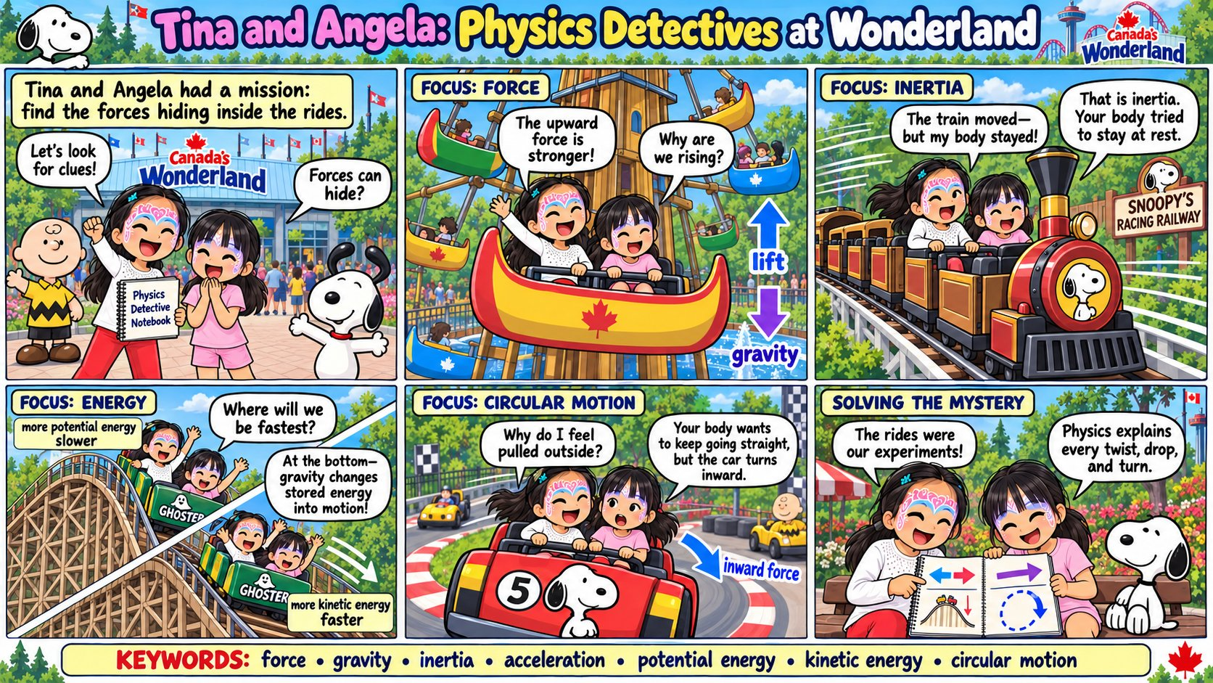
Prototype 1: Physics Detectives at the amusement park (overview page)

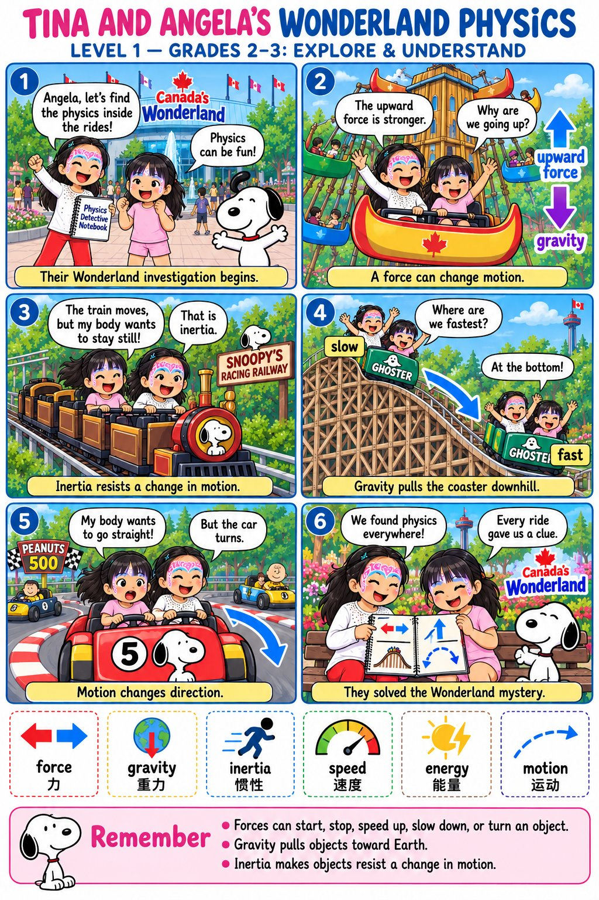
Prototype 2: Amusement-park physics, Level 1 (Grades 2 to 3)

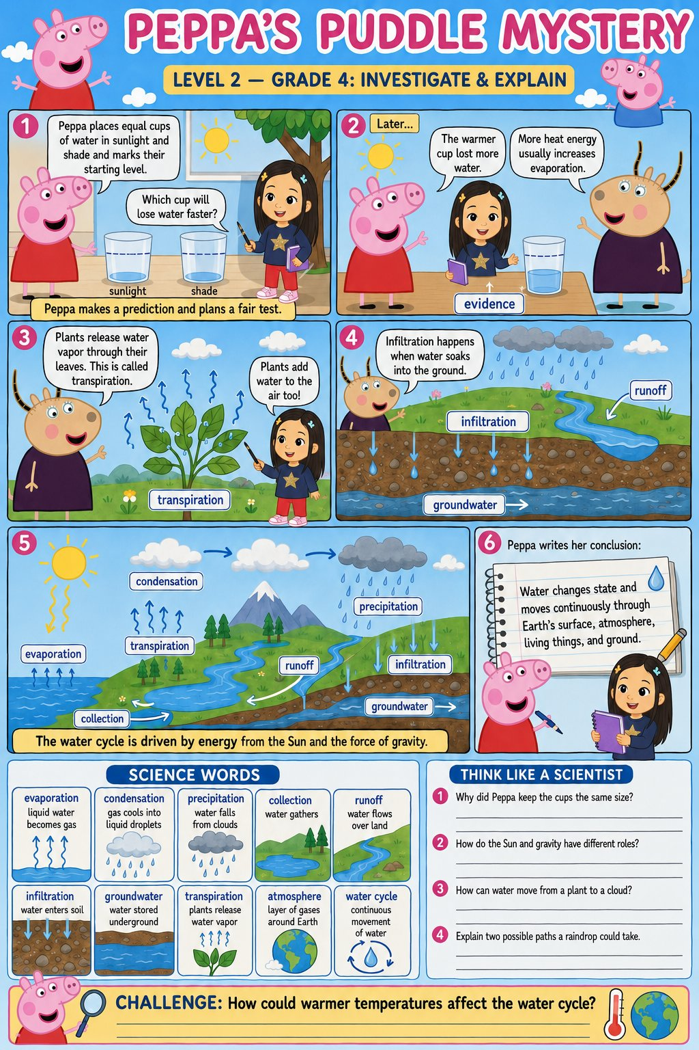
Prototype 3: Puddle Mystery, water cycle, Level 2 (Grade 4)

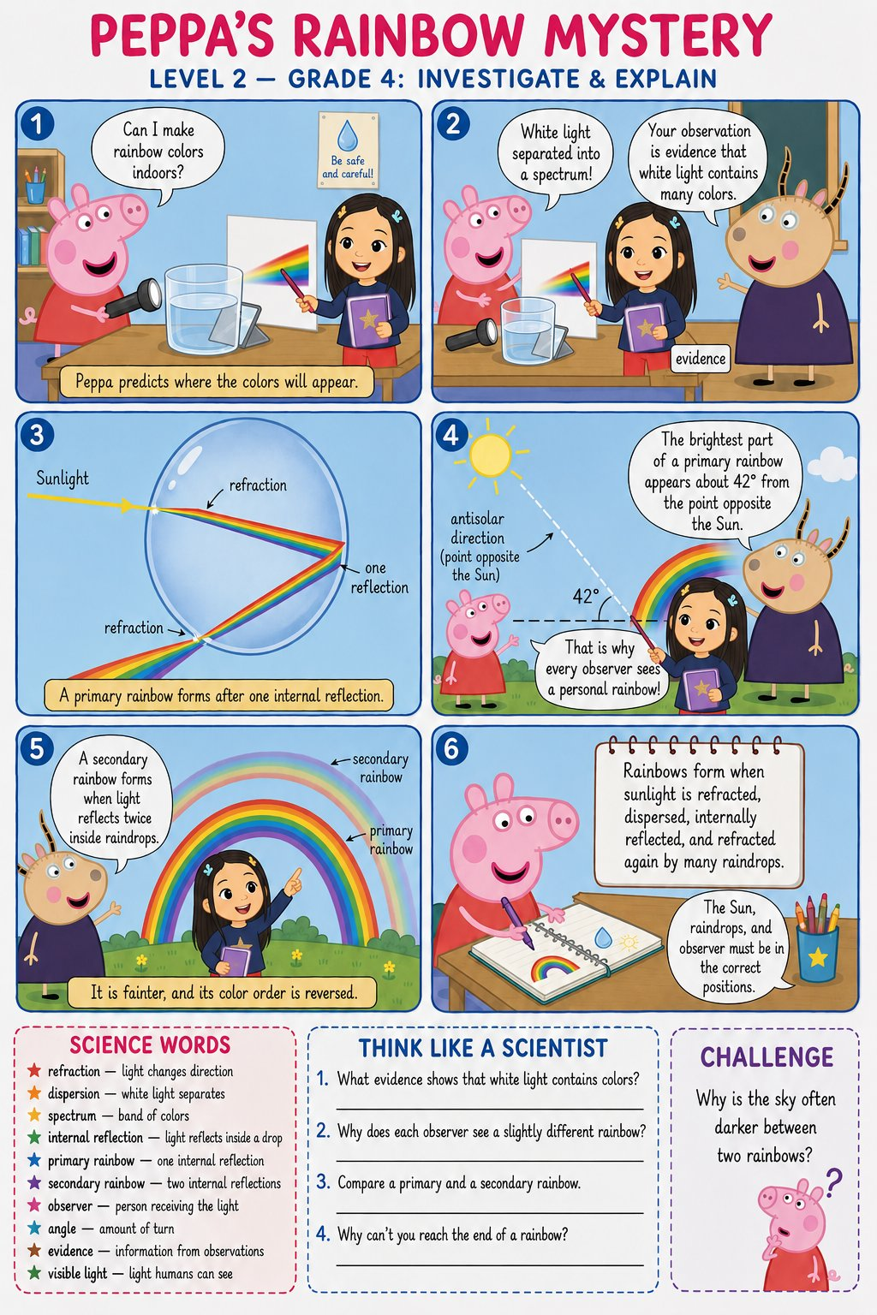
Prototype 4: Rainbow Mystery, Level 2 (Grade 4)

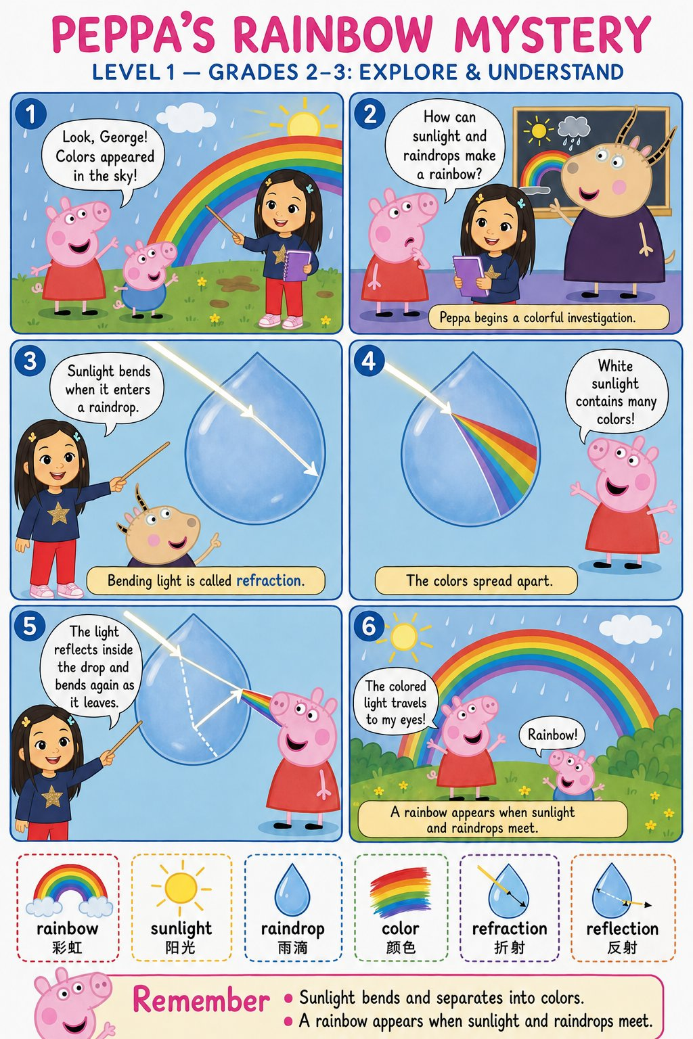
Prototype 5: Rainbow Mystery, Level 1 (Grades 2 to 3)

