|  |
| --- |
| My Puzzler Project |
| By Hunter Phillips  630-270-8241 |
| Puzzler |
| As part of my coursework with Udacity, I designed, tested, and iterated on a mobile VR experience called Puzzler. In this game, players enter a dark, gloomy, dungeon room and are required to solve a 3-D puzzle, similar to Simon Says. |

My Puzzler Project

Puzzler

# **Key Considerations**

For this application, several considerations were taken into account, specifically:

* Performance on mobile devices
* Simple, intuitive space and puzzle mechanics requiring little instruction or explanation
* Minimize VR sickness to ensure an enjoyable experience

# **Development Process**

## Potential Audience

As part of the development process, I developed a unique persona, named Mike, to serve as the potential audience. Mike enjoys simple games that present a moderate mental challenge. Because of this, he enjoys games that don’t require a long-term commitment. His ideal game can be played at his leisure, put down and revisited any number of times, without frequent check-ins or a lengthy familiarization period. Mike likes “games that engage my brain and challenge me” but “don’t require a lengthy time commitment.”

Development took place with this user in mind.

## Conceptual Sketches

***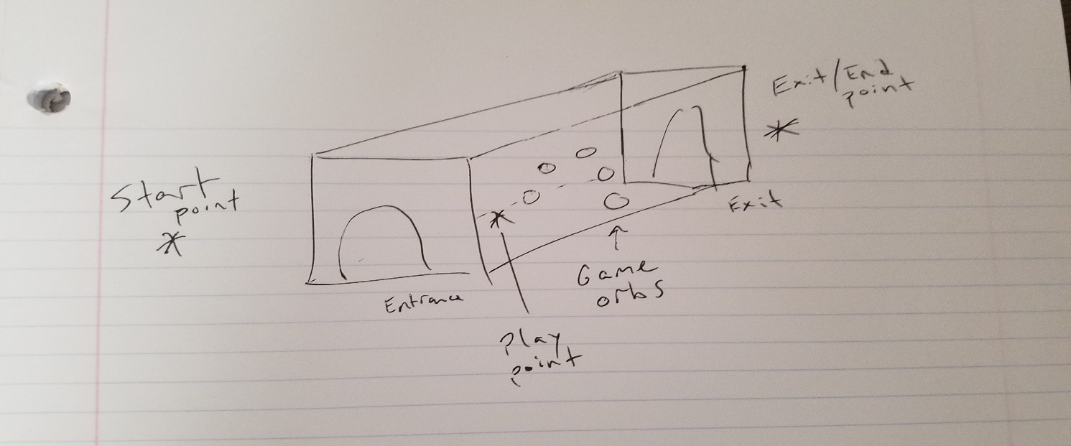****Scene Design Sketch*

*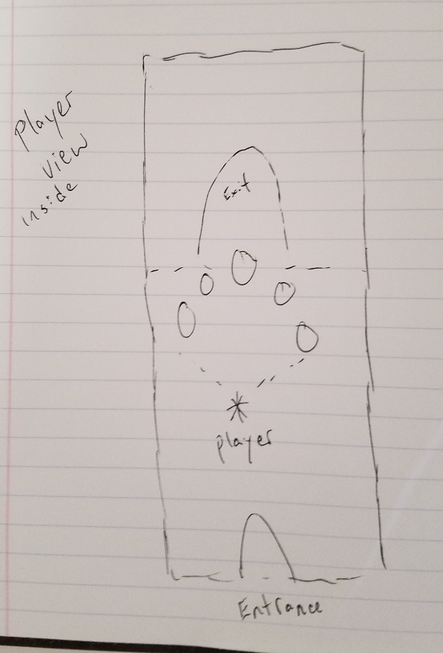Interior Player Viewpoint Sketch*

***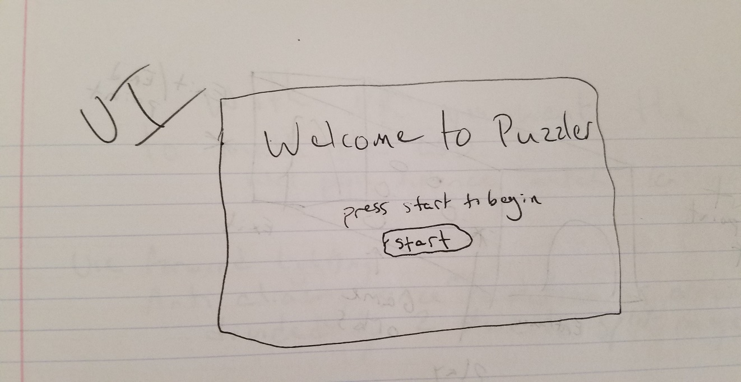****User Interface Sketch*

## Scene and Atmosphere

My initial goal was to establish a room that was dark and gloomy. I wanted to limit the overall lighting to maintain a darker mood, while using several spot lights to highlight the important game objects. Additional lighting was established to illuminate set pieces to enhance the atmosphere and allow curious users to look around and enjoy a fully developed room environment, while not distracting from the key gameplay components.

I then proceeded to more fully develop the exterior of the room to further enhance the overall atmosphere. I created an exterior environment to place this room in a secluded, abandoned farm-type location. I placed some mountains surrounding the room the give it a realistic location in a world, while also making it appear and feel secluded.

## Gameplay

The overall gameplay is fairly simple and straightforward. For VR, user movement is constricted to minimize VR sickness. The user starts at an initial spot outside of the main gameplay area. A simple user interface is displayed allowing the user to look around and select the start button using their gaze and the button click on the Google Cardboard.

After clicking started, the user “glides” inside of cabin, with the 5 gameplay orbs in clear view floating in front of him. The orbs begin to light up in a randomly generated sequence, with accompanying sounds to attract the user’s attention. After the light-up sequence is complete, the user is free to attempt to duplicate the sequence at their leisure.

Upon successful completion of the puzzle, the user is moved through the exit of the cabin, and a “success” UI is displayed. The user then has the ability to select restart to move back to the beginning and try again.

 ***Full Gameplay Walkthrough***

# **User Testing**

**Testing the Scene and Atmosphere**

Throughout development, I user-tested with one individual to obtain feedback regarding the overall mood and atmosphere within the scene.

I first tested that the scale of the building and camera height felt consistent with real world counterparts. The door, room, and camera height were all adjusted according to user feedback.

Next I focused on testing mood within the room where gameplay takes place. As stated in an earlier section, my initial goal was to establish a room that was dark and gloomy. My game-tester stated that the overall mood was “spooky” and “dark.” This was in line with my stated goal.

Finally, I tested the game mechanics and gameplay. Overall, all gameplay was reported as easy to intuit and perform. My user-tester stated that the difficulty level was “on the easy side,” however, that it was also, “hard enough that I didn’t always get it right on my first try.” For now, that is the appropriate difficulty level for this game.

Additionally, I tried to create a rapidly blinking light display when the puzzle was solved. My user indicated that the camera was moving before that blinking display finished, and that because of this, the sound effects with that light display were being played, but the user was not able to see what was going on. Through several additional iterations and tests, I decided that it was simply best to have all 5 game “globes” light once instead of blinking. In the future, I may wish to revisit this and develop a more elaborate “win” sequence to provide a more rewarding experience upon solving the puzzle.

# **Wrap up**

**Lessons Learned and Hopes for the Future**

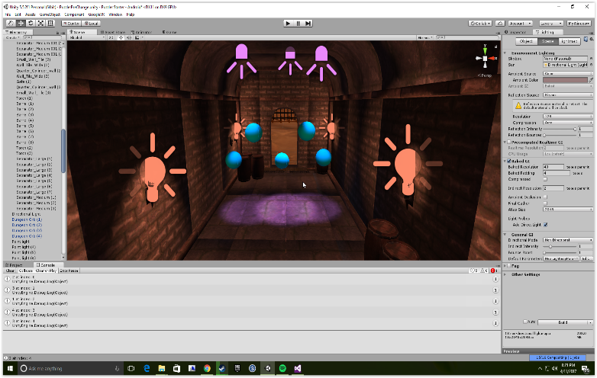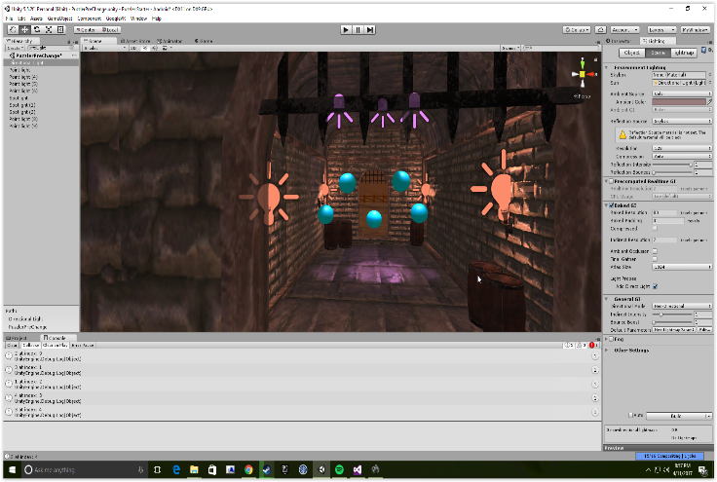During development, I I was getting a drastic difference from what I was expecting and what was actually being displayed. For some of the assets reimporting resolved some of the visual issues I was seeing, however it was very challenging trying to predict what my scene would look like while adjusting lights. Below are screenshots of my pre-bake and then baked scene.

*Pre-bake* *Baked*

As mentioned in the User Testing section, it is my plan to develop a more rewarding and stimulating “win” sequence in the future. Also, while the user is moving from the end point back to the start point, the pointer is not disabled, which leads to orbs being “clickable” during movement. This doesn’t inhibit gameplay in anyway but it does lead to an unintentional light-up of the one of the orbs during the player’s transit from end to start. That is something I would like to eliminate in a future version.

As a separate, personal endeavor I explored deploying my VR project to a Samsung Gear VR. Initially, the was not being displayed in any way playable. After troubleshooting and learning more about the settings preferred for the Gear VR, I was able to set up my project for quick deployment to either Google Carboard or Gear VR. That was one of the more satisfying outcomes of this project for me.

**Links**

Puzzler GitHub: <https://github.com/hphillip21/PuzzlerUdacity>

My GitHub Home: <https://github.com/hphillip21>