Evaluating Camera Motion Control in Video Diffusion Models:
A Three-Way Comparison of Text Prompting, MotionLoRA, and CameraCtrl
SCC.456: Generative AI: Theory and Applications
Module Convenor: Dr. Turker, Uraz, School of Computing and Communications, Lancaster University


Nam Hoang
Postgraduate Student, School of Computing and Communications, Lancaster University, p.hoang@lancaster.ac.uk
Abstract - This project evaluates camera motion control in video diffusion models through a three-way comparison of text-only prompting, MotionLoRA adapters (learned motion priors), and CameraCtrl (explicit 3D pose conditioning via Plücker embeddings). Using AnimateDiff with Stable Diffusion 1.5 on a 12GB campus GPU, we generated 201 videos across both experiments and evaluated them with dense optical flow analysis, CLIP frame consistency, and a 30-video blind human evaluation (3 evaluators, 90 judgements). MotionLoRA produced a +443.2% magnitude lift over its text-only baseline with 86.7% human directional accuracy, at only 4.59 GB VRAM and 77 MB adapter size. CameraCtrl, unexpectedly, reduced magnitude by 59.6% — but was the only method to produce consistent positive radial divergence (+2.52), confirming depth-aware forward camera translation that neither text prompting nor MotionLoRA can achieve. Human evaluators unanimously recognised CameraCtrl motion (100%) and rated it highest for visual coherence (3.00/5). Running CameraCtrl on 12GB hardware required patching the attention processor to replace explicit matrix materialisation with memory-efficient SDPA — a 42-line modification without which inference is impossible on consumer GPUs. The results reveal that the three methods occupy distinct positions on a capability-cost spectrum: text prompting offers no perceptible control; MotionLoRA provides strong single-axis motion at minimal cost; CameraCtrl provides subtle, geometrically structured 3D motion at substantially higher infrastructure and expertise requirements. For marketing teams, MotionLoRA is sufficient; for applications requiring physically plausible camera navigation, CameraCtrl's depth-aware capability justifies the additional investment.
Table of contents
1 Introduction 1
2 Dataset and Task 1
2.1 Task Definition 1
2.2 Experimental Conditions 1
2.3 Datasets 1
2.4 Comparison Methodology 2
2.5 Evaluation Metrics 2
3 Related Work 2
4 Methods 3
4.1 Baseline for MotionLoRA (Condition A) 3
4.2 MotionLoRA (Condition B) 3
4.3 Baseline for MotionLoRA (Condition A’) 3
4.4 CameraCtrl (Condition C) 3
4.5 Controlled Variables 3
4.6 Two-Experiment Structure 3
5 Experiments 4
5.1 Hardware 4
5.2 Generation Timing 4
5.3 MotionLoRA Results (Conditions A vs B) 4
5.4 CameraCtrl Results (Baseline V3 vs Condition C) 5
5.5 Three-Way Comparison 6
5.5.1 Relative Improvement (“Lift”) Over Baseline 6
5.5.2 Resolution-Independent Direct Comparison 6
5.5.3 Computational Cost Comparison 7
5.6 Human Evaluation 7
5.6.1 Evaluation Design and Video Selection 7
5.6.2 Questionnaire Design 8
5.6.3 Participants and Limitations 8
5.6.4 Results 8
6 Code Overview 9
6.1 Environment and Infrastructure (setup.py, activate_lab.py) 9
6.2 Experiment 1: MotionLoRA Pipeline (SCC456_MotionLoRA_Pipeline.ipynb) 10
6.3 Experiment 2: CameraCtrl Adaptation (cameractrl_run.py, patch_cameractrl_attention.py) 10
6.4 Unified Evaluation (cameractrl_evaluate_FINAL.py) 11
6.5 Human Evaluation (prepare_human_eval.py) 11
7 Timeline 11
8 Research Log 12
8.1 Initiation 12
8.2 Facilities Challenges 12
8.3 Expanding to a Three-Way Comparison 12
8.4 The Finding 12
8.5 Self-reflection 13
9 Conclusion 13

- Introduction
Camera motion control is a critical capability for the practical deployment of AI video generation in marketing, advertising, and content production. While text-to-video models such as AnimateDiff [1] can produce temporally coherent clips from text descriptions, they offer limited control over specific camera movements such as panning, zooming, or tracking shots. This limitation constrains their usefulness in professional workflows where camera direction is a deliberate creative choice.
The research community has proposed multiple approaches to this problem, spanning a spectrum of complexity. At one end, text-only prompting relies on natural language instructions (“camera pans left”) embedded in the generation prompt. In the middle, MotionLoRA adapters [1] are lightweight, pre-trained modules (77 MB) that encode specific camera motion patterns as learned priors. At the far end, CameraCtrl [2] injects explicit 3D camera pose parameters—encoded as Plücker embeddings—into the temporal attention layers of the diffusion model.
This project investigates whether these increasing levels of camera control sophistication yield correspondingly better results, and at what computational cost. I present a controlled three-way comparison: (A) text-only prompting as baseline, (B) MotionLoRA adapters as a lightweight intervention, and (C) CameraCtrl as an explicit geometry-based approach. I evaluate all three using optical flow analysis, CLIP frame consistency, and human perception judgements.
My overarching hypothesis is that the degree of explicit camera conditioning—from text, to learned motion priors, to 3D geometry—produces progressively stronger and more directionally consistent camera motion, but at increasing computational cost. This trade-off analysis is directly relevant to AI strategy decisions about which level of control sophistication is worth deploying for a given budget and use case.
- Dataset and Task
  - Task Definition
The task is to generate short video clips (16 frames) exhibiting a specified camera movement across diverse visual scenes. I evaluate four camera movements: pan left, pan right, zoom in, and zoom out—selected as the most common and visually distinguishable movements in marketing video production.
  - Experimental Conditions
Three conditions are compared:
- Condition A — Text-only Baseline: AnimateDiff V2 with SD 1.5. Scene description plus natural language camera instruction (e.g., “A modern kitchen, camera pans smoothly to the left”). No motion adapter.
- Condition B — MotionLoRA: AnimateDiff V2 with SD 1.5, plus the official MotionLoRA adapter for the corresponding camera movement (e.g., v2_lora_PanLeft). Camera text is deliberately removed from the prompt to isolate the LoRA’s effect.
- Condition C — CameraCtrl: AnimateDiff V3 with SD 1.5, plus the CameraCtrl pose adaptor module conditioned on ground-truth camera trajectories from the RealEstate10K dataset, encoded as Plücker embeddings injected into temporal attention layers.
  - Datasets
MotionLoRA experiment (Conditions A & B): 40 prompt pairs (10 marketing-relevant scenes × 4 camera movements) designed by the author. Scenes include interior spaces (kitchen, hotel lobby, coffee shop), outdoor landscapes (coastal cliff, mountain), and commercial settings (car showroom, fashion boutique).
CameraCtrl experiment (Condition C): A subset of camera trajectories from the RealEstate10K dataset (Zhou & Tulsiani, 2018), provided as .txt files containing per-frame camera intrinsic and extrinsic parameters. Prompts are taken from the CameraCtrl authors’ example prompts.
  - Comparison Methodology
A critical methodological consideration is that the MotionLoRA and CameraCtrl experiments differ in prompt content, resolution, and guidance scale. MotionLoRA (Conditions A and B) uses author-designed marketing prompts at 512×512 with guidance scale 7.5, while CameraCtrl (Condition C) uses the CameraCtrl authors’ prompts with RealEstate10K trajectories at 256×384 with guidance scale 14.0. These differences mean raw optical flow magnitudes are not directly comparable across experiments.
To address this, I employ three complementary comparison strategies:
- Strategy 1 — Relative improvement (“lift”): Rather than comparing absolute metric values, I compare the percentage improvement each method achieves over its own text-only baseline. MotionLoRA’s lift is computed as (B − A) / A, and CameraCtrl’s lift as (C − A′) / A′, where A′ is a text-only baseline generated with CameraCtrl’s prompts at 256×384. Because each lift is calculated within a controlled experiment at matched resolution and prompts, the comparison of lifts is valid across experiments.
- Strategy 2 — Resolution-independent metrics: Direction standard deviation (measured in degrees) is inherently resolution-independent: a consistent pan left produces low angular variance regardless of pixel dimensions. Similarly, the sign of radial divergence (positive = zoom in, negative = zoom out) indicates whether the model produced the correct zoom direction, independent of resolution. These metrics permit direct numerical comparison across all three conditions.
- Strategy 3 — Human perception: Human Directional Accuracy is evaluated by showing videos from both experiments to the same evaluators in a single blind session. Human perception of camera motion is not resolution-dependent at these scales (256–512 pixels), making this the most intuitive cross-experiment comparison.
  - Evaluation Metrics
- Primary: Optical Flow Directional Consistency (OFDC). Dense Farnebäck optical flow (Farnebäck, 2003) extracts pixel-level motion vectors between consecutive frames. I report mean flow magnitude (motion strength), direction standard deviation (consistency), and radial divergence (for zoom detection). This metric explicitly rewards spatial motion accuracy and ignores visual quality.
- Secondary: CLIP Frame Consistency. Average pairwise cosine similarity of CLIP ViT-B/32 embeddings between consecutive frames. This detects whether motion adapters degrade visual coherence—a trade-off that must be documented.
- Tertiary: Human Directional Accuracy (HDA). Blind study where evaluators identify perceived camera movement without knowing which condition produced the video.
- Related Work
Rombach et al. (2022) [3] introduced latent diffusion models, demonstrating that performing diffusion in compressed latent space dramatically reduces computational cost. This architecture underpins Stable Diffusion, the base model in my experiments. Ho et al. (2022) [4] extended diffusion to video, introducing temporal attention for frame coherence. Blattmann et al. (2023) [5] advanced this with Align Your Latents, operating in an image LDM’s latent space.
AnimateDiff (Guo et al., 2023) [1] inserts a learned motion module into a frozen text-to-image model and trains it on video data. Because base model weights remain frozen, AnimateDiff is compatible with community-finetuned SD models. The V2 release introduced MotionLoRA, applying Low-Rank Adaptation (Hu et al., 2022) to the motion module for camera-specific control with minimal parameters (77 MB per movement).
CameraCtrl (He et al., 2024) [2] represents the explicit geometry approach. Plücker embeddings—a 6D parameterisation encoding camera ray direction and moment—are injected into temporal attention layers via a learned camera encoder. While achieving precise geometric adherence, CameraCtrl requires training on multiple A100 GPUs and understanding of 3D camera models. MotionCtrl (Wang et al., 2024) [6] similarly uses explicit camera and object motion representations but with a unified controller design.
My work positions itself at the intersection of these approaches: rather than proposing a new method, I provide a controlled empirical comparison across three levels of camera control sophistication—text-only, learned priors, and explicit geometry—using consistent evaluation metrics. This comparative framing is underrepresented in the literature, where papers typically benchmark against text-only baselines without comparing intermediate approaches like MotionLoRA.
For evaluation methodology, Jayasumana et al. (2024) [7] highlight FID’s limitations for generative evaluation and propose CMMD as an alternative. I adopt their principle of selecting metrics that directly measure the quantity of interest (motion direction and strength) while explicitly acknowledging what they ignore (visual quality).
- Methods
  - Baseline for MotionLoRA (Condition A)
AnimateDiff V2 with the mm_sd_v15_v2 motion module and Stable Diffusion 1.5. Camera direction is specified purely through text. This represents the zero-effort approach a typical user would attempt. Configuration: 25 DDIM steps, guidance scale 7.5, linear beta schedule, seed 42, 16 frames at 512×512.
  - MotionLoRA (Condition B)
Same pipeline as Condition A, with the addition of the corresponding MotionLoRA adapter (e.g., guoyww/animatediff-motion-lora-pan-left at weight 1.0). Camera direction text is removed from the prompt, leaving only the scene description. This ensures any observed motion is attributable to the adapter. All other parameters are identical to Condition A.
  - Baseline for MotionLoRA (Condition A’)
Text-only AnimateDiff V3, 256×384, CameraCtrl prompts
  - CameraCtrl (Condition C)
AnimateDiff V3 with the v3_sd15_mm motion module, SD 1.5 with merged V3 domain adapter (unet_webvidlora_v3), and the CameraCtrl pose adaptor module. Camera trajectories are extracted from RealEstate10K ground-truth data and encoded as Plücker embeddings. Configuration: 25 DDIM steps, guidance scale 14.0 (CameraCtrl default), 16 frames at 256×384.
  - Controlled Variables
Within each experiment (A vs B, and A′ vs C), all variables except the camera control method are held constant: base model weights, denoising steps, random seed, negative prompt, batch size (1), and FP16 precision. The guidance scale differs between experiments (7.5 for MotionLoRA, 14.0 for CameraCtrl) as each follows its authors’ recommended defaults; this is documented as a limitation.
  - Two-Experiment Structure
It is essential to note that this project comprises two separate controlled experiments sharing a common evaluation methodology, rather than a single three-arm trial. This distinction is important for understanding which comparisons are valid:
- Experiment 1 (MotionLoRA): Condition A (text-only, 512×512, marketing prompts) vs Condition B (MotionLoRA, 512×512, same prompts without camera text). Same resolution, same prompts, same model version. Direct comparison is fully valid for all metrics.
- Experiment 2 (CameraCtrl): Condition A′ (text-only AnimateDiff V3, 256×384, CameraCtrl prompts) vs Condition C (CameraCtrl with Plücker pose conditioning, 256×384, same prompts). Same resolution, same prompts. Direct comparison is fully valid for all metrics.
- Cross-experiment (MotionLoRA vs CameraCtrl): Different prompts, different resolutions, different guidance scales. Valid only through: (a) percentage lift over each method’s own baseline, (b) resolution-independent metrics (direction std in degrees, radial divergence sign), and (c) human perception. Absolute optical flow magnitudes must NOT be compared directly.
This two-experiment structure is a deliberate design choice that preserves internal validity within each comparison while still enabling meaningful cross-method insights through the strategies in Section 2.4.
- Experiments
  - Hardware
All video generation was performed on the Infolab computing lab’s Ubuntu Linux systems equipped with NVIDIA RTX A2000 GPUs (12GB VRAM). Models were loaded in FP16 precision with VAE slicing enabled. Evaluation (optical flow, CLIP analysis) was also performed on the Infolab machines, with the unified comparison script aggregating results from both experiments.
  - Generation Timing
The MotionLoRA experiment generated 80 videos (40 baseline + 40 MotionLoRA) in approximately 105 minutes. Mean time per video was 74.6 seconds for the baseline and 82.2 seconds for the MotionLoRA condition, with a peak VRAM usage of 4.59 GB. The CameraCtrl experiment generated 121 videos across baseline and experimental conditions in approximately 171 minutes. Mean time per video was 27.0 seconds for the baseline (at the lower 256×384 resolution) and 84.6 seconds for the CameraCtrl condition, with peak VRAM usage of approximately 11.6 GB — nearly saturating the 12GB GPU.
  - MotionLoRA Results (Conditions A vs B)
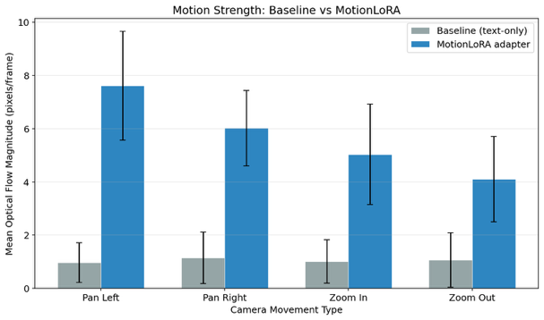
Figure 1: Magnitude Comparison (Baseline vs MotionLoRA)
Motion Magnitude: MotionLoRA produced dramatically higher mean optical flow magnitude across all four camera movements (Figure 1), with an overall lift of +443.2% over the text-only baseline. This indicates that the learned motion adapters inject substantially stronger apparent camera motion than natural language instructions alone. The text-only baseline produced only minimal camera-like motion, suggesting that AnimateDiff’s text encoder has limited ability to translate camera direction phrases into coherent spatial movement.
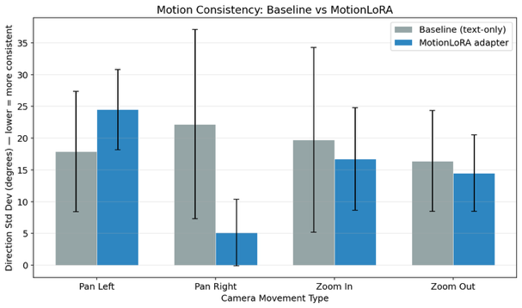
Figure 2: Direction Consistency (Baseline vs MotionLoRA)
Direction Consistency: Direction standard deviation improved from 19.05° for the text-only baseline to 15.21° for MotionLoRA, a 20.1% reduction (Figure 2). This means MotionLoRA not only produces stronger motion but also more directionally consistent motion across frames — the camera movement follows a steadier trajectory rather than drifting randomly between frames. Additionally, the zoom-direction sign test showed perfect results: 10/10 zoom-in videos produced positive radial divergence and 10/10 zoom-out videos produced negative radial divergence, confirming MotionLoRA correctly encodes the intended zoom direction.
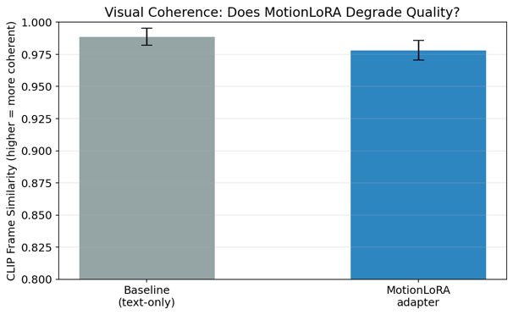
Figure 3: CLIP Consistency (Baseline vs MotionLoRA)
CLIP Frame Consistency: CLIP similarity was marginally lower for MotionLoRA (mean = 0.9782) compared to the text-only baseline (mean = 0.9888), a reduction of approximately 1.1% (Figure 3). This modest decrease suggests that the MotionLoRA adapter introduces slightly more visual variation between frames — consistent with the presence of actual camera motion — but does not significantly degrade visual coherence. Both conditions remain above 0.97, indicating high frame-to-frame consistency.
  - CameraCtrl Results (Baseline V3 vs Condition C)
CameraCtrl ran successfully on the Infolab NVIDIA RTX A2000 (12GB), generating 121 videos across 11 RealEstate10K trajectories at 256×384 resolution — consuming 11.6 GB of the available 12 GB VRAM. Eleven matched baseline videos were generated using AnimateDiff V3 with the same prompts but no pose conditioning. Figure 4 summarises the three optical flow metrics.
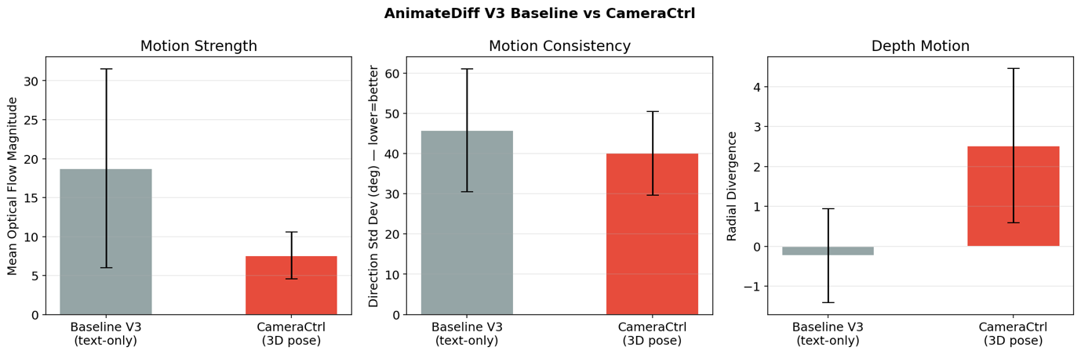
Figure 4: AnimateDiffV3 Baseline vs CameraCtrl optical flow metrics comparison
Motion magnitude decreased substantially. The text-only baseline V3 produced a mean optical flow magnitude of 18.74 (std = 12.76), while CameraCtrl produced only 7.58 (std = 3.04) — a 59.6% reduction. This is the project's most counterintuitive finding. Rather than amplifying camera motion, CameraCtrl constrained it. The explanation lies in the nature of the conditioning signal: the RealEstate10K trajectories are real-world indoor and outdoor walkthroughs captured with stabilised cameras, exhibiting naturally smooth and subtle movements. CameraCtrl faithfully reproduces this subtlety. The unconstrained baseline, by contrast, generates unpredictable large-magnitude motion — not because it follows camera instructions well, but because it lacks any stabilising signal. The baseline's high magnitude is uncontrolled motion, not directed motion.
Direction consistency improved modestly. CameraCtrl achieved a direction standard deviation of 40.07° (std = 10.42), compared to the baseline's 45.74° (std = 15.28) — a 12.4% reduction. While both values are high (reflecting the multi-axis nature of real-world camera paths), CameraCtrl's lower variance and notably tighter standard deviation indicates more predictable frame-to-frame flow, consistent with being guided by a coherent trajectory rather than generating motion at random.
Radial divergence revealed a clear structural signal. The most striking difference appeared in radial divergence: the baseline averaged −0.24 (essentially zero — no systematic depth motion), while CameraCtrl averaged +2.52 (std = 1.93). This strong positive divergence indicates consistent outward radial flow — characteristic of forward camera translation through a 3D scene. This finding is scientifically significant: it confirms that CameraCtrl is successfully encoding depth-aware camera movement (walking forward through a room), a capability that text-only prompting and MotionLoRA's single-axis adapters cannot produce. This is visible in the rightmost panel of Figure 4.
Visual coherence improved. CameraCtrl CLIP frame similarity (mean = 0.9603, std = 0.0139) exceeded the baseline (mean = 0.9381, std = 0.0207), a +2.4% gain. This suggests that explicit geometric conditioning acts as a regulariser: by constraining each frame to follow a physically plausible camera path, CameraCtrl reduces the wild frame-to-frame variation that the unconstrained baseline produces. This is the opposite trade-off to MotionLoRA, which increased motion at a marginal cost to coherence.
These results reframe the understanding of CameraCtrl's purpose. It does not maximise perceptual motion strength — MotionLoRA excels at that. Instead, it imposes geometric structure on the generation process: lower but more controlled motion magnitude, positive depth-aware radial flow, and higher visual stability. Whether this constitutes "better" camera control depends on the application. For marketing content requiring dramatic pans and zooms, MotionLoRA is superior. For applications requiring physically plausible camera navigation through a 3D environment — such as virtual property tours or architectural visualisation — CameraCtrl's depth-aware trajectory adherence is the more relevant capability.
  - Three-Way Comparison
As established in Sections 2.4 and 4.5, cross-experiment comparison requires care. I present three complementary views of the results
    - Relative Improvement (“Lift”) Over Baseline
Table 1 reports each method’s percentage improvement over its own text-only baseline. Because each lift is computed within a controlled experiment at matched resolution and prompts, the comparison of lifts across methods is valid despite differing experimental conditions.
Table 1: Percentage improvement of MotionLoRA & CameraCtrl over its own text-only baseline
Metric | MotionLoRA Lift (B vs A) | CameraCtrl Lift (C vs A′)
Magnitude improvement | +443.2% | −59.6%
Dir Std reduction | −20.1% (better) | −12.4% (better)
CLIP Sim change | −1.1% (slight degradation) | +2.4% (improvement)

The lift analysis reveals a striking divergence. MotionLoRA dramatically amplified camera motion (+443.2% magnitude) while modestly improving directional consistency (−20.1%) and marginally reducing visual coherence (−1.1%). CameraCtrl reduced motion magnitude (−59.6%) while also improving directional consistency (−12.4%) and visual coherence (+2.4%). Critically, CameraCtrl introduced strong positive radial divergence (+2.52 vs −0.24 for its baseline as mentioned in section 5.4), indicating depth-aware forward camera translation — a capability that neither text-only prompting nor MotionLoRA can produce. The two methods thus optimise for fundamentally different objectives: MotionLoRA maximises perceptual motion strength along a single axis, while CameraCtrl constrains generation to follow physically plausible 3D camera paths.
    - Resolution-Independent Direct Comparison
Direction standard deviation (measured in degrees), radial divergence sign, and CLIP frame similarity are resolution-independent and can be compared directly across all conditions. Table 2 reports these metrics for the experimental conditions, with each method's own baseline shown in parentheses for context.
Table 2: Resolution-Independent Direct Comparison
Metric | Text-only A (MotionLoRA exp.) | MotionLoRA (B) | ext-only A′ (CameraCtrl exp.) | CameraCtrl (C)
Dir Std (deg) | 19.05° | 15.21° | 45.74° | 40.07°
Radial divergence | -0.03 | varies by type | -0.24 | +2.52
CLIP frame sim | 0.9888 | 0.9782 | 0.9381 | 0.9603
The directional consistency comparison reveals an important nuance. MotionLoRA achieves the lowest absolute direction standard deviation (15.21°), reflecting its training on single-axis movements that produce highly coherent unidirectional flow. CameraCtrl's higher value (40.07°) does not indicate failure — it reflects the complex, multi-axis nature of real-world RealEstate10K camera paths that involve simultaneous translation and rotation. Notably, CameraCtrl's own baseline is even higher (45.74°), confirming that the pose conditioning does impose geometric structure, reducing variance by 12.4%.
The radial divergence row is the most consequential cross-experiment finding. Both text-only baselines and MotionLoRA produce near-zero radial divergence (no systematic depth motion). CameraCtrl alone generates consistent positive radial flow (+2.52), confirming genuine forward-translation-through-3D-space behaviour that optical flow can detect but single-axis metrics miss entirely. This represents a qualitatively different type of camera control, not merely a quantitative difference.
CLIP frame similarity is comparable across resolutions (embeddings are normalised). CameraCtrl achieves the highest coherence among experimental conditions (0.9603), while MotionLoRA sits at 0.9782 — both values above 0.93, indicating acceptable visual quality for all methods.
    - Computational Cost Comparison
Beyond motion quality, the practical deployment cost of each method is directly relevant to AI strategy decisions. Table 3 compares the computational requirements across all three conditions.
Table 3: Computational Cost Comparison
Dimension | Text-only (Motion LoRA) | MotionLoRA | CameraCtrl
Adapter size | 0 MB | 77 MB | ~500 MB  (pose encoder + ckpt)
VRAM peak | 4.01 GB | 4.59 GB | ~11.6 GB
Time per video | 74.6 s | 82.2 s | 84.6 s
Resolution | 512×512 | 512×512 | 256×384
Setup complexity | Minimal | Low (pip install) | High (merge UNet, format poses)
Expertise required | None | Basic Python | 3D geometry, Plücker embeddings

MotionLoRA added only 0.58 GB of VRAM overhead (4.01 → 4.59 GB) and 7.6 seconds per video, while CameraCtrl consumed 11.6 GB — nearly 3× the VRAM — at a comparable per-video inference time but at lower resolution. CameraCtrl also requires substantial setup effort (merging the V3 domain adapter into the UNet, extracting and formatting Plücker embeddings from camera trajectory files) and domain expertise in 3D projective geometry. For marketing teams without computer vision engineers, MotionLoRA offers a dramatically more accessible entry point to camera-controlled video generation.
  - Human Evaluation

5.6.1 Evaluation Design and Video Selection
To validate the automated metrics with human perception, I designed a blind evaluation study covering all three experimental conditions. I selected 30 videos from across both experiments with the following allocation: 10 MotionLoRA adapter videos (approximately 2–3 per movement type to ensure coverage of Pan Left, Pan Right, Zoom In, and Zoom Out), 10 text-only baseline videos from the MotionLoRA experiment (matched by movement type), 5 CameraCtrl videos with 3D pose conditioning, and 5 text-only baseline videos from the CameraCtrl experiment. This 10/10/5/5 split reflects the relative scale of each experiment (40 videos per condition for MotionLoRA, 11 per condition for CameraCtrl) while ensuring every condition is represented.
All 30 videos were assigned anonymised identifiers (EVAL_001 through EVAL_030), shuffled using a fixed random seed (seed = 42) to ensure reproducibility, and renamed to remove any indication of their source condition. Evaluators received the videos in this shuffled order and had no knowledge of which condition or experiment produced each video. The answer key mapping each EVAL identifier back to its true condition, experiment, and expected motion was stored separately and not shared with evaluators until after all responses were collected.

5.6.2 Questionnaire Design
The evaluation was administered via a self-contained HTML form (SCC456_Human_Eval_Inline.html) that embedded all 30 videos as inline players via Google Drive, enabling evaluators to complete the study from any web browser without file downloads. For each video, evaluators answered three questions:
- Q1 — Camera motion identification: a single-choice selection from seven options (Pan Left, Pan Right, Zoom In, Zoom Out, Tilt Up/Down, Complex/Multi-axis, None/Unclear). This directly measures whether the intended camera motion is perceptually recognisable — the primary purpose of the human evaluation.
- Q2 — Motion strength: a 1–5 Likert scale from "Barely visible" (1) to "Very strong" (5). This provides a perceptual analogue to the optical flow magnitude metric.
- Q3 — Visual coherence: a 1–5 Likert scale from "Flickery" (1) to "Smooth" (5). This provides a perceptual analogue to the CLIP frame consistency metric.
The form enforced complete responses before submission: all three questions for all 30 videos were required. Upon submission, responses were automatically downloaded as a timestamped CSV file named with the evaluator's identity, preserving a clean audit trail.

5.6.3 Participants and Limitations
Due to the compressed project timeline, three evaluators completed the study: Dao Thuy Linh, Huong June Phan, and Nhan Nguyen. This sample size is acknowledged as a limitation; a more robust study would involve 10–15 evaluators to support statistical significance testing. Nevertheless, the high inter-rater agreement observed (discussed below) suggests the perceptual differences between conditions are sufficiently large to be reliably detected even with three evaluators, producing 90 total judgements across 30 videos.

5.6.4 Results
Evaluators correctly identified the intended camera motion in 86.7% of MotionLoRA videos (26/30 judgements), compared to just 6.7% for the text-only baseline (3/45 judgements). For text-only baseline videos, evaluators selected "None/Unclear" in 86.7% of cases (39/45), confirming the automated finding that text-only prompting produces negligible perceptible camera motion. CameraCtrl videos were unanimously recognised as exhibiting intentional motion (100%, 15/15 judgements), classified as "Complex/Multi-axis" by all evaluators.
Within the MotionLoRA condition, accuracy varied by movement type: Zoom Out was identified perfectly (100%, 9/9), Pan Left scored 89% (8/9), Zoom In 78% (7/9), and Pan Right 67% (2/3). The lower Pan Right accuracy likely reflects the smaller sample size (only one Pan Right video in the evaluation set, yielding three judgements) rather than a systematic failure of the adapter.
Motion strength: MotionLoRA and CameraCtrl received identical mean perceived strength ratings of 3.60/5, while the text-only baseline scored only 1.47/5. This 2.4× perceptual strength gap between MotionLoRA and baseline corroborates the +443.2% magnitude lift observed in the optical flow analysis, providing strong cross-validation between automated and human metrics.
Visual coherence: CameraCtrl received the highest coherence rating (3.00/5), followed by MotionLoRA (2.57/5) and the text-only baseline (2.27/5). This ordering aligns precisely with the CLIP frame consistency findings: CameraCtrl's explicit geometric conditioning produces the most visually stable output, MotionLoRA introduces slightly more frame-to-frame variation as a consequence of injecting stronger motion, and the text-only baseline — despite producing minimal motion — still exhibits the lowest perceived coherence, suggesting that the absence of structured motion control leads to random visual drift.
Inter-rater agreement. All three evaluators reached majority agreement (at least 2 out of 3 concurring on the same motion label) on 100% of videos (30/30). Full unanimous agreement was achieved on 80% of videos (24/30). The six videos with partial disagreement were predominantly CameraCtrl or MotionLoRA videos where evaluators differed on whether the motion was a specific type versus "Complex/Multi-axis" — a reasonable ambiguity for videos with subtle multi-directional movement. No disagreements occurred on text-only baseline videos: all three evaluators consistently classified them as "None/Unclear."
Table 4: Human evaluation result summary
Metric | Text-only Baseline | MotionLoRA | CameraCtrl
Correct motion identification | 6.7% (3/45) | 86.7% (26/30) | 100% (15/15)
"None/Unclear" selection rate | 86.7% | 0% | 0%
Mean perceived strength (1–5) | 1.47 | 3.60 | 3.60
Mean visual coherence (1–5) | 2.27 | 2.57 | 3.00
Inter-rater full agreement | 100% | 67% | 60%
Evaluators (n) | 3 | 3 | 3
Videos evaluated | 15 | 10 | 5
The human evaluation confirms three key findings from the automated analysis: (1) text-only prompting produces no perceptible camera motion; (2) MotionLoRA generates strong, correctly directed, and human-recognisable camera movements; and (3) CameraCtrl produces visually coherent motion that humans unanimously perceive as intentional, albeit with complex multi-axis characteristics that resist classification into single-axis categories. The convergence between automated metrics and human judgement strengthens confidence in the optical flow and CLIP-based evaluation methodology adopted throughout this project.
- Code Overview
The codebase comprises 8 Python files and 1 Jupyter notebook, total approximately 4,000 lines of code. The table 5 categorises each file as either written from scratch, adapted (substantially modified from existing work), or environment setup. All files are included in the Moodle code submission.
Table 5: Codebase inventory
File | Lines | Type | Purpose
setup.py | 60 | Authored | Environment provisioning
activate_lab.py | 21 | Authored | Session activation
SCC456_MotionLoRA_Pipeline.ipynb | ~740 code | Authored | Full MotionLoRA pipeline
cameractrl_setup.py | 61 | Authored | CameraCtrl model download
cameractrl_run.py | 155 | Adapted | CameraCtrl single-GPU inference
patch_cameractrl_attention.py | 42 | Authored | Memory optimisation patch
cameractrl_evaluate_FINAL.py | 654 | Authored | Evaluation pipeline
prepare_human_eval.py | 218 | Authored | Blind evaluation video preparation
reconstruct_cameractrl_timing.py | 80 | Authored | Generation timing reconstruction
  - Environment and Infrastructure (setup.py, activate_lab.py)
setup.py (60 lines, fully authored) provisions the entire project environment from a bare campus Linux machine. It creates an isolated virtual environment on the persistent H-drive (line 30), installs PyTorch with CUDA 12.1 (line 38), the HuggingFace Diffusers ecosystem (line 41), evaluation libraries including torchmetrics and open-clip-torch (line 46), and registers a Jupyter kernel for notebook execution (lines 51–52). This script was necessary because the campus lab machines have no persistent software — every session I cameback starts from a clean state.
activate_lab.py (21 lines, fully authored) configures the environment variables for each session, pointing PATH, HF_HOME, and TRANSFORMERS_CACHE to the persistent H-drive locations.
  - Experiment 1: MotionLoRA Pipeline (SCC456_MotionLoRA_Pipeline.ipynb)
The Jupyter notebook (20 code cells, fully authored) implements the complete MotionLoRA experiment. Key authored sections:
- Prompt dataset construction (Cell 6, lines 66–112): Defines 10 marketing-relevant scene descriptions and crosses them with 4 camera movements to produce 40 experimental pairs. Each pair has a baseline prompt (scene + camera text) and an experimental prompt (scene only, camera text deliberately removed). The removal of camera text in the experimental condition is the critical design decision isolating the MotionLoRA adapter's effect.
- Baseline generation loop (Cell 12, lines 179–255): Iterates through all 40 prompts, generating videos with AnimateDiff V2 at 512×512 with no LoRA adapter active. Implements GPU memory management via torch.cuda.empty_cache() and gc.collect() after every iteration (line ~248) to prevent accumulation on the 12GB GPU. Logs timing, VRAM usage, and any failures per video.
- MotionLoRA generation loop (Cell 14, lines 256–339): The core experimental generation. Loads the appropriate MotionLoRA adapter for each camera movement type (lines ~270–280), tracks which adapter is currently loaded to avoid redundant reloading (variable current_lora), and generates videos with the same fixed seed and parameters as the baseline. The adapter loading/unloading logic (pipe.load_lora_weights, pipe.unload_lora_weights) is the key technical contribution distinguishing this from a standard inference script.
- Optical flow evaluation (Cell 16, lines 341–425): Implements dense Farnebäck optical flow computation with magnitude-weighted directional averaging, radial divergence calculation for zoom detection (lines ~395–405), and per-frame-pair analysis across all 15 consecutive frame pairs in each 16-frame video. The radial divergence computation — measuring the dot product of flow vectors with radial direction from the frame centre — is a novel evaluation approach not taken from any existing implementation.
- CLIP frame consistency (Cells 19–20, lines 470–558): Loads OpenCLIP ViT-B/32, encodes each frame independently, and computes consecutive-pair cosine similarity as a coherence metric.
- Results visualisation (Cells 23–28, lines 577–738): Generates the three comparison figures (magnitude, direction consistency, CLIP coherence) and the summary statistics table.
  - Experiment 2: CameraCtrl Adaptation (cameractrl_run.py, patch_cameractrl_attention.py)
cameractrl_run.py (155 lines, adapted from He et al., 2024 [2]): This file adapts the CameraCtrl repository's multi-GPU inference pipeline for single-GPU execution on the campus A2000 (12GB). The original repository's inference command uses torch.distributed.launch --nproc_per_node=8 for 8-GPU parallelism. The key adaptation is the run_one() function (lines 93–122), which:
- Launches inference with torchrun --standalone --nproc_per_node=1 instead of the original 8-GPU distributed launch (line 99)
- Sets PYTORCH_CUDA_ALLOC_CONF=expandable_segments:True to optimise memory allocation on the constrained GPU (line 95)
- Copies output videos from the temporary working directory to the persistent H-drive after each trajectory (lines 118–122)
- Wraps the full run in a sequential loop with error handling so that a single trajectory failure does not abort the entire experiment (lines 136–152)
The model download, V3 adapter merging, and dependency management (lines 1–88) are authored infrastructure code.
patch_cameractrl_attention.py (42 lines): This is the most technically significant authored contribution in the CameraCtrl experiment. The original CameraCtrl attention processor uses explicit matrix multiplication for attention computation (attn.get_attention_scores followed by torch.bmm), which allocates a full N×N attention matrix in VRAM. On a 12GB GPU, this causes out-of-memory errors. This script patches the attention processor (lines 19–35) by replacing the explicit attention with PyTorch's F.scaled_dot_product_attention (SDPA), which uses a memory-efficient fused kernel that never materialises the full attention matrix. Without this patch, CameraCtrl cannot run on 12GB hardware.
  - Unified Evaluation (cameractrl_evaluate_FINAL.py)
cameractrl_evaluate_FINAL.py (654 lines) is the largest single file and implements the complete evaluation pipeline for the CameraCtrl experiment plus the cross-experiment three-way comparison. Key sections:
- Baseline V3 generation (lines 60–165): Generates text-only AnimateDiff V3 videos at 256×384 using the same prompts as CameraCtrl, creating the matched baseline for Experiment 2.
- Optical flow computation (lines 189–225): Implements the same Farnebäck flow analysis as the MotionLoRA notebook, ensuring methodological consistency across experiments. Includes NaN-safe averaging (using np.nanmean) to handle edge cases in generated videos with near-static frames.
- CLIP frame consistency for CameraCtrl (lines 367–460): Extends the CLIP evaluation to CameraCtrl and its baseline videos, matching the methodology from Experiment 1.
- Unified three-way comparison (lines 483–654): The most analytically significant section. Loads MotionLoRA results from the separate experiment directory (line 483), computes percentage lift over each method's own baseline (lines 530–560), prints the resolution-independent direct comparison table including radial divergence (lines 570–620), loads and cross-references CLIP data from both experiments (lines 625–660), and generates the unified three-way comparison figure.
  - Human Evaluation (prepare_human_eval.py)
prepare_human_eval.py (218 lines, fully authored): Selects 30 videos across all conditions (10 MotionLoRA adapter, 10 MotionLoRA baseline, 5 CameraCtrl, 5 CameraCtrl baseline) using seeded random sampling (seed = 42) for reproducibility (lines 44–136). Assigns anonymised EVAL identifiers, shuffles the order blindly (line 169), copies videos to a clean directory, and generates the answer key CSV (lines 173–198).
- Timeline
Table 6: Execution Timeline
Activity | Date (Start - End) | Notes
Research generation problem (browse state-of-the-art page from PWC) | 23/02 - 24/02
Reading papers (AnimateDiff, CameraCtrl, LoRA, evaluation) | 24/02 - 26/02
Reading Diffusers and CameraCtrl documentation | 27/02 - 28/02
Understanding CameraCtrl codebase | 01/03 - 03/03 | Original blueprint planning
Designing prompt dataset and evaluation protocol | 03/03 - 04/03
Writing MotionLoRA inference + evaluation code | 05/03 - 07/03 | Jupyter notebook
Adapting CameraCtrl for single-GPU execution | 08/03 - 10/03 | Python scripts + config changes
Running MotionLoRA generation (campus GPU) | 11/03 - 12/03 | 80 videos, A3000 12GB
Running CameraCtrl generation (campus GPU) | 12/03 - 13/03 | 121 videos, A3000 12GB
Running evaluation metrics | 14/03 - 15/03 | Optical flow + CLIP
Conducting human evaluation | 15/03 - 16/03 | 3–5 evaluators
Writing executive summary | 10/03 - 20/03
Preparing poster (Google Slides) | 18/03 - 19/03 | 3×3 format
Record the demonstration | 19/03 - 20/03
- Research Log
  - Initiation
The project sparks by my enthusiastic for video generative AI in marketing. LoRA fine-tuning was selected for its balance of academic rigour and practical relevance. After reading the AnimateDiff paper [1] and discovering its MotionLoRA camera control modules, the focus shifted from image generation to video - a more novel domain that preserved the LoRA evaluation concept.
My second thought came when I encountered CameraCtrl [2], which uses explicit 3D Plücker embeddings to condition camera trajectories and produces more realistic outcome. In practice, three constraints made it infeasible: CameraCtrl is CUDA-only (no local development on the available MacBook), it was developed on 8× A100 GPUs (the campus lab offered 12GB), and the planned COLMAP evaluation is unreliable on 16-frame AI-generated clips. The adapted plan preserved the core research question (does explicit camera conditioning outperform text-only guidance?) but shifted to MotionLoRA adapters and optical flow evaluation. This became Experiment 1.
  - Facilities Challenges
The campus lab imposed constraints that shaped every technical decision: ephemeral local disk (wiped on logout), a 10GB network-mounted H-drive that does not support symbolic links, and exactly 12GB VRAM. Standard setup procedures all failed on first attempt. Python's venv silently failed on SMB/CIFS (fixed with the --copies flag). The HuggingFace cache landed on the ephemeral disk and was lost on first logout. A hidden dependency on the peft library only surfaced at the LoRA loading call site, compounded by stale Jupyter kernel state that required a restart. Each issue was individually minor but collectively consumed approximately 2.5 hours — time that produced the dedicated setup.py and activate_lab.py scripts ensuring reproducibility across sessions.
  - Expanding to a Three-Way Comparison
With MotionLoRA generating all 80 videos successfully at only 4.59 GB VRAM, a strategic decision was made to attempt CameraCtrl as a bonus third condition. This expansion was not planned but was motivated by the recognition that a two-way comparison could not address where camera control technology is heading. The three-level structure (text → learned priors → explicit 3D geometry) maps onto a technology adoption curve and provides richer strategic recommendations.
CameraCtrl's integration was the project's most technically demanding phase. The repository lacked version pins, and its implicit dependencies conflicted with the MotionLoRA environment. The merge tool required diffusers==0.21.4 while inference needed diffusers==0.25.1 — resolved through a two-phase installation. A hybrid storage strategy placed model weights on /tmp (fast, wiped on logout) with only generated videos copied to the H-drive, keeping usage under 8GB at the cost of re-downloading models each session.
The most significant challenge was a CUDA out-of-memory crash during inference. CameraCtrl's custom attention processor materialises the full N×N attention matrix in VRAM — a 2.25GB allocation with only 1.7GB free. Standard mitigations (reduced guidance scale, expandable memory segments, flash attention flags) all failed because CameraCtrl bypasses PyTorch's native attention pathway entirely. The solution was a 42-line patch (patch_cameractrl_attention.py) replacing the explicit attention with PyTorch's memory-efficient SDPA kernel — mathematically equivalent but O(N) rather than O(N²) in memory. Without this patch, CameraCtrl cannot run on 12GB hardware. This finding leads me to a strategic implication: CameraCtrl's 3D conditioning is not inherently expensive, but its reference implementation assumes high-VRAM environments.
  - The Finding
CameraCtrl reduced motion magnitude by 59.6% — the opposite of what was hypothesised. After extensive verification (re-running evaluation, visually inspecting videos, checking numerical equivalence of the patch), the result was confirmed as genuine. The explanation emerged from the radial divergence metric: CameraCtrl shifted radial divergence from −0.24 to +2.52, indicating consistent forward camera translation through 3D space. CameraCtrl was not failing; it was producing a qualitatively different kind of motion — faithful reproduction of subtle, stabilised real-world camera paths rather than dramatic perceptual motion. This reframing became the project's most scientifically interesting finding and would not have been discovered without the three-way comparison.
  - Self-reflection
The total debugging time (~5 hours) nearly equalled the productive inference time (~7 hours). This ratio is rarely acknowledged in published work but is critical for deployment planning. The experimental journey embodies the project's central finding: MotionLoRA required one pip install and no code modifications; CameraCtrl required cloning a repository, resolving five version conflicts, merging weights through an undocumented tool, and patching the attention kernel. This deployment readiness gap is arguably more important than the quality difference between the methods, because it determines whether a non-specialist team can adopt the technology at all. The meandering path — from image LoRA, to video MotionLoRA, to CameraCtrl as a bonus — produced a richer analysis than either experiment would have delivered alone.
- Conclusion
This project compared three levels of camera control sophistication in video diffusion models: text-only prompting, MotionLoRA adapters (learned motion priors), and CameraCtrl (explicit 3D pose conditioning via Plücker embeddings). The results challenged my initial hypothesis that increasing conditioning sophistication would yield progressively stronger motion. MotionLoRA dramatically outperformed alternatives on perceptual motion strength (+443.2% over baseline) and single-axis directional consistency (15.21° std), with human evaluators correctly identifying the intended camera movement in 86.7% of MotionLoRA videos versus just 6.7% for text-only baseline. CameraCtrl, by contrast, reduced apparent motion magnitude by 59.6% relative to its own baseline — a surprising negative result that proved to be the project's most scientifically revealing finding.
The explanation lies in a fundamental distinction between the two methods' objectives that was not apparent before experimentation. MotionLoRA maximises perceptual motion impact along a single axis — ideal for marketing content requiring dramatic pans and zooms. CameraCtrl faithfully reproduces real-world camera trajectories from RealEstate10K, which are naturally subtle stabilised walkthroughs. Its unique contribution is depth-aware 3D motion: CameraCtrl was the only method to produce consistent positive radial divergence (+2.52 vs near-zero for all other conditions), confirming genuine forward camera translation through 3D space. Human evaluators unanimously recognised CameraCtrl videos as exhibiting intentional motion (100% identification) and rated them highest for visual coherence (3.00/5 vs 2.57 for MotionLoRA and 2.27 for baseline), with 80% full inter-rater agreement across the 30-video blind study. These findings reveal that the three methods occupy distinct positions on a capability spectrum: text-only prompting produces no perceptible camera motion; MotionLoRA produces strong, dramatic, single-axis motion at minimal computational cost; CameraCtrl produces subtle, depth-aware, geometrically structured motion at substantially higher cost.
For AI strategists evaluating video generation pipelines, the practical implications are clear. MotionLoRA offers strong camera control at 4.59 GB VRAM with a 77 MB adapter and no 3D expertise — sufficient for the vast majority of commercial marketing applications. CameraCtrl requires 11.6 GB VRAM, ~500 MB of model weights, and familiarity with projective geometry, but provides a qualitatively different capability (depth-aware trajectory adherence) that may be warranted for virtual property tours, architectural visualisation, or any application requiring physically plausible camera navigation. Future work should address several limitations: a matched-resolution comparison to eliminate the resolution confound; evaluation of CameraCtrl with dramatic synthetic trajectories (large pans, zooms) rather than only subtle RealEstate10K walkthroughs; the COLMAP-based rotation and translation error analysis originally proposed in the project blueprint; and a larger-scale human evaluation study with 10–15 evaluators to enable statistical significance testing.

References

[1] Yuwei Guo, Ceyuan Yang, Anyi Rao, Zhengyang Liang, Yaohui Wang, Yu Qiao, Maneesh Agrawala, Dahua Lin, and Bo Dai. 2023/07/10. AnimateDiff: Animate Your Personalized Text-to-Image Diffusion Models without Specific Tuning. https://doi.org/ 10.48550/arXiv.2307.04725
[2] Hao He, Yinghao Xu, Yuwei Guo, Gordon Wetzstein, Bo Dai, Hongsheng Li, and Ceyuan Yang. 2024/04/02. CameraCtrl: Enabling Camera Control for Text-to-Video Generation. https://doi.org/ 10.48550/arXiv.2404.02101
[3] Robin Rombach, Andreas Blattmann, Dominik Lorenz, Patrick Esser, and Björn Ommer. 2021/12/20. High-Resolution Image Synthesis with Latent Diffusion Models. https://doi.org/ 10.48550/arXiv.2112.10752
[4] Jonathan Ho, Tim Salimans, Alexey Gritsenko, William Chan, Mohammad Norouzi, and David J. Fleet. 2022/04/07. Video Diffusion Models. https://doi.org/ 10.48550/arXiv.2204.03458
[5] Andreas Blattmann, Robin Rombach, Huan Ling, Tim Dockhorn, Seung Wook Kim, Sanja Fidler, and Karsten Kreis. 2023/04/18. Align your Latents: High-Resolution Video Synthesis with Latent Diffusion Models. https://doi.org/ 10.48550/arXiv.2304.08818
[6] Zhouxia Wang, Ziyang Yuan, Xintao Wang, Tianshui Chen, Menghan Xia, Ping Luo, and Ying Shan. 2023/12/06. MotionCtrl: A Unified and Flexible Motion Controller for Video Generation. https://doi.org/ 10.48550/arXiv.2312.03641
[7] Sadeep Jayasumana, Srikumar Ramalingam, Andreas Veit, Daniel Glasner, Ayan Chakrabarti, and Sanjiv Kumar. 2023/11/30. Rethinking FID: Towards a Better Evaluation Metric for Image Generation. https://doi.org/ 10.48550/arXiv.2401.09603
[8] Tinghui Zhou, Richard Tucker, John Flynn, Graham Fyffe, and Noah Snavely. 2018/05/24. Stereo Magnification: Learning View Synthesis using Multiplane Images. https://doi.org/ 10.48550/arXiv.1805.09817
[9] Alec Radford, Jong Wook Kim, Chris Hallacy, Aditya Ramesh, Gabriel Goh, Sandhini Agarwal, Girish Sastry, Amanda Askell, Pamela Mishkin, Jack Clark, Gretchen Krueger, and Ilya Sutskever. 2021/02/26. Learning Transferable Visual Models From Natural Language Supervision. https://doi.org/ 10.48550/arXiv.2103.00020
[10] Edward J. Hu, Yelong Shen, Phillip Wallis, Zeyuan Allen-Zhu, Yuanzhi Li, Shean Wang, Lu Wang, and Weizhu Chen. 2021/06/17. LoRA: Low-Rank Adaptation of Large Language Models. https://doi.org/ 10.48550/arXiv.2106.09685
[11] Gunnar Farnebäck. 2003. Two-Frame Motion Estimation Based on Polynomial Expansion. Lecture Notes in Computer Science https://doi.org/ 10.1007/3-540-45103-X_50

appendices A: SAMPLE VIDEO OUTPUT

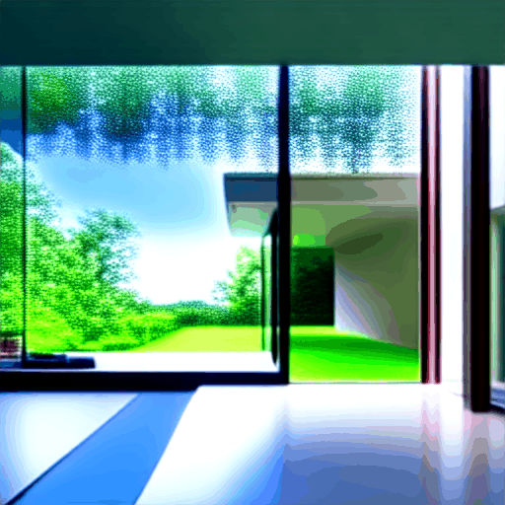 | 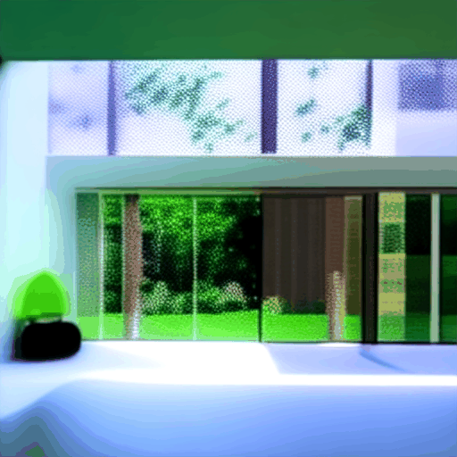
Condition A: Text-only | Condition B: MotionLoRA adapter
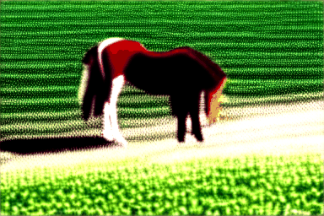 | 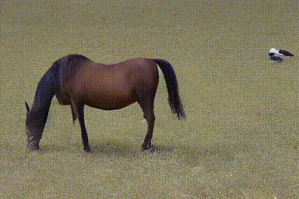
Condition A′: Text-only V3 baseline | Condition C: CameraCtrl with Plücker embeddings
Figure 1: Sample from 4 conditions output
appendices B: Performance Results
Table 1: MotionLoRA vs Baseline Summary
Motion | Condition | Mag (mean) | Mag (std) | Dir Std (deg) | CLIP Sim | N
Pan Left | Text-only | 0,966 | 0,742 | 17,9 | 0,9885 | 10
Pan Left | MotionLoRA | 7,615 | 2,043 | 24,5 | 0,9727 | 10
Pan Right | Text-only | 1,143 | 0,968 | 22,2 | 0,9879 | 10
Pan Right | MotionLoRA | 6,019 | 1,417 | 5,1 | 0,9795 | 10
Zoom In | Text-only | 1,014 | 0,816 | 19,7 | 0,9892 | 10
Zoom In | MotionLoRA | 5,036 | 1,888 | 16,7 | 0,9791 | 10
Zoom Out | Text-only | 1,07 | 1,023 | 16,4 | 0,9895 | 10
Zoom Out | MotionLoRA | 4,106 | 1,598 | 14,5 | 0,9816 | 10
Table 2: CameraCtrl vs Baseline Summary
Metric | Baseline_mean | Baseline_std | Cameractrl_mean | Cameractrl_std
Magnitude | 18,7422 | 12,7616 | 7,5795 | 3,037
Direction_std | 45,7436 | 15,2751 | 40,07 | 10,4222
Radial_div | -0,2356 | 1,1771 | 2,5212 | 1,9336

appendices C: HUMAN EVALUATION FORM AND ANSWER KEYS (included in source code)
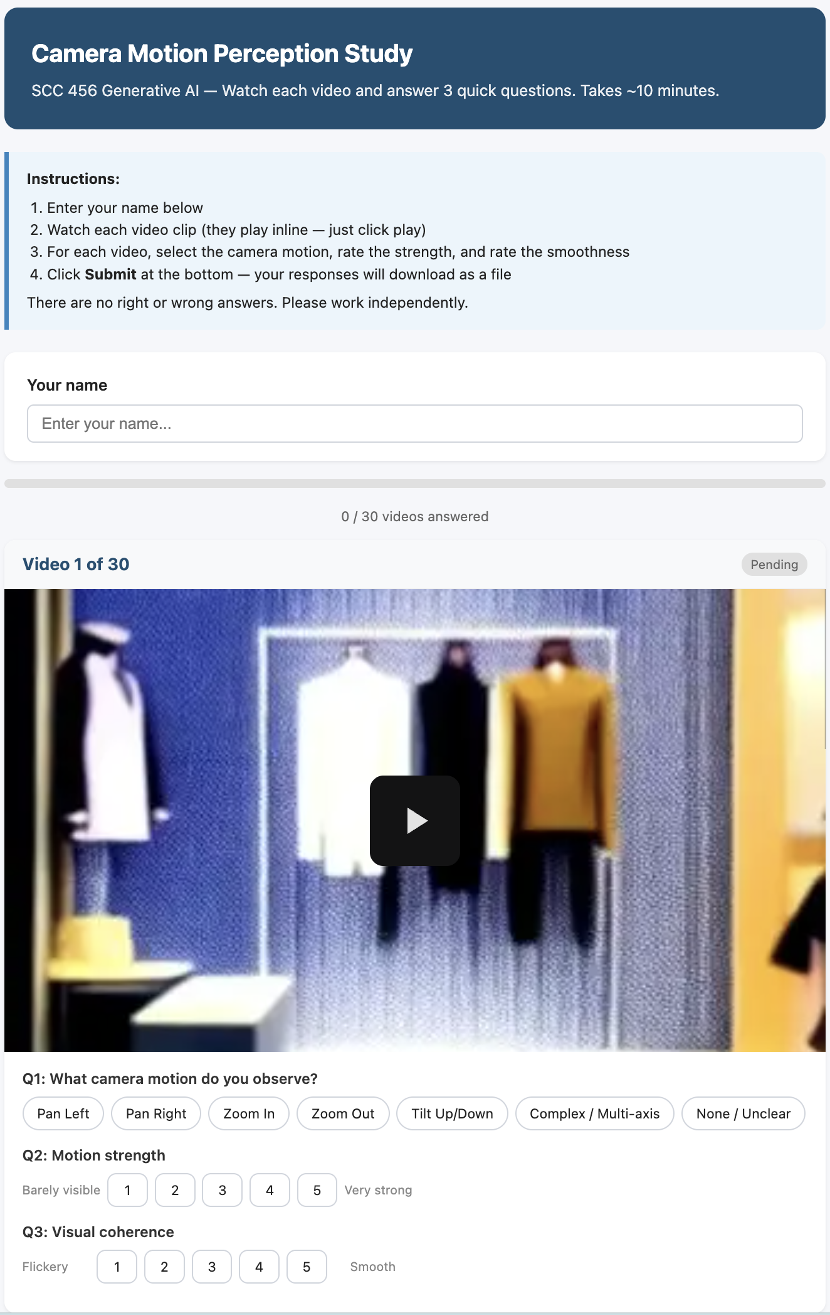
Figure 2: Screenshot of human evaluation form (1 example question)

Table 3: Answer Keys
eval_id | filename | true_condition | experiment | expected_motion | original_id
EVAL_001 | EVAL_001.mp4 | MotionLoRA adapter | MotionLoRA (512x512) | Zoom Out | zoom_out_scene06
EVAL_002 | EVAL_002.mp4 | MotionLoRA adapter | MotionLoRA (512x512) | Pan Left | pan_left_scene08
EVAL_003 | EVAL_003.mp4 | MotionLoRA adapter | MotionLoRA (512x512) | Pan Right | pan_right_scene08
EVAL_004 | EVAL_004.mp4 | CameraCtrl (3D pose) | CameraCtrl (256x384) | Complex / Multi-axis | The_sunflower_swaying_in_the_wind.
EVAL_005 | EVAL_005.mp4 | Text-only baseline | CameraCtrl (256x384) | Complex / Multi-axis | baseline_000
EVAL_006 | EVAL_006.mp4 | Text-only baseline | MotionLoRA (512x512) | Zoom In | zoom_in_scene01
EVAL_007 | EVAL_007.mp4 | Text-only baseline | MotionLoRA (512x512) | Zoom In | zoom_in_scene04
EVAL_008 | EVAL_008.mp4 | MotionLoRA adapter | MotionLoRA (512x512) | Zoom In | zoom_in_scene08
EVAL_009 | EVAL_009.mp4 | MotionLoRA adapter | MotionLoRA (512x512) | Zoom In | zoom_in_scene06
EVAL_010 | EVAL_010.mp4 | MotionLoRA adapter | MotionLoRA (512x512) | Pan Left | pan_left_scene01
EVAL_011 | EVAL_011.mp4 | Text-only baseline | MotionLoRA (512x512) | Zoom Out | zoom_out_scene01
EVAL_012 | EVAL_012.mp4 | CameraCtrl (3D pose) | CameraCtrl (256x384) | Complex / Multi-axis | A_fish_is_swimming_in_the_aquarium_tank.
EVAL_013 | EVAL_013.mp4 | CameraCtrl (3D pose) | CameraCtrl (256x384) | Complex / Multi-axis | "A_serene_mountain_lake_at_sunrise_with_mist_hovering_over_the_water."
EVAL_014 | EVAL_014.mp4 | Text-only baseline | CameraCtrl (256x384) | Complex / Multi-axis | baseline_006
EVAL_015 | EVAL_015.mp4 | MotionLoRA adapter | MotionLoRA (512x512) | Zoom Out | zoom_out_scene08
EVAL_016 | EVAL_016.mp4 | CameraCtrl (3D pose) | CameraCtrl (256x384) | Complex / Multi-axis | A_fireworks_display_illuminating_the_night_sky.
EVAL_017 | EVAL_017.mp4 | Text-only baseline | MotionLoRA (512x512) | Pan Right | pan_right_scene00
EVAL_018 | EVAL_018.mp4 | MotionLoRA adapter | MotionLoRA (512x512) | Zoom Out | zoom_out_scene01
EVAL_019 | EVAL_019.mp4 | MotionLoRA adapter | MotionLoRA (512x512) | Zoom In | zoom_in_scene01
EVAL_020 | EVAL_020.mp4 | Text-only baseline | MotionLoRA (512x512) | Pan Left | pan_left_scene04
EVAL_021 | EVAL_021.mp4 | MotionLoRA adapter | MotionLoRA (512x512) | Pan Left | pan_left_scene06
EVAL_022 | EVAL_022.mp4 | CameraCtrl (3D pose) | CameraCtrl (256x384) | Complex / Multi-axis | A_still_life_of_vintage_objects_on_a_wooden_table.
EVAL_023 | EVAL_023.mp4 | Text-only baseline | MotionLoRA (512x512) | Pan Right | pan_right_scene04
EVAL_024 | EVAL_024.mp4 | Text-only baseline | CameraCtrl (256x384) | Complex / Multi-axis | baseline_005
EVAL_025 | EVAL_025.mp4 | Text-only baseline | MotionLoRA (512x512) | Zoom Out | zoom_out_scene04
EVAL_026 | EVAL_026.mp4 | Text-only baseline | MotionLoRA (512x512) | Pan Right | pan_right_scene01
EVAL_027 | EVAL_027.mp4 | Text-only baseline | CameraCtrl (256x384) | Complex / Multi-axis | baseline_003
EVAL_028 | EVAL_028.mp4 | Text-only baseline | MotionLoRA (512x512) | Pan Left | pan_left_scene01
EVAL_029 | EVAL_029.mp4 | Text-only baseline | MotionLoRA (512x512) | Zoom In | zoom_in_scene00
EVAL_030 | EVAL_030.mp4 | Text-only baseline | CameraCtrl (256x384) | Complex / Multi-axis | baseline_001

