Openbis implementation at INGV-HPHT
Manuela Sbarra, Stefano Aretusini
Version: 2024-10-21
Table of contents
Openbis implementation at INGV-HPHT 1
Structure of metadata and data 1
Introduction 1
TYPES 2
DATABASE (masterdata) 6
Proposed implementation 7
Discussion topics 8
Users 8
Introduction 8
Proposed implementation 9
General architecture, metadata and data interfaces 10
Interface AB: Apparatus to Local PC 10
Interface BC: Local PC to Openbis 11
Level C: Openbis 12
Interface CD: Openbis to the outer world 13
Interface DE: Aggregation of aggregated data 14
Future work 14
Data analysis tools 14

Structure of metadata and data

Introduction
Instance
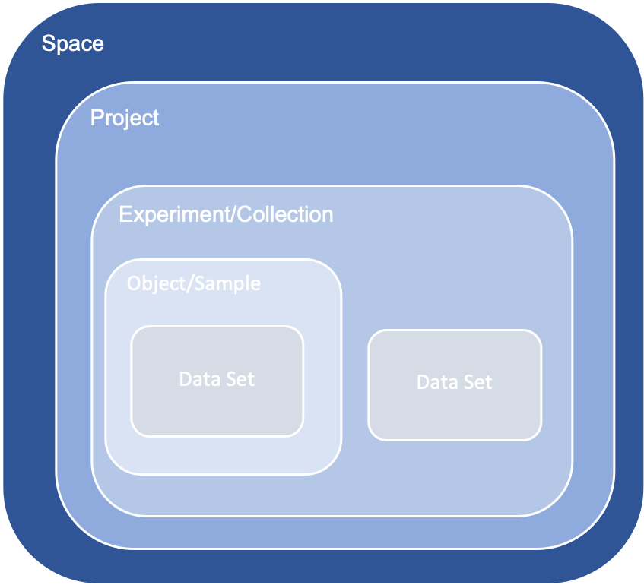
Figure 1. Hierarchic structure of metadata model.
- Inventory (o Lab Notebook) = Instance
  - Space
    - Project
      - Experiment/Collection
        - Object/Sample
          - Dataset
Object/Samples have Parent-Children (n:n) relationships. They are the basic component of the metadata schema.

Datasets are the file based data. They can be contained in Collections or in Object/Sample (n:1).

TYPES
In this section, we list hierarchically the Experiment/Collection, Object/Sample, Data Set, Vocabulary and Property Types that define our Data Model.

Experiment/Collection types
The Openbis default types, that are:
- COLLECTION: generic collection of objects/samples
- DEFAULT_EXPERIMENT: Container of experimental steps
No new types are added.

Object/Sample types

Customized
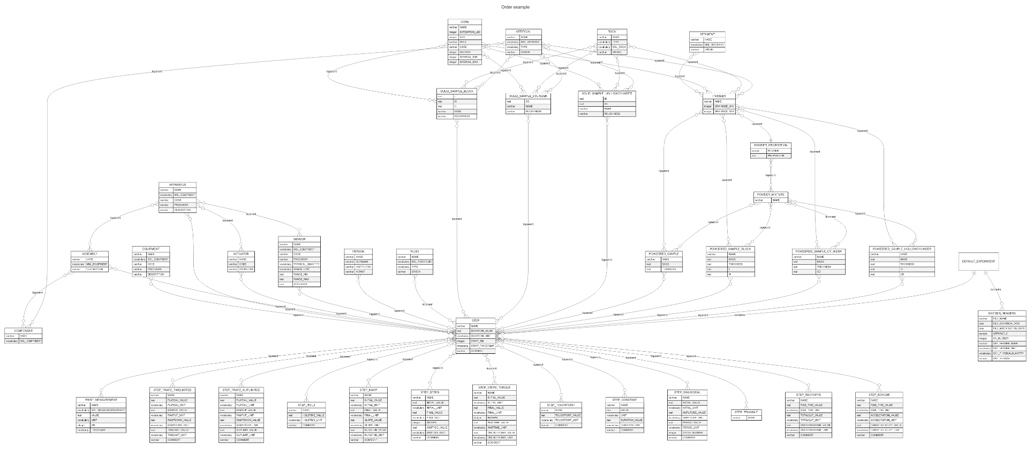
Figure 2. Metadata schema. Online version: https://www.mermaidchart.com/raw/ee3c9d19-2017-4c2f-8f4e-201144b03a09?theme=light&version=v0.1&format=svg
Object/Samples type of types (supertypes) are materials, shaped materials, instruments, people, experimental steps, and derived measurements. These supertypes are included here for descriptive reasons.
The underlying idea is that abstract categories should be included as vocabularies, whereas real tangible items should be included as objects.

Materials supertype include:
- ARTIFICIAL. Attributes: Name, MSL artificial (V), Type (V), Origin. E.g. a steel plate, PTFE plate, PTFE tube.
- CORE. Attributes: Expedition or Leg, Site, Hole, Core, Section, Interval min, Interval max. E.g. a IODP core (link).
- FLUID. Attributes: Name, MSL pore fluid (V), Type (V), Origin. E.g. a fluid sampled from the field or a bottle of commercial fluids.
- ROCK. Attributes: Name, Type (V), MSL rock (V), Origin. E.g. a rock sampled from the field or a purchased slab.
- SEDIMENT. Attributes: Name, MSL sediment (V), Origin. E.g. a sediment sampled from the field, a sample of natural granular materials.
Children of ARTIFICIAL, ROCK, CORE or SEDIMENT
- POWDER. Attributes: Name, Grain size min, Grain size max. E.g. any material above after being ground or powdered and sieved.
- POWDER_PROPORTION. Attributes: POWDER, Proportion
  - POWDER_MIXTURE (Child of POWDER_PROPORTION). Attributes: Name

Shaped materials supertype include:
Children of: ROCK, CORE or ARTIFICIAL
- SOLID_SAMPLE_HOLLOWCYLINDER. Attributes: Name, Inner diameter, Outer diameter, Roughness
- SOLID_SAMPLE_CYLINDER. Attributes: Name, Outer diameter, Roughness
- SOLID_SAMPLE_BLOCK. Attributes: Name, Length, Width, Height, Roughness
Children of: POWDER, POWDER_MIXTURED, GOUGE, or GOUGE_MIXTURE
- POWDERED_SAMPLE. Attributes: Name, Mass, Thickness
- POWDERED_SAMPLE_HOLLOWCYLINDER. Attributes: Name, Mass, Thickness, Inner diameter, Outer diameter
- POWDERED_SAMPLE_CYLINDER. Attributes: Name, Mass, Thickness, Outer diameter
- POWDERED_SAMPLE_BLOCK. Attributes: Name, Mass, Thickness, Length, Width
E.g. any materials supertype casted/molded/cored/transformed into a shape.

Instruments supertype include:
- EQUIPMENT. Attributes: Name, MSL equipment (V), Code, Producer, Description. E.g. balance, drill, heating plate.
- APPARATUS. Attributes: Name, MSL equipment (V), Code, Producer, Description. E.g. a triaxial apparatus.
Children of Apparatus:
- ACTUATOR. Attributes: Name, Code, Producer. E.g. a piston, valve, pump.
- ASSEMBLY. Attributes: Name, MSL equipment (V), Description. E.g. a hooke triaxial cell.
  - Component (Child of ASSEMBLY and ARTIFICIAL or ROCK). Attributes: Name, MSL equipment (V). E.g. a rubber jacket, graphite oven.
- SENSOR. Attributes: Name, MSL equipment (V), Code, Producer, Physical quantity (V), Range unit (V), Range min, Range max, Accuracy. E.g. a LVDT, pressure transducer, piezoresistive transducer.

People supertype include:
- PERSON. Attributes: Name, Surname, Institution, Now at.

Experimental steps supertype (Child of: other experimental steps, experimental samples, ACTUATOR, PERSON, SENSOR, APPARATUS, ASSEMBLY). Can be tailored depending on the application. They include:
Generic across several APPARATUS
- STEP. Attributes: Name, Duration value, Duration unit (V), Start RN, Start timestamp, Comment. E.g. a constant temperature experimental step (or stage).

- STEP_CONSTANT. Attributes: Name, Value, Unit, Duration value, Duration unit (V), Comment
- STEP_SINUSOIDAL. Attributes: Name, Initial value, Initial unit (V), Amplitude value, Amplitude unit (V), Period value, Period unit (V), Cycle number, Comment
- STEP_TRIANGLE. Attributes: Name
- STEP_REGYOFFE. Attributes: Name, Rise time value, Rise time unit (V), Total slip value, Total slip unit (V), Smoothing time value, Smoothing time unit (V)
- STEP_BOXCAR. Attributes: Name, Rise time value, Rise time unit (V), Acceleration value, Acceleration unit (V), Target velocity value, Target velocity unit (V).
- STEP_HOLD: wait and do nothing for a certain amount of time. Attributes: Name, Hold time value, Hold time unit (V), Comment. Can be equivalent to constant something with value 0.
- STEP_RAMP: generic ramp. Attributes: Name, Initial value, Initial unit (V), Final value, Final unit (V), Slope value, Slope unit (V), Comment
- STEP_STEPS: generic ramp divided in n steps. Attributes: Name, Initial value, Initial unit (V), Final value, Final unit (V), N steps, Wait time, Wait time unit (V), Comment
E.g. name is the variable name described by the step.

Generic across APPARATUS with piston
- STEP_TOUCHPOINT: generic touchpoint procedure (force increase due to contact of piston on specimen). Attributes: Name, Touchpoint value, Touchpoint unit (V), Comment

Tailored for SHIVA APPARATUS
- STEP_TRAPZ_TIMELIMITED: velocity control SHIVA. Attributes: Name, Plateau value, Plateau unit (V), Ramp up value, Ramp up unit (V), Ramp down value, Ramp down unit (V), Time limit, Time limit unit (V), Comment. E.g. a velocity control step.
- STEP_TRAPZ_SLIPLIMITED: position control SHIVA. Attributes: Name, Plateau value, Plateau unit (V), Ramp up value, Ramp up unit (V), Ramp down value, Ramp down unit (V), Slip limit, Slip limit unit (V), Comment. E.g. a position control step.
- STEP_STEPS_TORQUE: torque control SHIVA. Attributes: Name, Initial value, Initial unit (V), Final value, Final unit (V), N steps, Wait time, Wait time unit (V), Velocity limit, Velocity limit unit (V), Comment. E.g. a torque control step.

Derived measurements supertype (Child of: other experimental steps, PERSON)
- POINT_MEASUREMENT. Attributes: Name, MSL measured property (V), Value, Unit (V), RN, Timestamp. E.g. a friction point measurement during a trapezoidal time limited step.

Defaults (ELN LIMS)
- ENTRY
- GENERAL_ELN_SETTINGS
- GENERAL_PROTOCOL
- ORDER
- PRODUCT
- PUBLICATION
- REQUEST
- SEARCH_QUERY
- STORAGE
- STORAGE_POSITION
- SUPPLIER
- UNKNOWN

Data Set types

Customized
Any Experimental Step Sample or any Experiment can have 1:n specific Data Set Types.

Data files with native annotated metadata
Custom Data Set Types with a common Section and a custom Section depending on metadata.

Data files without native annotated metadata
Custom Data Set Types with a common Section and a custom Section with headers description (when available):
- 16HEADERS. Attributes: File name, File creation date, File modification date, APPARATUS, Channel number. Then, for each Channel number (x from 1 to 16): Channel x name, Channel x unit (V), Channel x physical quantity (V), Channel x sensor (O).

Defaults (ELN LIMS)
- ANALYSIS_NOTEBOOK
- ANALYZED_DATA
- ATTACHMENT
- ELN_PREVIEW
- OTHER_DATA
- PROCESSED_DATA
- PUBLICATION_DATA
- RAW_DATA
- SOURCE_CODE
- UNKNOWN

Vocabulary types

Customized

From many sources
- Physical quantity types (PHYSICALQUANTITIES). Source: https://en.wikipedia.org/wiki/List_of_physical_quantities
- Measurement unit types (UNITS). Sources (merged together): https://en.wikipedia.org/wiki/SI_base_unit; https://en.wikipedia.org/wiki/SI_derived_unit
- Artificial material types (ARTIFICIALMATERIALS). Source: custom.
- Fluid types (FLUIDS). Source: custom.
- Rocks types (ROCKS). Source: https://en.wikipedia.org/wiki/List_of_rock_types. Alternative source (unused here): https://www.bgs.ac.uk/information-hub/dictionaries/vocabularies-web-service/

From MSL vocabularies
Dictionaries from github were regrouped (link). The parenthesis indicates the level (1 = parent, 2 = child, 3 = grandchild, and 4 = grandgrandchild) in the .JSON file.
- MSL_EQUIPMENT. Merge of: Ancillary equipment (2), Apparatus (2), equipment (2), Equipment (2)
- MSL_MEASURED_PROPERTY. Merge of: Measured property (2) and measured property (2)
- MSL_MINERAL. Minerals (2).
- MSL_ARTIFICIAL. Merge of: analogue modelling material (2) and synthesized material (2).
- MSL_ROCK. Merge of: fault rock (2), igneous rock (2), metamorphic rock (2), metasomatic rock (2), meteorite (2), sedimentary rock (2).
- MSL_SEDIMENT. Unconsolidated sediment (2).
- MSL_POREFLUID. Pore fluid (1).
- MSL_INFERRED. Merge of: Inferred parameter (2), Inferred behavior (2), Inferred deformation behavior (2).
MSL vocabularies not included yet in our data model:
- MSL_SETTING. Merge of: (sub)surface utilizations setting (1), Geological setting (1)
- MSL_MODEL. Merge of: Modeled geomorphological feature (2), Modeled structure (2), Models (2)
- MSL_SOFTWARE. Software (2)
- MSL_ANALYSIS. Merge of: analysis (2), Technique (2)
- MSL_FACILITY. Facility names (2)
- MSL_FACILITY_TYPE. Facility types (2)
- MSL_GEOLOGICALAGE. Geological age (1)
- MSL_MICROSTRUCTURE. Analyzed feature (2)
- MSL_ENVIRONMENTCONTROL. Environment control (2).

From FS (Fair Sample V2) vocabularies

Property types
Define some common properties across objects to avoid repetition. Not implemented at the moment.

DATABASE (masterdata)
Instances: Inventory, Lab Notebook: one per each Laboratory.
Space: One per each APPARATUS (especially those connected to the intranet to Openbis).
Project: Legacy (old experiments is a default project. In addition to this, each space administrator can add specific projects depending on their needs (e.g. active projects, collaborations, external contracting service, TNA-NOAs, etc.).
Experiment/Collection: DEFAULT_EXPERIMENT for each experiment registered in the Project, COLLECTION(s) of samples for each Project.
Object/Sample: see section above.
Dataset: the actual files composing our data. Generally included within a DEFAULT_EXPERIMENT.

Inventory
The shared space among all individual Spaces and Projects. It contains all shared objects.
Inventory
|
+ - Space
|
+ - Project
|
+ - Collection or experiment

Inventory
|
+ - Materials
| |
| + - Apparatuses
| | |
| | + - Apparatuses
| | + - Actuators
| | + - Assemblies
| | + - Equipment
| | + - Components
| | + - Sensors
| |
| + - Materials
| | |
| | + - Cores
| | + - Fluids
| | + - Artificials
| | + - Powders
| | + - Powder proportions
| | + - Powder mixtures
| | + - Rocks
| | + - Sediments
| |
| + - People
| | |
| | + - People
| |
| + - Specimens
| |
| + - Solid Sample Hollow Cylinders
| + - Solid Sample Cylinders
| + - Solid Sample Blocks
| + - Powdered Samples
| + - Powdered Sample Hollow Cylinders
| + - Powdered Sample Cylinders
| + - Powdered Sample Blocks
|
+ - Methods
| |
| + - Methods
|
+ - Publications

Lab Notebook
Space
|
+ - Project
|
+ - Collection or experiment

Spaces: for each apparatus that can be connected via intranet to Openbis.
Brava
|
+ - Brava legacy
|
+ - Brava legacy blocks
+ - Brava legacy gouges
+ - Brava legacy gouge blocks
+ - n-th experiment
Meera
|
+ - Meera legacy
|
+ - Meera legacy blocks
+ - n-th experiment

Permie
|
+ - Permie legacy
|
+ - Permie legacy cylinders
+ - n-th experiment

Shiva
|
+ - Shiva legacy
|
+ - Shiva legacy cylinders
+ - Shiva legacy hollow cylinders
+ - Shiva legacy gouges
+ - Shiva legacy gouge cylinders
+ - Shiva legacy gouge hollow cylinders
+ - n-th experiment

Quickpress
|
+ - Quickpress legacy
|
+ -
+ - n-th experiment

Experiments: the experiments or acquisition of data. Not shared between Projects.

Proposed implementation

Object types and masterdata (metadata)
To install the entire metadata schema and the masterdata. From admin-ng-ui: import in the following order (mode: “update if exist”):
- MSL vocabularies: msl-dictionaries.xlsx
- Our metadata model: metadata-model-rockmechanics_V3_spaces.xlsx
- Dataset models: dataset_models.xlsx
- Experimental metadata, i.e., the first 50 SHIVA experiments: sync_test_prod_docker.xlsx
Other models (optional)
- FAIR SAMPLE metadata model: metadata-model-fairsample_V2.xlsx

Planned: Python package with schema: when the schema is definitive. Like they did in Ulrich Kerzel / openbis_materialsscience_schema · GitLab

Users

Introduction
In the table below are the details on the users roles as structured in Openbis (Link). Roles are cumulative moving from the first to the last table column (i.e., the Space User is also a Space Observer).
Table 1. User roles in Openbis.
Instance/Space/Project Observer can:  - list  - persons  - spaces  - projects  - sample types  - experiment types  - data types  - file format types  - material types  - data set types  - samples  - experiments  - data sets  - materials  - property types  - vocabularies  - vocabulary terms  - attachments  - data store services  - get details of  - project  - sample  - experiment  - data set  - material  - download  - attachment  - sample registration template  - create report for data sets  - search for  - samples  - experiments  - materials  - data sets | - Space/Project User can:  - create  - sample  - experiment  - edit  - sample  - experiment  - project | Space/Project Power User can:  create project  delete  - project  - data sets  - samples  - experiments  - attachments  edit attachments  process data sets  add, update and delete vocabulary terms | Space/Project Admin can:  list roles  create and delete space role  edit data set | Instance Admin can:  create  - space  - material  - person  - property type  - vocabulary  - material type  - sample type  - experiment type  - data set type  - file format type  create/delete instance admin role  edit  - material  - property type  - property type assignment  - vocabulary  - material type  - sample type  - experiment type  - data set type  - file format type  assign/unassign property type  delete  - space  - vocabulary terms  - material type  - sample type  - experiment type  - data set type
Remember: Observers can download Datasets!

Proposed implementation
Table 2. Role mapping.
HPHT role | Openbis role | Openbis level (Lab notebook)
General user or guest | Observer | None
Producer of data | User | Project
Research collaborator | User | Project
Instrument operator (power user) | Power user | Project
Instrument manager | Admin | Space
Lab data manager | Admin | Instance

List of users: shiva.admin, brava.admin, meera.admin, quickpress.admin in .LDIF import file.

General architecture, metadata and data interfaces
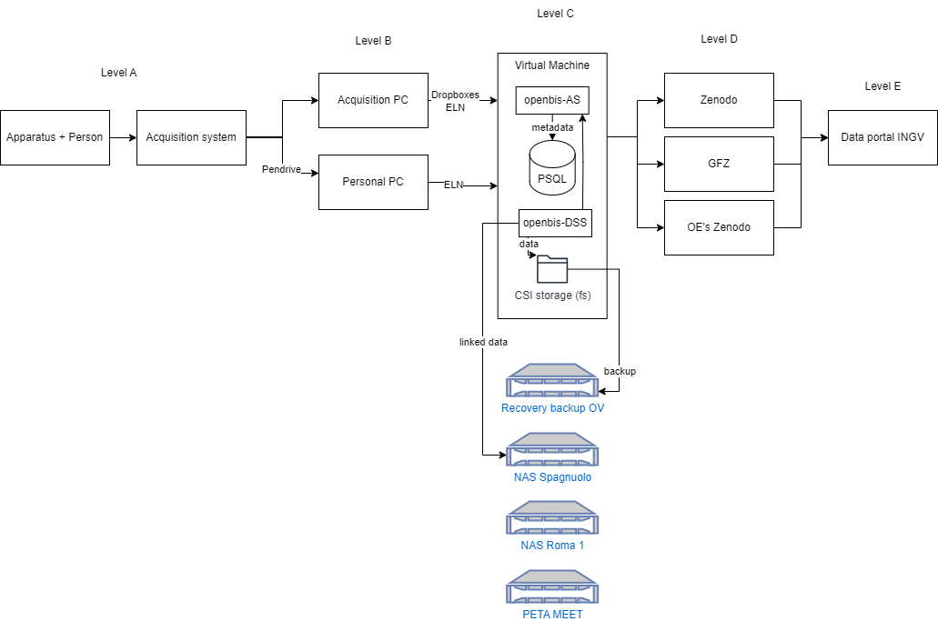Figure 3. Interfaces diagram.

Interface AB: Apparatus to Local PC
Depending on the case, Apparatus can be or not controlled by an Acquisition PC. In the case it is not controlled by an Acquisition PC, data and metadata need to be manually moved to a PC via Pendrive.

Interface BC: Local PC to Openbis
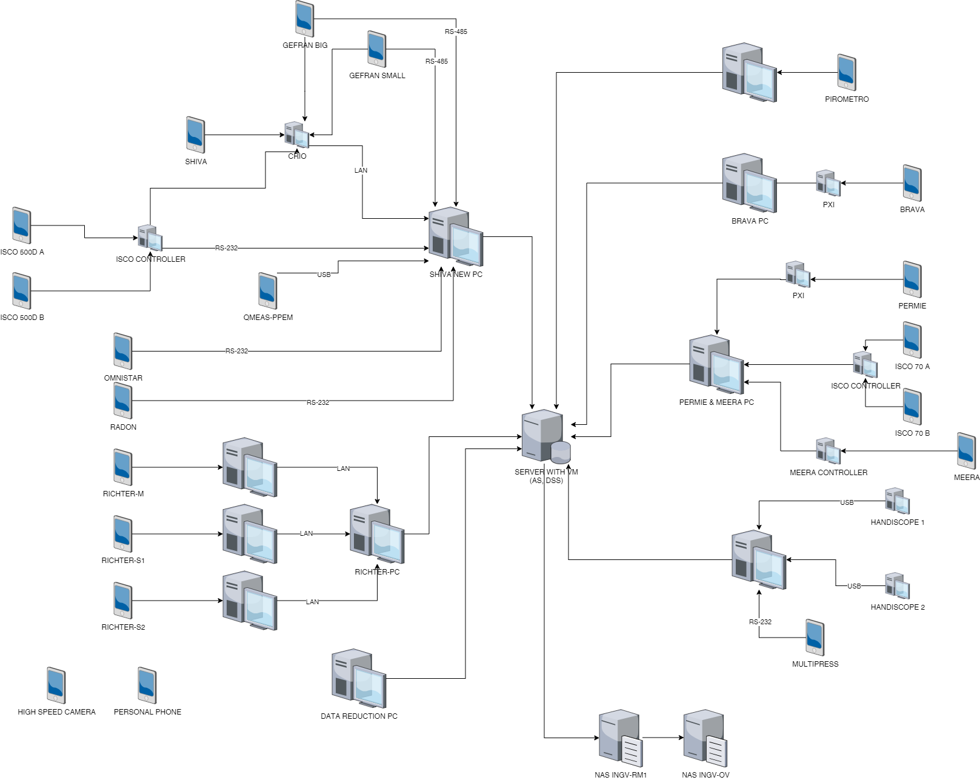
Figure 4. Map of devices connected to network in HPHT limitedly to Rock Mechanics (updated at 15/12/2023).
The Acquisition PC can be or not connected to the Intranet LAN (see Figure 4). For connected Acquisition PCs, data and metadata can be populated into Openbis via the ELN web UI or via dropboxes (when metadata are already annotated to a file). For Acquisition PC not connected, a Pendrive will allow to move files to a PC and then populate to Openbis in the ELN web UI.
Creation of Metadata Tree Structure according to the Object/Sample schema (see Figure 2).
Transfer of Raw data files and Reduced data files as Datasets, Contained in Default Experiment Collections within the Metadata Tree Structure. Processed Data Datasets are Children of Raw Data Datasets.

Implementation
Case 1. PREFERRED. Dataset Files do not have annotated metadata (e.g. prototype Apparatuses: SHIVA, BRAVA, etc):
- Manually in the ELN. Necessary when there are no metadata annotated to Dataset files but to paper logbooks. See “Manual ingestion of legacy metadata and data - V3” document.
- Automatic ingestion with streamlit web site.
Case 2. TBD. Dataset Files have annotated metadata (e.g. SEM, EMPA, etc) so that metadata extraction is possible:
- Jython Dropboxes (link). Limit: Python <= 2.7 (Jython unsupported for Python > 2.7), needs Samba. Examples by Ulrich.
- Custom python scripts. Not limited to Python <= 2.7. Customization by Ulrich.
- Annotation and data mover (link). Limit: install in each APPARATUS PC, support not clear.
- Obit (openbis importer toolset). Automatic extraction of metadata from images for microscopy. Limit: install in each APPARATUS PC, support not clear.

Level C: Openbis

Openbis web interfaces

Admin user interface
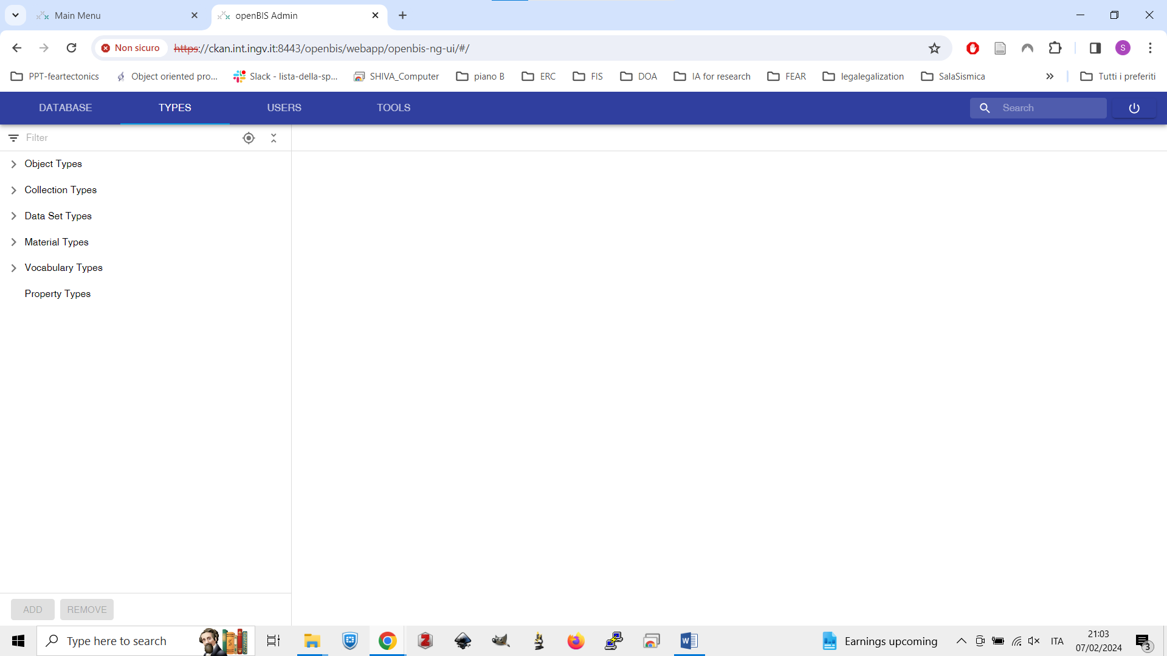
Figure 5. Openbis administration interface.

Electronic Lab Notebook (ELN-LIMS)
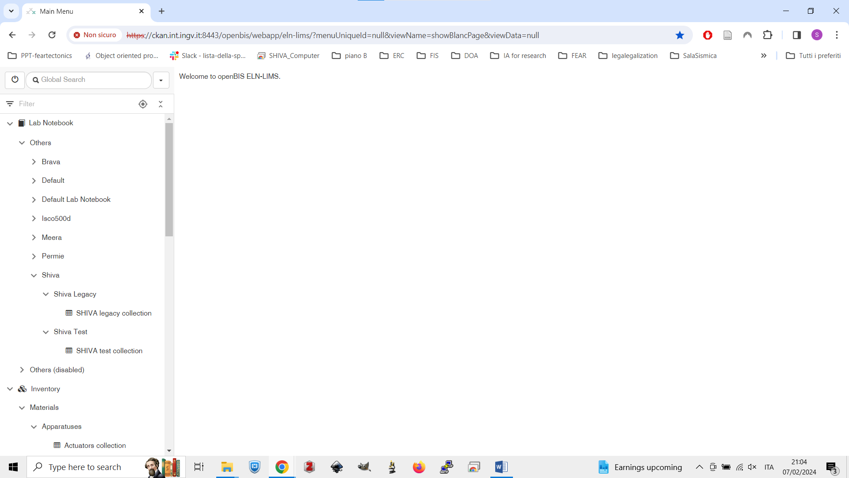
Figure 6. The main user interface between users and Openbis.

Customization and installation of Openbis with Docker
To promote distribution even across other laboratories, a docker-compose .YAML file will be provided. Then the service.properties file will need to be copy/pasted.
Dockerfile to obtained fully customized container image (ldap configuration) is under progress.

Dataset file storage
Possibilities:
- Dataset files in the VM server’s filesystem (current strategy). VM’s filesystem in disaster recovery.
- Installation of separate Datastore Servers in other remote machines (to be tested in Petabyte server).
- Linked data. Limit: use of Openbis CLI. Customization by Ulrich. Limit: no direct downloading from openbis web ui.
- Big link data

Interface CD: Openbis to the outer world

Aggregated access
Aggregation of Metadata Tree Structure with Children Datasets and Export. Hereon: 1:n experiments.
Export to zenodo-like services is already implemented:
- Zenodo https://zenodo.org/
- Zenodo-Catania https://oedatarep.ct.ingv.it/ - mirrored to https://data.ingv.it/en
Export to CKAN-like services is not yet implemented and will not be developed or discussed here:
- GFZ https://dataservices.gfz-potsdam.de/panmetaworks/metaedit/
- Unipd https://researchdata.cab.unipd.it/

Atomistic access
Work in progress

Implementation of HPHT Data Policy

User roles and export
- INGV, indipendente (o responsabile strumento) = 1° autore INGV
- INGV o esterno assistito da INGV, indipendente (1° autore non-INGV e co-autori gli assistenti INGV)
- INGV o esterno non assistito (autore unico se a incarico ricerca, possibile co-autore gli assistenti INGV)
- Esterno (conto terzi) = autore esterno conto terzi = RESTRICTED (NO PUBBLICAZIONE)
Table 3. Attempt to formalize HPHT Data Policy.
CASO | è INGV? | azione | è indipendente da altri User su un Apparatus? | è responsabile di Apparatus? | ha incarico di ricerca? | è conto terzi? | Openbis Role | Author order in Exported Aggregated
1A | si |  | si | no |  |  | Project Admin | 1
1B | si |  | si | si |  |  | Space Admin | 1
2A | si | assistito | si |  |  |  | Project Admin | 1
2B | no | assistito | si |  |  |  | Project Admin | 1
2A, 2B | si | assiste |  |  |  |  | Project User | >1
3A | si | non assistito |  |  | si |  | Project Admin | 1
3B | no | non assistito |  |  | si |  | Project Admin | 1
3A, 3B | si | non assiste |  |  |  |  | Project User | >1
4 | no |  |  |  |  | si | Project Admin | 0
Nei casi 1, 2, 3, per Aggregazione e Export di default dopo 36 mesi di embargo con Licenza CC-BY-NC.
Nel caso 4 non è prevista Aggregazione e Export.

Interface DE: Aggregation of aggregated data
Not developed or discussed here.

