Implementazione Openbis
Sbarra, Aretusini
17/05/2022
Pro | Contro
Sistema collaudato a ETH
Struttura metadati molto flessibile
API per Zenodo (e non solo)
Importer toolset

Nei computer di acquisizione
Nel computer di acquisizione si potrebbe mettere obit (openbis importer toolset). Link to web page.

Introduzione alla struttura dati di Openbis

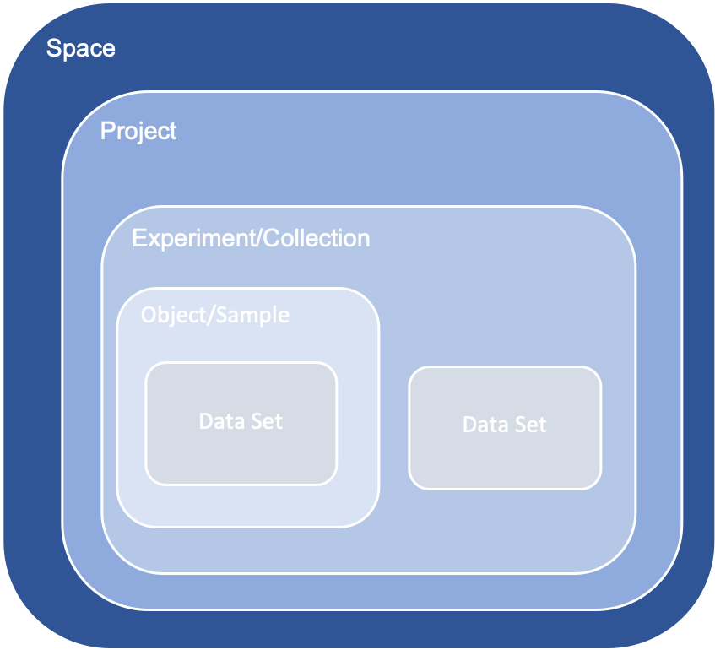

HIERARCHY IN OPENBIS
Descrizione modello gerarchico. Link to web page.
- Inventory (or Lab Notebook)
  - Space
    - Project
      - Experiment/Collection
        - Object/Sample
          - Dataset
Gli OBJECTS hanno relazioni n:n tra di loro, di tipo parent-children.

In questo modo, l'esperimento (OBJ) può avere molti parents (materiali, portacampioni, macchinari, etc etc) e ho provato a seguire questa strada nell'openbis che ha installato Manuela (grazie).

Un esempio operativo. Link to web page.

Lavoro di implementazione (20/10/2022)

Schema generale dell’organizzazione del Lab Notebook
Space = Rock mechanics
Project = for each of the two Spaces above, one Project for each “main” local acquisition PC of major Apparatus (SHIVA, BRAVA, MEERA, PERMIE, RICHTER)
Experiment/Collection = one each major experimental goal, or one list of samples, compulsory ones: Legacy, Contractor and Test
Object/Sample = the actual “Measurement” Object Type.
Dataset = the Raw Data or Reduced Data

Alternative to be evaluated
Space = for each of the major apparatuses
Project = for each person or actual research project (including: Legacy, Contractor, Test)
Collection = one each major experimental goal or research question in a Project
Object/Sample = the actual “Measurement” Object Type.
Dataset = the Raw Data or Reduced Data

Schema generale dell’organizzazione dell’Inventory
Space = Equipment, People, Materials, Methods

Schema dei ruoli degli Utenti
Resumed in the next tables are the details: each role is additive to all roles on its left. Link to web page.
Instance/Space/Project Observer can:  - list  - persons  - spaces  - projects  - sample types  - experiment types  - data types  - file format types  - material types  - data set types  - samples  - experiments  - data sets  - materials  - property types  - vocabularies  - vocabulary terms  - attachments  - data store services  - get details of  - project  - sample  - experiment  - data set  - material  - download  - attachment  - sample registration template  - create report for data sets  - search for  - samples  - experiments  - materials  - data sets | - Space/Project User can:  - create  - sample  - experiment  - edit  - sample  - experiment  - project | Space/Project Power User can:  create project  delete  - project  - data sets  - samples  - experiments  - attachments  edit attachments  process data sets  add, update and delete vocabulary terms | Space/Project Admin can:  list roles  create and delete space role  edit data set | Instance Admin can:  create  - space  - material  - person  - property type  - vocabulary  - material type  - sample type  - experiment type  - data set type  - file format type  create/delete instance admin role  edit  - material  - property type  - property type assignment  - vocabulary  - material type  - sample type  - experiment type  - data set type  - file format type  assign/unassign property type  delete  - space  - vocabulary terms  - material type  - sample type  - experiment type  - data set type

TYPES

Implementazione “Material Types”
Implementazione dei “Material types” seguendo la proposta degli oggetti (appartengono allo Space: Materials).
“Note: Material types are also part of the openBIS masterdata. However, they are no longer supported and will be decommissioned soon. They should NOT be used.”

Implementazione “(Experiment) Collection types”
Per ora niente collection types.

Implementazione degli “(Sample) Object types”
NB: Parents o Children non si mettono dai form, ci sono sezioni apposite dei form configurabili dall’ELN
Seguendo la proposta degli oggetti qui schematizzati.
Usando i template di excel. Link alla pagina web.
Riadattato da noi: metadata-model-rockmechanics.XLSX (we have the V2 version now)
- Core: https://joidesresolution.org/wp-content/uploads/2013/06/What-is-a-Core.pdf
- Artificial: Name, Type (Vocabulary), Origin
- Fluid: Name, Type (Vocabulary), Origin
- Rock: Name, Type (Vocabulary), Origin
- Solid sample hollow cylinder (Parents: Rock, Core)
- Solid sample full cylinder (Parents: Rock, Core)
- Solid sample block (Parents: Rock, Core)
- Sawcut (Parents: Solid sample hollow cylinder, Solid sample full cylinder, Solid sample block)
- Gouge (Parents: Rock, Core or 2+ different Gouges)
  - Gouge proportion
    - Gouge mixture
- Powdered sample (Parents: Gouge)
- Apparatus
  - Actuator (child of Apparatus)
  - Assembly (child of Apparatus)
    - Component (child of Assembly)
- Sensor (child of Apparatus/Assembly)
- Variable (child of Step and of Actuator): the numerical variable (control variable)
- Property (child of Event): the generic categorical property
- Measurement (child of Powdered sample or any Solid sample; Assembly; Apparatus; Operator)
  - Step (child of Experiment)
    - Event (child of Step + Sensor?)

- Person/user (Parent of 0:n Apparatus, 0:n Measurement). Attributes: Name, Surname, Institution, Now at.

Implementazione dei Vocabulary Types
Are they vocabularies or rather objects?
I think the answer to this question is whether we are creating new objects or not: if not, we use dictionaries.
- Rocks_vocabulary:
  - NOT USED “lithology” in BGS: https://www.bgs.ac.uk/information-hub/dictionaries/vocabularies-web-service/
  - I USED THIS https://en.wikipedia.org/wiki/List_of_rock_types
- Minerals_vocabulary TBD:
  - NOT USED https://en.wikipedia.org/wiki/List_of_minerals
  - I USED THIS https://rruff.info/ima/
- Physical quantities: I USED THIS https://en.wikipedia.org/wiki/List_of_physical_quantities
- Measurement units: I USED THIS https://en.wikipedia.org/wiki/SI_base_unit; https://en.wikipedia.org/wiki/SI_derived_unit
- (Measurement’s) step types: homemade
- Measurement types: homemade

Implementazione dei Dataset Types
- Raw Dataset
- Reduced Dataset

USERS

Users & Groups
Work in progress
https://unlimited.ethz.ch/display/openBISDoc2010/User+Group+Management+for+Multi-groups+openBIS+Instances
Con il dummy authentication service la password è “changeit”
“file-based” non è sicuro poiché scrive password e utenti nel server
Installazione servizio “ldap” (slapd ldap-utils)

DATABASE (masterdata)
Space: ROCK_MECHANICS
- BRAVA
  - BRAVA_TEST
  - BRAVA_LEGACY
  - BRAVA_CONTRACTOR
- MEERA
  - MEERA_TEST
  - MEERA_LEGACY
  - MEERA_CONTRACTOR
- PERMIE
  - PERMIE_TEST
  - PERMIE_LEGACY
  - PERMIE_CONTRACTOR
- SHIVA
  - SHIVA_TEST
  - SHIVA_LEGACY
  - SHIVA_CONTRACTOR
- RICHTER
- TEST_APPARATUS (to test obit configuration)
Collections (each Space):
- CONTRACTOR
- LEGACY
- TEST
Space: MATERIALS
- MATERIALS
  - CORES
  - FLUIDS
  - ROCKS
  - ARTIFICIALS
  - GOUGES
  - GOUGE_PROPORTIONS
  - GOUGE_MIXTURES
  - SOLID_SAMPLE_CYLINDERS
  - SOLID_SAMPLE_HOLLOW_CYLINDERS
  - SOLID_SAMPLE_BLOCKS
  - POWDERED_SAMPLES
- APPARATUSES
  - APPARATUSES
  - ACTUATORS
  - ASSEMBLIES
  - COMPONENTS
  - SENSORS
- PEOPLE
  - PEOPLE
Space: METHODS
- METHODS
  - STEPS
  - EVENTS
  - VARIABLES
  - PROPERTIES
For each User: default space is ROCK_MECHANICS.
Limited use: most of metadata annotation performed by jython dropbox (o obit?) before/during/after the experiment

DATABASE (masterdata) (alternative)
Per gestire meglio gli user roles. La lascio qui come nota.
Spaces (one per networked PC):
- BRAVA
- MEERA
- SHIVA
- PERMIE
- RICHTER
- TEST_APPARATUS
Projects (each Space):
- TEST
- LEGACY
- CONTRACTOR-<name>
- Others depending on active projects

Inserimento degli archivi storici
Work in progress
For registering entities in a batch mode: https://openbis.ch/index.php/docs/user-documentation/inventory-of-materials-and-methods/batch-register-entries-in-several-collections/
For registering datasets in a batch mode: ???

Relation between User & Dataset and export rules
Vedere anche link alla presentazione.
User (or Person) is parent of a Measurement and all children Dataset.
(Power or Responsible) User (or Person) is also parent of Apparatus and its children Measurements and children Datasets
Ideas of Massimo
User roles
-> producer of data -> power user (on apparatus) or not, INGV or not
-> requester of data
Rules for the attribution of Authorship (and authorship order) during the export of a Dataset
Export to zenodo-like services is implemented:
- Zenodo https://zenodo.org/
- Zenodo-Catania https://oedatarep.ct.ingv.it/ - mirrored to https://data.ingv.it/en
Export to CKAN-like services is not yet implemented:
- GFZ https://dataservices.gfz-potsdam.de/panmetaworks/metaedit/
- Unipd https://researchdata.cab.unipd.it/
From Politica Dati HPHT
- INGV, indipendente (o responsabile strumento) = 1° autore INGV
- INGV o esterno assistito da INGV, indipendente (1° autore non-INGV e co-autori gli assistenti INGV)
- INGV o esterno non assistito (autore unico se a incarico ricerca, possibile co-autore gli assistenti INGV)
- Esterno (conto terzi) = autore esterno conto terzi = RESTRICTED (NO PUBBLICAZIONE)
Aggregazione 1,2,3 in dataset con embargo 36 mesi a meno che tutti (autore e co-autori) siano d’accordo. Licenza CC-BY-NC.
Responsabili strumento = responsabile dato
From https://data.ingv.it/docs/attuazione/
Dataset attributes following official INGV document (https://data.ingv.it/docs/attuazione/ 4.1 Metadati Registro Dati)
Can this be done with API export to Zenodo-Catania? Yes because once the Aggregated Data is created in Zenodo-Catania, it is also created in Registro Dati INGV.

Data analysis from within Openbis
https://openbis.ch/index.php/docs/user-documentation-before19-06-4/tools-for-analysis-of-data-stored-in-openbis/
Jupyter
https://openbis.ch/index.php/docs/user-documentation-before19-06-4/tools-for-analysis-of-data-stored-in-openbis/jupyter-notebooks/
Matlab
https://sissource.ethz.ch/hluetcke/matlab-openbis

Interface local pc to openbis
Annotation and data mover: https://unlimited.ethz.ch/display/openBISDoc2010/Annotating+and+registering+data+with+the+Annotation+Tool
Openbis labview
Jython Dropboxes: https://unlimited.ethz.ch/display/openBISDoc2010/Dropboxes
Labview+Jython?

