A) ANALYSIS

1) Requirements List
- The system allows students to submit a campus service request.
- Each request must have an ID.
- Each request must include a title.
- Each request must include a description.
- Each request must have a status.
- The default status of a new request is Pending.
- Students can view a list of requests.
- Students can view request details.
- Staff can view all requests.
- Staff can update the request status.
- The system should support three statuses: Pending, In Progress, and Done.
- The system should validate input before saving data.
- The system should follow OOP principles such as SRP and naming conventions.
- The system should be organized using the MVC structure.
- The system should be simple and easy for school use.

2) User Roles

Student
- Submit a request
- View request list
- View request details

Staff
- View all requests
- View request details
- Update request status

3) Use Cases

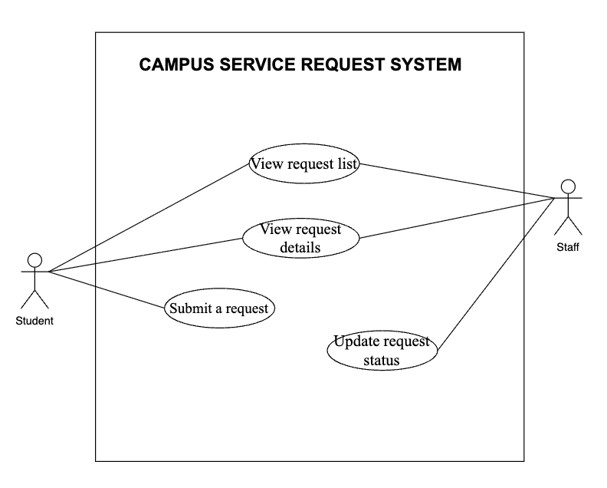Use Case 1: Submit a Request
- Use Case Name: Submit Service Request
- Actor: Student
- Trigger: A student wants to report a problem in school.
- Main Flow:
  - The student opens the request form.
  - The student enters the title and description.
  - The system validates the input.
  - The system saves the request.
  - The system sets the status to Pending.
- Alternative Flow: If the input is incomplete, the system shows an error message.
- Success Outcome: A new request is created successfully.

Use Case 2: View Request List
- Use Case Name: View Request List
- Actor: Student / Staff
- Trigger: The user wants to see all requests.
- Main Flow:
  - The user opens the request list page.
  - The system retrieves all requests.
  - The system displays the list.
- Alternative Flow: If there are no requests, the system displays “No requests found”.
- Success Outcome: The request list is shown.

Use Case 3: View Request Details
- Use Case Name: View Request Details
- Actor: Student / Staff
- Trigger: The user selects one request.
- Main Flow:
  - The user clicks a request.
  - The system finds the request by ID.
  - The system shows full request information.
- Alternative Flow: If the request ID does not exist, the system shows “Request not found”.
- Success Outcome: The request details are displayed.

Use Case 4: Update Request Status
- Use Case Name: Update Request Status
- Actor: Staff
- Trigger: Staff wants to change the request status.
- Main Flow:
  - Staff opens the request detail page.
  - Staff selects a new status.
  - The system checks whether the status is valid.
  - The system updates the request status.
  - The system confirms the update.
- Alternative Flow: If the status is invalid, the system shows an error message.
- Success Outcome: The request status is updated successfully.

B) DESIGN

4) Class Responsibility Table (SRP)
Class name | Responsibility (1 sentence) | Reason to change (1 reason only)
Request | Stores request data such as id, title, description, status, and createdBy | Data fields change
RequestRepository | Reads and writes request data to storage | Storage method changes
RequestService | Applies business rules such as creating requests and changing status | Business rules change
RequestValidator | Validates user input before saving | Validation rules change
RequestController | Handles user requests and chooses actions/views | Routes or actions change
ViewRenderer | Loads and renders view files | Rendering method changes

5) Simple UML Class Diagram

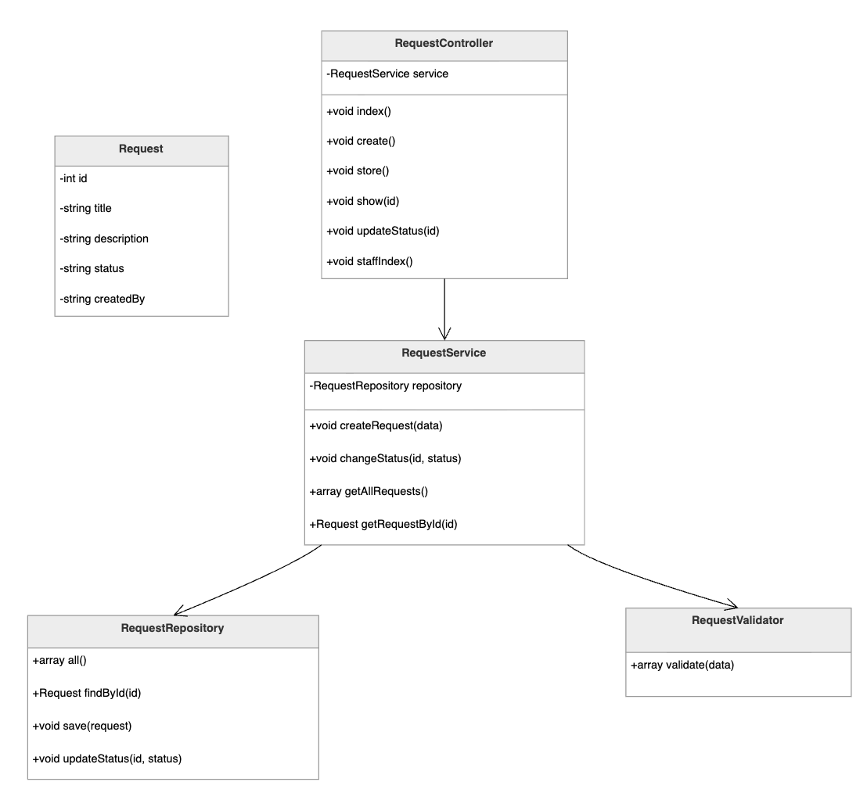

Relationships:
RequestController --> RequestService
RequestService --> RequestRepository
RequestService --> RequestValidator

6) MVC Mapping Table
Item | MVC Layer | Why?
Request | Model | Represents request data
RequestRepository | Model | Handles data storage
RequestService | Model | Contains business logic
RequestValidator | Model | Validates input data
RequestController@index | Controller | Controls the request list page
RequestController@show | Controller | Controls the detail page
RequestController@store | Controller | Saves a new request
RequestController@updateStatus | Controller | Updates request status
requests/index.php | View | Displays request list
requests/show.php | View | Displays request details

7) Route Table
HTTP | URL | Controller@Action | Purpose
GET | /requests | RequestController@index | List requests
GET | /requests/create | RequestController@create | Show request form
POST | /requests | RequestController@store | Save new request
GET | /requests/{id} | RequestController@show | View request details
POST | /requests/{id}/status | RequestController@updateStatus | Update request status
GET | /staff/requests | RequestController@staffIndex | Staff request list

C) MINIMAL CODE
Theo yêu cầu, phần minimal code chỉ cần tạo đúng các file sau: app/Controllers/RequestController.php, app/Models/Request.php, app/Views/requests/index.php, app/Views/requests/show.php, và public/index.php.

1) File Structure
campus-service-request/
├── app/
│ ├── Controllers/
│ │ └── RequestController.php
│ ├── Models/
│ │ └── Request.php
│ └── Views/
│ └── requests/
│ ├── index.php
│ └── show.php
└── public/
└── index.php

2) Source Code

app/Controllers/RequestController.php
<?php

class RequestController
{
public function index(): void
{
echo "Request list page";
}

public function create(): void
{
echo "Create request form";
}

public function store(): void
{
echo "Store new request";
}

public function show(int $id): void
{
echo "Show request with ID: " . $id;
}

public function updateStatus(int $id): void
{
echo "Update status for request ID: " . $id;
}

public function staffIndex(): void
{
echo "Staff request list";
}
}

app/Models/Request.php
<?php

class Request
{
public int $id;
public string $title;
public string $description;
public string $status;
public string $createdBy;

public function __construct(
int $id,
string $title,
string $description,
string $status,
string $createdBy
) {
$this->id = $id;
$this->title = $title;
$this->description = $description;
$this->status = $status;
$this->createdBy = $createdBy;
}
}

app/Views/requests/index.php
<h1>Request List</h1>
<p>This page displays all requests.</p>

app/Views/requests/show.php
<h1>Request Details</h1>
<p>This page displays one request.</p>

public/index.php
<?php

echo "Hello MVC";

3) Short Explanation
The minimal code follows the MVC structure. Request.php is the Model, RequestController.php is the Controller, and index.php and show.php are the Views. The file public/index.php is the entry point of the application.

D) REFLECTION

1) Which parts of your design are Model, View, and Controller?
In my design, the Model includes Request, RequestRepository, RequestService, and RequestValidator because they handle data and business logic. The View includes requests/index.php and requests/show.php because they display information to the user. The Controller is RequestController, which receives requests, calls the model layer, and selects the correct view.

2) Where should validation happen, and why?
Validation should happen in RequestValidator or inside the service layer before data is saved. This is better because validation has its own responsibility. It should not be placed inside the view. This design follows the Single Responsibility Principle and makes the code easier to maintain.

3) What would break if you put SQL inside a View file?
If SQL is placed inside a View file, the view will mix presentation with data logic. This makes the code harder to read, test, and maintain. It also breaks the MVC structure and the Single Responsibility Principle. If the database changes, the View file would also need to change.

4) What code do you expect to write next week to make this real?
Next week, I expect to write a Router to handle URLs, implement real controller actions, connect models to storage, and create real HTML views. I may also need autoloading so classes can be loaded automatically.

CONCLUSION
This homework shows a simple design for a Campus Service Request System. The system follows OOP best practices such as SRP, avoids God classes, uses proper naming conventions, and prepares the project for MVC implementation next week. The minimal code is small, clear, and matches the required file structure from the worksheet.

