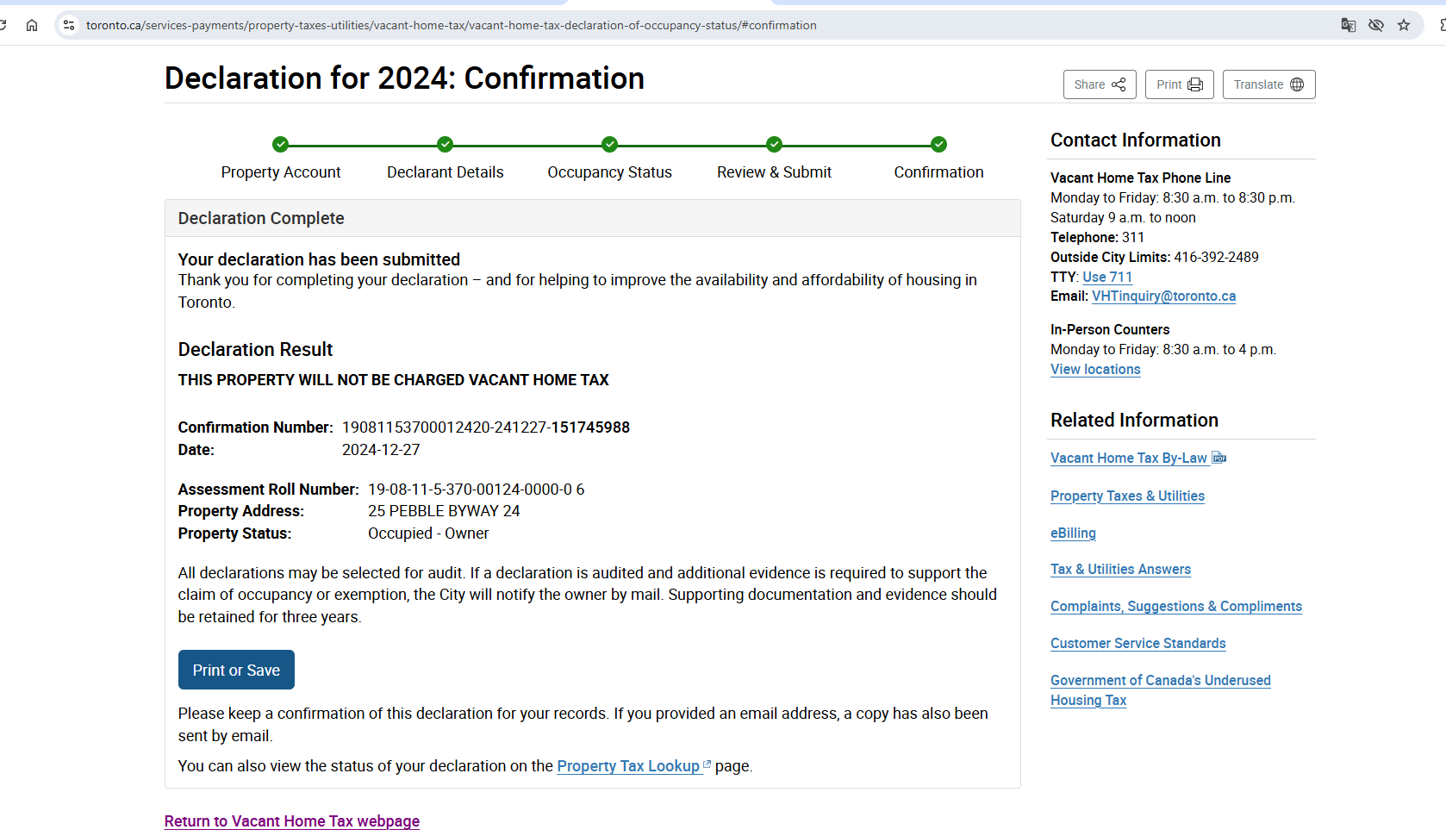

<https://www.canada.ca/en/revenue-agency/services/payments/payments-cra/individual-payments/make-payment.html>

## One-time payment using CRA online services

You can only use a **debit card** to pay with CRA's My Payment service. You **cannot use credit cards** with MyPayment.

Payments you **can** and **cannot** make online through My Payment

**Learn how to pay:** [Using My Payment](https://www.canada.ca/en/revenue-agency/services/e-services/payment-save-time-pay-online.html)

* **Considered as paid:** usually the **same or**

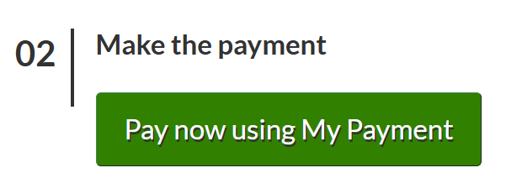

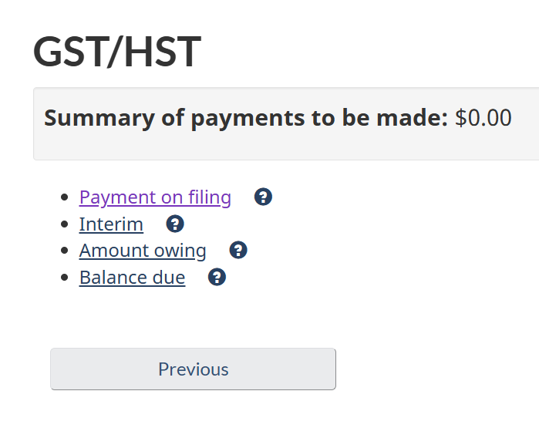

819137662

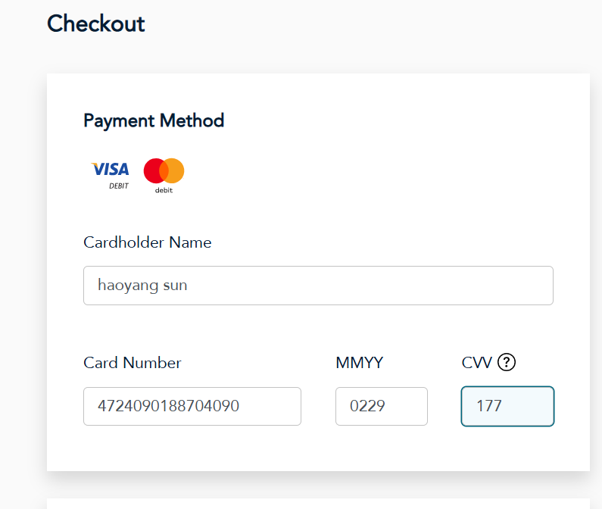

**Receipt**

========== Transaction Record =========

**Transaction number :**

20241109578905340

**Date :**

2024-11-09

**Time :**

13:02:10

**Transaction by :**

VISA DEBIT

**Canada Revenue Agency**

**Issuer Name :**

haoyang sun

**Issuer Confirmation :**

155776

**Debit amount :**

$3,189.97 CAD

**Authorization number :**

155776

**Approved - Thank You**

**Important - Retain this copy for your records**

**Receipt**

========== Transaction Record =========  
**Transaction number :**

20241206581215483

**Date :**

2024-12-06

**Time :**

12:48:43

**Transaction by :**

VISA DEBIT

**Canada Revenue Agency**

**Issuer Name :**

haoyang sun

**Issuer Confirmation :**

136540

**Debit amount :**

$3,189.97 CAD

**Authorization number :**

136540

**Approved - Thank You**

**Important - Retain this copy for your records**

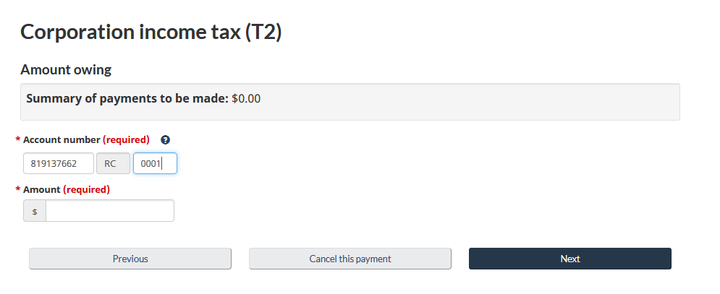

4724090950638104

