- The APCalendar class contains methods used to calculate information about a calendar. You will write two methods of the class.

public class APCalendar {

/**
* Returns true if year is a leap year and false otherwise.
*/
private boolean isLeapYear(int year)
{ /* implementation not shown */ }

/**
* Returns the number of leap years between year1 and year2, inclusive.
* Precondition: 0 <= year1 <= year2
*/
public static int numberOfLeapYears(int year1, int year2)
{ /* to be implemented in part (a) */ }

/**
* Returns the value representing the day of the week for the first
* day of year,
* where 0 denotes Sunday, 1 denotes Monday, ..., and 6 denotes Saturday.
*/
private static int firstDayOfYear(int year)
{ /* implementation not shown */ }

/**
* Returns n, where month, day, and year specify the nth day of the year.
* Returns 1 for January 1 (month = 1, day = 1) of any year.
* Precondition: The date represented by month, day, year is a valid date.
*/
private static int dayOfYear(int month, int day, int year)
{ /* implementation not shown */ }

/**
* Returns the value representing the day of the week for the given date
* (month, day, year), where 0 denotes Sunday, 1 denotes Monday, ...,
* and 6 denotes Saturday.
* Precondition: The date represented by month, day, year is a valid date.
*/
public static int dayOfWeek(int month, int day, int year)
{ /* to be implemented in part (b) */ }

// There may be instance variables, constructors, and other methods not shown.
}

- Write the method numberOfLeapYears, which returns the number of leap years between year1 and year2, inclusive.

In order to calculate this value, a helper method is provided for you.

- isLeapYear(year) returns true if year is a leap year and false otherwise.

Complete method numberOfLeapYears below.

You must use isLeapYear appropriately to receive full credit.

/**
* Returns the number of leap years between year1 and year2, inclusive.
* Precondition: 0 <= year1 <= year2
*/
public static int numberOfLeapYears(int year1, int year2)

/* to be implemented in part (a) */
int leapYearCount = 0;
for(int y = year1; y <=year2; y++){
if(isLeapYear(y)){
leapYearCount++;
}
}
return leapYearCount;

/5
- Write the method dayOfWeek, which returns the integer value representing the day of the week for the given date (month, day, year), where 0 denotes Sunday, 1 denotes Monday, ..., and 6 denotes Saturday. For example, 2019 began on a Tuesday, and January 5 is the fifth day of 2019. As a result, January 5, 2019, fell on a Saturday, and the method call dayOfWeek(1, 5, 2019) returns 6.

As another example, January 10 is the tenth day of 2019. As a result, January 10, 2019, fell on a Thursday, and the method call dayOfWeek(1, 10, 2019) returns 4.

In order to calculate this value, two helper methods are provided for you.

- firstDayOfYear(year) returns the integer value representing the day of the week for the first day of year, where 0 denotes Sunday, 1 denotes Monday, ..., and 6 denotes Saturday. For example, since 2019 began on a Tuesday, firstDayOfYear(2019) returns 2.
- dayOfYear(month, day, year) returns n, where month, day, and year specify the nth day of the year. For the first day of the year, January 1 (month = 1, day = 1), the value 1 is returned. This method accounts for whether the year is a leap year. For example, dayOfYear(3, 1, 2017) returns 60, since 2017 is not a leap year, while dayOfYear(3, 1, 2016) returns 61, since 2016 is a leap year.
Complete method dayOfWeek below. You must use firstDayOfYear and dayOfYear appropriately to receive full credit.
/**
* Returns the value representing the day of the week for the given date
* (month, day, year), where 0 denotes Sunday, 1 denotes Monday, ...,
* and 6 denotes Saturday.
* Precondition: The date represented by month, day, year is a valid date.
*/
public static int dayOfWeek(int month, int day, int year)

/* to be implemented in part (b) */
int dOfYear = dayOfYear(month, day, year);
int fdOfYear = firstDayOfYear(year);
return (dOfYear + fdOfYear - 1)%7;

/4

- This question involves the implementation of a fitness tracking system that is represented by the StepTracker class. A StepTracker object is created with a parameter that defines the minimum number of steps that must be taken for a day to be considered active. The StepTracker class provides a constructor and the following methods.

- addDailySteps, which accumulates information about steps, in readings taken once per day
- activeDays, which returns the number of active days
- averageSteps, which returns the average number of steps per day, calculated by dividing the total number of steps taken by the number of days tracked The following table contains a sample code execution sequence and the corresponding results
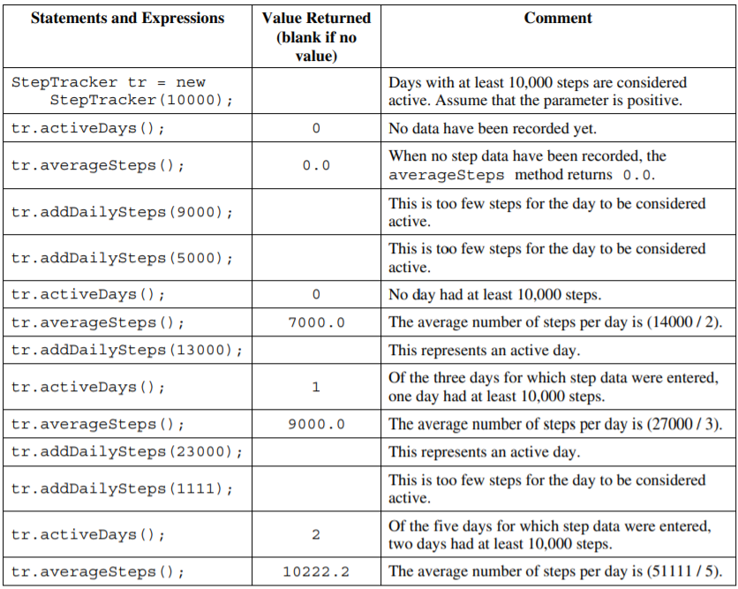

Write the complete StepTracker class, including the constructor and any required instance variables and methods. Your implementation must meet all specifications and conform to the example.
public class StepTracker {
private int minSteps;
private int dailySteps;
private int activeDays;
private int days;
private int totalSteps;
public StepTracker(int s){
minSteps = s;
dailySteps = 0;
activeDays = 0;
days = 0;
totalSteps = 0;
}
public void addDailySteps(int s){
dailySteps += s;
days++;
if(dailySteps > minSteps){
activeDays++;
}
totalSteps += dailySteps;
dailySteps = 0;
}
public double averageSteps(){
return totalSteps/days;
}
public int activeDays(){
return activeDays;
}
}

/9

