1. The picture below shows the following directory listing,

Home → Desktop → APComputerScienceA → Homework

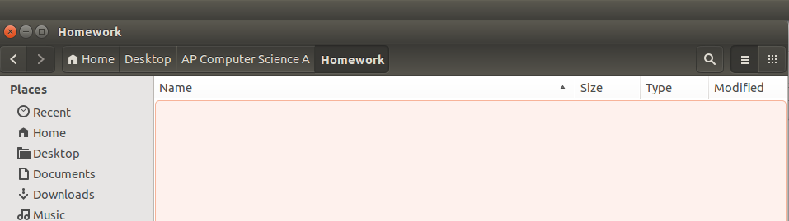
- Beginning in the “Home” directory, write the command(s) need to navigate from the “Home” directory to the “Homework” directory in the Terminal.

cd Desktop/APComputerScienceA/Homework

- Write the command(s) needed to create another directory entitled “Homework1” in the homework directory

mkdir Homework1

(c) Write the command needed to list all the files and directories in a folder.

ls (Linux or Mac)
dir (Windows)

/3

2. Write a driver class called “Tester” that prints “Hello Ms. Pluska” to the console.
public class Tester{

public static void main(String args[]){

System.out.println(“Hello Ms. Pluska”);
}
}

/4

3. A student needs to document their name and the date in the program above using remarks. Write two different sets of code that could be used to identify you as the author and date.
//Pluska
//Aug 29, 2017

OR

/*
Pluska
Aug 29, 2017
*/

/3

4. Indicate what is printed when the following is executed
System.out.print(“Hello”);  System.out.print(“ ”);  System.out.print(“Timberline”);  System.out.println();  System.out.println(“JAVA”);  System.out.println(“is”);  System.out.print(“Awesome!”); | Hello Timberline!  JAVA  is  Awesome!
 |  | /4

5. A student writes a driver class called Tester.java.
(a) Write the command required to compile this class

javac Tester.java

(b) Write the command required to run this class

java Tester

/2

