- Complete the stack/heap diagram for the following code segment. Then, indicate what is printed.
public class BankDriver {

static BankAccount myAccount = new BankAccount(200); //sets balance to 200

public static void main(String[] args)
{
double b[] = new double[5];
b[3] = 24;
int x = 12;
method1(x, b, myAccount);
BankAccount anotherAccount = new BankAccount(600);//sets balance = 600
anotherAccount = myAccount;
System.out.println(x + " " + b[3] + " " + myAccount.balance);
}

public static void method1(int x, double a[], BankAccount theAccount){

x = 890;
a[3] = 16;
theAccount.balance = 100;
myAccount.deposit(100); //adds 100 to the balance
}
}
Stack | Heap
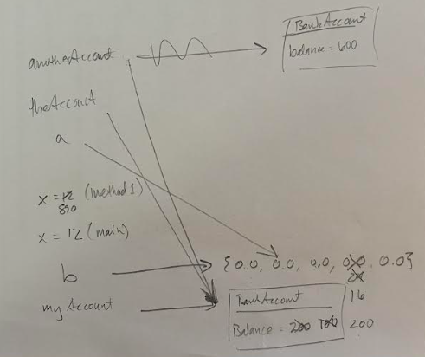

What is printed when the code above is executed?

12 16 200

 |  | /4

- Complete the stack/heap diagram for the following code segment. Then, indicate what is printed.
public class Testing3 {
public static void main(String args[]){
int s[] = {0,1,2,3,4,5};

for(int g = 0; g < s.length; g++)
System.out.print(s[g] + " ");

System.out.print("\n");
testMethod(s);

int p[] = s;

for(int g = 0; g < s.length; g++)
System.out.print(p[g] + " ");
}

public static void testMethod(int pp[]){
int len = pp.length;
int t2[] = new int[len/2];
int i = 0;

for(int j=len/2-1; j>=0; j--){
i+=2;
t2[j] = pp[i-1];
}
for(int k=0; k<t2.length; k++)
System.out.print(t2[k] + " ");

System.out.print("\n");
pp = t2;
}
}

Stack | Heap
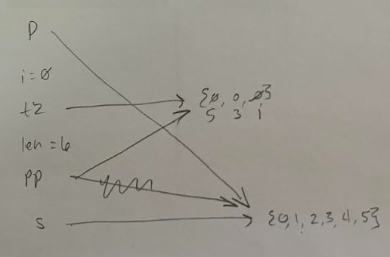

What is printed when the code above is executed?
0 1 2 3 4 5
5 3 1
0 1 2 3 4 5
 |  | /4

- Complete the stack/heap diagram for the following code segment. Then, indicate what is printed.
public class Testing
{
public static void main(String args[])
{
int [] prf = {2,3,8,2};
double d = 4.58;
Circle myCir = new Circle(11);//set rad = 11
myCir.rad = 25;
fg(prf, d, myCir);

System.out.println(d);
System.out.println(prf[0]);
System.out.println(myCir.rad);
}

public static void fg(int [] x, double d, Circle c)
{
d++;
x[0] = 15;
c.rad = 34;
System.out.println(++d);

int nn[] = new int[x.length];
nn[3] = x[0];
x = nn;
x[0] = 2;
}
}
Stack | Heap
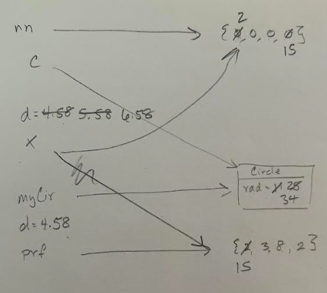

What is printed when the code is executed?
6.58
4.58
15
34
 |  | /4

- This question involves the implementation of a class, called StringManip, which is used to perform manipulation on strings.

The class provides the following methods,

- removeSpaces, takes a string and returns a new string with the spaces removed. For example, removeSpaces(“hi how are you”), returns “hihowareyou”.
- reverseString, which takes a string and returns a new string with the characters in reverse order. For example, reverseString("ABCDE") should return "EDCBA".
- palindromeChecker, takes a string and determines whether the string is a palindrome and prints a message indicating the result. Examples of the intended behavior of the method are shown in the following table.
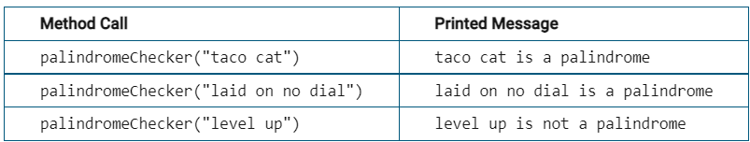

The following table illustrates how the StringManip class works.

Statements and Expressions | Value Returned (blank if no value) | Comment
StringManip.removeSpaces(“laid on no dial”); | laidonnodial | Returns a string with the spaces removed
StringManip.reversString(“laid on no dial”); | laid on no dial | Returns a string in reverse order
StringManip.palindromeChecker(“laid on no dial”) | laid on no dial is a palindrome | Returns a message indicating whether or not the string is a palindrome
StringManip.palindromeChecker(“taco cat”) | taco cat is a palindrome | Returns a message indicating whether or not the string is a palindrome
StringManip.palindromeChecker(“level up”); | level up is not a palindrome | Returns a message indicating whether or not the string is a palindrome

Write the complete StringManip class, including the necessary constructors and any required instance variables and methods. Your implementation must meet all specifications and conform to the example.
public static String removeSpaces(String phrase){
String result = "";
for(int letter = 0; letter < phrase.length(); letter++){
if(!phrase.substring(letter, letter+1).equals(" ")){
result += phrase.substring(letter, letter+1);
}
}
return result;
}

public static String reverseString(String phrase){
String result = "";
for(int letter = phrase.length() - 1; letter >=0; letter--){
result += phrase.substring(letter, letter + 1);
}
return result;
}

public static String palindromeChecker(String phrase){
String result = removeSpaces(phrase);
String reverse = reverseString(result);
if(result.equals(reverse)){
return phrase + " is a palindrome";
}
return phrase + " is not a palindrome";
}

/13

- The following class represents a customer. The variable name represents the name of the customer, and the variable currAccNum represents the customer’s account number. Each time a Customer object is created, the static variable nextAccNum is used to assign the customer’s account number.

public class Customer
{
private static int nextAccNum = 1;
private String name;
private int currAccNum;

public Customer(String n) {
name = n;
currAccNum = nextAccNum;
nextAccNum++;
}
}

(a) Write a method for the Customer class that that will return a string representing a bill notice when passed a double value representing an amount due.

For example, if the customer has name "Jeremiah", has account number 3, and has amount due 50.50, the method should return a string in the following format.

Jeremiah, account number 3, please pay $50.50

Write the method below. Your implementation must conform to the example above.

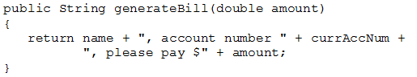

/2
(b) Write a method for the Customer class that returns the value of the next account number that will be assigned.
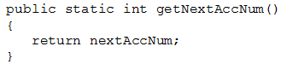

/2
(c) A student has written the following method to be included in the Customer class. The method is intended to update the name of a customer but does not work as intended.

public void updateName(String name)
{
name = name;
}

Write a correct implementation of the updateName method that avoids the error in the student’s implementation.
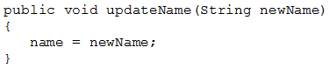

Or

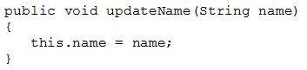

/1

