1. Refer to the following code:

int [][] zorro = new int[3] [4];

for(int row=0; row<zorro.length; row++)
{
for(int col=0; col<zorro[row].length; col++)
{
zorro[row][col] = row * 2;
}
}
(a) Indicate the values of the zorro array above. The numbers in the table indicate the indices of the array.

 | 0 | 1 | 2 | 3
0
1
2

/2

2. The Grid class below prints a two-dimensional array of doubles. The Grid constructor should accept a two dimensional array of any size as a parameter. The showGrid method should print out the contents.

(a) Declare a two-dimensional array called doubleArray, but do not initialize it. (1 point)
(b) Write the constructor that accepts a two-dimensional array as a parameter then assigns the array to doubleArray. (2 ponts)
(c) Write the showGrid method which prints out the contents of the two dimensional array (4 points)
public class Grid{

}
/7

3. In the driver class below,

(a) Declare and initialize a 3x3 two-dimensional array called doubleArray (1 point)
(b) Create a Grid object called doubleGrid. (2 points)
(c) Print the contents of doubleGrid. (1 point)
public class gridDriver{

public static void main(String[] args){

}

}
/4

4. The LightBoard class models a two-dimensional display of lights, where each light is either on or off, as represented by a Boolean value. You will implement a constructor to initialize the display and a method to evaluate a light.

public class LightBoard
{
/** The lights on the board, where true represents on and false
* represents off.
*/

private boolean[][] lights;

/** Constructs a LightBoard object having numRows rows and numCols columns
* Precondition: numRows > 0, numCols > 0
* Postcondition: each light has a 40% probability of being set to on
*/

public LightBoard(int numRows, int numCols)
{ /* To be implemented in part (a) */ }

/** Evaluates a light in row index row and column index col
* and returns a status as described in part (b).
* Precondition: row and col are valid indexes in lights.
*/

public boolean evaluateLight(int row, int col)
{ /* to be implemented in part (b) */ }

// There may be additional instance variables, constructors, and methods not shown.
}

(a) Write the constructor for the LightBoard class, which initializes lights so that each light is set to on with a 40% probability. The notation lights[r][c] represents the array element at row r and column c.

Complete the LightBoard constructor below.

/** Constructs a LightBoard object having numRows rows and numCols columns.
* Precondition: numRows > 0, numCols > 0
* Postcondition: each light has a 40% probability of being set to on.
*/

public LightBoard(int numRows, int numCols)

(b) Write the method evaluateLight, which computes and returns the status of a light at a given row and column based on the following rules.

1. If the light is on, return false if the number of lights in its column that are on is even, including the current light.
2. If the light is off, return true if the number of lights in its column that are on is divisible by three.
3. Otherwise, return the light’s current status.

For example, suppose that LightBoard sim = new LightBoard(7, 5) creates a light board with the initial state shown below, where true represents a light that is on and false represents a light that is off. Lights that are off are shaded.

lights

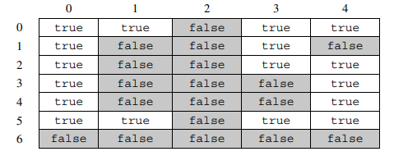

Sample calls to evaluateLight are shown below.

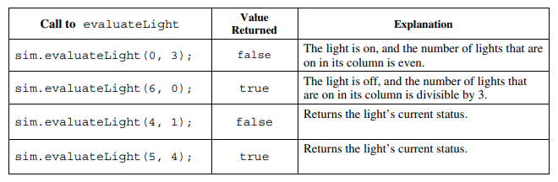

Class information for this question

public class LightBoard
private boolean[][] lights
public LightBoard(int numRows, int numCols)
public boolean evaluateLight(int row, int col)

Complete the evaluateLight method below.
/** Evaluates a light in row index row and column index col and returns a status
* as described in part (b).
* Precondition: row and col are valid indexes in lights.
*/

public boolean evaluateLight(int row, int col)

