AP Computer Science A

Setting Up your JDK Environment

Windows
Navigate to  https://java.com/en/  Click on the “Free JAVA Download” button. | 
Once the download has completed, double click on the jdk download link. It is located in the lower left corner of your browser.  If you accidently navigated closed the link, the link to the execution file is also located in the “downloads” folder.  Follow the steps for completing the installation. (See Ms. Pluska if prompted for an administrator password) | 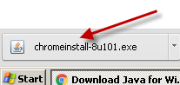
Navigate to http://www.oracle.com/technetwork/java  /javase/downloads/index.html | 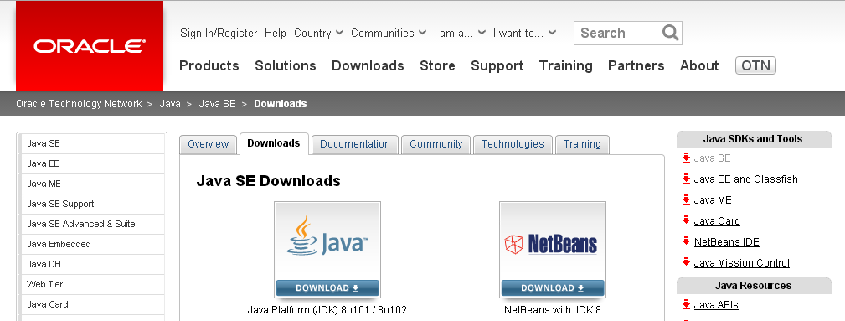
Click on the JAVA JDK Download button | 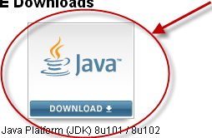
Select the “Accept License Agreement” option, then click on the windows x64 option. | 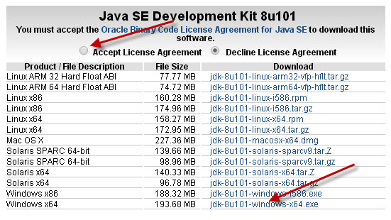
Once the download has completed, double click on the jdk download link. It is located in the lower left corner of your browser.  If you accidently navigated closed the link, the link to the execution file is also located in the “downloads” folder.  Follow the steps for completing the installation. (See Ms. Pluska if prompted for an administrator password) | 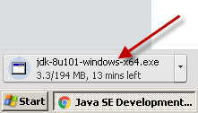
Locate the folder icon at the bottom of your screen.  Select the “This PC” option in the left menu.  Select the “C” drive | 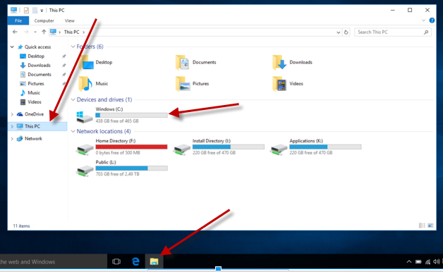
Click on Program files -> Java -> jdk1.8.0_101 -> bin  Click in the address bar, then click Ctrl-c to copy the location address | 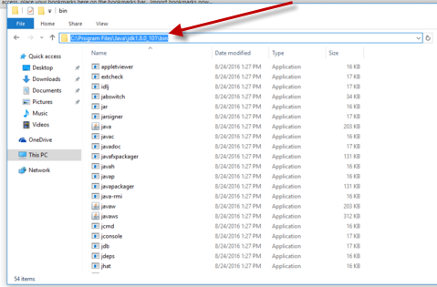
Right click on the start menu, then navigate to System | 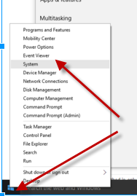
Click on Advanced system settings in the left menu.  Click on Environment Variables | 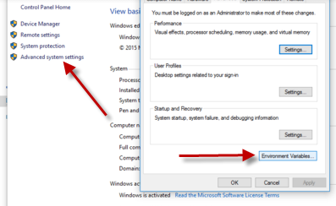
Locate the “Path” option under System variables, then click “Edit…” | 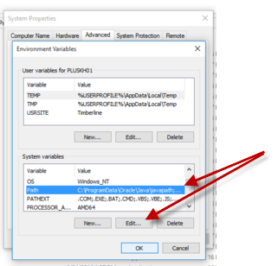
Scroll to the end of the text DO NOT DELETE ANYTHING!  Type a semi-colon, then click Ctrl-v to paste the address you saved previously to your clipboard.  Click OK when done  Reboot your computer when done.  Now it is time to write your first program! | 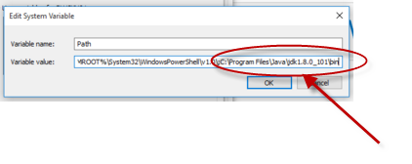
Linux
Type Ctrl-ALT-T to open the terminal
In the command line type sudo apt-get update
When prompted for a password type “password”
To check for the latest version of java type java –version
Type sudo apt-get install default-jre
Type sudo apt-get install default-jdk
All done!
Mac
Navigate to

https://java.com/en/

Click on the “Free JAVA Download” button.

