1. The picture below shows the following directory listing,

Home → Desktop → AP Computer Science A → Homework

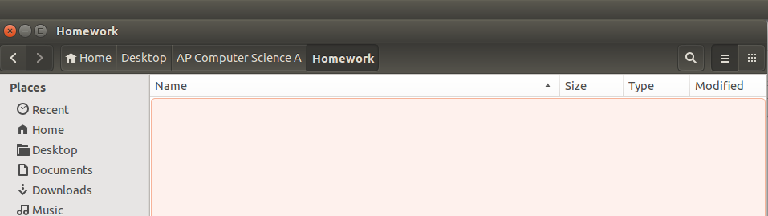
- Beginning in the “Home” directory, write the command(s) need to navigate from the “Home” directory to the “Homework” directory in the Terminal.

- Write the command(s) needed to create another directory entitled “Homework 1” in the homework directory

(c) Write the command needed to list all the files and directories in a folder.

/3

2. Write a driver class called “Tester” that prints “Hello Ms. Pluska” to the console.
/4

3. A student needs to document their name and the date in the program above using remarks. Write two different sets of code that could be used to identify you as the author and date.
/3

Skill 0.3 Exercise 1
Indicate what is printed when the following code is executed
System.out.print(“Hello”);
System.out.print(“ “);
System.out.print(“Timberline!”);
System.out.println();
System.out.println(“JAVA”);
System.out.println(“is”);
System.out.print(“awesome!”);
/2

5. A student writes a driver class called Tester.java.
(a) Write the command required to compile this class

(b) Write the command required to run this class

/2

