- The GradBookStats class is intended to compute basic statistics associated with different assignments in a gradebook. Below is a portion of a gradebook.

 | Exam 1 | Exam 2 | Exam 3 | Lab 1 | Lab 2 | Lab 3 | Project 1 | The number of assignments continues.
Bart | 5 | 1 | 3 | 1 | 2 | 3 | 3 | The number of assignments continues.
Homer | 4 | 4 | 4 | 4 | 4 | 4 | 4 | The number of assignments continues.
Wilma | 4 | 5 | 2 | 5 | 3 | 4 | 4 | The number of assignments continues.
Averages | 4.33 | 3.33 | 3.0 | 3.33 | 3.0 | 3.66 | 3.66

The grade book above can be visualized as a series of parallel arrays as follows,

String assignments[] = {"Exam 1","Exam 2","Exam 3","Lab 1","Lab 2","Lab 3","Project 1", …};
int Bart[] = {5,1,3,1,2,3,3, …};
int Homer[] = {4,4,4,4,4,4,4, …};
int Wilma[] = {4,5,2,5,3,4,4, …};
/* averages array implementation not shown */
- In the space below write code that could be used to calculate the average of each assignment, then store the resulting average in a new array called averages. Each index in averages should map to the appropriate assignment. The number of assignments is not known; therefore, averages should be initialized in terms of the length of the assignments array. You must also be mindful that the number of digits to the right of the decimal should not exceed 2. For example, the Exam 1 average should be reported as 4.33, not 4.333333333333333
public class GradeBookStats{
public static void main{

double averages[] = new double[assignments.length];
for(int i = 0; i < assignments.length;i++){
double tempTotal = Bart[i] + Homer[i] + Wilma[i];
//below calculates the average and converts it to the
//correct decimal places
int tempAverage = (int)(tempTotal/3*100);
averages[i] = tempAverage/100.0;
}

}
}
/5
- The mode of a data set refers to the value that occurs most often. The mode for each assignment is shown below.
 | Exam 1 | Exam 2 | Exam 3 | Lab 1 | Lab 2 | Lab 3 | Project 1 | mode
Bart | 5 | 1 | 3 | 1 | 2 | 3 | 3 | 3
Homer | 4 | 4 | 4 | 4 | 4 | 4 | 4 | 4
Wilma | 4 | 5 | 2 | 2 | 3 | 3 | 2 | 2

In the space below write code that could be used to calculate the mode for a given student. Where student represents an array of scores received by a student. For example,
int student[] = Bart;

The score that occurs most often should be assigned to the variable mode.
public class GradeBookStats{
public static void main{
int Bart[] = {5,1,3,1,2,3,3};
int Homer[] = {4,4,4,4,4,4,4};
int Wilma[] = {4,5,2,5,3,4,4};
int student[] = Bart;
int mode = 0;
int count = 0;
for(int i = 0; i < student.length; i++){
int tempMode = student[i];
int tempCount = 0;
for(int j = 0; j < student.length; j++){
if(student[i] == student[j]){
tempCount++;
}
}
if(tempCount > count ){
mode = tempMode;
count = tempCount;
}

}

}
}
/5

- The Vocab class, is used to analyze words in terms of their presence in a vocabulary list. For example,

Consider the vocabulary and word lists below which are stored in the arrays vocabList and wordList, respectively.
String vocabList[] = {"time","food","dogs","cats","health","plants","sports"};
String wordList[] = {"dogs","toys","sun","plants","time"};

The Vocab class does the following,

- Counts the number of words in wordList that are not in the vocabList and stores this value in countNotInVocab
- Creates a new array called missingVocab that is the same length as the value of countNotInVocab
- Stores the missing vocab in the missingVocab array

The following example illustrate the behavior of the Vocab class.

vocabList
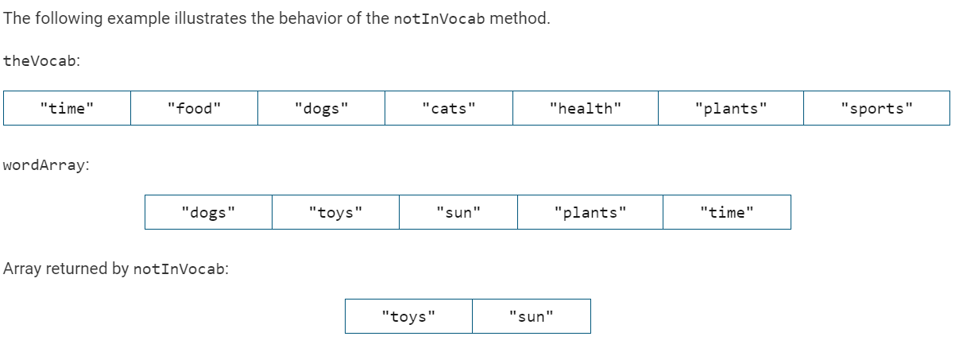
wordList
missingVocab
- Write code that could be used to count the number of words in wordList that are not found in vocabList. The final value should be stored in the variable countNotInVocab.
public class Vocab{
public static void main{
String vocabList[] = {"time","food","dogs","cats","health","plants","sports"};
String wordList[] = {"dogs","toys","sun","plants","time"};
String missingVocab[];
int countNotInVocab = 0;

String notFound = "";

for(int i = 0; i < wordList.length; i++){
boolean found = false;
for(int j = 0; j < vocabList.length;j++){
if(wordList[i].equals(vocabList[j])){
found = true;
}
}
if(found == false){
notFound += wordList[i] + ",";
}
}
missingVocab = notFound.split(",");
countNotInVocab = missingVocab.length;

}
}
/6

