Hello World!

Your Tasks (Mark these off as you go)
- Write your first driver class
- Create a new repository on GitHub
- Initialize your local repository
- Create a file in your local repository and push it to your remote GitHub repository
- Receive credit for the group portion of this lab

- Write your first driver class

All java programs require a “driver class”. You can think of a driver class as the engine starting your program. Without an engine your car will not run, without a driver class, your program will not run.
The following steps will guide you through writing your first driver class. At this point, you will not understand all the words and syntax, but over the course of the year you will – promise!
- In the labs directory of your APCompSciA GitHub repository create a new directory called HelloWorld
- Inside this directory create a new file called HelloWorld.java.
  - Linux users use gedit
  - Windows users use notepad++ (download this and install it)
  - Mac users use atom (download this and install it)
- Type the following code EXACTLY as shown into the text editor. At this point, do not worry about what any of this means. It’s just something we must do for every program.

Curly brackets are used to enclose the code in a class

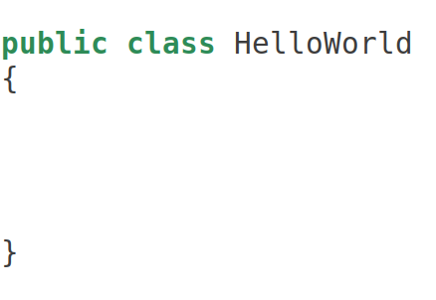

The name that follows the class declaration MUST
be the same name as the filename, minus the .java declaration

- Create a new repository on GitHub

- Once you've created your directory structure, go to your GitHub account "Repositories" page and create a new repository! This repository will have the same name as the one you just created on your computer (APCompSciARepo).
  - If you have the student developer pack, mark this repository as private
  - Un-check the box that says "initialize this repository with a README"

Some images to guide you through this process are included below:
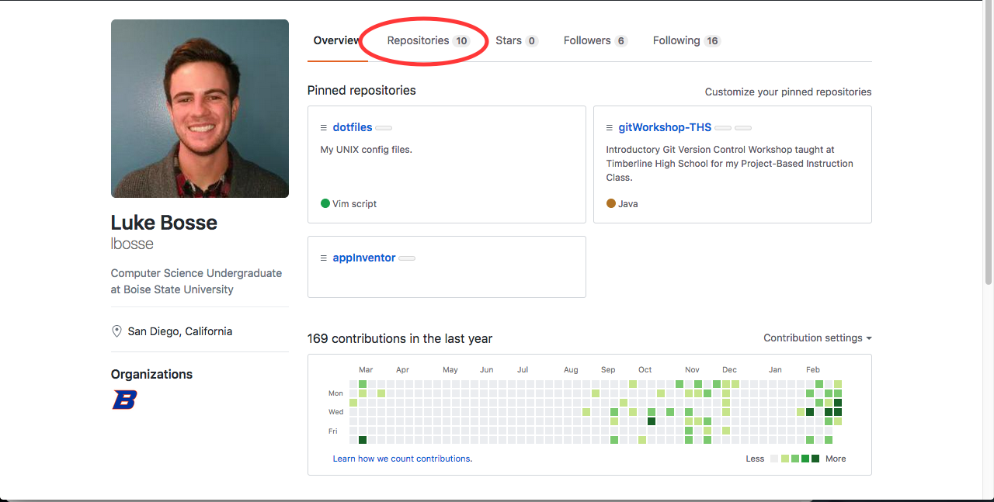
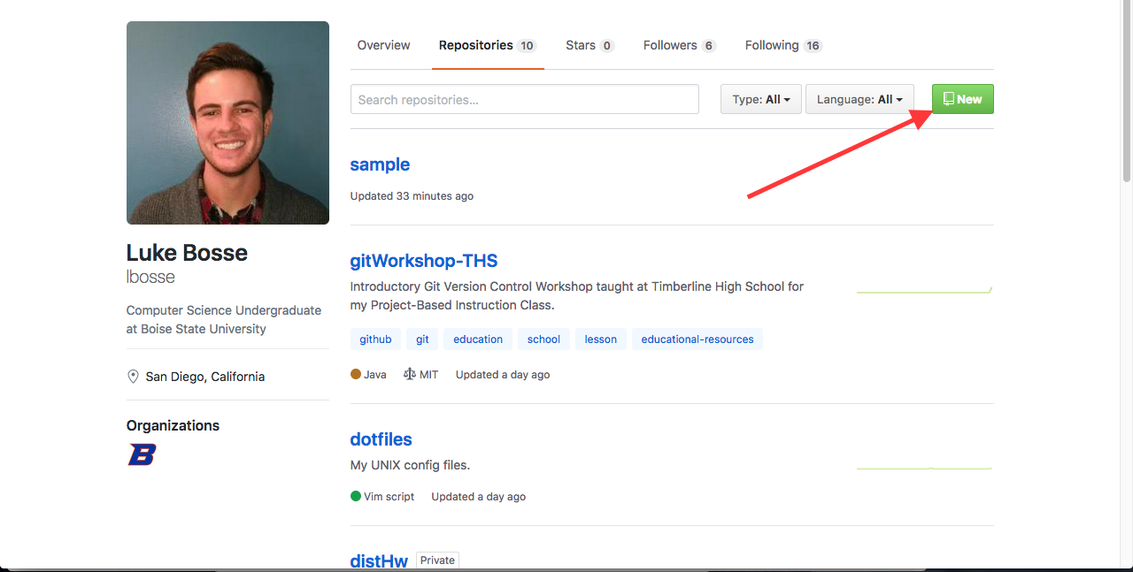
- Intialize your local repository

Once you create a repository, GitHub will show you the commands you need to run in your local repository to link it to the remote repository you just created. Really just two are needed however.
- Navigate to the APCompSciARepo folder you created on your desktop, copy each of the commands (ctrl-c) and paste them into the command line (ctrl-shift-v).
git init
git remote add origin <link to your repository>

- Create a file in your local repository and push it to your remote GitHub repository

- Use the command below to create a new file inside your APCompSciARepo directory you just created on your desktop.

gedit helloGitHub

- Inside this file type a message to yourself... “Hello GitHub!”, “Coding is Awesome!”, or whatever you like. Save thie file and close it.
- Now push your changes to your remote GitHub repository,

git add .
git commit -m “Type your commit message here”
git push origin master

- Receive Credit for the group portion of this lab

Switch roles, and repeat this workshop with your partner.
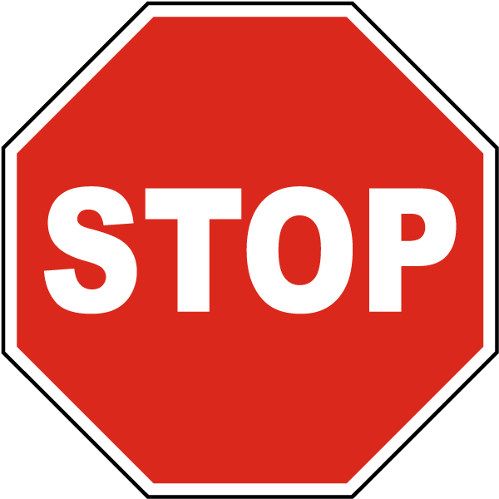

Before you submit your lab have Ms. Pluska check that both you and your partner have linked local and remote repositories.
Do not continue until you have Ms. Pluska’s (or her designated TA’s) signature ____________

