- The DivBySum class is intended to compute the sum of all the elements in an int array arr that are divisible by the int num. Consider the following examples,

arr | num | result | Explanation
{4, 1, 3, 6, 2, 9} | 3 | 18 | Result is 18 which is the sum of 3, 6, and 9
{4, 1, 3, 6, 2, 9} | 5 | 0 | Result is 0 since none of the integers are divisible by 5
{1, 3, 5, 8, 12, 27, 8} | 2 | 28 | Result is 28 which is the sum of 8, 12, and 8

Complete the DivBySum class using an enhanced for loop. Assume that arr and num are properly declared and initialized. You must use an enhanced for loop to earn full credit.
public class DivBySum{

public static void main(String args[]){

int result = 0;
for(int x : arr){
if(x % num == 0){
result += x;
}
}

}
}
/3

- The WordScrambler class, takes words from two different arrays, scrambles them, then stores the result in a new array. The words are scrambled by taking the first half of the word from arr1 and the second half of the word from arr2 and combining them. Below are examples,

array | word | half | combined
arr1 | apple | ap | arap
arr2 | pear | ar | arap

The scrambled words are then stored in a new array called result. Below is an example,

arr1 | {“apple”, “bear”, “Timberline”, “Thanksgiving”}
arr2 | {“pear”, “light”, “school”, “Friday”}
result | {“arap”, “ghtbe”, “ooltimbe”, “daythanks”}

Complete the WordScrambler class below. You may assume that arr1 and arr2 are the same size and have been declared and properly initialized.
public class WordScrambler{

public static void main(String args[]){

String result[] = new String[arr1.length];

for(int i = 0; i<arr1.length;i++){
String half1 = arr1[i].substring(0, arr1[i].length()/2);
String half2 = arr2[i].substring(arr2[i].length()/2);
result[i] = (half2 + half1).toLowerCase();
}

}
}
/5
- The FindValley class evaluates whether an array of integers has the valley property. An array of positive integers has the valley property if the elements are ordered such that successive values decrease until a minimum value (the minimum of the valley) is reached and then the successive values increase.

The following table illustrates the value assigned to valleyIndex for several integer arrays. In each case, if a valley is not found valleyIndex has a value of -1, otherwise it has the value of the first valley found.

arr | valleyIndex
{11, 22, 33, 22, 11} | -1
{11, 22, 11, 22, 11} | 2
{11, 22, 33, 55, 77} | -1
{99, 33, 55, 77, 120} | 1
{99, 33, 25, 77, 55} | 2
{33, 22, 11} | -1

Complete the FindValley class below. You may assume that arr and valleyIndex are properly declared and initialized.
public class FindValley{

public static void main(String args[]){

int valleyIndex = -1;
for(int i = 1; i < arr.length - 1; i++){
if(arr[i - 1]>arr[i] && arr[i+1] > arr[i]){
valleyIndex = i;
break;
}
}

}
}
/5

- The GradBookStats class is intended to compute basic statistics associated with different assignments in a gradebook. Below is a portion of a gradebook.

 | Exam 1 | Exam 2 | Exam 3 | Lab 1 | Lab 2 | Lab 3 | Project 1 | The number of assignments continues.
Bart | 5 | 1 | 3 | 1 | 2 | 3 | 3 | The number of assignments continues.
Homer | 4 | 4 | 4 | 4 | 4 | 4 | 4 | The number of assignments continues.
Wilma | 4 | 5 | 2 | 5 | 3 | 4 | 4 | The number of assignments continues.
Averages | 4.33 | 3.33 | 3.0 | 3.33 | 3.0 | 3.66 | 3.66

The grade book above can be visualized as a series of parallel arrays as follows,

String assignments[] = {"Exam 1","Exam 2","Exam 3","Lab 1","Lab 2","Lab 3","Project 1", …};
int Bart[] = {5,1,3,1,2,3,3, …};
int Homer[] = {4,4,4,4,4,4,4, …};
int Wilma[] = {4,5,2,5,3,4,4, …};
/* averages array implementation not shown */
- In the space below write code that could be used to calculate the average of each assignment, then store the resulting average in a new array called averages. Each index in averages should map to the appropriate assignment. The number of assignments is not known; therefore, averages should be initialized in terms of the length of the assignments array. You must also be mindful that the number of digits to the right of the decimal should not exceed 2. For example, the Exam 1 average should be reported as 4.33, not 4.333333333333333
public class GradeBookStats{
public static void main{

double averages[] = new double[assignments.length];
for(int i = 0; i < assignments.length;i++){
double tempTotal = Bart[i] + Homer[i] + Wilma[i];
//below calculates the average and converts it to the
//correct decimal places
int tempAverage = (int)(tempTotal/3*100);
averages[i] = tempAverage/100.0;
}

}
}
/5
- The mode of a data set refers to the value that occurs most often. The mode for each assignment is shown below.
 | Exam 1 | Exam 2 | Exam 3 | Lab 1 | Lab 2 | Lab 3 | Project 1 | mode
Bart | 5 | 1 | 3 | 1 | 2 | 3 | 3 | 3
Homer | 4 | 4 | 4 | 4 | 4 | 4 | 4 | 4
Wilma | 4 | 5 | 2 | 2 | 3 | 3 | 2 | 2

In the space below write code that could be used to calculate the mode for a given student. Where student represents an array of scores received by a student. For example,
int student[] = Bart;

The score that occurs most often should be assigned to the variable mode.
public class GradeBookStats{
public static void main{
int Bart[] = {5,1,3,1,2,3,3};
int Homer[] = {4,4,4,4,4,4,4};
int Wilma[] = {4,5,2,5,3,4,4};
int student[] = Bart;
int mode = 0;
int count = 0;
for(int i = 0; i < student.length; i++){
int tempMode = student[i];
int tempCount = 0;
for(int j = 0; j < student.length; j++){
if(student[i] == student[j]){
tempCount++;
}
}
if(tempCount > count ){
mode = tempMode;
count = tempCount;
}

}

}
}
/5

- The Vocab class, is used to analyze words in terms of their presence in a vocabulary list. For example,

Consider the vocabulary and word lists below which are stored in the arrays vocabList and wordList, respectively.
String vocabList[] = {"time","food","dogs","cats","health","plants","sports"};
String wordList[] = {"dogs","toys","sun","plants","time"};

The Vocab class does the following,

- Counts the number of words in wordList that are not in the vocabList and stores this value in countNotInVocab
- Creates a new array called missingVocab that is the same length as the value of countNotInVocab
- Stores the missing vocab in the missingVocab array

The following example illustrate the behavior of the Vocab class.

vocabList
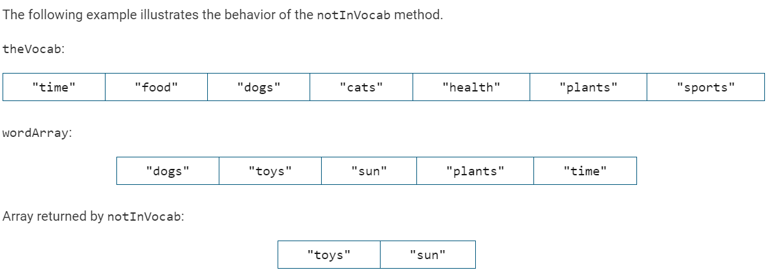
wordList
missingVocab
- Write code that could be used to count the number of words in wordList that are not found in vocabList. The final value should be stored in the variable countNotInVocab.
public class Vocab{
public static void main{
String vocabList[] = {"time","food","dogs","cats","health","plants","sports"};
String wordList[] = {"dogs","toys","sun","plants","time"};
String missingVocab[];
int countNotInVocab = 0;

String notFound = "";

for(int i = 0; i < wordList.length; i++){
boolean found = false;
for(int j = 0; j < vocabList.length;j++){
if(wordList[i].equals(vocabList[j])){
found = true;
}
}
if(found == false){
notFound += wordList[i] + ",";
}
}
missingVocab = notFound.split(",");
countNotInVocab = missingVocab.length;

}
}
/6

