1. The image below represents an array of String type variables called houses. The value associated with each house corresponds to the name of the person who lives there.



(a) Write code that could be used to declare and initialize the array, but does not populate it.

(b) Write the address of each house on the roof.

(c) Write code that could be used to assign the value of house 3 to “Wilma”, and the value of house 6 to “Barney”, and the value of house 2 to “Homer”

(d) What is the value of the house with address 4?

(e) Homer and Barney have decided to trade houses. Write code to assign Homer and Barney to their new homes.

/6

2. A new neighbor named “Wirt” has moved into the neighborhood from the previous exercise. You have no idea which house he lives in. Write a for loop to iterate over all the houses in the neighborhood and locate “Wirt”. If “Wirt” is found the value of int address will be equal to his address, otherwise it will be equal to -1.
/3

3. Two new houses are being built in the neighborhood so you will need a new array to store all the people. Create a new array that is two houses larger than the neighborhood in the previous exercise. Copy all the values from the previous array into the new array.
/3

4. Refer to the following code to indicate the output for each of the following

int num = 4;
String houses[] = new String[num];
int address[] = new int[num];
int value[] = {450000, 500000, 489000, 525000};
int age[];

(a) System.out.println(houses[2]);

(b) System.out.println(address[0]);

(c) System.out.println(value[4]);

(d) System.out.println(age[0]);

5. Refer to the following code to indicate the output for each of the following

String s = “Hello againnn”, sp[];

sp = s.split(“a”);
System.out.println(sp[0]);
System.out.println(sp[1]);
System.out.println(sp[2]);

sp = s.split(“\\s”);
System.out.println(sp[0]);
System.out.println(sp[1]);

sp = s.split(“e|g”);
System.out.println(sp[0]);
System.out.println(sp[1]);
System.out.println(sp[2]);

sp = s.split(“n”);
System.out.println(sp.length – 1);

sp = s.split(“H”);
System.out.println(sp.length – 1);

6. Refer to the table of assignments and corresponding grades below. Write code to locate and print the name student with the highest score on assignment 3 – assume you do not know the index of assignment 3 in the assignments array.
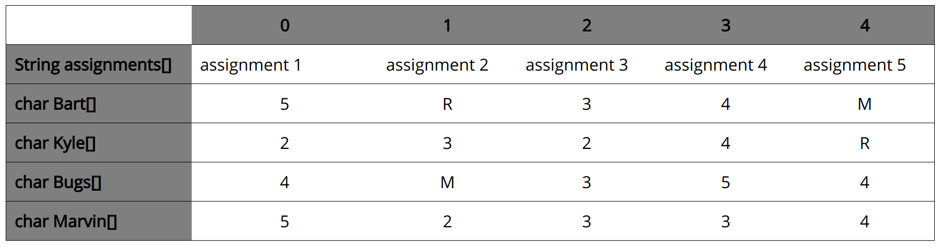

String students = {Bart, Kyle, Bugs, Marvin};

