Set 0: Hello World

Skill 0.1: I can declare a class.
Skill 0.2: I can write a main method.
Skill 0.3: I can print to the console.
Skill 0.4: I can compile and run a Java program.
Skill 0.5: I can add comments to a program.

Skill 0.1: I can declare a class.

Skill 0.1 Concepts

A “class” in the context of the Java programming language is a template for something. Classes in Java also serve to organize your code in a logical manner - kind of like school! At school, your day is divided among different classes. You may go to a math class, a history class, and, if you are reading this, a computer science class. Just as a math class can be offered at different schools from a shared design, a Java class provides a description that can be used within a program.

Classes in Java are typically separated into different Java files, just like your classes at school are separated into different rooms. The way you declare a class in Java is illustrated below.

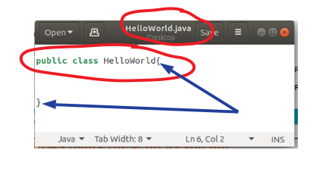
- Notice in the screenshot above that the file name, HelloWorld.java, ends with the .java extension. This is required for all Java source files.
- To declare a new class in Java, use the keyword “class” followed by the class name. When a class is public, its name must match the file name exactly, without the .java extension.
- We have also added the word “public” before the class declaration. The public keyword makes the class accessible from other classes. Because this class is public, its file name must be HelloWorld.java.
- Finally, we added an opening curly brace after the “public class HelloWorld” declaration and a closing curly brace farther down the page. All code associated with the HelloWorld class must appear between these curly braces.

Skill 0.1 Exercise 1

Skill 0.2: I can write a main method.

Skill 0.2 Concepts
Inside the classes we create are "methods." Methods (also known as functions) allow us to define the things a class can do. For example, in a math class we can add, subtract, divide, and multiply numbers. A method that adds two numbers could be represented simply as a + b, where a and b represent different numbers.
To run a Java class as a standalone program, it must have a main method. When the program begins, Java starts by calling main. The main method is also referred to as the "driver" because it drives the program.
The way you declare the main method is illustrated below.
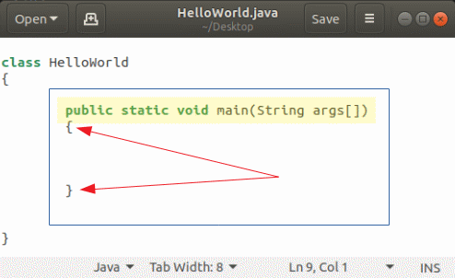
- At this point, do not worry about what all the words mean. The only word you need to be concerned with at this point is the word "main". This is the name of the method.
- Notice the main method appears between the curly brackets in the HelloWorld class.
- We have added an open curly bracket after the "public static void main(String args[])" declaration and a closing curly bracket further down the page. All the code associated with the main method must appear between these curly brackets.
Skill 0.2 Exercise 1

Skill 0.3: I can print to the console.

Skill 0.3 Concepts
For now, our programs will display information in the console. When we work from the command line, that output appears in the terminal. We will also use the terminal to compile and run our Java programs.
Printing to the console can be done using the following statement:
- Notice the semicolon at the end. It terminates the statement and is required at the end of this print statement.
- System.out.print() is a method call that sends output to the console. Whatever you place inside quotation marks between the parentheses will be printed.
- Java is case-sensitive. The word "System" must be capitalized, while "out" and "print" must be lowercase.
Printing to the console can also be done using the following statement:
- The difference between this statement and the previous one is the "ln" after "print."
- This statement prints whatever is between the quotation marks and then moves the cursor to the next line.
Skill 0.3 Exercise 1

Skill 0.4: I can compile and run a Java program.

Skill 0.4 Concepts

Before you can run a Java program, you must first compile it. The javac compiler converts Java source code into bytecode that the Java Virtual Machine can execute.

Consider the HelloWorld.java file from before. The following line of code would compile this program.

When you compile a Java program, an additional file is created. It has the same name as the class, but its extension is .class. In this example, the command above creates a HelloWorld.class file.
When you run the program, the Java launcher loads the compiled class. The following command runs the compiled HelloWorld program:

Skill 0.4 Exercise 1

Skill 0.5: I can add comments to a program.

Skill 0.5 Concepts

Comments are segments of text in a program that the compiler ignores. They are important for explaining code and can also help during testing and debugging. As we move through the course, you will see the importance of comments and clear documentation.

There are two common ways to add comments to a program. They are demonstrated below.

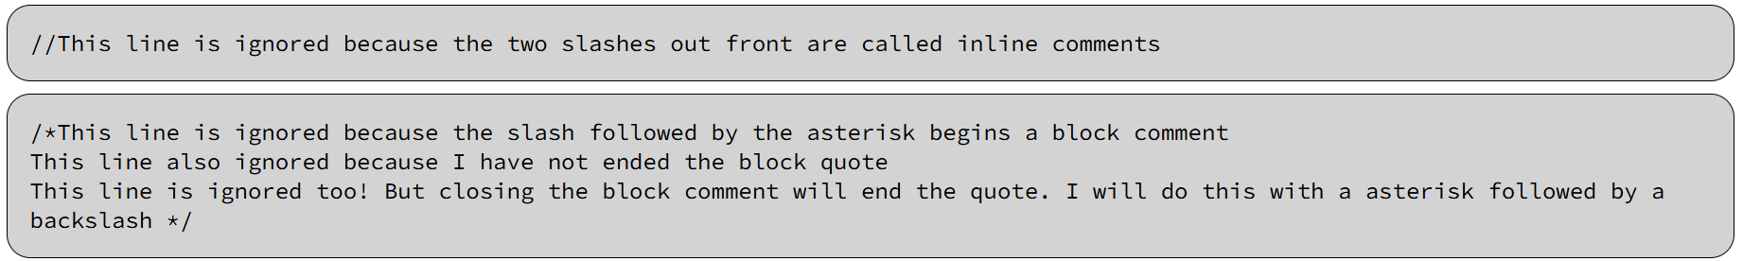

Skill 0.5 Exercise 1

