Set 2: Basic String Operations

Skill 2.1: Concatenate String type variables
Skill 2.2: Use the length method to find the number of characters in a String
Skill 2.3: Retrieve a portion of a String using the substring method
Skill 2.4: Convert between lower and upper case
Skill 2.5: Use escape sequences to print special characters

Skill 2.1: Concatenate String type variables

Skill 2.1 Concepts

Concatenation means to combine or attach things together. In Java this is done with the plus (+) sign.

Consider the following example. Below, the variables initialized to “Hello” and “good buddy” are concatenated and assigned to a new variable c. The program prints Hellogood buddy to the screen.

Code
String mm = "Hello";
String nx = "good buddy";
String c = mm + nx;
System.out.println(c);

Output
Hellogood buddy

Notice, in the example above that there is no space between Hello and good. A space between the words “Hello” and “good” could have been achieved by concatenating a space between these words as shown below,

Code
String mm = "Hello";
String nx = "good buddy";
String c = mm + " " + nx;
System.out.println(c);

Output
Hello good buddy

The example below also illustrates another way a space could have been achieved,

Code
String mm = "Hello";
String nx = " good buddy";
String c = mm + nx;
System.out.println(c);
Output
Hello good buddy

It is possible to concatenate a String with a numeric variable as follows. This is a useful technique for converting an int variable type to a String variable type.

Code
int x = 17;
String s = "Was haben wir gemacht?"; //German for "What have we done"
String combo = s + " " + x;
System.out.println(combo);
Output
Was haben wir gemacht? 17

Skill 2.1 Exercise 1

Skill 2.2: Use the length method to find the number of characters in a String

Skill 2.2 Concepts

In the previous lesson we learned about a String type variable. While, String type variables are nothing more than a serious of characters, they are also considered objects in Java (as oppossed to primitives). The String object class in Java provides a library of methods which are useful for manipulating String type variables.

To access these methods, we can use the "dot" notation. One method in the String library that is useful is the lenth() method. This method can be used to find the number of characters in a String. Consider the following example,
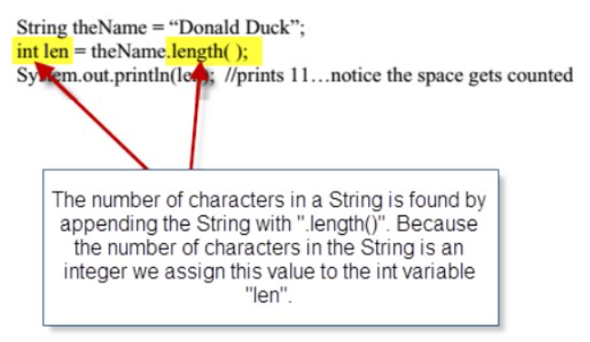
Skill 2.2 Exercise 1

Skill 2.3: Retrieve a portion of a String using the substring method

Skill 2.3 Concepts

The substring method can be used to indicate the portion of the String we want to retrieve. In computer science counting begins at 0. In the String “Sparky the dog”, the character assignments are as follows,

Letter | S | p | a | r | k | y |  | t | h | e |  | d | o | g
Index | 0 | 1 | 2 | 3 | 4 | 5 | 6 | 7 | 8 | 9 | 10 | 11 | 12 | 13

If we wanted to print all the characters starting at position 4 (“k”), we could use substring(4). This is illustrated below,

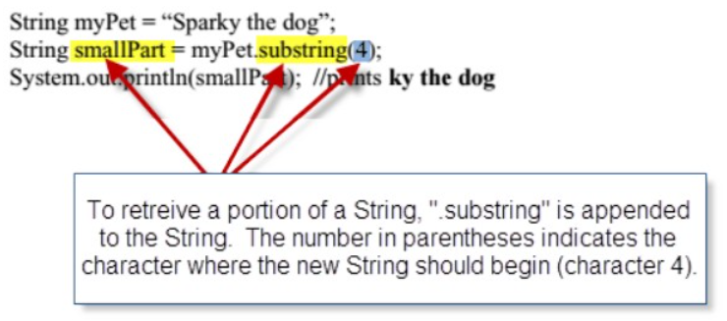
Another application of the substring() method involves retrieving the characters from the middle of a String.

If we want to print all the characters starting at k (position 4) and ending at d (position 11), we could use substring(4, 12). This is illustrated below,

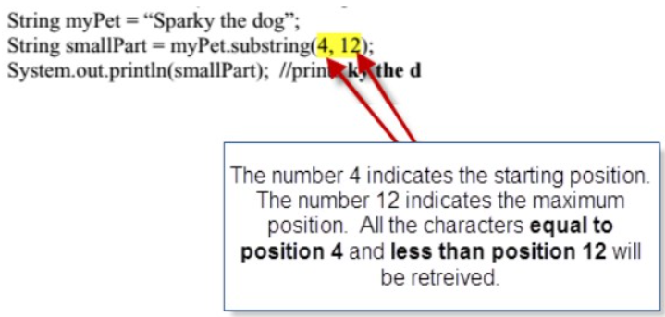

Skill 2.3 Exercise 1

Skill 2.4: Convert between lower and upper case

Skill 2.4 Concepts

The method toLowerCase converts all characters to lower case (small letters)

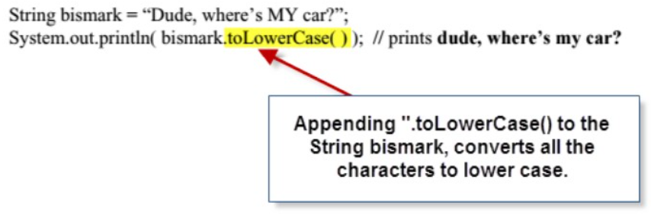

The method toUpperCase converts all characters to upper case (capital letters)

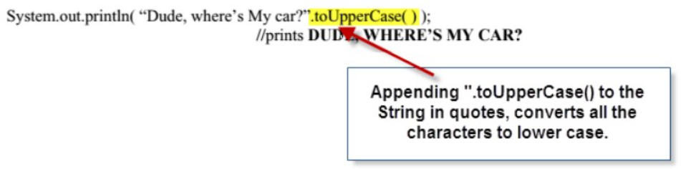

Skill 2.4 Exercises 1 & 2

Skill 2.5: Use escape sequences to print special characters

Skill 2.5 Concepts

To force a quote character (") to printout, or to be part of a String, use the escape sequence, “\”. Note escape sequences always start with a “\” character.

Consider the following example,

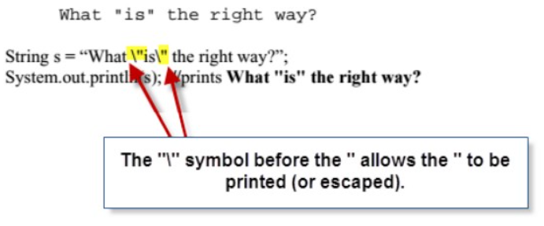
Another escape sequence, \n, will create a new line (also called a line break) as shown below

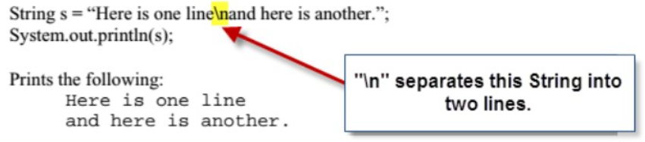

The escape sequence, \\, will allow us to print a backslash within our String. Otherwise, if we try to insert just a single \ it will be interpreted as the beginning of an escape sequence,

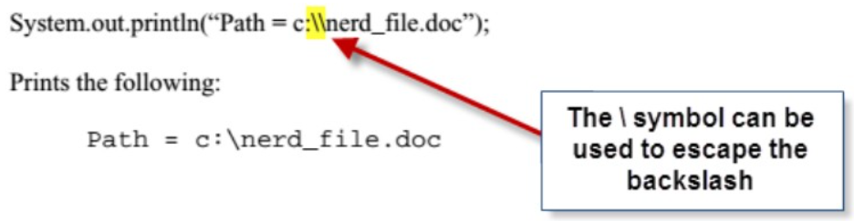

The escape sequence, \t, will allow us to tab over. The following code tabs twice.

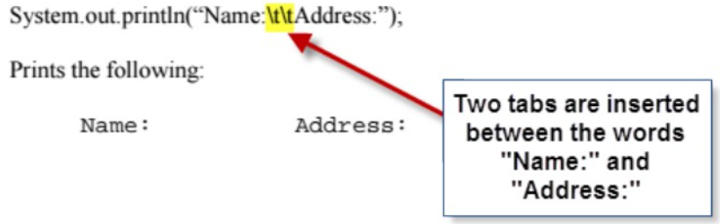

Skill 2.5 Exercise 1

